create table student_exp7_csa_05(roll_no number(2) primary key,name varchar(10),physics number(2),chemistry number(2),mathematics number(2));

table created.

insert into student_exp7_csa_05 values(1,'Adithyan',19,13,50);

insert into student_exp7_csa_05 values(2,'Alan',21,23,48);

insert into student_exp7_csa_05 values(3,'Akhil',10,15,39);

insert into student_exp7_csa_05 values(4,'Aparna',16,9,46);

insert into student_exp7_csa_05 values(5,'Biniya',23,21,36);

insert into student_exp7_csa_05 values(6,'Charlie',8,6,34);

insert into student_exp7_csa_05 values(7,'Dayana',14,21,43);

insert into student_exp7_csa_05 values(8,'Ginny',24,25,49);

insert into student_exp7_csa_05 values(9,'Helen',10,13,40);

insert into student_exp7_csa_05 values(10,'Salvatore',21,23,41);

10 rows inserted.

select * from student_exp7_csa_05;

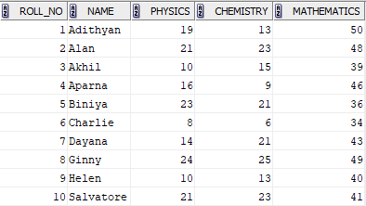

select avg(physics) from student_exp7_csa_05;



select max(mathematics) as highest_marks_maths from student_exp7_csa_05;



select min(chemistry) as lowest_marks_chemistry from student_exp7_csa_05;



select count(physics) from student_exp7_csa_05 where physics>=12;



select count(name) from student_exp7_csa_05 where physics>=12 and chemistry>=12 and mathematics>=25;



alter table student_exp7_csa_05 add total_marks int;

table altered

update student_exp7_csa_05 set total_marks=chemistry+mathematics+physics;

10 rows updated

alter table student_exp7_csa_05 add result varchar(1);

table altered

update student_exp7_csa_05 set result='p' where physics>=12 and chemistry>=12 and mathematics>=25;

6 rows updated

update student_exp7_csa_05 set result='f' where physics<12 or chemistry<12 or mathematics<25;

4 rows updated

select * from student_exp7_csa_05;

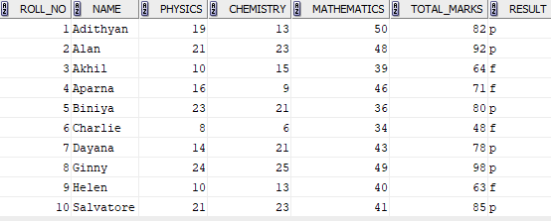

select count(name)*10 as pass_percent_maths from student_exp7_csa_05 where mathematics>=25;



select count(name)*10 as pass_percent from student_exp7_csa_05 where result='p';



select avg(total_marks) as class_average from student_exp7_csa_05;



select count(name) as passed_students from student_exp7_csa_05 where result='p';

