**MENTAL HEALTH LIBERIA User Documentation**

**1. Client**

**1.1 Prerequisite:**

* Before installing, please make sure you have JRE (Java Runtime Environment) installed on target system. This can be downloaded from <http://www.oracle.com>.

**1.2 Installing:**

* Execute the installer and follow its instructions. Make sure you have the administrative rights on target system before attempting to install the program.

**1.3 Main Screen:**

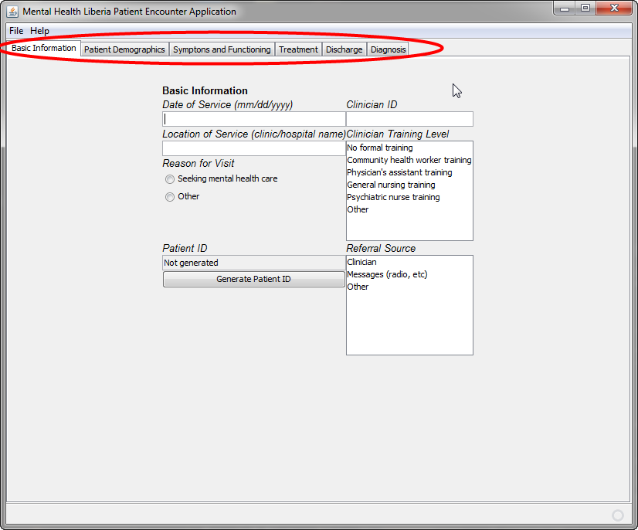

* The form has multiple parts – you can navigate to different parts of the form by clicking the appropriate tab, highlighted by the red circle.

**1.4 Basic Information:**

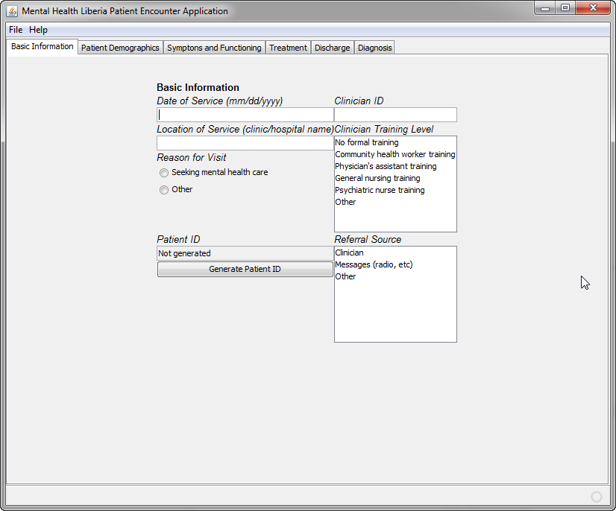

* Date of Service: Input the date of service in “mm/dd/yyyy” form. For example, if the date of service was May 10th 2011, then input “05/10/2011”.
* Clinician ID: Input clinician ID number here.
* Location of Service: Input the name of clinic/hospital.
* Reason for Visit: Select the appropriate option by clicking on one of the options.
* Clinician Training Level: Select the appropriate option by clicking on one of the options.
* Referral Source: Select the appropriate option by clicking on one of the options.

**1.4.1 Generating Patient ID:**

* The basic information section of the form has the option to automatically generate non-identifying, unique patient ID based on patient information. Please note that program does not save any information inputted during this process.
* To start generating patient ID, click “Generate Patient ID” button.

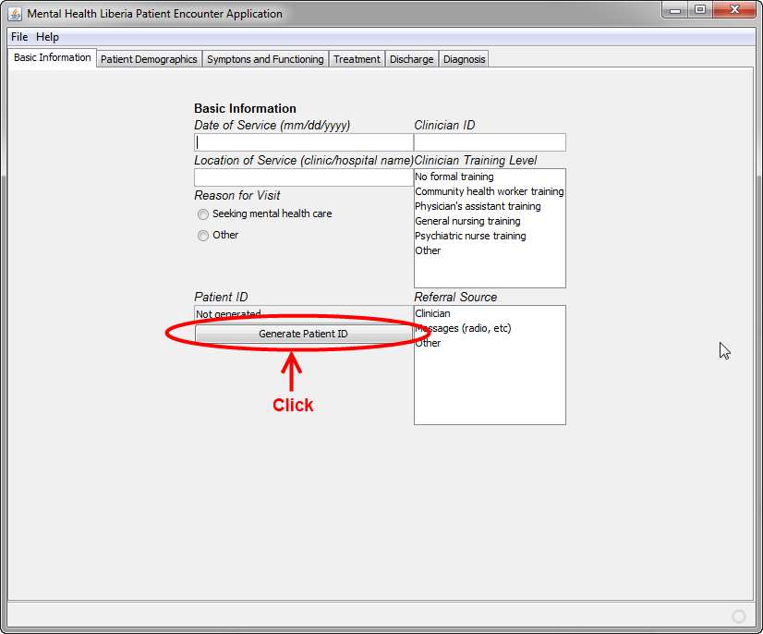

* Clicking the button will display this screen.

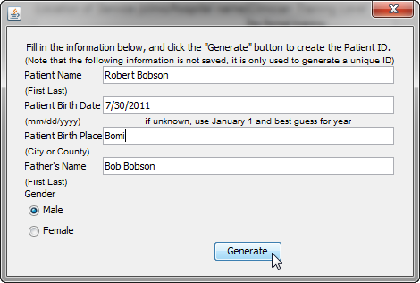

**(Note: above picture is for display purpose only; this screenshot may not match your patient’s information.)**

* Patient Name: Type in the patient’s name, in ([First name] [Last name]) format.
* Patient Birth Date: Type in the patient’s birth date, in form of (mm/dd/yyyy).
  + It is okay to omit the leading zero if the month is single digit number.
* Patient Birth Place: Type in the patient’s birth place.
* Father’s Name: Type in the name of the patient’s father.
* Gender: Select the patient’s gender.

After typing all the information to this form, please click “Generate”.

* Program will indicate that patient ID is generated by displaying “Generated” under “Patient ID” section.

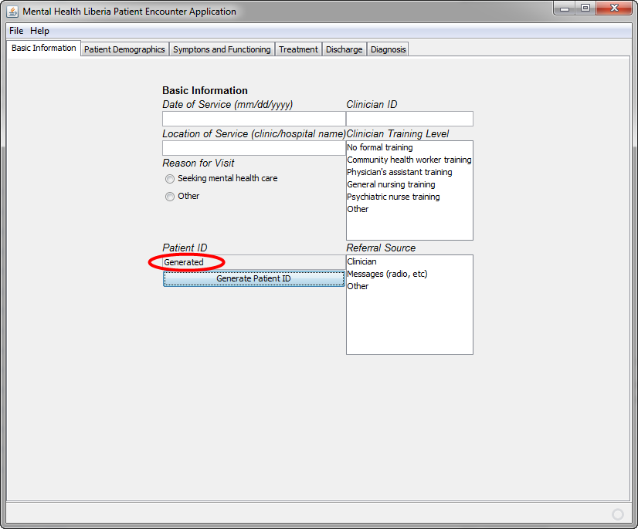

**1.5 Patient Demographics:**

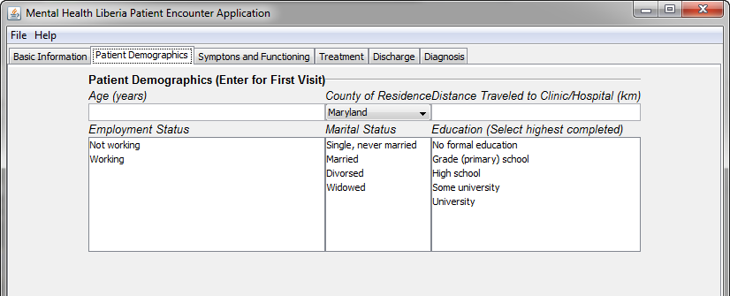

* Age: Type in the patient’s age in years.
* County of Residence: Select the patient’s county of residence.
  + 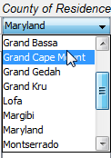
  + When the field is clicked, it will display a “drop-down menu”, where the user can scroll up or down and find the appropriate options.
* Distance Traveled to Clinic/Hospital: Type in the appropriate distance the patient has travelled to get to the clinic/hospital in kilometers, rounded to a whole number.
* Employment status: Click the appropriate option that reflects the employment status of the patient.
* Marital status: Click the appropriate option that reflects the marital status of the patient.
* Education: Click the appropriate option that reflects the highest education completed by the patient.

**1.6 Symptoms and Functioning:**

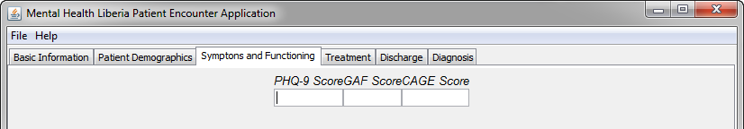

* PHQ-9 Score: Type in the patient’s PHQ-9 score here.
* GAF Score: Type in the patient’s GAF score here.
* CAGE Score: Type in the patient’s CAGE score here.

**1.7 Treatment:**

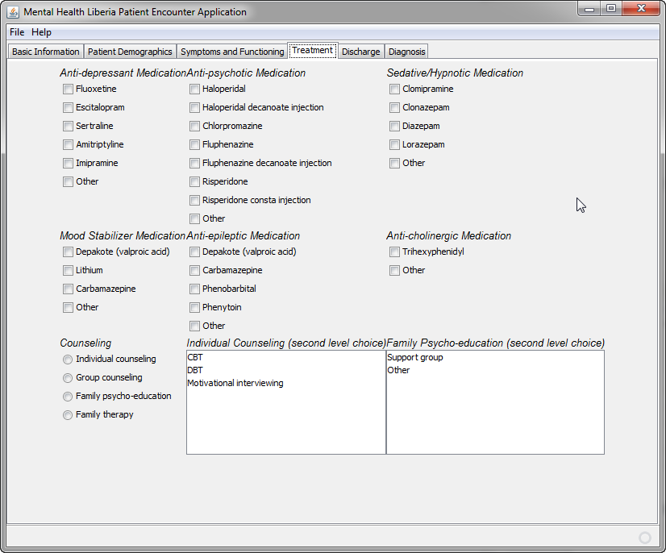

* Medication: The form shows medication categories (anti-depressant, anti-psychotic, etc.) and medications under that category. If patient has received any medications, please check the box next to the medication name.
* Counseling: Click the appropriate option that reflects any counseling done to the patient as a part of a treatment.
* Individual counseling: if “Individual Counseling” was chosen from the “Counseling” section, select the type of given counseling.
* Family Psycho-education: if “Family psycho-education” was chosen from the “Counseling” section, select the type of given counseling.

**1.8 Discharge:**

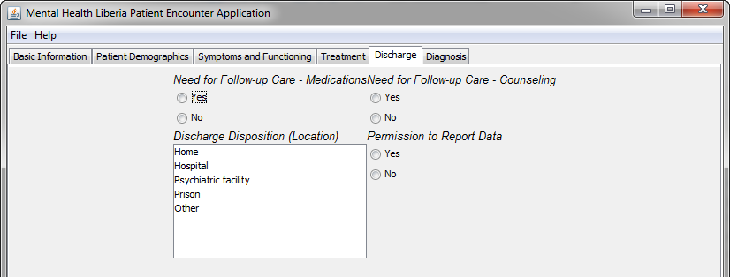

* Need for Follow-up Care - Medications: Select “Yes” if the patient needs follow-up care due to medication reasons. Otherwise, select “No”.
* Need for Follow-up Care - Counseling: Select “Yes” if the patient needs follow-up care due to counseling reasons. Otherwise, select “No”.
* Discharge Disposition (Location): Select the location patient has discharged to.
* Permission to Report data: Select “Yes” if you’d like to report this patient’s data. Otherwise, select “No”.

**1.8 Diagnosis:**

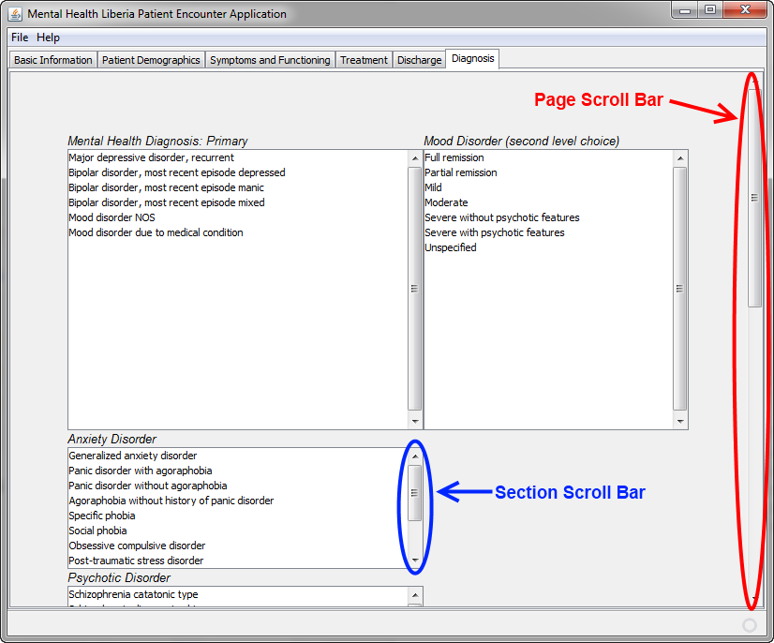

* Select the appropriate diagnosis for the patient here.
* Note that this section has a “page scroll bar”, highlighted in red. You can use this to scroll up or down this page.
* Note that this section has a “section scroll bar”, highlighted in blue. You can use this to scroll up or down a specific section.

**1.9 File Menu:**

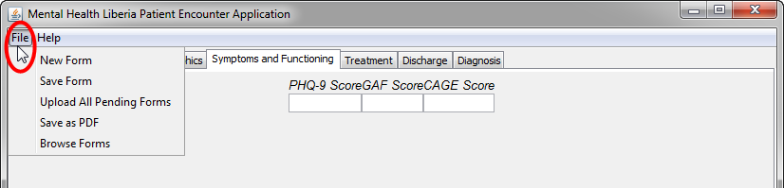

* **Click the “File” on upper left section to access the file menu.**
* New Form: Discards the current form and start a new form.
* Save Form: Save current form to a local disk.
* Upload All Pending Forms: Uploads all saved forms. See section 1.9.1 for more information.
* Saves as PDF: Saves current form as a .pdf file.
* Browse Forms: Open any saved forms using “Save Form” option.

**1.9.1 Upload All Pending Forms:**

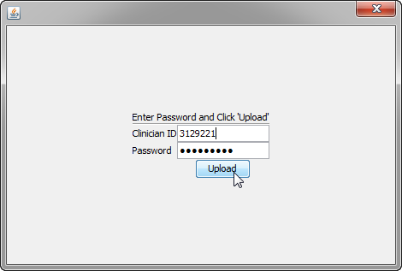

* Above screen will pop-up after clicking the “Upload All Pending Forms” option.
* Enter the clinician ID number and password, then click “Upload” button to upload any forms saved in local disk.
  + If you have forgotten this information, please contact the administrator.