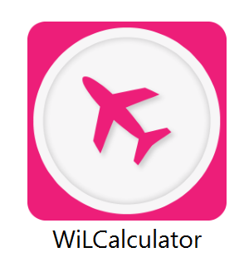

The Wing Lift Calculator (WiLCalculator) evaluates the wing lift curve of a lifting surface and the cl distibution along semi-span using the Nasa-Blackwell method for the evaluation of the load distribution. Simply setting an input variable it is possible to choose if calculate only the wing lift characteristics ( such as the maximum lift coefficient or the lift linear slope) or also the lift coefficient distribution.
In order to evaluate the wing lift curve it is necessary to obtain the following elements:
- Zero lift angle
- Lift coefficient slope
- End of linearity angle
- Maximum lift coefficient
- Stall angle of Attack

Introduction

Methods
The elements introduced in the previous section, useful to define the complete lift curve of the wing, are obtained using the following methods.
- α_{oL} , C_{Lα} → Nasa-Blackwell method

- α* → Mean Arifoil

- C_{LMAX} → Stall path
- α_{s} → Semi-empirical charts

The Nasa-Blackwell is a numerical method for calculating the subsonic load distribution for arbitrary lifting surface arrangements at a fixed angle of attack. The method is suitable for swept wings, non-planar wings, wing with pylons and/or end-plates; it can be also used to study the aerodynamic interaction of the wing and the horizontal tail. The method has been implemented because its results, as shown in the report, were in good agreement with the experimental results. The lifting surfaces are divided in several rectangular horse-shoe vortices along the span; one horseshoe vortex along the chord is used, that is, the midpoints of the vortices are placed only at points along the quarter-chord lines.
Contents
1 Introduction
2 Methods
3 How to use the executable
4 Input and output tables
5 Input Data

Input file: Wing Lift Analysis
EXECUTABLE INPUT FILE. vers1
updated to 18/05/2016
Reference libraries version : 10052016
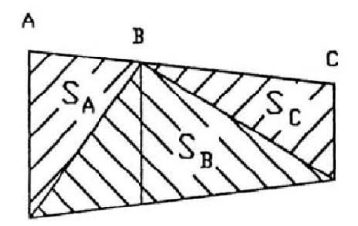
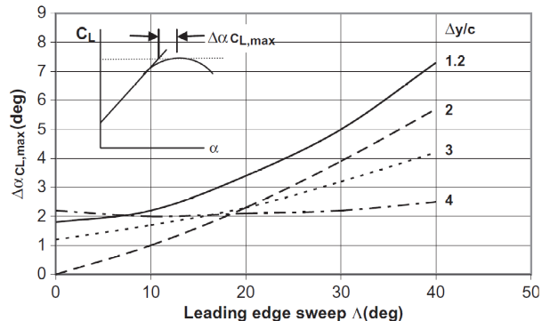
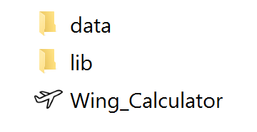
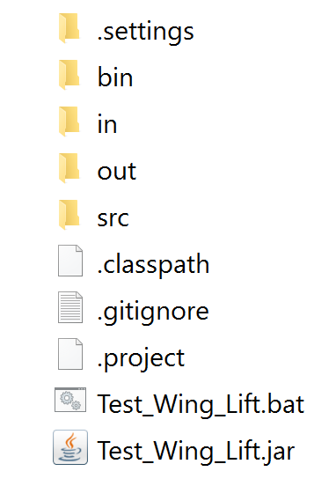
An equal number of control points are located along the three-quarter-chord lines. The velocity from the total vortex system is equated to the component of free-stream velocity normal to the lifting surface chord at each control point. Application of this tangent-flow boundary condition for a symmetrical loading provides a set of N simultaneous equations in the N unknown circulation strengths. Solution of this set of equations provides the loading distributions over the lifting surfaces. Mach number effect is introduced through a Prandtl-Glauert correction.
The mean airfoil is an airfoil that has the mean characteristics of the wing airfoils calculated using influence areas.
Nasa-Blackwell is an inviscid method for calculating the subsonic aerodynamic load distributions for arbitrary lifting-surface arrangements. This means that it does not see the non linear trait of the lift curve. So in correspondence of the value of C_{LMAX} calculated, the angle of attack obtained from the Nasa-Blackwell method is not correct because it is the maximum angle of attack that you would get if you reach the max CL linearly. So first it is evaluated the angle of attack at maximum lift coefficient through the linear trend of the lift line, then it’s added to this angle the increment evaluated by the diagram in the following figure, this is valid strictly for wing with high taper ratio without twist, with unique airfoil type and Mach number included between 0.2 and 0.6.

Fig 2. Diagram useful for evaluation of Δα

How to use the executable

Influence area for finite wing
In the WiLCalculator folder there are three sub-folder:
- data → that contains the serialized database
- lib → that contains the library
- Wing_Calculator → that contains the .jar, .bat and the input and output
folders.

In order to execute an analysis it is necessary to oper the Input folder (in) and insert the data in the xml file. After it is necessary to double click on the file “Test_Wing_Lift.exe” and open the output folder to see the results.

Folders organization

Number of Mach -
Altitude m
Number of Alpha -
Alpha initial deg
Alpha Final deg
Wing Surface m²
Aspect Ratio -
Number of points along semispan -
Adimensional kink station -
Number of input sections -
Mean Airofoil family -
Mean airfoil tichness -

Input Values
If the number of alpha is zero, the executable produces as output only the wing lift characteristics and the lift curve. Instead for each value of alpha it produces the cl distribution. The blue values are array. The orange values are charts.

Always
Zero lift angle deg
Lift slope coefficient 1/deg
End of linearity angle deg
End of linearity lift coefficient -
C_{L,MAX} -
Angle of stall deg
CL vs alpha array -
Alpha Array deg
CL vs alpha
Stall path

If number of alpha ≠ 0
eta stations -
cl distribution at alpha -
cl distribution vs eta

Output Values
Y input station distribution -
Chord distribution m
X_{LE} distribution m
Geometrical twist angle distribution deg
dihedral angle distribution deg
Zero lift angle distribution deg
End of linearity angle distribution deg
Maximum lift coefficient distribution -

Input data
 |  | Name of Variable | Description
Operating Conditions |  | altitude
Operating Conditions |  | mach_number
Operating Conditions |  | number_of_alpha | This is the number of angles of attack for which you want to calculate the cl distribution along the semi-span. The maximum number of alpha is 7.
Operating Conditions |  | alpha_initial | This is the initial value of angle of attack attack for which you want to calculate the cl distribution along the semi-span.
Operating Conditions |  | alpha_final | This is the final value. The intermediate values are obtained with a linespace using alpha initial, final and the number of alpha
Wing | Global | surface
Wing | Global | aspect_ratio
Wing | Global | number_of_point_semispan | These are the station along semi-span for which you want to calculate the local cl and the number of point used by the nasa blackwell method
Wing | Global | adimensional_kink_station | This is the station of kink adimentionalized on yhe semi-span
Wing | Distribution | number_of_given_sections | This is the number of section given as input ( for example root, kink, tip → 3)
Wing | Distribution | airfoil_family | This is the family of the airfoils.  The usable values are:  - NACA_4_DIGIT  - NACA_5_DIGIT  - NACA_63_SERIES  - NACA_64_SERIES  - NACA_65_SERIES  - NACA_66_SERIES  - BICONVEX  - DOUBLE_WEDGE  If your airfoil isn’t in the list, you can use the most similar one.
Wing | Distribution | max_thickness_mean_airfoil
Wing | Distribution | y_adimensional_stations | This is the stations, adimentionalized with the semispan, for which the input data are given. The number of these stations must to be the same of the number_of_given_sections
Wing | Distribution | chord_distribution
Wing | Distribution | x_le_distribution | This is the distance between the TE of the root airfoil and the TE of the local airfoil. (The root value must be zero)
Wing | Distribution | twist_distribution | This is the geometrical twist angle between the local airfoil and the root airfoil. (The root value must be zero)
Wing | Distribution | dihedral_distribution | (The root value must be zero)
Wing | Distribution | alpha_zero_lift_distribution
Wing | Distribution | alpha_star_distribution
Wing | Distribution | maximum_lift_coefficient_distribution

