RESULTS.
DartBoard.
1.1 Overall improvement on in-game stereoacuity performance
We performed a two-way between-subjects ANOVA on the in-game stereoacuity measures to examine the effect of group (stereo-normal and stereo-anomalous) and difficulty level (1, 2, and 3) on game performance. There was a statistically significant interaction between group and difficulty level on in-game stereoacuity performance F(2, 102245) = 100.53, p < 0.001. Main effect analysis showed that the stereo-normal group achieved a lower threshold (Mean = 235” ± 164”) than the stereo-anomalous group (Mean = 291” ± 220”, p < 0.001) and performance scaled with difficulty level (p < 0.001). All participants showed an improvement in game performance as measured by the pre to post ratio (Figure 1).
Figure 1. Participant game performance. Level 1 is represented as solid circles, Level 2 as hollow squares, and Level 3 as hollow diamonds. (A) In-game stereoacuity performance for stereo-normal participants. (B) In-game stereoacuity performance for stereo-anomalous participants. Colors represent binocular condition (Red: Strabismus, Blue: Anisometropia, and Green: Stereo-weak).
To assess the amount and rate of learning in the DartBoard game, we fit the data of each participant and difficulty level with a three-parameter exponential function (Eq. 1). From the fit, we calculated the asymptotic threshold, time constant, and the ratio of baseline to asymptotic threshold (PPR). The asymptotic threshold represents the best performance achieved through training. The time constant represents the time it took for the exponential to fall 37% (1/e) of the starting value. Thus, it represents the rate of learning. Lastly, the PPR represents the amount of learning as a factor of the starting threshold (higher PPR indicates greater learning).
Equation 1. $\left(PPR×e^{-\frac{\# of sessions}{Time constant}}+1\right)×asymptotic threshold$
We performed a two-way between-subjects ANOVA on the PPR to assess whether there was an effect of group or difficulty level on the amount of in-game learning (Figure 2). We found no significant effect of group F(1, 54) = 0.46, p = 0.5 or difficulty level F(2, 54) = 1.19, p = 0.31 on PPT.
We performed a two-way between-subjects ANOVA on the asymptotic threshold to assess whether there was an effect of group or difficulty on final threshold (Figure 3). We report a significant effect of group F(1, 54) = 3.88, p = 0.05 on asymptotic threshold with the stereo-normal group reaching a lower threshold on average (Mean = 168.48, SEM = 6.74) compared to the stereo-anomalous group (Mean = 192.15, SEM = 14.26). There was no significant effect of difficulty level on asymptotic threshold F(2, 54) = 1.05, p = 0.36.
Figure 3. Effect of group and difficulty on asymptotic threshold. Circles represent the asymptotic threshold of a single participant at each difficulty level. The horizontal line inside the box indicates the group median while the top and bottom lines represent interquartile ranges.
Figure 2. Effect of group and difficulty level on PPT. Circles represents the PPR of a single participant at each difficulty level. The horizontal line inside the box indicates the group median while the top and bottom lines of the box represent interquartile ranges.

We performed a two-way between-subjects ANOVA on the time constant to assess whether there was an effect of group or difficulty level on the amount of time it took for learning to level off (i.e., reach the asymptote) (figure 4). We report a non-significant effect of group F(1, 54) = 1.06, p = 0.31 and a non-significant effect of difficulty F(2, 54) = 1.03, p = 0.36 on the time it took to reach the asymptote. Meaning, there was no statistically significant difference in the rate of learning between groups and across difficulty level.
A.
B.
Figure 5. Typical example of in-game stereoacuity performance for a stereo-normal (top) and stereo-anomalous (bottom) participant.
Figure 4. Effect of group and difficulty level on the time constant. Circles represent the time constant for a single participant at each difficulty level. The horizontal line inside the box indicates the group median while the top and bottom lines represent interquartile ranges.
A dichoptic error is defined as failure to accurately identify the dichoptic stimulus in a 3-AFC anti-suppression task presented at the beginning of each trial. The task is designed to bring awareness to participants on their binocular coordination. The trial does not begin until the participant accurately identifies the dichoptic stimulus. Since there are three possible stimuli to choose from, we set three as the maximum number of dichoptic errors that could be made per trial. Anything above indicates a failure to do the task and is assigned a value of three.
To assess the if participants made less errors at the end of the study compared to the beginning, we calculated error ratio. Error ratio was calculated by taking the sum of all errors for one participant across the three difficulty levels and dividing by the number of trials. We then, took average of the first 4 sessions (eight blocks) and divided it by the average of the last 4 sessions. We found a moderate correlation of error ratio to ppr in the positive direction, indicating that participants who showed a greater ratio (made less errors at the end compared to the beginning) also showed a greater learning ratio (had a greater performance improvement in the game).
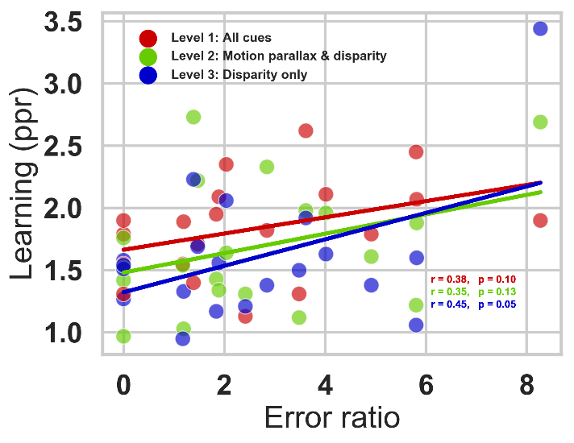
Figure 6. Relationship of error and learning ratio.

Halloween.
1.2. Transfer to clinical measures of stereoacuity.
All participants in the stereo-anomalous group (except AMS1) showed an improvement in the Randot Stereotest after training with a geometric mean improvement of 95” (Figure 6A- solid symbols). Notably, participant AS4 failed the Randot Stereotest before training and improved by 860”. Only participant AMS1 showed no transfer of stereoacuity in the Randot Stereotest. Seven out of the ten stereo-anomalous participants showed an improvement in the Random Dot 3 Stereo Acuity Test with a geometric mean of 142”. Three of the ten participants in the stereo-anomalous group (AS1, AS2, and AS4) failed the Randot3 test before training, but only AS4 improved after training (improved by 1400”). All participants in the stereo-normal group were at ceiling for both the Randot (20”) and the Random Dot 3 (12.5”) before training and remained at ceiling after training. Thus, their data is not shown.
All four participants with anisometropia showed an improvement in Randot (geometric mean: 90”) and Random Dot 3 (geometric mean: 205”). Alternatively, four participants with strabismus showed an improvement in Randot (geometric mean: 103”), but only two (AS3 and AS4) showed an improvement in Random Dot 3 (geometric mean: 229”). The stereo-anomalous participant classified as micro-strabismic (AMS1) did not show an improvement for Randot or Random Dot 3 after training, while the stereo-weak participant (AS-W1) improved by 80” in Randot and 12.5” in Random Dot 3.
To assess whether the initial stereo threshold gives an indication of future improvement, we calculated stereo PPR by taking the initial stereo threshold and dividing it by the post stereo threshold (Figure 7B). Overall, participants with a lower initial stereo threshold as measured with Randot show a higher stereo PPR, meaning they improved more after training.
A.
B.
Figure 7. Clinical stereoacuity improvement as a function of initial Randot and Random Dot 3 stereotests. Each symbol represents data from one participant in the stereo-anomalous group. Color indicates binocular condition: anisometropia (blue), strabismus (red), or weak stereo (green). (A) Shows a pre- versus post-training plot for Randot (solid symbols) and Random Dot 3 (open symbols) stereoacuity measures. Data under the diagonal unity line indicate an improvement in stereoacuity. (B) Shows the relationship between the initial stereo threshold and the pre to post stereo ratio. Data above the horizontal line indicate an improvement in stereo PPR.

1.3 Clinical stereoacuity change across training in the stereo-anomalous group
Since participants were measured at least five times, with the exception of AS1 and AA1 who were measured seven times since they completed an additional ten hours, we were interested to assess stereo threshold changes across training. Overall, most stereo-anomalous participants showed an improvement with training. Of particular interest was whether participants with anisometropia differ from those with strabismus. In Figure 8, we plot stereo threshold (Randot- large circles; Random Dot 3- small circles) for participants with anisometropia (blue symbols) and strabismus (red symbols) as a function of hours of game play. Overall, participants with anisometropia show a higher rate of learning (insert slope) compared to participants with strabismus (insert slope).
Figure 8. Rate of stereo threshold change between participants with anisometropia and strabismus as a function of hours of training.

Figure 9.

Pyschophysical measures of stereoacuity.
Figure 11.
Figure 10.

Figure 12.
DISCUSSION.
Although there was no statistically significant effect of difficulty level on in-game stereoacuity performance, a few participants (AMS1, AS-W1, AS4) in the stereo-anomalous group show a difference in learning rate in difficulty Level 1 compared to Level 2 and 3.

