RESULTS.
DartBoard.
1.1 Overall improvement on in-game stereoacuity performance
We performed a two-way between-subjects ANOVA on the in-game stereoacuity measures to examine the effect of group (stereo-normal and stereo-anomalous) and difficulty level (1, 2, and 3) on game performance. There was a statistically significant interaction between group and difficulty level on in-game stereoacuity performance F(2, 102245) = 100.53, p < 0.001. Main effect analysis showed that the stereo-normal group achieved a lower threshold (Mean = 235” ± 164”) than the stereo-anomalous group (Mean = 291” ± 220”, p < 0.001) and performance scaled with difficulty level (p < 0.001). All participants showed an improvement in game performance as measured by the pre to post ratio (Figure 1).
Figure 1. Participant game performance. Level 1 is represented as solid circles, Level 2 as hollow squares, and Level 3 as hollow diamonds. (A) In-game stereoacuity performance for stereo-normal participants. (B) In-game stereoacuity performance for stereo-anomalous participants. Colors represent binocular condition (Red: Strabismus, Blue: Anisometropia, and Green: Stereo-weak).
To assess the amount and rate of learning in the DartBoard game, we fit the data of each participant and difficulty level with a three-parameter exponential function (Equation 1). From the fit, we calculated the asymptotic threshold, time constant, and the ratio of baseline to asymptotic threshold (PPR). The asymptotic threshold represents the best performance achieved through training. The time constant represents the time it took for the exponential to fall 37% (1/e) of the starting value. Thus, it represents the rate of learning. Lastly, the PPR represents the amount of learning as a factor of the starting threshold (higher PPR indicates greater learning).
Equation 1. $\left(PPR×e^{-\frac{\# of sessions}{Time constant}}+1\right)×asymptotic threshold$
We performed a two-way between-subjects ANOVA on the PPR to assess whether there was an effect of group or difficulty level on the amount of in-game learning (Figure 2). We found no significant effect of group F(1, 54) = 0.46, p = 0.5 or difficulty level F(2, 54) = 1.19, p = 0.31 on PPT.
Figure 2. Effect of group and difficulty level on PPT. Circles represents the PPR of a single participant at each difficulty level. The horizontal line inside the box indicates the group median while the top and bottom lines of the box represent interquartile ranges.
We performed a two-way between-subjects ANOVA on the asymptotic threshold to assess whether there was an effect of group or difficulty on final threshold (Figure 3). We report a significant effect of group F(1, 54) = 3.88, p = 0.05 on asymptotic threshold with the stereo-normal group reaching a lower threshold on average (Mean = 168.48, SEM = 6.74) compared to the stereo-anomalous group (Mean = 192.15, SEM = 14.26). There was no significant effect of difficulty level on asymptotic threshold F(2, 54) = 1.05, p = 0.36.
Figure 3. Effect of group and difficulty on asymptotic threshold. Circles represent the asymptotic threshold of a single participant at each difficulty level. The horizontal line inside the box indicates the group median while the top and bottom lines represent interquartile ranges.
We performed a two-way between-subjects ANOVA on the time constant to assess whether there was an effect of group or difficulty level on the amount of time it took for learning to level off (i.e., reach the asymptote) (figure 4). We report a non-significant effect of group F(1, 54) = 1.06, p = 0.31 and a non-significant effect of difficulty F(2, 54) = 1.03, p = 0.36 on the time it took to reach the asymptote. Meaning, there was no statistically significant difference in the rate of learning between groups and across difficulty level.
Figure 4. Effect of group and difficulty level on the time constant. Circles represent the time constant for a single participant at each difficulty level. The horizontal line inside the box indicates the group median while the top and bottom lines represent interquartile ranges.
A.
B.
Figure 5. Typical example of in-game stereoacuity performance for a stereo-normal (top) and stereo-anomalous (bottom) participant.
A dichoptic error is defined as failure to accurately identify the dichoptic stimulus in a 3-AFC anti-suppression task presented at the beginning of each trial. The task is designed to bring awareness to participants on their binocular coordination. The trial does not begin until the participant accurately identifies the dichoptic stimulus. Since there are three possible stimuli to choose from, we set three as the maximum number of dichoptic errors that could be made per trial. Anything above indicates a failure to do the task and is assigned a value of three.
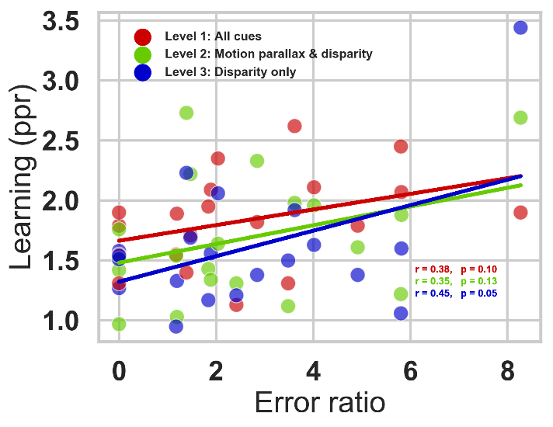
To assess the if participants made less errors at the end of the study compared to the beginning, we calculated error ratio. Error ratio was calculated by taking the sum of all errors for one participant across the three difficulty levels and dividing by the number of trials. We then, took average of the first 4 sessions (eight blocks) and divided it by the average of the last 4 sessions. We found a moderate correlation of error ratio to ppr in the positive direction, indicating that participants who showed a greater ratio (made less errors at the end compared to the beginning) also showed a greater learning ratio (had a greater performance improvement in the game).

Figure 6. Relationship of error and learning ratio.
Halloween.
1.2. Transfer to clinical measures of stereoacuity.
All participants in the stereo-anomalous group (except AMS1) showed an improvement in the Randot Stereotest after training (Mean = 167” ± 266”) (Figure 7A- solid symbols). Notably, participant AS4 failed the Randot Stereotest before training and improved by 860”. Only participant AMS1 showed no transfer of stereoacuity in the Randot Stereotest with a consistent measurement of 70” before and after training. Seven out of the ten stereo-anomalous participants showed an improvement in the Random Dot 3 Stereo Acuity Test (Mean = 251” ± 433”). Three of the ten participants in the stereo-anomalous group (AS1, AS2, and AS4) failed the Randot3 test before training, but only AS4 improved after training (improved by 1400”). Stereo threshold for participant AMS1 was at 400” before and after training, while
AS1 and AS2 failed the Random Dot 3 before and after training.
All participants in the stereo-normal group were at ceiling for both the Randot (20”) and the Random Dot 3 (12.5”) before training and remained at ceiling after training. Thus, their data is not shown in Figure 7 since it would fall on the unity line.
All four participants with anisometropia showed an improvement in Randot (Mean = 138” ± 162”) and Random Dot 3 (Mean = 264” ± 158”). Comparatively, all four participants with strabismus showed an improvement in Randot (Mean = 260” ± 402”), but only two (AS3 and AS4) showed an improvement in Random Dot 3 (Mean = 360” ± 963”). The stereo-anomalous participant classified as micro-strabismic (AMS1) did not show an improvement in Randot or Random Dot 3 after training, while the stereo-weak participant (AS-W1) improved by 80” in Randot and 12.5” in Random Dot 3.
To assess whether the initial stereo threshold gives an indication of future improvement, we calculated stereo PPR by taking the initial stereo threshold and dividing it by the post stereo threshold (Figure 7B). Overall, participants with a lower initial stereo threshold as measured with Randot show a higher stereo PPR, meaning they improved more after training.
A.
B.
Figure 7. Clinical stereoacuity improvement as a function of initial Randot and Random Dot 3 stereotests. Each symbol represents data from one participant in the stereo-anomalous group. Color indicates binocular condition: anisometropia (blue), strabismus (red), or weak stereo (green). (A) Shows a pre- versus post-training plot for Randot (solid symbols) and Random Dot 3 (open symbols) stereoacuity measures. Data under the diagonal unity line indicate an improvement in stereoacuity. (B) Shows the relationship between the initial stereo threshold and the pre to post stereo ratio. Data above the horizontal line indicate an improvement in stereo PPR.
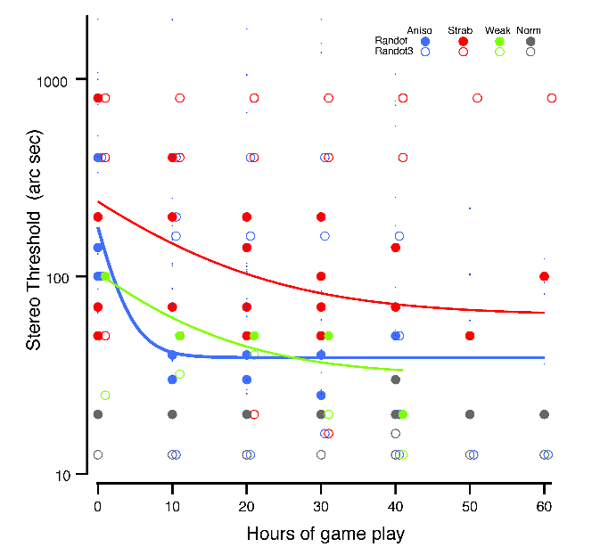
Participants were measured with the Randot and Random Dot 3 stereo tests at least five times with the exception of AS1, AA1, N5, N8, N10, and N11 who were measured seven times and N2 and N4 who only completed half of the study and were measured three times. Testing at every ten hours allowed us to track clinical stereoacuity changes as a function of training hours. Overall, most stereo-anomalous participants showed an improvement in clinical stereoacuity with training (Wilcoxon signed-rank test pre and post stereoacuity) (Figure 8). Participants with anisometropia reached a lower threshold (Randot mean = 138” ± 162”; Random Dot 3 mean = 264” ± 158”) at a faster rate (time constant) compared to participants with strabismus (Randot mean = 260” ± 402”; Random Dot 3 = 360” ± 963”, time constant).

Figure 8. Clinical stereo threshold as a function of training hours for Randot (solid symbols) and Random Dot 3 (open symbols). Colors indicate binocular condition: anisometropia (blue), strabismus (red), stereo-weak (green), and normal stereo (grey). Measurements were taken before training (0) and after every 10 hours until the completion of the study. Each symbol represents the stereo measure for one individual.
To normalize stereo threshold across participants, we took each measured stereo threshold and divided by the highest score possible (20” for Randot and 12.5” for Random Dot 3). We then fit the data, collapsing across stereo tests, with an exponential fit (Equation 2) where y0, A, and tau are fit coefficients.
Equation 2. $Normalized stereo threshold=y0+A^{exp⁡(\frac{x - x0}{tau})}$
Participants with anisometropia show greater learning at a higher rate than participants with strabismus and weak-stereo (Figure 9).
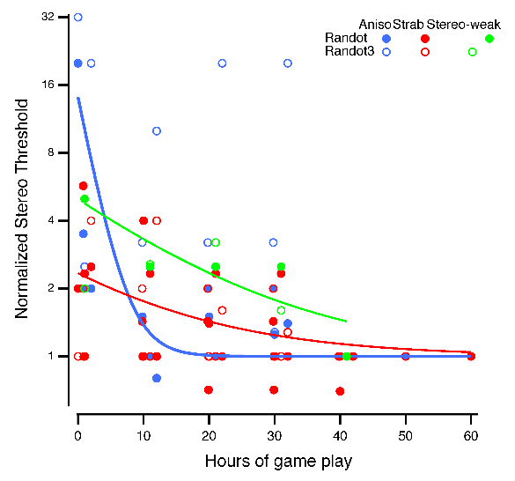
Figure 9. Normalized stereo threshold for stereo-anomalous observers across hours. Each symbol represents stereo the threshold for one participant as measured by Randot (closed symbols) and Random Dot 3 (open symbols).
1.3 Pyschophysical measures of stereoacuity.
All participants in the stereo-anomalous group, except for AA3 and AS2, showed an improvement in PDT (Mean = 169” ± 153”) (Figure 10). Participant AA3 and AS2 performed slightly worse after training compared to the initial PDT measurement by 7” and 67” respectively. Participants with strabismus showed a greater improvement (Mean = 193” ± 237”) compared to participants with anisometropia (Mean = 36” ± 51”). All participants in the stereo-normal group, except for N1, N10 and N11, showed an improvement in PDT (Mean = 16” ± 13”). The improvement was smaller compared to the stereo-anomalous group since most stereo-normal participants were close to celling.
The stereo-anomalous group had a greater improvement in RDS small (Mean = 395” ± 717”), medium (Mean = 160” ± 336”), and big (Mean = 539” ± 1255”) compared to the stereo-normal group who were close to celling at the beginning of training and showed only a small improvement (Mean = small: 4” ± 6”; medium: 2” ± 4”; big: 7” ± 11”). RDS improvement in the stereo-anomalous group was largely driven by participants with strabismus (Mean = small: 428” ± 477”; medium: 387” ± 472”; big: 1127” ± 1946”) compared to participants with anisometropia (Mean = small: 14” ± 17”; medium: 13” ± 13”; big: 215” ± 383”).

A.
B.
Figure 9. Psychophysical stereoacuity improvement as a function of initial stereo threshold. Each symbol represents a psychophysical test: PDT (triangle), RDS small (small circle), RDS medium (medium circle) and RDS big (big circle). Colors indicate binocular condition: anisometropia (blue), strabismus (red), stereo-weak (green), and normal stereo (grey). (A) Shows a pre- versus post-training plot. Data under the diagonal unity line indicate an improvement in stereoacuity. (B) Shows the relationship between initial stereo threshold and the amount of stereo improvement. Data above the horizontal line indicates an improvement in stereo.
Psychophysical tests were administered before, after every ten hours, and after the training. Thus, we were able to track psychophysical stereoacuity changes as a function of training hours. Similar to clinical measures of stereoacuity, stereo-anomalous participants showed an overall improvement in stereoacuity with training (Wilcoxon signed-rank test) (Figure 10). Participants with anisometropia reached a lower threshold at a faster rate (time constant) compared to participants with strabismus (time constant).

Figure 10. Psychophysical stereo threshold as a function of training hours for PDT (triangle), RDS small (small circle), RDS medium (medium circles), and RDS big (big circles). Colors indicate binocular condition: anisometropia (blue), strabismus (red), stereo-weak (green), and normal stereo (grey). Measurements were taken before training (0) and after every 10 hours until the completion of the study. Each symbol represents the stereo measure for one individual.
We normalized psychophysical stereoacuity by dividing each measurement by the highest score possible. We then fit the data, collapsing across stereo tests, with an exponential fit (Equation 2). Similar to the clinical stereoacuity results, participants with anisometropia reached a lower threshold at a faster rate for RDS (Figure 11A) and PDT (Figure 11B).

Figure 11. Normalized psychophysical stereo threshold for DRS and PDT. Each symbol represents strereo threshold for one participant. [Need: legend. What do solid symbols represent?]

