RESULTS.
In-game stereoacuity performance.
DartBoard.
We applied a two-way between-subjects ANOVA to the in-game stereoacuity measures to examine the effect of group and difficulty level on game performance. There was a statistically significant interaction between group and difficulty level on in-game stereoacuity performance F(2, 102245) = 100.53, p < 0.001. Simple main effects analysis showed that the stereo-normal group performed better than the stereo-anomalous group (p < 0.001) and performance scaled with difficulty level (p < 0.001). All participants showed an improvement in game performance as measured by the pre to post ratio (Fig. 1).

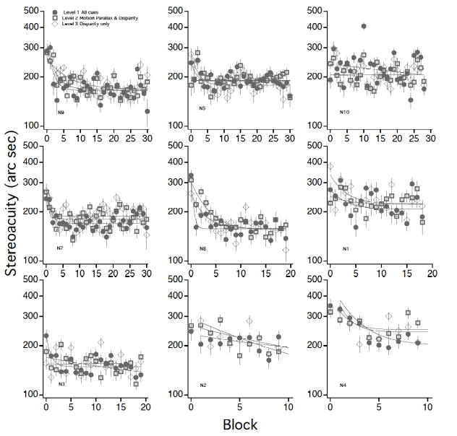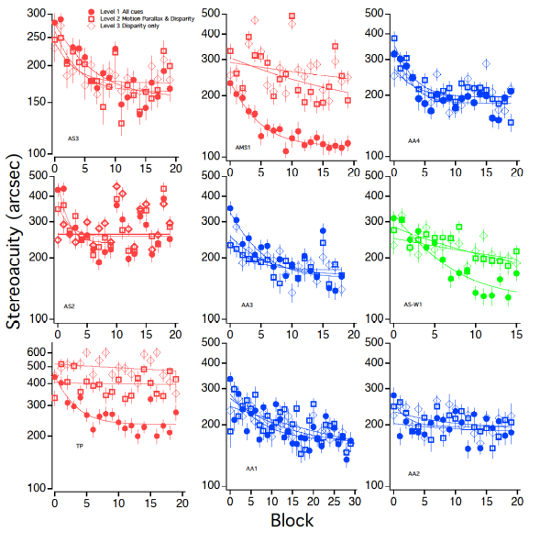
Learning levels out (2 x 3 ANOVA on asymptotic threshold)
Pre:post ratio tells us how much learning happened as a factor. Factor of 2=double learning or threshold halved.

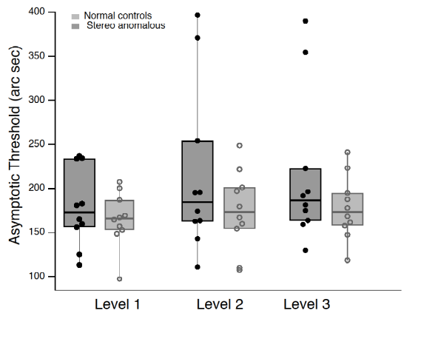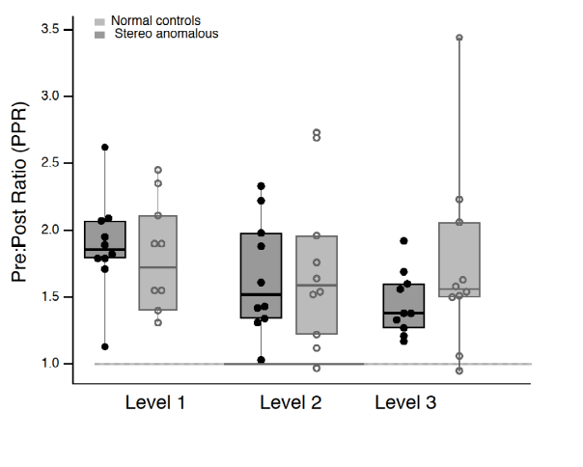
Time costant= how long it took to reach the asymptote
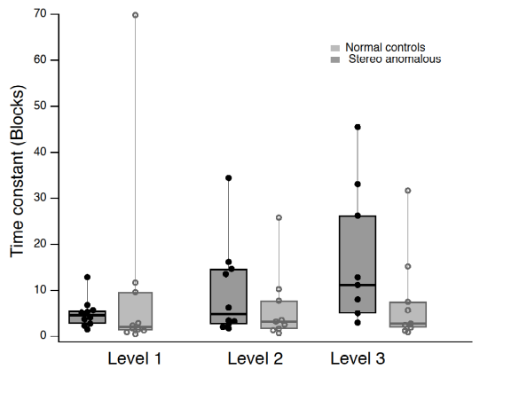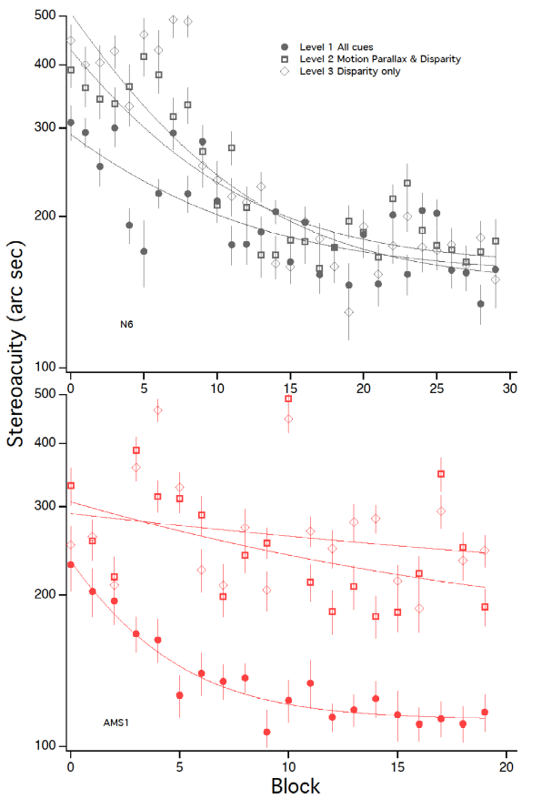

Halloween.

Clinical measures of stereoacuity.
Normalized to their asymptotic threshold.
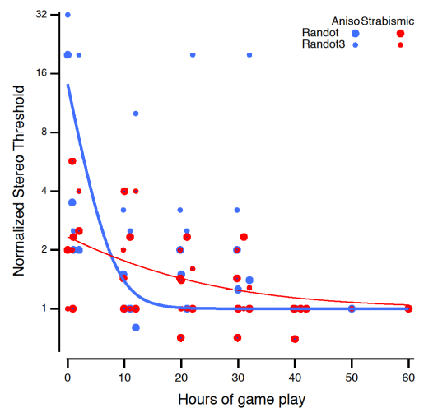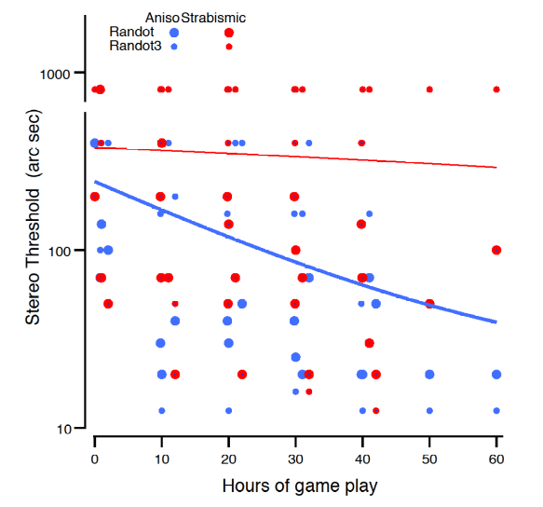
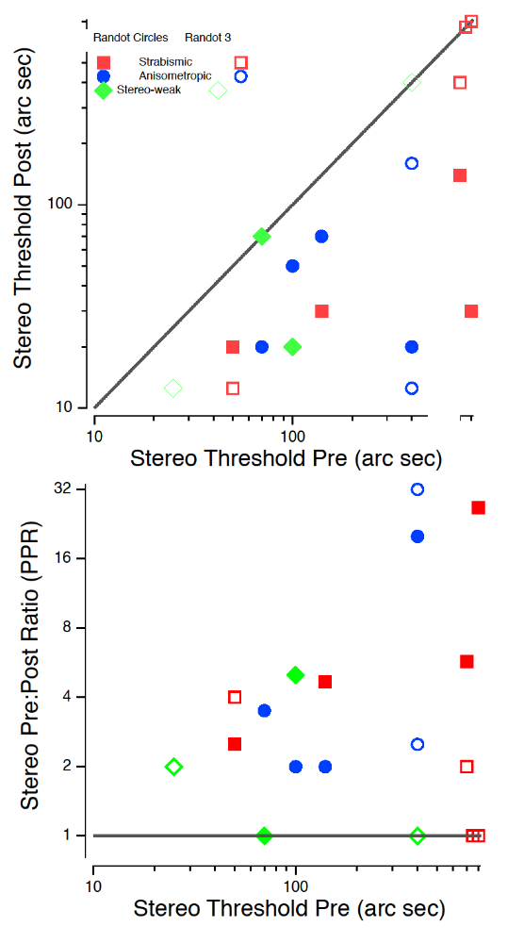
This before previous 2 images
Pyschophysical measures of stereoacuity.
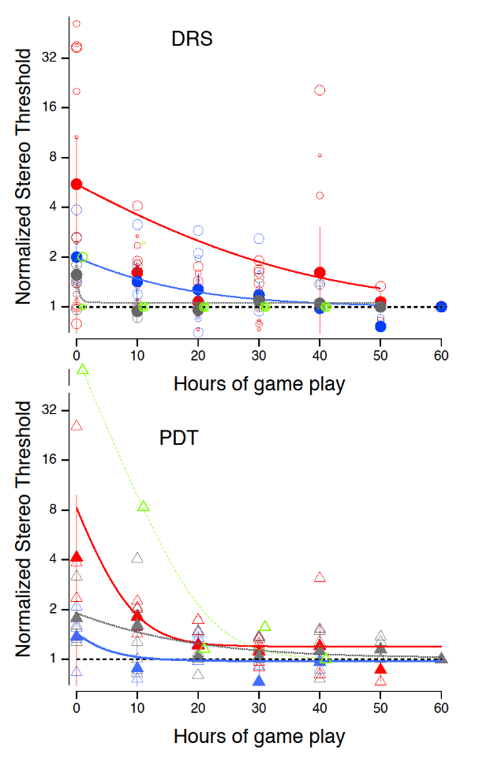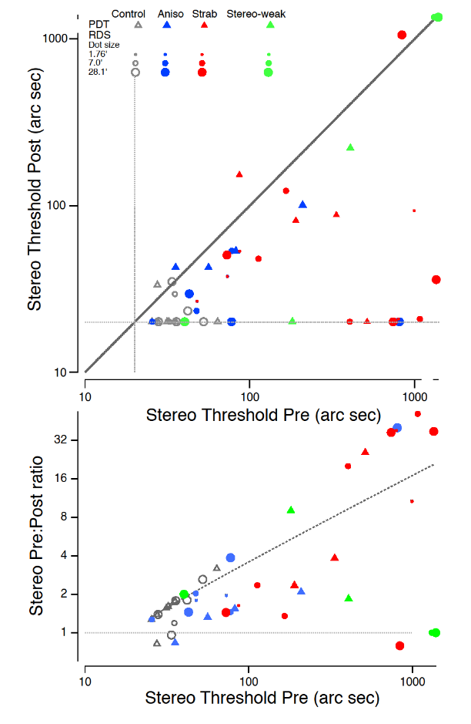

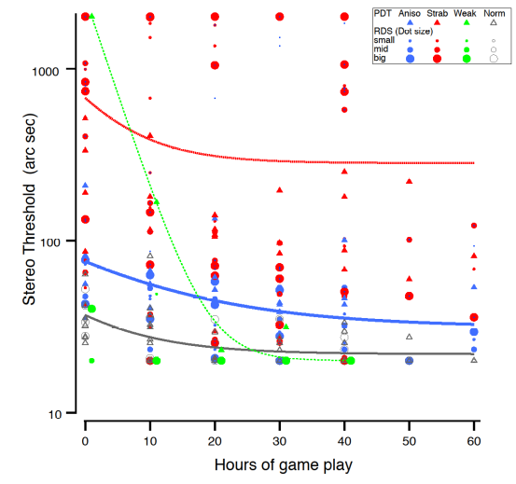

Fig. 1 Learning curves for stereo-normal participants. Each symbol represents the median in-game stereoacuity performance for a difficulty level and session. Error bars represent the SEM.

