Occurrence of Crystals in Switzerland

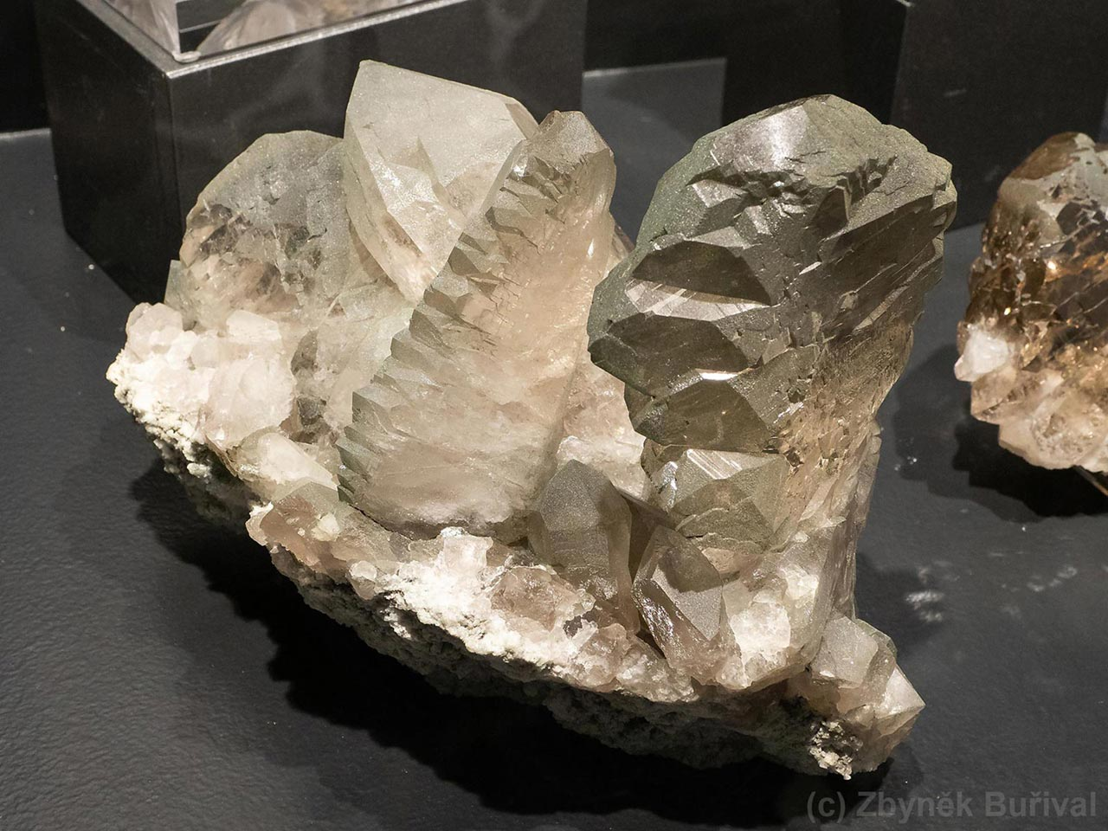

CIP02 – Data Collection, Integration & Preprocessing

|  |  |
| --- | --- |
| Lucerne University of Applied Sciences & Arts  MSc in Applied Information and Data Science  Spring Semester 2025  **Authors:**  Andreas Goerre  Barbara Maier  Sheena Walker | **Lecturer Info**  Andreas Melillo  Ramón Christen |

**Table of Contents**

1 Introduction 1

2 Preprocessing 1

3 Analysis 1

4 Conclusion 1

# Introduction

# Preprocessing

# Analysis

To structure our analysis, we propose the following key research questions:

1. **What is the spatial distribution of crystal occurrences across different regions in Switzerland?**To achieve this we will:

* Collect geolocation data on known crystal sites from mineralogical databases and geological surveys.
* Use GIS tools (e.g., GeoPandas, Folium) to map occurrences across different regions.
* Categorize sites by geographic features (e.g., Alpine vs. Jura regions).
* Identify spatial clustering patterns and regional mineral diversity.

1. **What are the most common crystal types found in Switzerland?**For this we will:

* Extract and classify crystal occurrences by **mineral type**.
* Analyze frequency distributions of different crystal types across Switzerland.
* Compare findings with **geological literature** to validate classification.
* Identify **potential geological factors** influencing crystal variety.

1. **Is there a statistically significant correlation between the occurrences of crystals and the elevation of the place found?**  
   We will do this:

* Categorize crystal occurrences by mineral type.
* Perform statistical correlation analysis (e.g., Pearson or Spearman correlation) between mineral type and elevation.
* Use data visualization techniques (e.g., histograms, box plots, scatter plots) to identify trends.
* Compare results with geological literature to interpret possible scientific reasons for observed patterns.

# Conclusion