**Molecular dynamics study of interfacial load transfer capability in amorphous SiOx films deposited on alumina surfaces**

*Youngoh Kima,b and Joonmyung Choia,b,\**

a*Department of Mechanical Design Engineering, Hanyang University,  
222 Wangsimni-ro, Seongdong-gu, Seoul 04763, Korea*

b*Department of Mechanical Engineering, BK21 FOUR ERICA-ACE Center,   
Hanyang University, 55 Hanyangdaehak-ro, Sangnok-gu Ansan 15588, Korea*

Corresponding author

E-mail address: [joonchoi@hanyang.ac.kr](mailto:joonchoi@hanyang.ac.kr)

**SUPPLEMENTARY DATA**

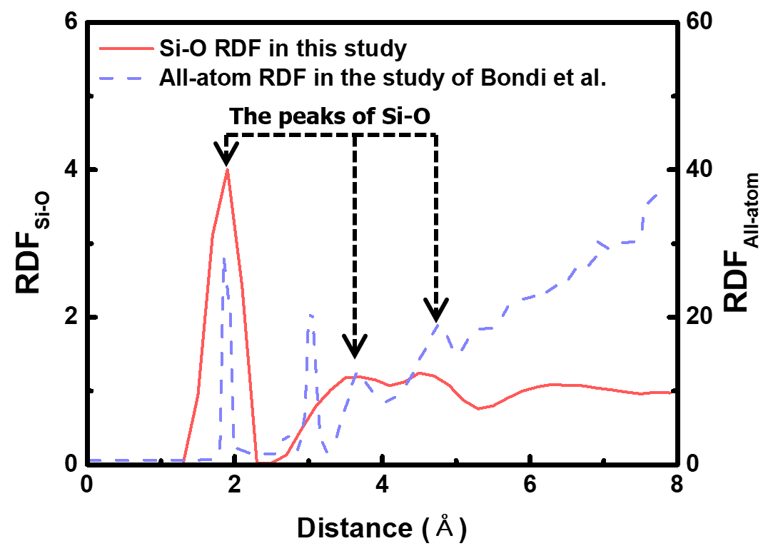

**Figure S1** Radial distribution functions of annealed SiOx (x = 1.5) obtained from the model considered in this study and the first-principles calculation [S1].

**Figure S2** (a) Formation of the distribution of nanopores after the Al (111) surface with 30% oxide coverage contacts SiOx film. For clarity, only nanopores and oxides are visualized in the bilayer structure. (b) Distributions of residual stress components in the in-plane and depth directions of the AlOx surface before SiOx adhesion. (c) Residual stress variation (left) during SiOx adhesion and stress distribution after the construction of AlOx/SiOx bilayer (Right). The purple circles and blue triangles represent the dominant regions of oxides and nanopores, respectively.

The oxide-dependent local stress in Al (111) was investigated, which adopted the cluster growth model for oxidation. The analysis of the nanopore formation induced by the stress concentration at the interface requires more quantitative data. Therefore, we further analyzed the stress distribution on the surface of the 30% oxidized Al (111) substrate after coating the SiOx film. **Figure S2(a)** shows the oxide islands of the 30% oxidized Al (111) substrate and the distribution of the nanopores after bilayer formation. As the SiOx film was covered on the Al surface, a clear change was observed in the distribution between the nanopores and oxygen islands.

To investigate the spatial distribution of the residual stress, the substrate was divided into 20 × 20 bins on the x-y plane. The maximum stress component of the aluminum atoms in each bin was extracted as a representative value of the spatial sample. As shown in **Figure S2(b)**, the influence of the non-uniform oxide on the formation of nanopores was closely associated with the residual stress distribution. The non-uniform oxides have a high tensile stress. The residual stress of the oxide is influenced by the collapse of the crystalline lattice structure and the adsorption of oxygen dimers [S2, S3]. In other words, the heterogeneous oxide forms localized residual stresses on the surface.

After the formation of the AlOx/SiOx bilayer, the change in the residual stress distribution in the z-direction was calculated. The results are shown in **Figure S2(c)**, which indicates major contributions to the stress concentration of the non-uniform oxide. The nanopores have some residual stress distribution around them after the bilayer construction. Therefore, they contribute in dispersing the tensile stress that occurs under mechanical deformation.

**Appendix S1**

The stress tensor was used to evaluate the mechanical strength applied to the bilayer system during the pull-out simulations. Based on the virial theorem, the stress tensor (**S**) that acts on the atoms can be calculated as [S4]:

$S=\frac{1}{V}\left(-\sum_{i}^{N}{m_{i}\left(v_{i}×v_{i}\right)}+\frac{1}{2}\sum_{i}^{N}{\sum_{j≠i}^{N}{r_{ij}}×F_{ij}}\right)$ Eq. (S1)

where, V is the occupied volume of the system, N is the total number of atoms in the system, $m_{i}$ is the mass of the i-th atom in the atomic unit, $v_{i}$ is the velocity of the i-th atom, $r_{ij}$ is the relative position vector between the i-th and j-th atoms, and $F_{ij}$ is the force caused by the interaction between the i-th and j-th atoms, respectively. The first term of the stress tensor is the kinetic energy induced by thermal fluctuations, and the second term is the virial contribution of the interatomic forces. The value is composed of six independent components ($σ_{xx}$, $σ_{yy}$, $σ_{zz}$, $τ_{yz}$, $τ_{xz}$, and $τ_{xy}$) and can be represented as a symmetric matrix as follows:

$S=\left[\begin{matrix}σ_{xx} & τ_{xy} & τ_{xz} \\ τ_{xy} & σ_{yy} & τ_{yz} \\ τ_{xz} & τ_{yz} & σ_{zz}\end{matrix}\right]$ Eq. (S2)

where, $σ$ is the normal stress component and $τ$ is the shear stress component. All components can be calculated using the LAMMPS code. In this study, the value is obtained to analyze the mechanical behavior of the interfacial layer under the forced displacement of the SiOx film. Because the variation of axial stress in the direction of displacement is a typical method for measuring the interfacial strength [S5, S6], the $σ_{zz}$ component is the most significant and indicates the adhesion strength.

The technical details for the calculation of the stress tensor are as follows: During the MD run, the velocity, mass, and position of all the atoms are determined. The velocity and mass inherent in each atom determine the kinetic contribution ($\sum_{i}^{N}{m_{i}\left(v_{i}×v_{i}\right)}$) of the stress tensor, and the virial contribution ($\sum_{j≠i}^{N}{r_{ij}}×F_{ij}$) is composed of the distance and interatomic forces by the interatomic interaction. Subsequently, the sum of the two contributions is divided by the volume (V) occupied by N atoms.

**Figure S3** Ionic bond density at AlOx/SiOx interface.

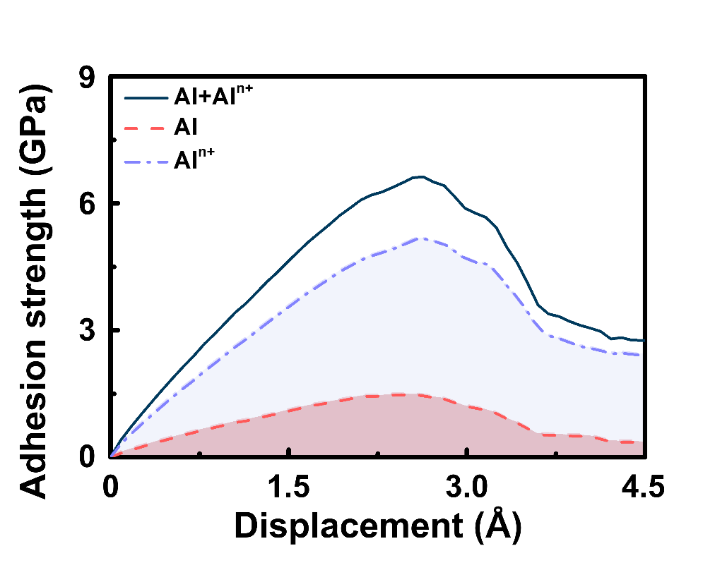

**Figure S4** Adhesion strength of aluminum on the surface of Al (110) with 60% oxide coverage. For clarity, values for components other than aluminum are not shown.

Al (110) with an oxide coverage of 60% was analyzed to confirm the contribution of surface oxides to the mechanical characteristics of the interface during the pull-out tests. Note that the Al (110) substrate has a homogeneous oxide and is predicted to exhibit the best load transfer capability because of its minimized stress concentration. **Figure S4** illustrates the stress applied to the surface layer of Al (110) during the pull-out simulations. The results show that the adhesion strength of the cations ​is four times greater than that of the metallic aluminum. Such an intensive adhesion strength of the cation suggests that the oxide at the interface occupies most of the mechanical stress in the AlOx layer under mechanical loading. In other words, the formation of ionic bonds at the interface is one of the significant reasons for the improved mechanical stability of the AlOx/SiOx bilayer. The overall trend of the stress distribution of aluminum at the interface is included in the Supplementary Video.

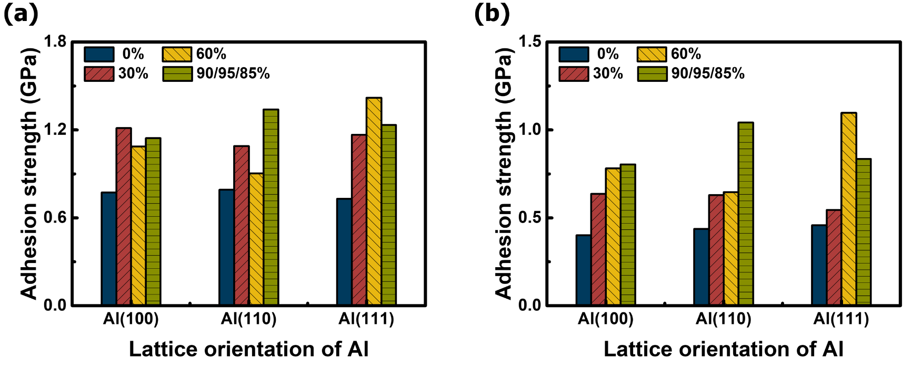

**Figure S5** Maximum tensile strength of (a) Si and (b) O constituting SiOx during pull-out simulations.

**References**

[S1] R. J. Bondi, S. Lee, G. S. Hwang, First-principles study of the mechanical and optical properties of amorphous hydrogenated silicon and silicon-rich silicon oxide. *Phys. Rev. B* **81** (2010) 195207.

[S2] Y. Kim, J. Choi, Oxide growth characteristics on Al(100), (110), and (111) surfaces: A chemo-mechanical evaluation. Mater. Today Commun. 26 (2021) 102006.

[S3] Y. Sun, Y. Liu, X. Chen, Z. Zhai, F. Xu, Y. Liu, Micromechanism of oxygen transport during initial stage oxidation in Si (100) surface: a ReaxFF molecular dynamics simulation study. *Appl. Surf. Sci.* **406** (2017) 178-185.

[S4] A. K. Subramaniyan, C. T. Sun, Continuum interpretation of virial stress in molecular simulations. *Int. J. Solids Struct.* **45** (2008) 4340–4346.

[S5] S. C.Chowdhury, R.Prosser, T. W. Sirk, R. M. Elder, J. W. Gillespie Jr., Glass fiber-epoxy interactions in the presence of silane: A molecular dynamics study. *Appl. Surf. Sci.* **542** (2021) 148738.s

[S6] L. Wu, W. Wang, J. Lu, R. Sun, C.-P. Wong, Study of the interfacial adhesion properties of a novel Self-healable siloxane polymer material via molecular dynamics simulation. *Appl. Surf. Sci.* **583** (2022) 152471.