HEICODERS ACADEMY
SE100: RESPONSIVE WEB DEVELOPMENT

Capstone Project
Student Name: | Enter your full name here

Before submission, rename your file to SE100 Capstone Project - <FirstName> <LastName>.docx

Please delete everything in red (including this paragraph) before submitting this document, as these are instructions guiding you on how to complete this template to meet your project requirements. All the best working on this project!

Introduction
In this project, you will build a finance dashboard using React and Vite. The dashboard will allow users to enter multiple stock purchases and display the current value and profit/loss for each stock. This project aims to reinforce your understanding of React concepts such as components, conditional rendering, props, hooks (useState, useEffect, useCallback, useContext), and state management.
This document serves as the template for you to provide evidence of meeting the 9 Ability requirements for this course. Please fill in the required information and screenshots for each question.

Capstone Project Deliverables
Submit the following to your Canvas portal before the stipulated deadline:
- This document in either .docx or .pdf format
- Submit the hosted site URL to both your GitHub repository and Page (as a comment on Canvas)
- The completed .zip file containing all your code

Question 1: Your commit history should document the progression of the project with meaningful messages. Provide a screenshot of your git history on GitHub. Here’s an example:
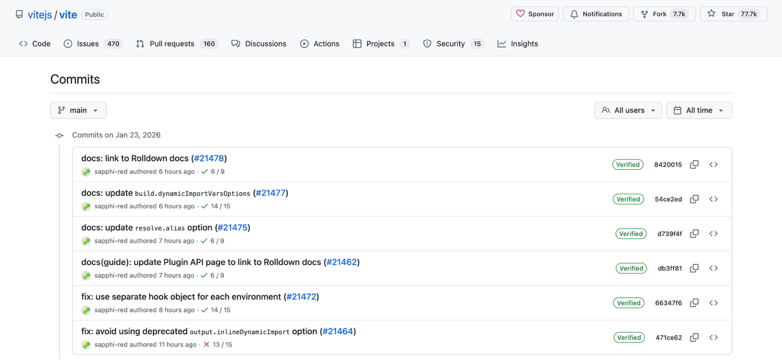
(Paste screenshot of your Git history in this box)

Question 2
You must use JavaScript/JSX to implement the stock entry form. Provide the code for your form component (e.g., StockForm.jsx):
(Paste the code of your form component in this box)

Question 3
Your application must handle invalid stock symbols gracefully by not adding them to the list. Explain how you would test your application to ensure it works as expected:
(Describe your testing process)

Question 4
You must identify and handle potential error scenarios, such as API failures. Provide a screenshot of the code that handles API errors (e.g., your try...catch block or .catch() method):
(Paste the code of your API error handling in this box)

Question 5
You must demonstrate effective component composition by breaking down the UI into reusable components and passing data via props. Provide the code showing a parent component passing props to a child component.
(Paste the code of your API error handling in this box)

Question 6
You must use React with Vite as specified for the project. Provide the code of your package.json file showing the Vite and React dependencies.
(Paste the code of your package.json file in this box)

Question 7
The requirement to display profit/loss must be translated into functions.

Provide the code where you fetch the stock price from the API:
(Paste the code of your stock price fetching in this box)

Provide the code where you calculate the profit/loss:
(Paste the code of your profit/ loss calculation in this box)

Question 8: You must create a clear component hierarchy. Provide a screenshot of your project's file structure, showing your different component files (e.g., StockForm.jsx, StockList.jsx, StockItem.jsx). Here’s an example:
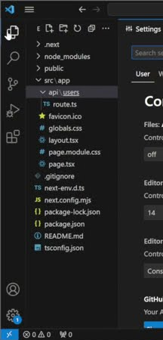
(Paste screenshot of your Git history in this box)

Question 9: Your application must fetch and display real-time stock prices. Provide a screenshot of your deployed application successfully displaying a list of stocks with their real-time data. Here’s an example:
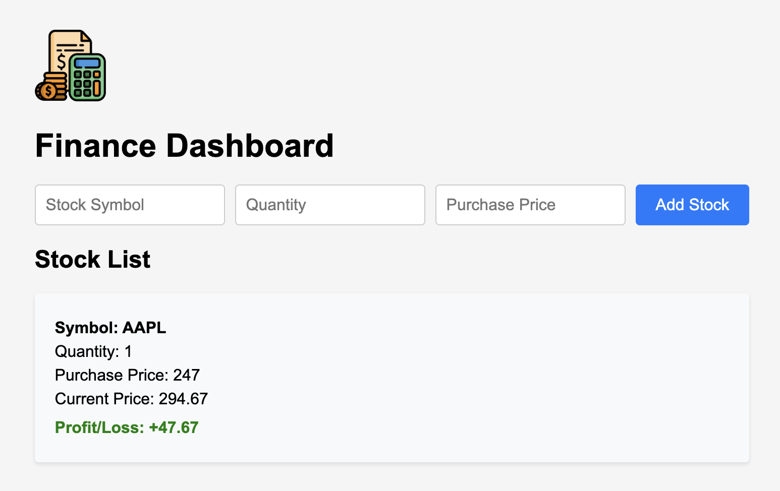
(Paste screenshot of your finance dashboard in this box)

