Abel Gonzalez

COSC 4328 Assignment 6 - Ray Tracer

Time: 30+ hrs

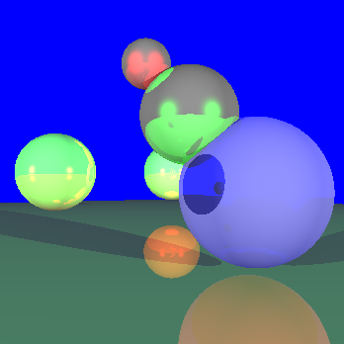

**Figure 1**: First scene with spheres showing lighting, shadows, and reflections

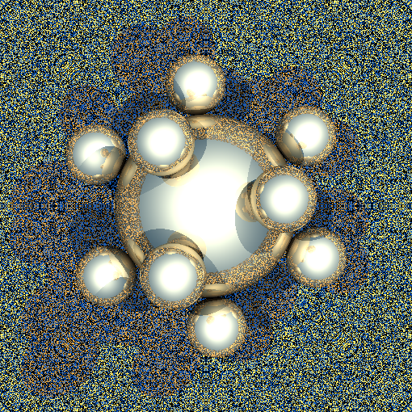

**Figure 2**: First sphere flake scene with spheres showing lighting, shadows, and reflections

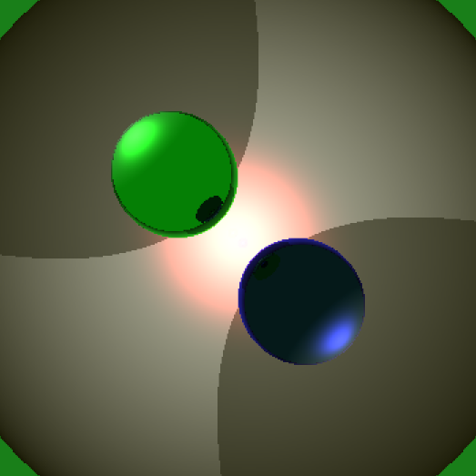

**Figure 3**: My custom scene with spheres showing lighting, shadows, and reflections

**Discussion 4 am**:

Wow. I think this assignment really took the cake for “assignments will be addicting and take lots of your time”. Did not fully believe you until this one. I absolutely loved messing with it and loved getting good results. Granted it is 2 am the day it is due and I still have lots of errors, it's so fun being within arms reach of the correct output after working so hard. All in all, it took a while! For the record, I started as soon as I could, however, the first week I worked on reading in the file, the next week was transforming spheres, and the final weekend was lighting/shading. I wrote and broke down and rewrote my code probably about 2 or 3 times. At first I was doing intersections in world space, big boo boo, then wrote it to be in object space and have correct transforms. Then I spent the weekend, F-Sunday (today), working on lighting, shadows, and reflections. None of them are finished as of now, but are in arms reach. Lighting looks great, except it sometimes changes the background as if reflecting?? Great example is sphereflake. Shadows are producing cancer along with the correct shadows. Finally, reflections are producing the correct reflections, but reflections are pure white and the rest of the image is += with background. It's a big mess. But it's super fun!

It is 4 am and I am out of time. I know I have until 8am but I can’t think straight anymore. If I had another day or two to ask questions or work on it, it may have been finished but that is not this reality. So here is what I have:

My raytracer has almost lighting, almost shadows, and almost reflections. The shadows and reflections have been commented out of the trace function, to avoid eye strain, but lighting still remains.

Also, to run in riddler I had to use the command:

g++ -std=c++11 raytracer.cpp

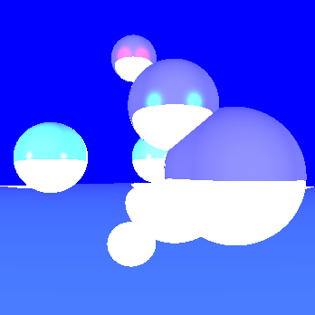

**Figure 4:** Bad reflections

**Final Update 11/25**

I spent this week moving things around trying to get some kind results that produced the correct output, but I was getting nothing but errors. On Wednesday I decided to clean up my project using three structs: intersection, ray, and materialsprop that store their respective variables. With this, I realized my reflections were using object hitpoint instead of the world as well as some lighting being calculated incorrectly. Thus, by specifying object and world hitpoint, I made sure to use the correct hitpoint and corrected my reflections as seen below. I was able to correct all the errors as well as make the whole program much more readable. However, there was still one error that was bugging me. Looking at sphere flake 2, or figure 2, the pixelated background is a sphere with width 0.0005. For some reason, my raytracer could not correctly showcase the width and thus showed it pixelated. I could not fix this at all. I had asked for help in the discord and someone recommended moving t by a small amount similar to secondary rays, however, this didn’t really help and honestly hurt me more. I could not figure it out in a week of messing with it, so I accepted it and completed the shadows, reflections and lighting.

I also created my own test scene to show reflections and shadows. There is one large background sphere and two spheres in the center that are between two lights. Thus the shadows of each light go on each other and the sphere behind it as well. Also, the reflections of the other sphere are shown between each sphere. I think it looks awesome because it very quickly showcases shadows, reflections and lighting.

Below is a list of the things I have added to my raytracer or accomplished:

* Generate primary rays - 2 points
* Intersect with spheres - 3 points
* Lighting works (correct illumination calculation at intersection) - 4 points
* Transform spheres with correct lighting - 4 points
* Correctly save your output to a ppm - 1 point
* Multiple lights - 1 points
* Shadows - 2 points
* Reflections - 2 points
* Standard report - 1-2 points
* Extra (good) scene files - 1-2 points
* Cool images (maybe from a scene you created or an error) - 1-2 points



**Figure 5:** Corrected Image

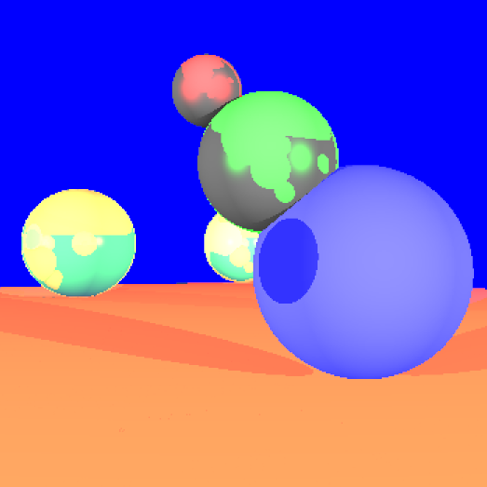

**Figure 6**: Cool image after messing with reflections

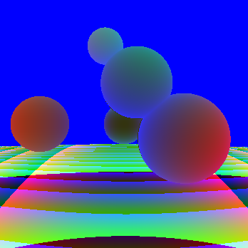

**Figure 7**: Cool error Image