J&J Chocolates Online Project Report

MGMT 216-450 / Business Data Analytics
2026 Summer Semester
Dr. Chang
Araceli Gonzalez / Student ID: 31626799
06/14/2026

Data Analysis
In this project, we conduct analysis of online sales of J&J Chocolates that recently started to make sales via its site. Our goal is to understand how such factors as day of week, payment method, time spent on the site, and number of pages viewed influence sales. Below, we provide descriptive analysis for mentioned variables. Also, we perform cross-tabulation, graphical analysis, and correlation analysis to estimate influence of explanatory variables on our target variable. Our data analysis is done on subset of 50 observations.
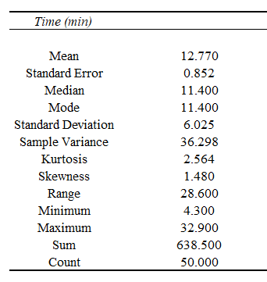
Figure 1. Statistical summary for time spent on the website
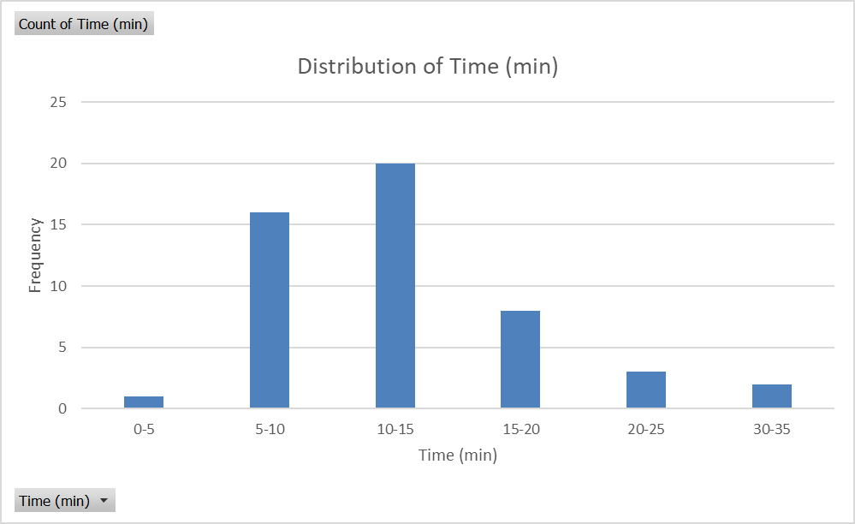
Figure 2. Distribution of time spent on the website

Customers spend from 4.3 to 32.9 minutes on the website with mean value of 12.77 minutes. According to median value, half of customers spend 11.4 minutes or more, while another half of customers spend 11.4 minutes or less. If we tell about 5-minutes bins, the peak is observed in interval from 10 to 15 minutes (20 customers). In general, distribution of time spent on the website has little skewness to the right but without some extreme values.
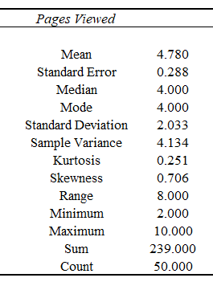
Figure 3. Statistical summary for pages viewed

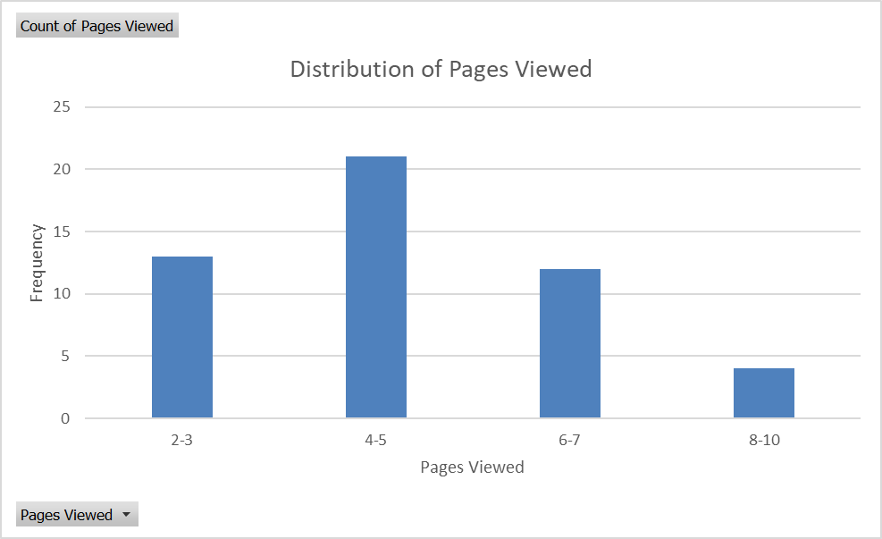 Figure 4. Distribution of pages viewed
Customers review from 2 to 10 pages on the website with mean value of 4.78 pages. According to median value, half of customers review 4 pages or more, while another half of customers review 4 pages or less. If we tell about 2-pages bins, the peak is observed in interval from 4 to 5 pages (21 customers). In general, distribution of pages viewed is close to normal and do not have some extreme values.

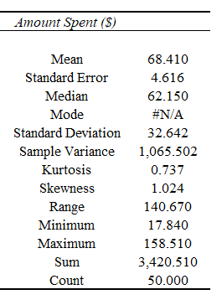
Figure 5. Statistical summary for amount spent

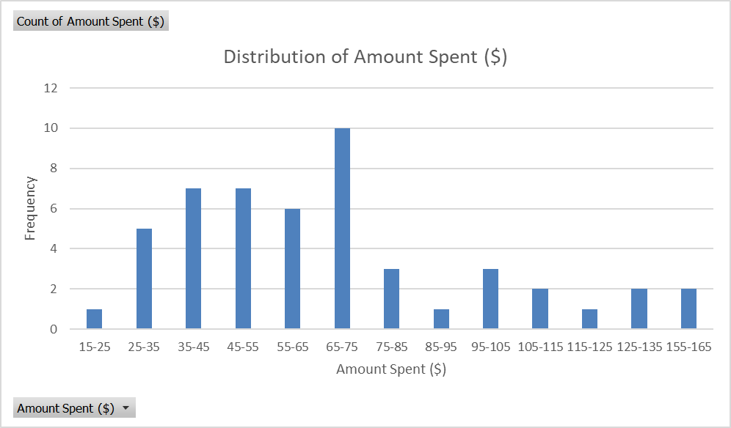
Figure 6. Distribution of amount spent
Customers spend from 17.84 to 158.51 dollars on the website with mean value of 68.41 dollars. According to median value, half of customers spend 62.15 dollars or more, while another half of customers spend 62.15 dollars or less. If we tell about 10-dollars bins, the peak is observed in interval from 65 to 75 dollars (10 customers). In general, distribution of amount spent on the website has little skewness to the right but without some extreme values.

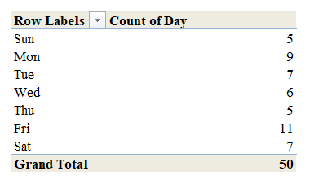
Figure 7. Distribution of number of transactions by days
Day with largest number of transactions is Friday (11 transactions), while days with lowest number of transactions are Sunday (5 transactions) and Thursday (also 5 transactions).

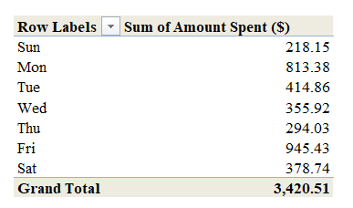
Figure 8. Total amount spent by days
Day with largest amount spent is Friday (945.43 dollars), while day with lowest amount spent is Sunday (218.15 dollars).

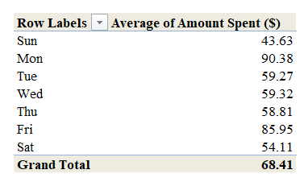
Figure 9. Average amount spent by days
Day with largest average amount spent is Monday (90.38 dollars), while day with lowest average amount spent is Sunday (43.63 dollars).

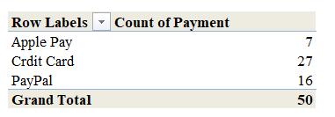
Figure 10. Distribution of number of transactions by payment methods
Payment method with largest number of transactions is Credit Card (27 transactions), while payment method with lowest number of transactions is Apple Pay (7 transactions).

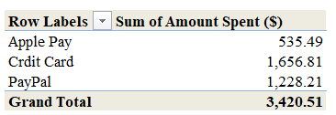
Figure 11. Total amount spent by payment method
Payment method with largest amount spent is Credit Card (1,656.81 dollars), while payment method with lowest amount spent is Apple Pay (535.49 dollars).
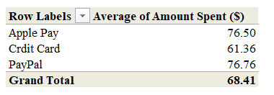
Figure 12. Average amount spent by payment method
Payment method with largest average amount spent is PayPal (76.76 dollars), while payment method with lowest average amount spent is Credit Card (61.36 dollars).

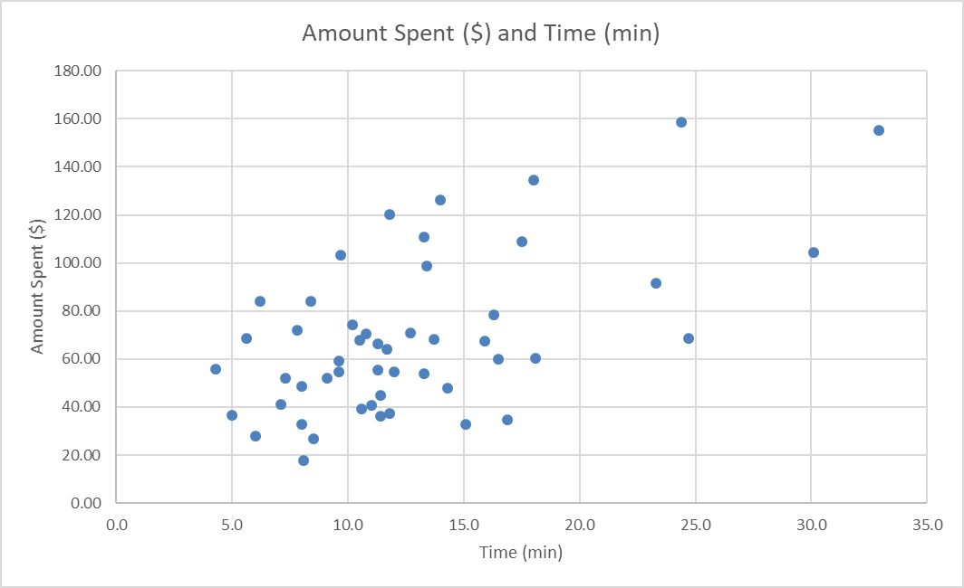
Figure 13. Relationship between amount spent and time
According to the plot, there is notable positive relationship between amount spent and time. It is also confirmed by high value of correlation coefficient (0.58).
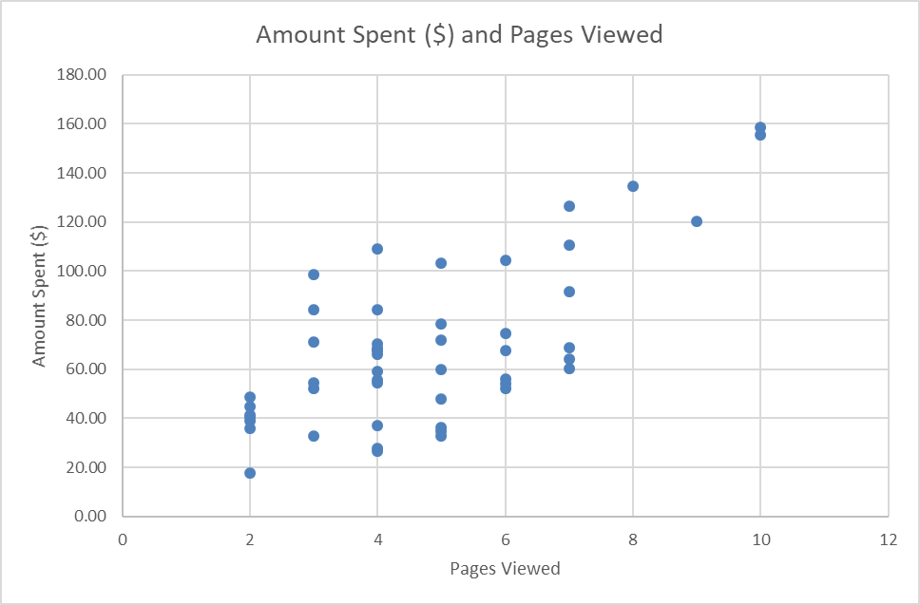
Figure 14. Relationship between amount spent and pages viewed
According to the plot, there is notable positive relationship between amount spent and pages viewed. It is also confirmed by high value of correlation coefficient (0.70).

Business Recommendation
Our results show that Friday is the busiest day. It has both highest number of transactions and highest total sales. Therefore, for maximization of revenue, company needs to ensure sufficient inventory level for this day as well as sufficient level of customer support. In turn, marketing activity can be conducted on Sunday as this day is worst in terms of sales and intensification is needed here. In turn, most frequently used payment method is credit card. Therefore, the company needs to be assured that it is always available. However, we also find that average size of sale with using of Apple Pay and PayPal is higher. Therefore, additional marketing activity is needed for stimulation of sales with these methods. Finally, there is significant positive influence of time spent on site and number of pages viewed on amount spent. Respectively, company needs to apply additional measures for retention of the clients on site and stimulating them to navigate through pages.
Conclusion
Our analysis shows that such factors as day of week, payment method, time spent on the site, and number of pages viewed influence sales. We also make respective recommendations. However, our analysis has some limitations. In particular, we use only data for 50 observations. To get more robust results, we need to increase sample size. Also, it has a sense to conduct regression analysis. In this case, we will have a chance to estimate size of change in sales with change in particular factor but not only direction of influence. Probably, inclusion of additional variables is also needed. They may be seasonality (month or time of year), indicator of holiday, temperature, and so on.

