**CAN-BUS**

**Motor**

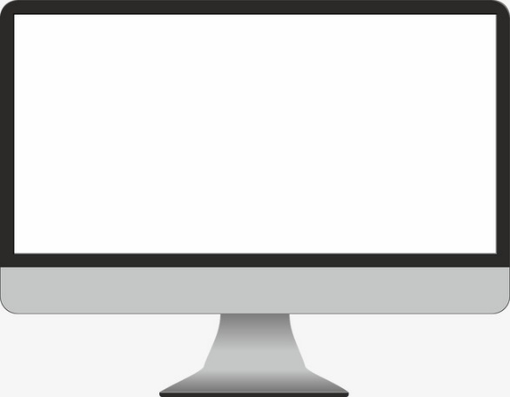

PC

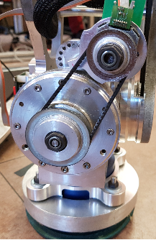

PROGRAMA

**MIDDLEWARE**

**Driver**