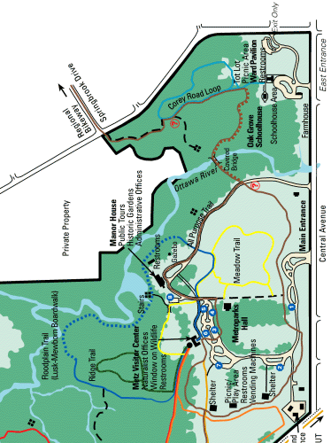

WILDWOOD PRESERVE METROPARK

From North
Take 23 South to Central Avenue exit. Turn right on Central and go past Reynolds. Main park entrance is on left at traffic light. Corey Road (East) entrance is approximately ½ mile past main entrance on left.
From South
Take Route 24 (Anthony Wayne Trail) to 475 North to Central Avenue exit. Turn right on Central and go past Reynolds. Main park entrance is on left at traffic light. Corey Road (East) entrance is approximately ½ mile past main entrance on left.
From East
Take Navarre Avenue (Route 2) to 280 North to 75 West to 475 West to Talmadge Road exit. Turn left onto Talmadge, take to Central Avenue and turn right on Central Avenue. Corey Road (East) entrance is on right just past Corey Road, main park entrance is at traffic light on right approximately ½ mile past Corey Road entrance.
From West
Take Central Avenue (Route 20/120) past Reynolds Road. Turn left at the main park entrance (the next traffic light). Continue east on Central approximately ½ mile to Corey Road (east) entrance.

