**Art Review**

**What Is Land Art?**

Land art (or Earth art) is a form of art which utilizes the landscape itself to produce the art. Structures are often made by placing natural materials, such as rocks or twigs, onto the land to form a pattern or picture. Another way they are produced is by sculpting the land itself to form patterns. The art itself is not simply placed onto the land, rather the land is the means of the creation. Pieces are often ephemeral in nature, being left to erode due to natural conditions over time, and so now only exist in photographic and video documentation [1].

**History**

Land art is a largely American movement which began in the late 1960s. The movement is an offshoot of conceptualism and minimalism and was a protest to the commercialization of American art, leading the artists to produce works which were removed from the art market [2].

It can be argued that land art was created by ancient cultures. Example of land art occurs around the world, such as the Nazca lines produced by the Nazca in southern Peru and The Great Serpent Mound in Ohio, US. It is believed these pieces could have been created as a form of worship to the Gods of the cultures which made these pieces.

The movement began with the group exhibition “Earth works” in New York City in October 1968. In the following year, Willoughby Sharp curated the “Earth Art” exhibition at Cornell University which included many artist, such as Robert Smithson and Richard Long, who were big influences within the movement. Due to their monumental size the pieces were usually documented in artworks using photographs and maps which the artist could exhibit in a gallery. Land art was occasionally also produced within the gallery. This was done by bringing in materials from the landscape and using them to create installations.

One of the most well-known artists in this movement was Robert Smithson. His best known piece, and possibly the most famous example of land art, is “Spiral Jetty” which was constructed in April 1970. It was constructed at Rozel Point, Great Salt Lake, Utah, reportedly this location was chosen by Smithson due to the blood red colour of the water which submerges the art at times of normal precipitation (the jetty is revealed during times of drought). The spiral structure was constructed using 6650 tons of black basalt rocks which were transported and manipulated in the lake bed using dumper trucks, tractors and front end loaders. The construction was documented and presented as a film, also called Spiral Jetty [3].

**Motivations**

A significant inspiration for the creation of land art came from people’s awareness of the negative impact they can have on the environment around them. By incorporating art into the natural landscape, artists hope that it will change people’s perspective of the environment around them.

**Styles and Artists**

There are various styles of sand art; the main two being large scale sculptures and 2D freehand drawings. Over recent years smaller scale sand story telling has developed and is concerned with both the performance and the final images produced. Large-scale artists mainly use easily accessible equipment such as shovels, buckets and rakes for freehand drawing and trowels and spatulas for sculpting. However, a sand-printing tractor, figure 1 [4], has been developed, by Swedish artist Gunilla Klingberg, producing large scale imprints across beaches, figure 2 [4]. A low tide is needed for both printing and free hand drawing due to the wet sand.

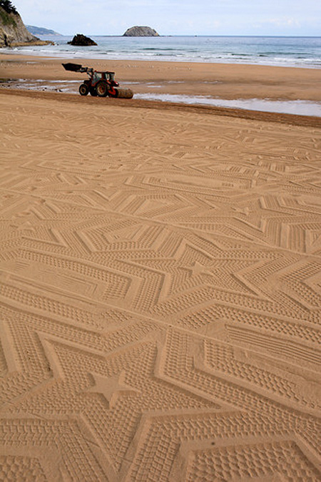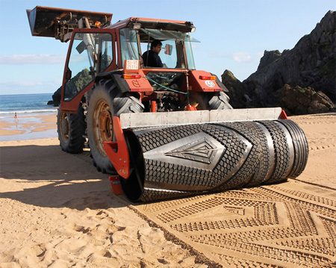

Figure 2 large-scale imprints produced using the tractor.

Figure 1 sand-printing tractor. The roller on the front produces the imprints.

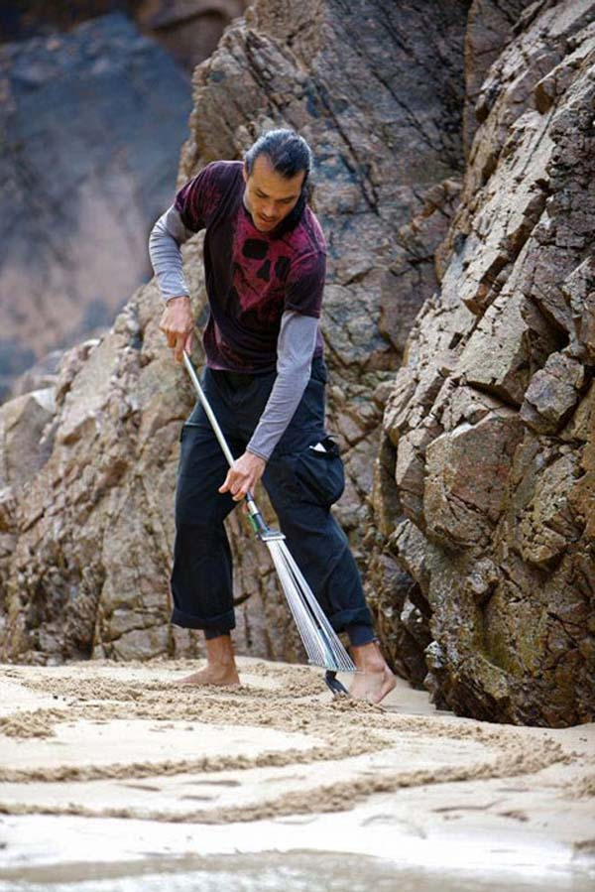

Figure 3 Andres Amador using a rake to produce his playa pictures.

Jim Denevan, a popular freehand sand artist, ranges the scale of his work from small beach compositions to land works the size of a city. He has done live performances for exhibitions at Yerba Buena Centre for the Arts, 2005, and the Vancouver Sculpture Biennale, 2010 [5]. His work has also been featured in popular magazines such as the New York Times Magazine and National Geographic. Denevan doesn’t use any sort of measuring tools and spends an average of 7 hours, walking about 30 miles, when producing his work. After all of this time his work is soon washed away by the incoming tide. Though the transient nature of this art form seems defeatist, it is actually the motivation for many sand artists. Andres Amador says he prefers a temporary medium and is much more concerned with his ‘process and less about the result’ [6]. He doesn’t produce any form of permanent art work. Amador’s pieces, known as playa paintings, are produced using simply a rake and a rope as a guide, figures 3 and 4 [6].

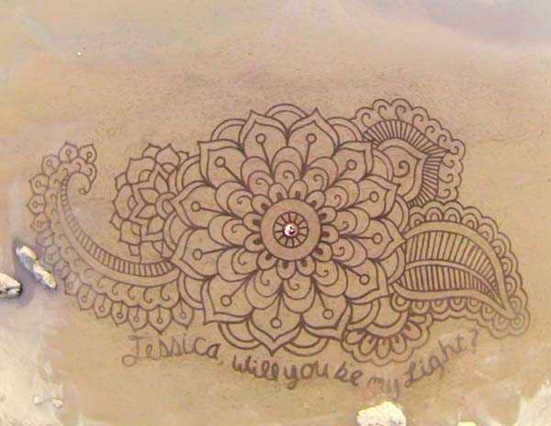

Figure 4 sand drawing created by Amador.

Charlene Lanzel produces small-scale sand stories. Their creation can be observed as she creates images on a table top, projected onto a large screen sitting above her. Lanzel produces her images in darkness, the sand sitting on a glass table under which lights stand, illuminating the art, figure 5 [7]. Unlike other forms of sand art her work isn’t washed away by the tide, instead she destroys her work herself in order to produce fluid images that play like an animation. Lanzel uses soundtracks alongside her performance to tell her stories and fully immerse her audience.

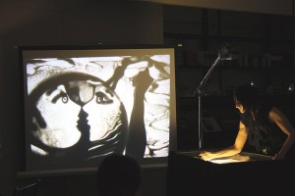

Figure 5 Charlene Lanzel performing one of her sand stories. The work she’s producing on top of a lightbox is then projected onto a screen for her audience to watch.

Sand sculpture may be the largest-scale form of sand art. Dan Belcher, 2007 Solo World Champion of sand sculpting, has produced sculptures with the stature and solidity of woodcarvings, figure 6 [8]. Sculpture also seems the most permanent style. Many sculptures produced indoors may last over a 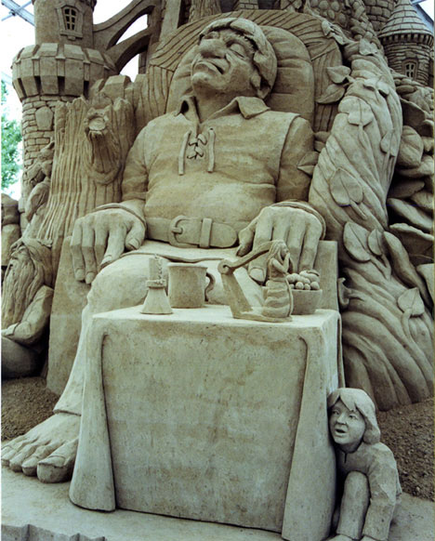year.

Figure 6 Belcher’s ‘Jack and the Beanstalk’, part of ‘Farie Tales and Nursery Rhymes’.

References;

[1] Available: <http://www.tate.org.uk/learn/online-resources/glossary/l/land-art> 18 Jan 2016

[2] Available: [http://www.theartstory.org/movement-earth-art.htm](http://www.theartstory.org/movement-earth-art.htm%20) 18 Jan 2016

[3] Available: <http://www.diaart.org/sites/main/spiraljetty> 18 Jan 2016

[4] Shi Min, Thia. "A 'Sand-Printing Machine' That Makes Beautiful Patterns On The Beach - Designtaxi.Com". *Designtaxi.com*. N.p., 2013. Web. 18 Jan. 2016.

[5] Denevan, Jim. "Bio / Press : Jim Denevan". *Jimdenevan.com*. N.p., 2016. Web. 18 Jan. 2016.

[6] ViralNova.com,. "A Man Takes A Single Rake To The Beach. And When You Zoom Out And See It... Mind BLOWN.". N.p., 2016. Web. 18 Jan. 2016.

[7] Lanzel, Charlene. "Sand Artist | Charlene Lanzel". *Sand-artist.com*. N.p., 2015. Web. 18 Jan. 2016.

[8] WebUrbanist,. "Sandcraft: 10 Amazing Sand Artists With Awesome Artwork". N.p., 2008. Web. 18 Jan. 2016.