Abstract— Visual-inertial localization systems (VILSs) rely on both an inertial measurement unit (IMU) and visual measurements to estimate poses. Utilizing feature observations from visual measurements, current state-of-the-art VILSs are able to minimize drifting errors apparent in IMU localization while providing high accuracy in state estimation. However, most VILSs have struggled in environments with sparse and unstable features due to the lack of sufficient utilizable landmarks and unsuccessful loop closure detection. In this work, we propose a tightly-coupled artificial landmark extension to the VILS framework. Our approach prevents feature insufficiency by introducing only a few artificial landmarks in the environment. A tightly-coupled, sliding window, nonlinear optimization-based method is employed to achieve high-accuracy localization by fusing squared fiducial markers (as artificial landmarks) with feature observations and IMU data. The experimental results demonstrate that higher accuracy with better robustness is achieved using the proposed approach in environments with sparse and unstable features.
Artificial Landmark Enhanced Visual-Inertial Localization System in Environments with Sparse and Unstable Features
Zhi Fang Tan, Matthias Schmid, Venkat Krovi, and Yunyi Jia*

INTRODUCTION
Visual odometry and simultaneous localization and mapping (SLAM) have long been used in a wide range of applications such as augmented reality (AR), virtual reality (VR) and computer vision (CV). They are both particularly crucial when building autonomous robot to estimate its position accurately. Recently, monocular VILS have attracted high research interest due to their ability to utilize low cost IMU and easy implementation. Monocular localization system which includes only a single camera without any inertial measurement unit has been well researched in the past with many influential monocular visual odometry (VO) approaches such as ORB-SLAM [1], DSO [2], SVO [3], and LSD-SLAM [4] have achieved decent results in structured human environment. However, localization systems that solely rely on monocular camera suffers from unobservable scale. Implementing inertial measurement unit in the system enables roll, pitch angles and scale to be observable. These systems are also to perform robustly when visual measurements are disrupted by motion blur or occlusion in short period of time. Noticeable works include VINS-Mono [5], OKVIS [6], and VI-ORB [7].
However, the majority of the existing research efforts focuses on environments with rich natural features. Two common techniques used in the VILS front end are direct and the indirect method. The indirect method, as a feature based approach, minimizes the reprojection error, whereas the direct method calculates the photometric error between frames or patches of pixels. In environments with sparse features or lack of texture, the direct method tends to outperform the indirect approach as it relies solely on the photometric error but not natural features. Yet, feature observations are necessary to enable loop closure detection. Loop closure can greatly reduce drift, especially in large-scale state estimation, and should therefore be included in a large-scale outdoor localization task. According to [8], the presence of locally dynamic vegetation in environments with sparse features, such as on lawn or in forests, will reduce the number of detected stable natural features due to wind disturbances and patchy light conditions. Despite including IMU measurements to bridge the gap between frames with poor visual measurements, most of the current VILS still faced problem of poor robustness in sparse features environment due to lack of stable features. To solve this problem, artificial landmark or fiducial marker is implemented in some localization systems.
Approaches mentioned above only utilize natural features and IMU measurements in the localization system backend. Another kind of approach is to include artificial landmark such as fiducial marker in the localization system. Fiducial marker is widely used in localization system, AR, VR, etc. due to several advantages. A fiducial marker as an artificial landmark not only serves as additional feature observation, but also provides geometric information of the marker features themselves. These markers are designed to be easily distinguished from one another using slight different pattern. In localization systems, fiducial markers are widely employed as artificial landmarks to provide pose estimation and landmark detection. Some popular fiducial markers such as ARTag [9], ARToolkits [10], AprilTag [11]-[13], etc. are often incorporated in AR applications providing high detection rates and precise marker to camera estimation. By using additional artificial landmarks that contain rich information, the system’s robustness increases as more trackable and stable features are available. One of the marker based approach, SPM-SLAM [14] presents square planar marker based monocular SLAM. SPM-SLAM uses keyframe culling and loop closure to achieve high scalability in large scenes. In contrast, both natural features and marker measurements are incorporated in approaches [15],[16] to achieve robust performance when markers are not observed in most of the frames. In the work of [16], initialization is performed using both natural features and markers are proposed. The use of marker prevents false relocalization and loop closure in the process. In the approach [17], both fiducial marker and IMU measurements are included. However, the IMU measurements are only used to estimate its pose when fiducial markers are occluded or absent in the camera frame. Combination of fiducial marker and IMU based localization system is also implemented in motion capture system [18].

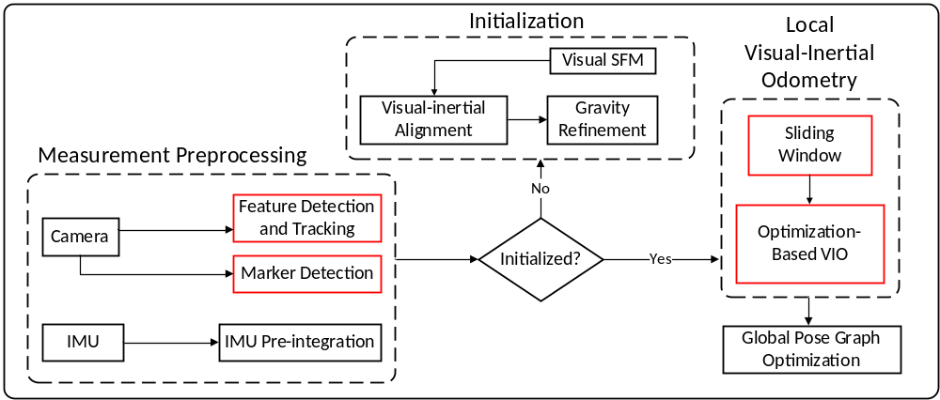
Fig. 1. Overview of proposed artificial feature enhanced visual-inertial localization system. Modified modules are highlighted with red box.

The mentioned approach estimates the pose by fusing IMU measurements and relative transformation between camera and markers based on Extended Kalman Filter (EKF) to achieve a real-time, lightweight motion capture system. Most of the system mentioned above require a lot of markers to achieve decent result. However, our approach which integrates VILS with fiducial markers can cope with sparse and unstable features with a small number of markers.
In this work, we propose a tightly-coupled artificial landmark extension to the VILS framework based on fiducial markers. We implement graph optimization method to tightly-coupled visual measurements, marker detection, and IMU measurements in order to handle environments with sparse and unstable features with small number of markers. For this implementation, a squared planar marker called AprilTag is used as the artificial landmark. Unlike natural features which can only be tracked in continuous frames, these markers provide a unique identification (id) number and can be tracked robustly when applying a sliding window optimization. Many fiducial marker based localization systems utilize the relative pose estimates from marker to camera coordinates. In our work, we only include the corner points of the fiducial marker and add geometric constraints between those points. Through the implementation of marker corner points, stable feature tracking within a sliding window is ensured during occlusions, motion blur from fast motion, or changing lighting conditions in short periods of time. By also including natural features, the system is still able to function when no artificial markers can be found in the environment. Similar to [15] and [16], the system is able to utilize either natural features, landmark features, or a combination of both. If we deploy VILS in environments with sparse features, only few stable feature observations will be available to perform structure from motion (SFM) during initialization. By using a combination of both natural features and marker points, robust initialization can be achieved even in such sparse environment with small number of markers. For this case, each squared planar marker has four distinct corner points which can be utilized for reprojection errors and for a new geometric constraint. Since each corner of a single marker can be identified, a constraint between the depth parameters of these four corner points can be formed. This constraint allows for estimating the depth of the corner points more accurately, thus achieving better pose estimation.
The major contributions of this work are: (1) we introduce artificial landmark features to the VILS front end to ensure stable feature observations within a sliding window for environments sparse in natural features; (2) we propose adding geometric constraints between landmark corner points into the back end optimization process; and (3) we evaluate the proposed method in direct comparison to a state-of-the-art algorithm and ground truth.

Visual-Inertial Localization System Enhanced by Artificial Landmark
To better distinguish variables in different coordinate systems, we establish some abstraction and notation as below:
- 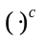demotes a quantity in the camera frame.
- 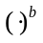 denotes the body frame of the IMU.
- 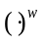 denotes a quantity in the world frame in which the z-axis is aligned with direction of gravity.
- 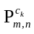 denotes the coordinates of the 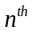 corner point on the 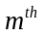 marker in the camera frame of the 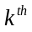 image.
- Both rotation matrices and Hamilton convention quaternion are used to describe rotation interchangeably in the system.
The proposed system structure as shown in Fig. 1 consists of the measurement preprocessing step (Section II-A,B), initialization step (Section II-C), local visual-inertial odometry (VIO) step (Section II-D), and the global pose optimization step. The raw data from IMU and camera are first processed in the measurement preprocessing step. Then, the initialization step is performed if the system has just started. The system 6 degree of freedom (DOF) poses are then output from the local visual-inertial odometry step.

A. Visual Front End with Marker Detection
Although fiducial markers can still be detected in distorted images, they require a rectified image to achieve a higher recall rate. Therefore, distortions are first removed before features and markers are extracted. Since fiducial markers can be robustly redetected and are almost outlier free, marker detection is first performed on every new image before existing natural features (Shi-Tomasi corner points [19]) are tracked using a Kanade-Lucas-Tomasi(KLT) sparse feature tracker [20]. Outlier rejection is only performed on natural features employing RANSAC with a fundamental matrix model.
Natural features are forced to be evenly distributed around detected markers in each frame by setting a minimum distance between features to reduce projection error. For each detected marker, the detectors provide marker’s id and four marker corner points in order. These are necessary information in marker redetection and “tracking”. As each natural feature is given a specific id to track it efficiently between frames, marker point id and marker point order are also recorded. Marker point id is used to distinguish between markers while marker point order is used to determine the point position in marker. As shown in Fig. 2, the marker id allows robust redetection across sliding windows as opposed to natural features which can only be tracked between continuous frames when using KLT.
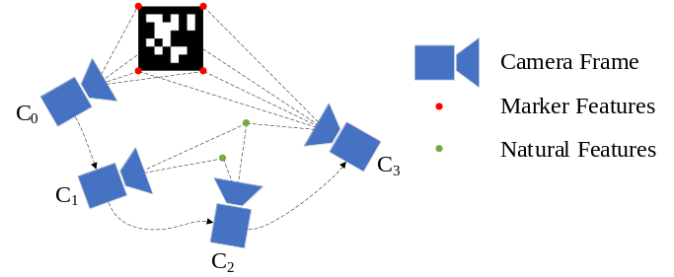
Fig. 2. Marker points can be redetected in the sliding window while natural features must be tracked continuously when using optical flow in KLT.

B. IMU Measurements Preprocessing
The concept of IMU pre-integration was first proposed in [21] and has since become an important step in VILS. In this study, a pre-integration method from [22] is built into the system as a constraint between two IMU body poses based on IMU measurements. The gyroscopes and accelerometers are modeled as
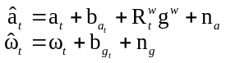
where accelerometer and gyroscope measurement noise, 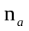, 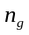 are assumed to be Gaussian distributed with zero mean, 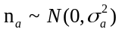, 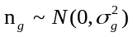. We defined , 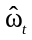 as the accelerometer and gyroscope measurements which are affected by bias and additive white noise. The vector 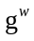 is the gravity vector in the world frame and is rotated to the IMU body frame using 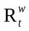. Both accelerometer and gyroscope bias, 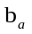, 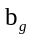 are modeled with “Brownian motion” in which derivatives are white noise. Relative position, velocity, and orientation of IMU body states of two consecutive poses can then be propagated using inertial measurements:
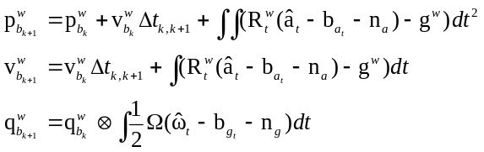
where
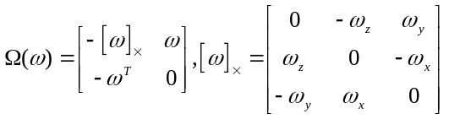
From (2), orientation, 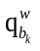, velocity, 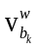 and position, 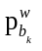 of frame 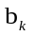 with respect to the world frame is required to re-propagate the IMU measurements. Implementation of IMU pre-integration can prevent repeated integration whenever changes in equation (2). The pre-integration expressions result as
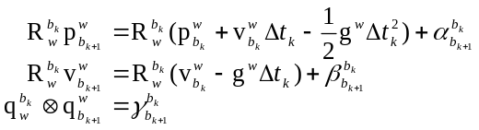
where,
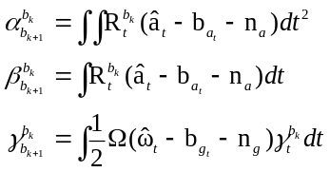
Here, 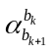,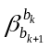, and 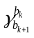 are the pre-integration terms for position, velocity and rotation from the to 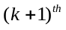 body frame. These pre-integration integration terms will be employed to calculate the IMU measurement residual in the optimization step as further detailed in Section III-D.

C. System Initialization
In our work, we follow the initialization process as described in [23] by starting with a sliding window SFM to recover the relative pose between frames. The Five-point algorithm from [24] is then used to recover relative rotation and up-to-scale translation between frames. More than 30 stable tracked features are required to successfully initialize the system assuming sufficient parallax exists. Corresponding features between frames are then checked based upon feature id, i.e. marker points are considered stably tracked features despite not being tracked continuously in the sliding window. Therefore, markers act as a stable feature source for the system when initializing in environments with sparse natural features.
During initialization, the visual-inertial alignment process begins with estimating the gyroscope bias. According to [5], accelerometer bias is hard to observe due to the large magnitude of the gravity vector during the short period of initialization. Hence, only gyroscope bias is estimated by minimizing
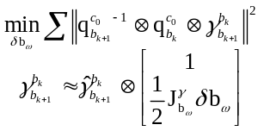
where 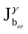 is the Jacobian matrix of rotation pre-integration term with respect to the gyroscope bias. At this point, we only have an up-to-scale transformation between camera frames through visual SFM, but not the exact world frame transformation as the scale is not calculated yet. The velocity of each frame, the gravity vector, and the metric scale of the visual data can then be recovered by aligning the visual SFM result with the IMU pre-integration term. This can be done by minimizing the following cost function:
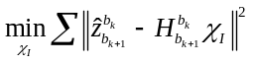
where,
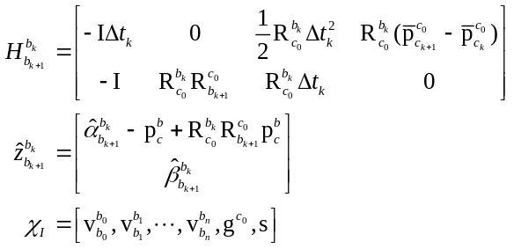
With 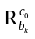, 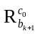, 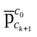, 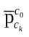 as the rotation and translation obtained from the up-to-scale visual SFM. By solving this problem, the initial values of the variables in (8) can be estimated and the initialization process is completed.

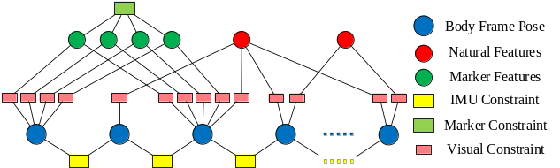
Fig. 3. Marker based geometric constraint is added on marker points to in the back end optimization.

D. Marker Based Geometric Constraint
In our work, a tightly-coupled sliding window based nonlinear optimization method is implemented with natural feature observation, marker detection, and IMU measurements. As illustrated by Fig. 3, visual measurements are exploited to calculate the reprojection error and to form visual constraints between poses to obtain optimal pose. In our tightly-coupled VILS, marker points are not only used for calculating the reprojection error between frames but are also included as geometric constraint between points in a single marker. Quantities that will be optimized in the sliding window include
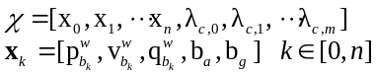
Where 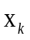 denotes the state of the IMU at image which includes its position, velocity, rotation from the IMU body to the world frame, accelerometer bias, and gyroscope bias. The notation 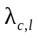 is the inverse depth of features (including both natural and marker points) from its first visual observations in the sliding window.
For each marker detection, pixel coordinates of four corner locations within a single squared planar marker are obtained along with its unique id in the detector output. Utilizing the characteristic of the marker being square, i.e. opposite corner points share the same middle point, we propose to add a constraint on the depth variables of these four corner points to aid in further refinement of the estimated depth variable. The proposed marker constraint can be formulated as
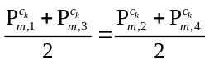
Where 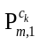, 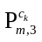 and 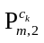, 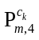 are opposite corner points from 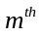 marker, respectively in the camera frame. Since only the inverse depth of feature from first observation in the sliding window is optimized in the back end, marker points are projected to the other frame where the marker is observed from the first observed frame. Considering four points from the same marker, are first observed in image and then in 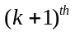 frame, the projected points can be written as:
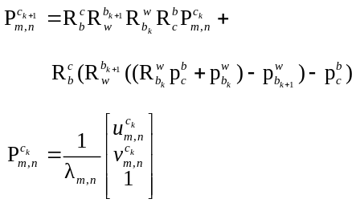
The normalized camera coordinates of marker points, 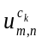, 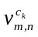 can be obtained from the system front end. The marker residual function can then be written as:
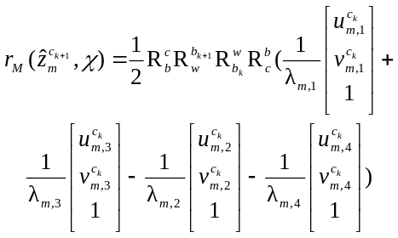
Introducing this relationship between corner points yields an improved estimation of the inverse depth and pose variable. Two different covariance matrices for the marker based geometric constraint are experimentally evaluated. As for the covariance, we proposed two approach and perform experiment to determine the optimal configurations. The first proposed covariance approach is similar to the visual reprojection error formulation in [5] with slight changes.
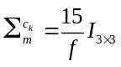
where denotes the focal length for a virtual camera projection. The proposed covariance in (12) does not consider position of the points as the covariance is constant no matter where the marker points are. Therefore, we proposed a second approach which its covariance will be a function of the inverse depth of marker points:
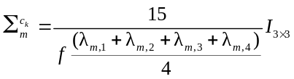
The second approach takes the inverse depth into consideration. Fiducial marker generally suffers from low accuracy in long distance detection. Hence, larger covariance will be yield when the distance of the marker to the camera increases. The marker measurement residual from equation (12) is then included in a visual-inertial bundle adjustment formulation to minimize measurement errors and sum or prior:
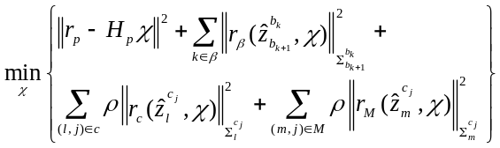
where, the optimal state vector is estimated. Huber norm, 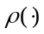 in equation (15) is included in both the visual measurement residual and the marker observation residual to prevent rapidly expanding residuals due to outliers. The prior information, 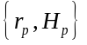 is resulted from marginalized variables while removing old images from the sliding window. Residuals in equation (13), , , and 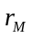 represent the IMU measurement, visual measurement, and marker observation residual, respectively. The visual measurement residual is formulated as a reprojection error of all features observed in the sliding window. The IMU measurement residual is formulated as
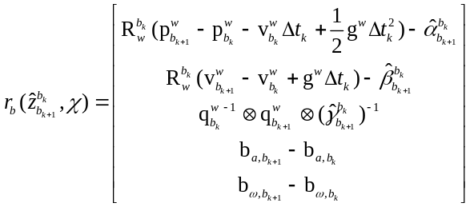
In the system back end, Ceres solver is used to solve equation (15).

E. Marginalization Strategy
The sliding window or fixed lag smoothing method limits the computational complexity of the optimization-based system by only addressing a limited number of states within a window. However, marginalization is required when removing states from the sliding window as a new frame is added. Measurements corresponding to marginalized states will then be converted into prior to constraint remaining frames in the sliding window. In this study, we follow the marginalization strategy from [5], [25].
Keyframes are first selected in the visual front end based upon two criteria. The first criterion requires that the average parallax between the current and the previous frame has to exceed a certain threshold in order to be labeled as a keyframe. For the second criterion, a minimum number of stably tracked features is required. These two criteria ensure high tracking quality as well as distance between keyframes. The oldest frame in the window will be marginalized when the penultimate frame is a keyframe. Otherwise, the visual measurements for this particular frame will be disregarded while the IMU measurements are kept. In our proposed extension, marker features are managed in the same way as natural features. Four corner points which are detected at the same time will be added to the system together. Likewise, they will also be removed together from the sliding window similar to the other natural features in the sliding window. Since the removal and addition of all four marker points are performed synchronously, removal will not cause unwanted fill-in of the fisher information matrix due to the newly added geometric constraints between features. Although the appearance of constraints between marker features will lead to a denser information matrix, we argue that it will not affect the system performance as the total number of markers are minimal compare to the number of detected natural features.

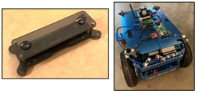
Fig. 4. MYNT Eye S210 (Left) and Magni ground robot (right) are used in the experiment.

Experimental Results and Analysis

A. Experimental Setup
In this work, we compare our proposed approach with VINS-Mono [5], a state-of-the-art VILS system which includes relocalization (loop detection), global pose optimization, and pose graph management for large scale localization applications. The SPM [14] dataset contains squared fiducial markers in the video feed along with the ground truth. However, it is not considered for testing in this study as it does not contain IMU data.
In our experiment, MYNT EYE S210 camera (global shutter, 60 FPS, which has a built-in IMU) is used to collect both visual and inertial data. To ensure sparse and unstable features for this experiment, an indoor texture-less environment with rectangular area is selected. Markers are then positioned around the rectangle edge to provide geometric information. A video sequence of 3 minutes duration has been recorded with a resolution of 1280×800 pixels using a Magni ground robot as shown in Fig. 4. The recorded video is then processed with both VINS-Mono and our proposed approach under different configurations. The

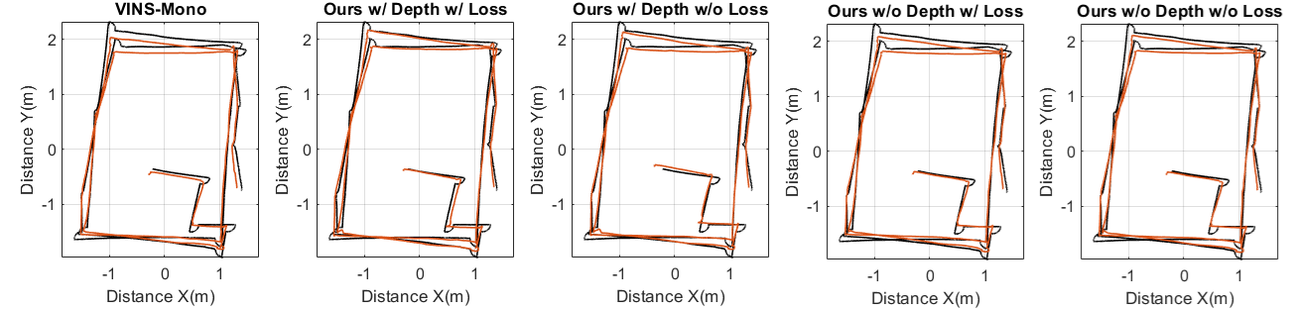

Fig. 5. Comparison of trajectories between VINS-Mono (red, 1st figure), our proposed approaches (red, 2nd–5th figures), and OptiTrack ground truth (black).
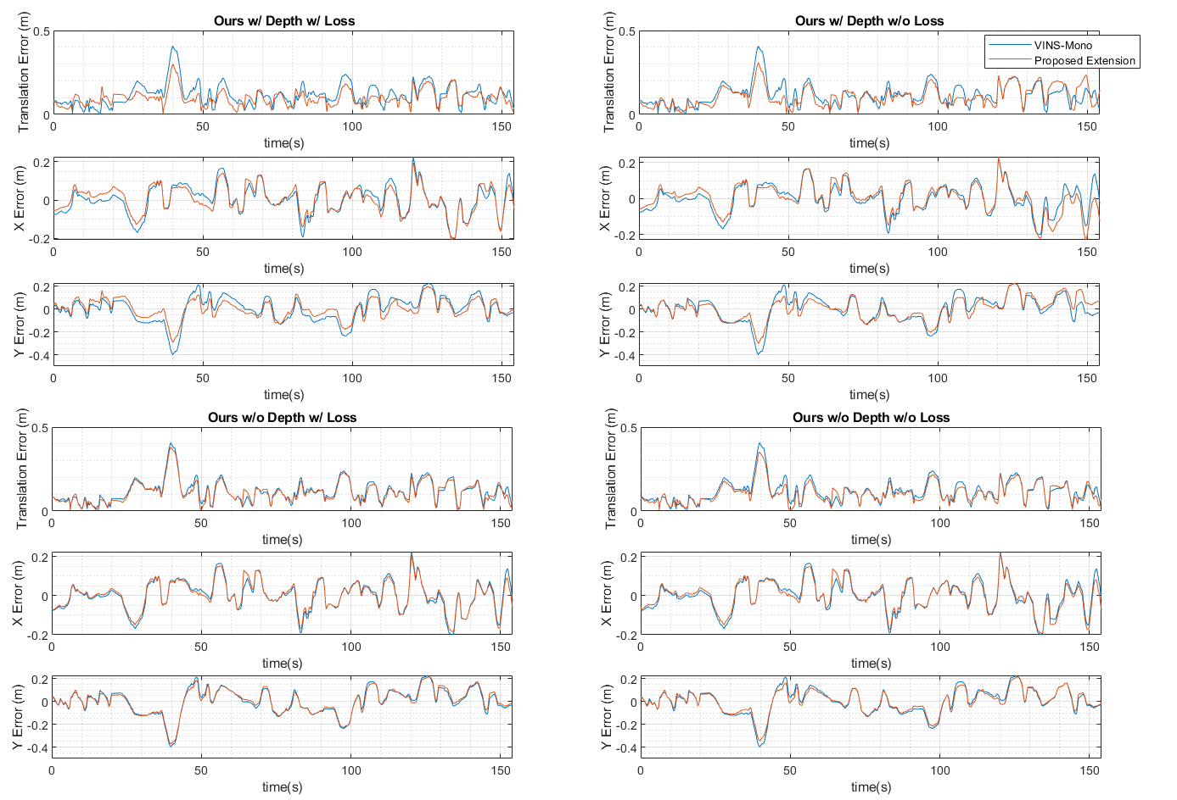
Fig. 6. Translation error comparison between VINS-Mono (blue) and our proposed approach (red).

output odometry for each approach is then compared to ground truth which is obtained by an OptiTrack system as reference.
The approaches implemented in the experiments and to be compared are introduced below:
- VINS-Mono: State-of-the-art VILS [5]
- Ours w/ depth w/ Loss: Our proposed approach with depth related covariance (14) and Huber loss function
- Ours w/ Depth w/o Loss: Our proposed approach with only depth related covariance (14) but without Huber loss function
- Ours w/o Depth w/ Loss: Our proposed approach with covariance (13) and Huber loss function
- Ours w/o Depth w/o Loss: Our proposed approach with covariance (13) but without Huber loss function

B. Experimental Results
We validated all the mentioned approaches on 6-DOF groundtruth using OptiTrack system which spans around 30m in a single room with sparse features. Trajectories of mentioned approaches are aligned to the ground truth as shown in Fig. 5 using Umeyama method [26]. In this study, we evaluated our proposed approaches alongside with VINS-Mono to provide a comparison to the state-of-the-art VILS which includes loop closure features using Absolute Trajectory Error (ATE) metric [27] in Fig. 6 and Table 1. We only compare x, y, and translation error in this experiment since vertical motion is negligible in the recorded sequence. The x, y, and translation error versus time are shown in Fig. 6.
Some errors are observed in the trajectory corners in Fig. 5 due to slight offset between OptiTrack frame and robot body frame. However, they are ignored in this experiment as the straight trajectory can be still be aligned using Umemaya method to provide fair comparison. From the aligned trajectory plots in Fig. 5, we observe clear trajectory drift in the y direction with VINS-Mono where our proposed approaches with marker detection have less error. This is because of the reduction in tracked stable features caused by fast rotating motion of the robot. Among all the approaches presented in Fig. 5, our approach incorporating depth information and robust loss function has minimal drift in the top edge of the trajectory. This also matches the translation error plot in Fig. 6, especially lower error in y direction.
It can be seen from Table 1 that our approaches which includes marker detection generally shows lower error and variance than VINS-Mono which has root mean square error of 0.1378 m. Although natural features have shown decent performance and trackability in structured human environment, marker points are easier to detect and track in sparse feature environment. The experiment also shows that our approach incorporating both depth information (14) and loss function has achieved translation error as low as 0.1091 m compared to the other approach without the depth information (13) with 0.1301 m. Since marker detection algorithm are commonly affected by distance from marker, the depth information is able to account for the distance sensitivity (larger distance leads to larger covariance). Marker detection algorithm generally exhibits high detection accuracy and is almost, but not entirely outlier free. Therefore, robust loss function is applied to our depth related approach and is able to achieve 12% lower error compared to the case without it. However, it is observed that applying robust loss function to the approach which does not consider depth covariance has actually yield higher error of 0.1301 m. A potential reason is that the robust loss function might have reduced the impact of marker geometric constraint with high residual from equation (12) due to constant covariance. By implementing both depth information and robust loss function, our proposed approach is able to achieve 20% lower error than state-of-the-art approach, VINS-Mono.
During the experiment, it has been noticeably observed during evaluation that marker detection often fails under rapid rotation. Prominent illumination in the video sequence also affected the performance of VILS due to the failed tracking of natural features. However, the system is still able to redetect the marker after brief moment of lose track, thus providing stable features. Our approaches which also introduces marker geometric constraint are able to perform better with the additional information acquired from the markers. For this
TABLE 1
Absolute Trajectory Error (ATE) for Different Approaches
 | RMSE (m) | Variance (m) | Max Error (m) | X  RMSE (m) | Y  RMSE (m)
VINS-Mono | 0.1378 | 0.0043 | 0.4066 | 0.0777 | 0.1138
Ours  w/ Depth  w/ Loss | 0.1091 | 0.0022 | 0.3000 | 0.0715 | 0.0825
Ours  w/ Depth  w/o Loss | 0.1245 | 0.0035 | 0.3082 | 0.0789 | 0.0963
Ours  w/o Depth  w/ Loss | 0.1301 | 0.0039 | 0.3809 | 0.0718 | 0.1085
Ours  w/o Depth w/o Loss | 0.1238 | 0.0033 | 0.3522 | 0.0742 | 0.0991

evaluation, our proposed approach incorporating depth related covariance with a Huber loss function has demonstrated the lowest error. Furthermore, the newly suggested extension combining both natural features and marker detections has exhibited higher accuracy in direct comparison with the state-of-the-art VILS approach when stable features are rare.

Conclusion
In this work, we propose an artificial landmark extension for a VILS framework. More precisely, we introduced fiducial marker detection as an artificial landmark into the VILS front end to ensure stable visual features even in otherwise sparse environments. The proposed approach can be used either with only natural features, only landmark features, or a combination of both. With a squared planar marker, we are able to impose an additional constraint between the corner points of the marker to further refine the depth estimation for these landmark feature points. The experimental results clearly demonstrate an improvement of the proposed combined system when compared to a state-of-the-art system in environments with sparse and unstable features. As for next work, we will further improve the approach by incorporating marker-to-marker geometric information to future reduce the required number of landmarks and improve the performance and robustness to sparse and unstable features in the environments.

Acknowledgement
The research work was supported by the South Carolina Department of Commerce.
References
- R. Mur-Artal, J. Montiel, and J. Tardós, "ORB-SLAM: A Versatile and Accurate Monocular SLAM System," in Proc. IEEE Transactions on Robotics, vol. 31, no. 5, pp. 1147-1163, 2015.
- J. Engel, V. Koltun, and D. Cremers, "Direct Sparse Odometry," in Proc. IEEE Transactions on Pattern Analysis and Machine Intelligence, vol. 40, no. 3, pp. 611-625, 2018.
- C. Forster, Z. Zhang, M. Gassner, "SVO: Semidirect Visual Odometry for Monocular and Multicamera Systems," in Proc. IEEE Transactions on Robotics, vol. 33(), no. 2, pp. 249-265, 2017.
- J. Engel, T. Schöps, and D. Cremers, "LSD-SLAM: Large-Scale Direct Monocular SLAM," in Proc. European Conference on Computer Vision, pp. 834-849, 2014.
- T. Qin, P. Li, and S. Shen, "VINS-Mono: A Robust and Versatile Monocular Visual-Inertial State Estimator," in Proc. IEEE Transactions on Robotics, vol. 34, no. 4, pp. 1004-1020, 2017.
- S. Leutenegger, S. Lynen, M. Bosse, R. Siegwart, and P. Furgale, "Keyframe-based visual–inertial odometry using nonlinear optimization," in Proc. International Journal of Robotics Research, vol. 34, no. 3, pp. 314-334, 2015.
- R. Mur-Artal, and J. Tardós, "Visual-Inertial Monocular SLAM with Map Reuse," in Proc. IEEE Robotics and Automation Letters, vol. 2, no. 2 pp. 796-803, 2016.
- J. Garforth and B. Webb, "Visual Appearance Analysis of Forest Scenes for Monocular SLAM," in Proc. IEEE International Conference on Robotics and Automation, pp. 1794-1800, 2019.
- M. Fiala, "ARTag, a fiducial marker system using digital techniques," in Proc. IEEE Computer Society Conference on Computer Vision and Pattern Recognition, vol. 2, pp. 590-596, 2005.
- M. Fiala, "Comparing ARTag and ARToolkit Plus fiducial marker systems," in Proc. IEEE International Workshop on Haptic Audio Visual Environments and their Applications, pp. 6, 2005.
- E. Olson, "AprilTag: A Robust and Flexible Visual Fiducial System," in Proc. IEEE International Conference on Robotics and Automation, pp. 3400-3407, 2011.
- J. Wang, and E. Olson, "AprilTag 2: Efficient and robust fiducial detection," in Proc. IEEE/RSJ International Conference on Intelligent Robots and Systems, pp. 4193-4198, 2016.
- M. Krogius, A. Haggenmiller, and E. Olson, "Flexible Layouts for Fiducial Tags," in Proc. IEEE/RSJ International Conference on Intelligent Robots and Systems, pp. 1898-1903, 2019.
- R. Muñoz-Salinas, M. J. Marín-Jimenez, and R. Medina-Carnicer, "SPM-SLAM: Simultaneous Localization and Mapping with Squared Planar Markers," in Pattern Recognition, vol. 86, pp. 156-171, 2019.
- R. Muñoz-Salinas, and R. Medina-Carnicer, "UcoSLAM: Simultaneous Localization and Mapping by Fusion of Keypoints and Squared Planar Markers," in Proc. Pattern Recognition, vol. 101, pp. 107193, 2020.
- B. Pfrommer, and K. Daniilidis, "TagSLAM: Robust SLAM with Fiducial Markers," arXiv:1910.00679, 2019.
- M. Maidi, F. Ababsa, and M. Mallem, "Vision-inertial tracking system for robust fiducials registration in augmented reality," in Proc. IEEE Symposium on Computational Intelligence for Multimedia Signal and Vision Processing, pp. 83-90, 2009.
- M. Neunert, M. Bloesch, and J. Buchli, "An open source, fiducial based, visual-inertial motion capture system," in Proc. International Conference on Information Fusion, pp. 1523-1530, 2016.
- B.D. Lucas and T. Kanade, “An iterative image registration technique with an application to stereo vision,” in Proc. International Joint Conference on Artificial Intelligence, pp. 24–28, 1981.
- J. Shi, and C. Tomasi, "Good Features to Track," in Proc. IEEE Conference on Computer Vision and Pattern Recognition, pp. 593-600, 1994.
- T. Lupton, and S. Sukkarieh, "Visual-Inertial-Aided Navigation for High-Dynamic Motion in Built Environments without Initial Conditions," in Proc. IEEE Transactions on Robotics, vol. 28, no. 1, pp. 61-76, 2012.
- S. Shen, N. Michael, and V. Kumar, "Tightly-coupled monocular visual-inertial fusion for autonomous flight of rotorcraft MAVs," in Proc. IEEE International Conference on Robotics and Automation, pp. 5303-5310, 2015.
- T. Qin, and S. Shen, "Robust initialization of monocular visual-inertial estimation on aerial robots," in Proc. IEEE/RSJ International Conference on Intelligent Robots and Systems, pp. 4225-4232, 2017.
- D. Nister, "An Efficient Solution to the Five-Point Relative Pose Problem," in Proc. IEEE Transactions on Pattern Analysis and Machine Intelligence, vol. 26, no. 6, pp. 756-770, 2004.
- G. Sibley, L. Matthies, and G. Sukhatme, "Sliding Window Filter with Application to Planetary Landing," in Proc. Journal of Field Robotics, vol. 27, no. 5, pp. 587-608, 2010.
- S. Umeyama, "Least-squares estimation of transformation parameters between two point patterns," in Proc. IEEE Transactions on Pattern Analysis and Machine Intelligence, vol. 13, no. 4, pp. 376–380, 1991.
- J. Sturm, N. Engelhard, F. Endres, W. Burgard, and D. Cremers, "A benchmark for the evaluation of RGB-D SLAM systems," in Proc. IEEE/RSJ International Conference on Intelligent Robots and Systems, pp. 573-580, 2012.

 Z. Tan, M. Schmid, V. Krovi, and Y. Jia are with the Department of Automotive Engineering, Clemson University, Greenville, SC 29607 USA (e-mail: zhifant@clemson.edu; Schmidm@clemson.edu; vkrovi@clemson.edu; yunyij@clemson.edu). *Corresponding author: Yunyi Jia.

