**Solucion HelloWorld**

1. [2/10]. After having been in class and reviewing the presentations, you should comment on the HelloMain.java, ControllerView.java and ControllerNew.java classes, which are located within src\main\java\com.example.helloworld. Put as many comments as you think appropriate so that you explain what each class is for, what each created object is and what each function does.

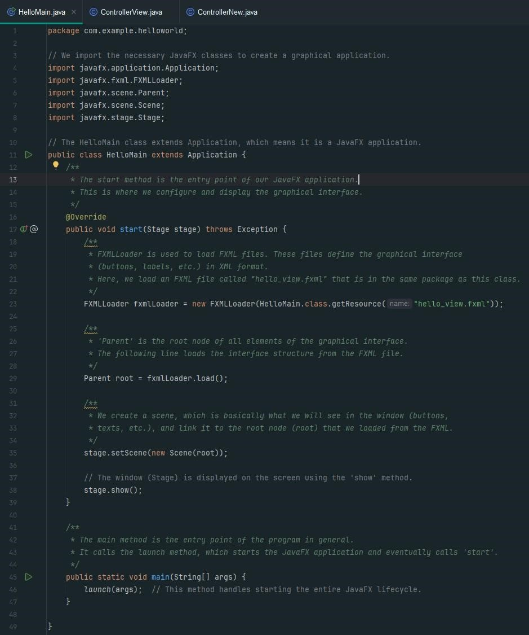

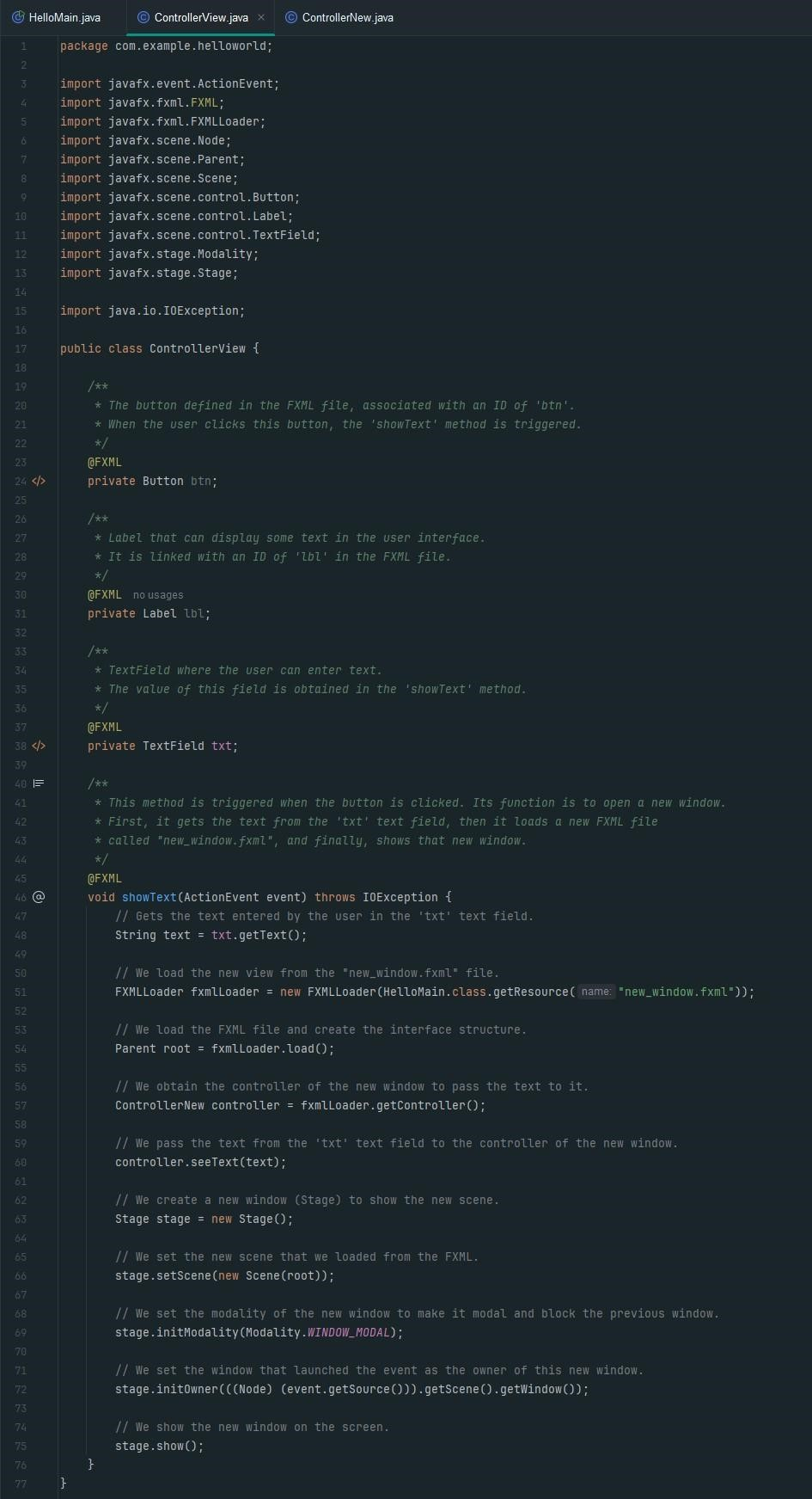

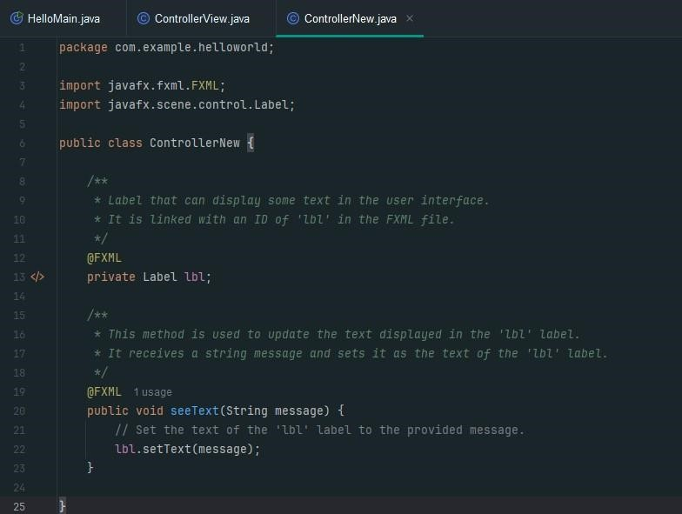

1. [3/10]. Starting from the example project, create a copy of it and make the appropriate changes so that:
   1. The project is organized with the Model – View – Controller.

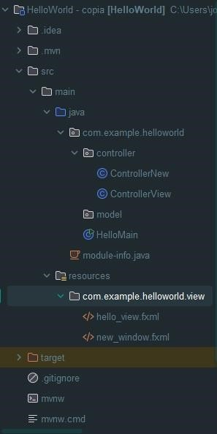

Rename main path so that it finds the hello_view and controller view so that it finds new_window





* 1. All hello_view and new_window elements are centered. Also, rename both fxml files to my_view and my_new_Window

Center

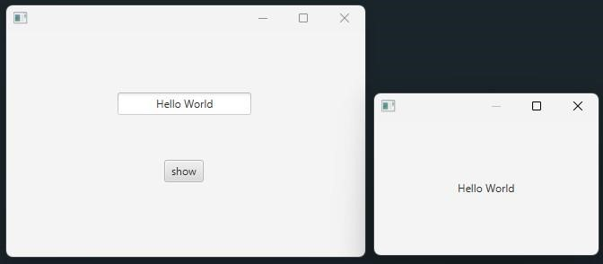

Center the text showing the my_new_window label

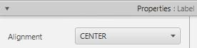

Rename

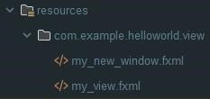

Update the controller and main where we pass the routes



In ControlallerView.java, a validation is done on the text variable so that, if it is empty (""), instead of opening my_new_window, it writes a message in a label (which you must add to the window) that says: “Please write something' and it will be displayed in red.

.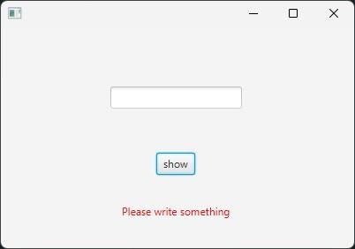

The label was added from the scene builder and the id was assigned

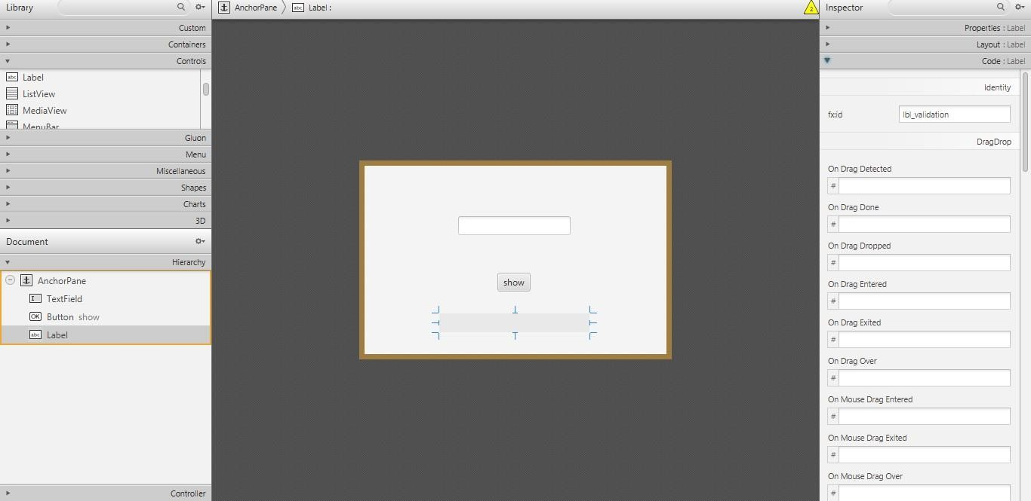

In properties it is set to show the text in red

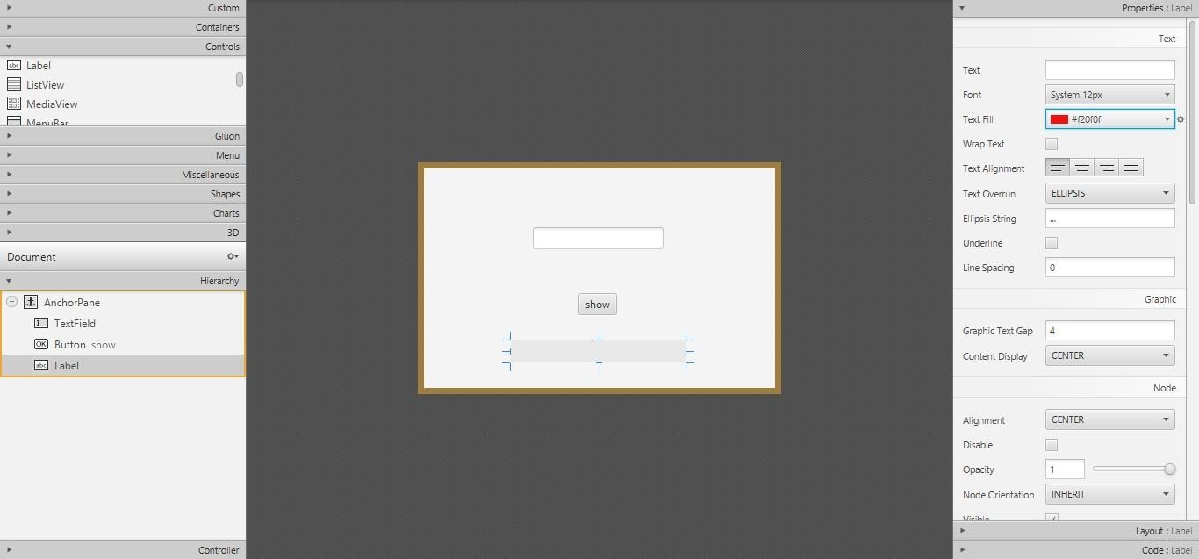

Controller code

