**Solution Login**

The material provided for this first part is the Login project (which you must download, unzip and open from Intellij IDEA

1. [1/10]. After having been in class and reviewing the presentations, answer the following questions:
   1. Describe the process to follow to create a window controller, when you

already have the user interface finished.

* + - Design the interface in Scene Builder.
    - Assign the fx and events to the components.
    - Create the controller class.
    - Add to the controller the names of the components and events defined in scene builder, annotate them with @FXML.
    - Link the driver to the FXML file.

* 1. How could you make the window maintain a fixed size and the user not Can I change its dimensions?

He achieved this by using the setResizable() method of the stage class, it is a method that allows you to control whether the window can change size or not. Passing the value false indicates that it should not be resizable.

stage.setResizable(false);

* 1. What is the style.css file for?

The style.css file applies custom styles to the TextField, Buttons, and Label, setting colors, sizes, borders, and visual effects.

* 1. What advantages would you say that using CSS has compared to editing the

style of the elements from the Scene Builder options themselves? Using CSS allows you to reuse styles across multiple elements, offers greater flexibility, and makes organization easier, while editing styles in

Scene Builder can be limited and harder to maintain in complex layouts.

1. [4/10]. Starting from the example project, create a copy, make the appropriate changes so that:
   1. The project is organized with the Model – View – Controller pattern.

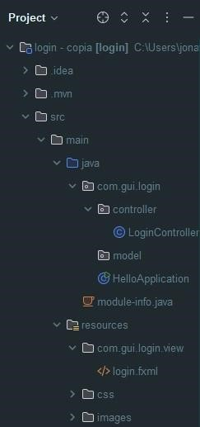

Controller -> contains LoginController

Model -> empty (we are not using classes)

View -> contains the .fxml files

* 1. The Login button has an onAction that opens a new welcome window to the application (you must create it, be as original as possible).

Adding id and OnAction

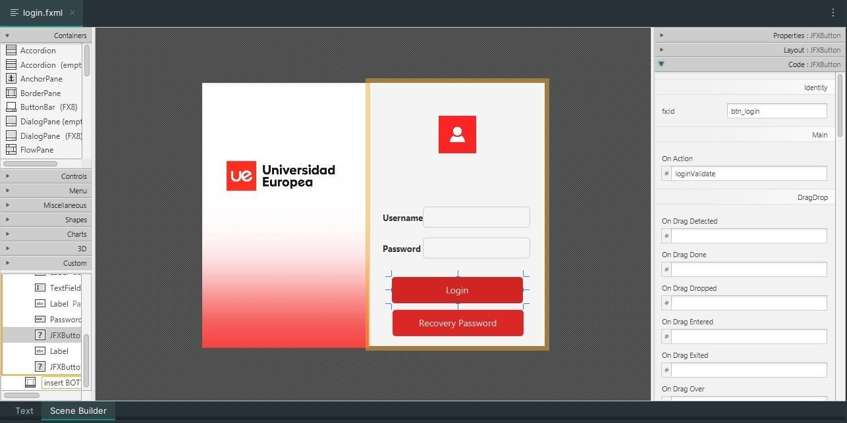

Adding functionality

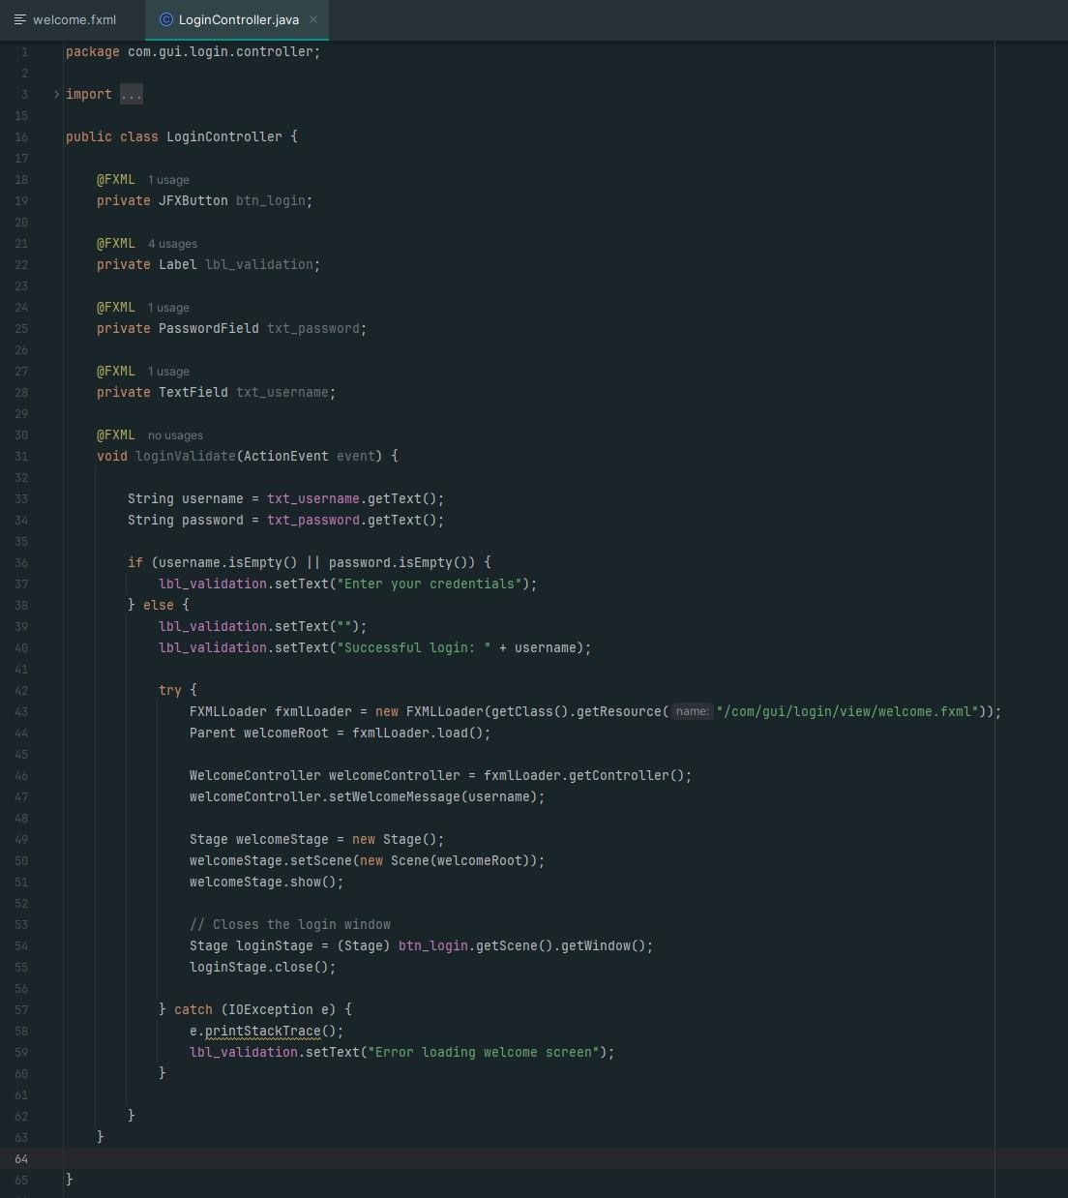

Welcome window showing the user who started

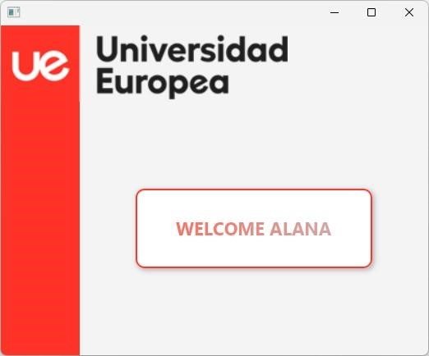

* 1. Add a button to recover password and when clicking on it a new window opens with a textField to enter an email and a button that says send (follow the style of the window created in section b). You do not have to develop any functionality in the controller of this window, just opening it and having the requested elements is enough.

