Xeno-Flight

By: Ethan Clayton

Ajai Gorowara

2/17/2018

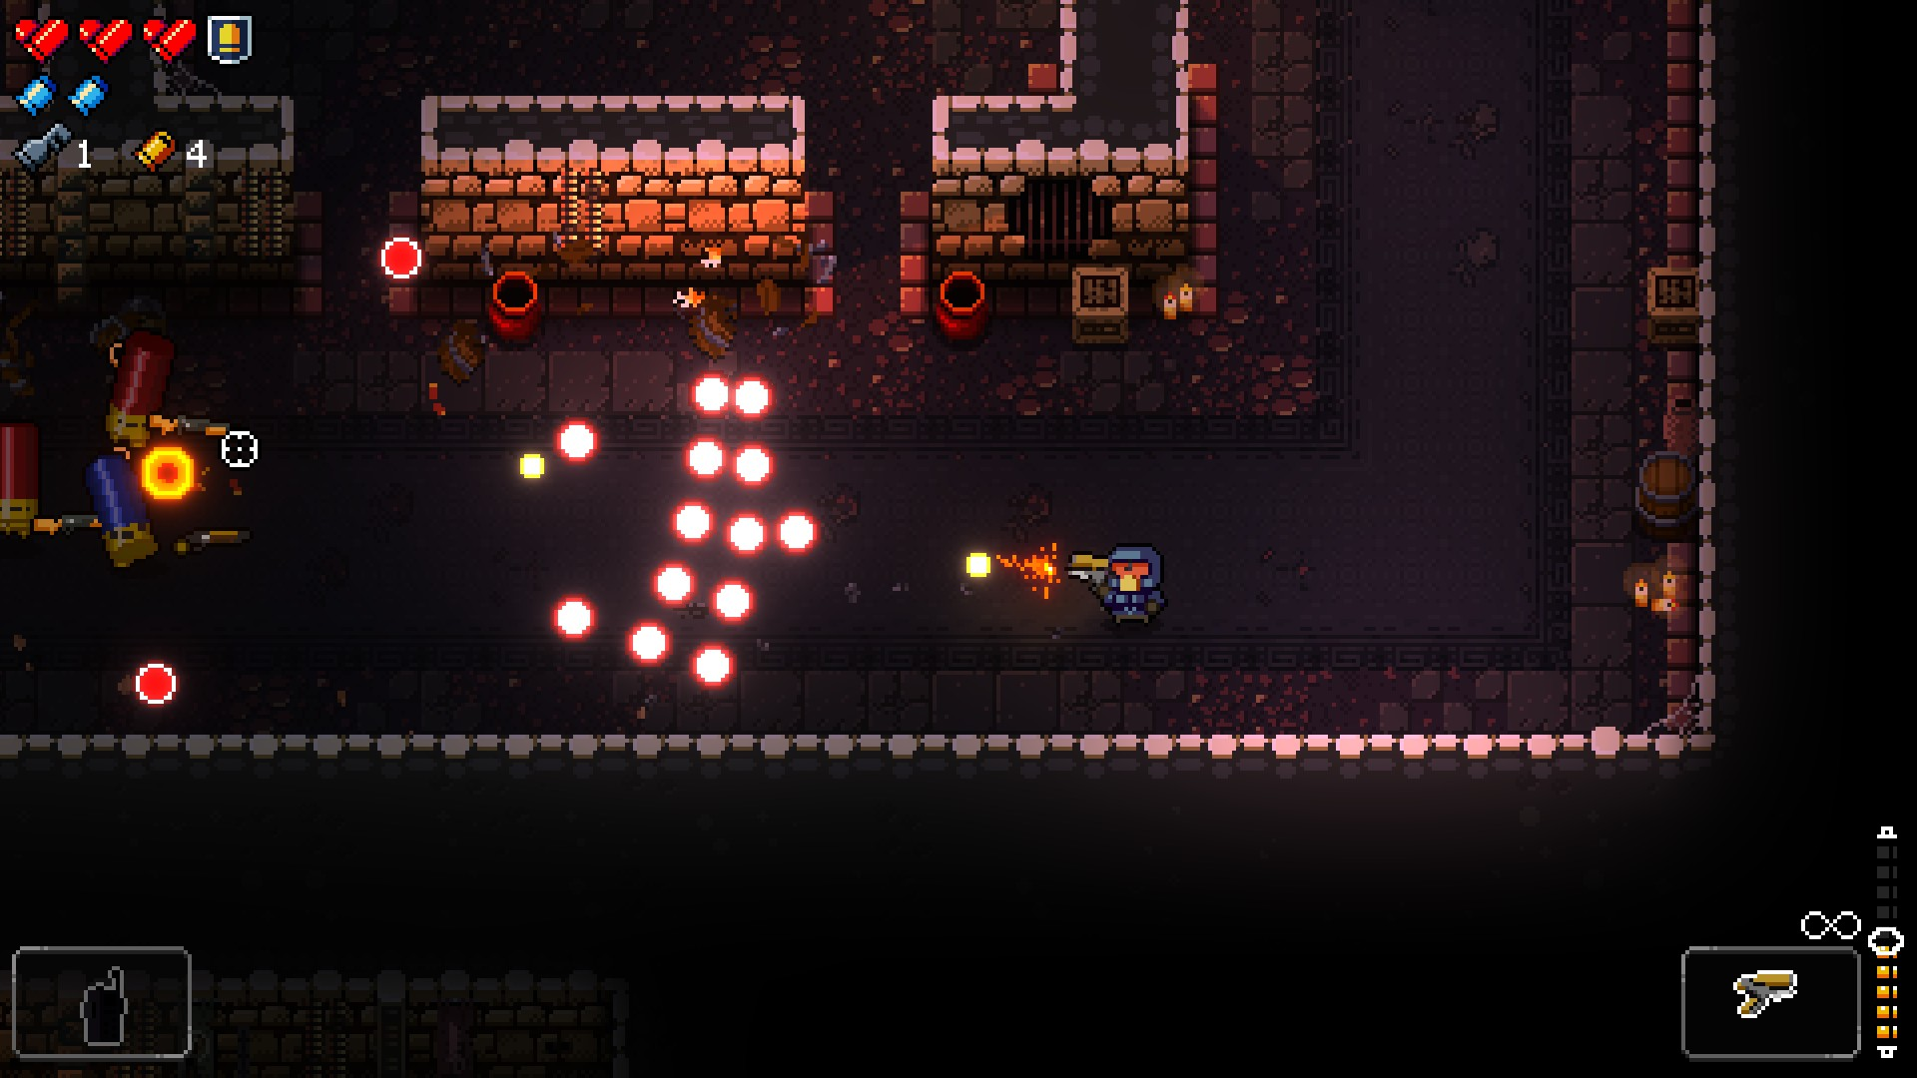

Image comes from Enter the Gungeon by Dodge Roll Games

Table of Contents

I. Overview: 3

II. Story: 3

III. General Look and Feel: 4

IV. Gameplay: 4

V. Mock Up and Screen Flow Diagram: 6

VI. Mechanics: 7

VII. Timeline: 7

VIII. Concept Art: 9

# Overview:

A short backstory of the game is that aliens are invading the world, and there is one ship that can defeat the aliens. The player wins if they can defeat a boss at the end of the level. The player must shoot down or dodge fire from alien ships on the way towards the boss. Along the level can collect health canisters and weapon upgrades. Score is gained over time while alive and from shooting down other ships. The game is over when the player takes too much damage from either the boss or the other alien ships. The genre of the game is a bullet hell or shoot ‘em up.

# Story:

The story takes place in the future, where technology on Earth has become extremely advanced. Aliens invade the planet in fear of the advanced technology and wish to destroy the planet. To combat the invasion, all of Earth's greatest powers combine their technology to create the Star Wing. The Star Wing is the only ship capable of defeating the invasion.

# General Look and Feel:

The general look of the game will depend on the level that the player is in. From going across cities, space, and the ocean. The players ship will start near the center with the time and score placed on top of the screen as an overlay. The game will look like 16-bit bullet hell games.

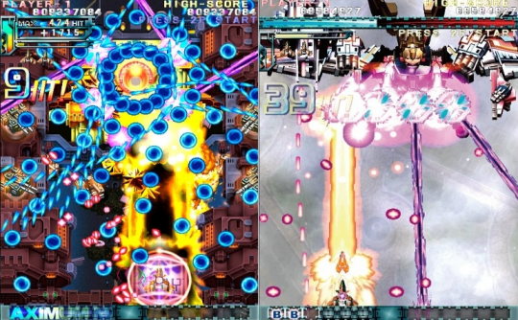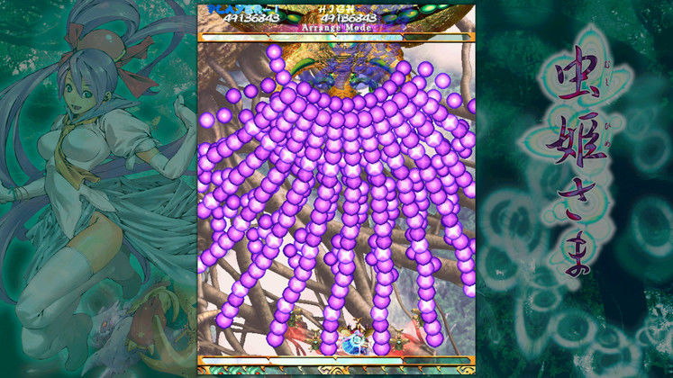

Image is taken from Dodonpachi Resurrection: Deluxe Edition by CAVE

Image is taken from Mushihimesama HD by CAVE

# Gameplay:

When the player opens the game, the player will view the title screen for a few seconds and then will be sent into the level select room. There the player can do two things, the player can select one of three levels, and the player can choose one of three ships. The first ship has three lives and does a set amount of damage. The second ship has only had one life but does double the set amount of damage. The third ship has an infinite amount of lives but does half the set amount of damage.

The player will be able to control a ship from a top-down view. The ship movements will be controlled with the mouse, with the left mouse click being the shoot button, the right mouse click being the special button, and the esc button brings up the pause menu. The ship will have three levels of power. The 1st power will shoot out a small blue line and does a small amount of damage. The 2nd power can be picked up as an upgrade object throughout the level. The 2nd power shoots out 3 small pellets in a line and does a medium amount of damage. The 3rd power can be gained after picking up two upgrade objects. The 3rd power shoots out 3 small red lines in a row and does large amounts of damage. The 4th power up can only be collected during a boss fight. The 4th power up will create a large constant beam that will do a large amount of damage for a few seconds, then afterwards the player will go back to the third power level.

The level will scroll down from the top, as the level is scrolling enemies and objects will spawn and will attack the player with weapons. The enemies can collide with the player to deal damage. The will be 4 different types of enemies and 3 boss enemies. Enemy #1 can be taken down with small amount of shots and shots small bullets. Enemy #2 can be taken down with a medium amount of shots and fires normal speed bullets. Enemy #3 can be taken down with large amount of shots and fires normal speed bullets. Enemy #4 can be taken down with 1 shot, but it is extremely fast and does not shoot anything. Instead after killing Enemy #4, it will either drop an extra life or a weapon upgrade. The three bosses appear at the end of their respective level. They take an extreme number of bullets to defeat and fire different shots then other enemies.

Each level will take up to 5-7 minutes, depending on the players skill and how many times they are defeated. The player will have 3 lives and can only take one hit before losing a life. When a player loses a life and respawns in, they will have a few seconds of invincibility for the player to get back in position and for them to not die automatically when respawning back in. During the invincibility, the player cannot shoot. When the player dies, the player respawns back in the bottom middle of the screen, and the level does not reset. When the player loses all their lives, they will be sent back into the level select.

# Mock Up and Screen Flow Diagram:



Title/Main Menu

Level Select Menu

Level 3

Level 2

Level 1

Death/Win

# Mechanics:

* Player Mechanics
  + Movement - Follows Mouse Pointer
  + Shoot - Left Mouse Button
  + Special Laser - Right Mouse Button
  + Colliding Enemy-Take Damage and Destroy Enemy
* Enemies Mechanics
  + Movement - Predetermined Pattern
  + Shoot - Every few seconds, enemy 4 cannot shoot
  + Colliding Player - Destroyed and They Damage Player
* Bullets Mechanics
  + Movement - Predetermined Pattern
  + Hit by Special Laser – Destroyed

# Timeline:

* Week 1
  + Research games and code
* Week 2
  + Gather and or create assets
* Week 3
  + Build Title and level selection
* Week 4
  + Build level 1
* Week 5
  + Build level 2
  + Play test existing levels
* Week 6
  + Build level 3
  + Play test existing levels
* Week 7
  + Play test entire game
  + Bug fix game
  + Refine levels based on play testing
* Week 8
  + Play test refined levels
  + Bug fix game
  + Refine levels based on play testing
* Week 9
  + Play test game
  + Bug fix

# Concept Art:

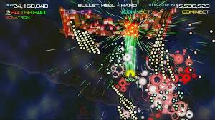

Image comes from Duality ZF by Xona Games, our bosses are likely to look something like this

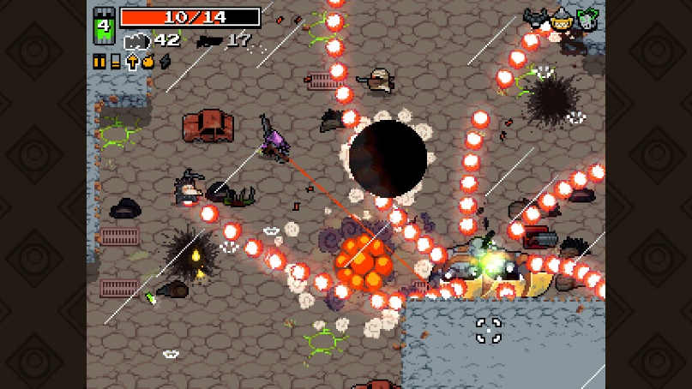

Image comes from Nuclear Thone by VlamBeer, shows how much we went to be on screen in boss battles