# Quick Start Guide

## Overview

This guide will help you to install and run agosense.fidelia. Once the system is up an running, we recommend that you watch the video tutorials that are also provided as part of the quick start package.

Your quick start package contains the following software components:

|  |  |
| --- | --- |
| File | Description |
| agosense.fidelia_windows_<version>.exe | Installer for the Microsoft Windows Platform |
| agosense.fidelia_linux_<version>.sh | Installer for Linux-based Platforms |
| agosense.fidelia_docker_<version>.tgz | Export of Docker image for Linux-based Docker hosts |
| agosense.fidelia_iso26262.zip | Solution template for safety critical development (ISO 26262), configures the application and installs sample data |

## Step 1: Installing and starting the software

A common prerequisite for Windows- and Linux-based installers is an existing installation of a Java Development Kit Version 8 (JDK). The provided Docker image already includes a matching JDK.

### Windows Installer

To start the installation procedure on Windows, run the following executable:

agosense.fidelia_windows_<version>.exe

The installation procedure will ask you to select an installation directory and choose the components to be installed. Please make sure to install all components (default).

After the installation succeeded, the following 3 windows services are installed, make sure they are all running:

* agosense.fidelia db (Database service)
* agosense.fidelia.idx (Index service)
* agosense.fidelia app (Application service)

Further details about the installation configuration can be taken from the Administration Guide.

### Linux Installer

To start the installation procedure on Linux (runs in graphical or command-line mode), run the following executable:

agosense.fidelia_linux_<version>.sh

The installation procedure will ask you to select an installation directory and choose the components to be installed. Please make sure to install all components (default).

After the installation succeeded, run the following commands to start all required services:

cd <install-directory>

./agosense.fidelia.db start

./agosense.fidelia.idx start

./agosense.fidelia.app start

Further details about the installation configuration can be taken from the Administration Guide.

### Docker Image

The docker image is provided as a compressed TAR archive (image export). To install the docker image into your local docker repository run the following command:

gunzip -c agosense.fidelia_docker_<version>.tgz | docker load

To start a docker container for testing purposes, run the following command:

docker run -it --name fidelia -e FIDELIA_MIGRATE=true -e FIDELIA_REPLICATION_FACTOR=1 -p 8443:8443 wagner.agosense.com:28443/fidelia:<version>-all

For the docker start, the version string is separated by dots such as:

docker run -it --name fidelia -e FIDELIA_MIGRATE=true -e FIDELIA_REPLICATION_FACTOR=1 -p 8443:8443 wagner.agosense.com:28443/fidelia:1.8.10-all

Further details about the docker configuration can be taken from the Administration Guide.

## Step 2: Applying the solution template

To apply the solution template open the admin interface at:

https://<server-or-ip>:8443/fidelia/ff/ui/admin

This will take you to the login screen.

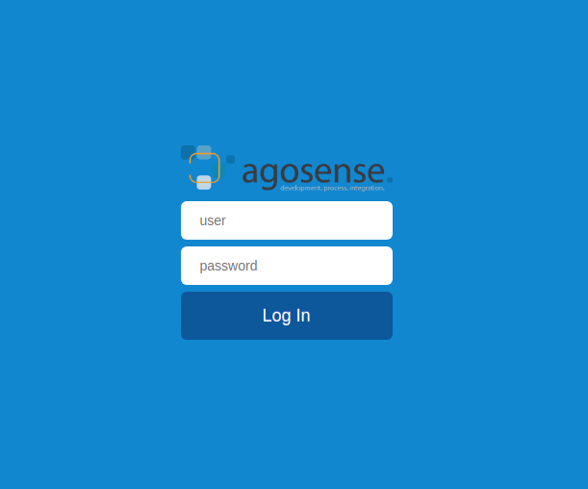

The system is initialized with a single administrative user with the following credentials:

|  |  |
| --- | --- |
| Username | root |
| Password | secret |

Select *Templates* on the navigation bar located on the left side of the screen.

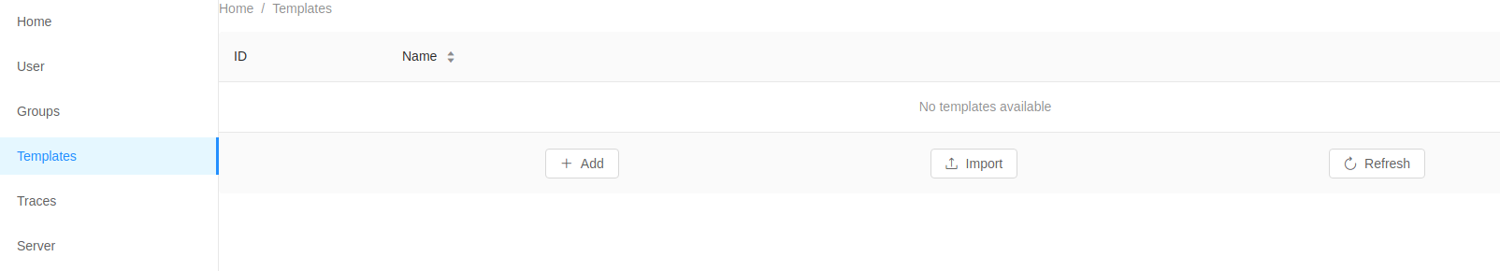

Now hit the *Import* button.

Then upload the provided solution template file:

agosense.fidelia_iso26262.zip

The installation of the solution template may take a couple of seconds to finish.

Once the solution is installed, the newly imported templates are showing up.

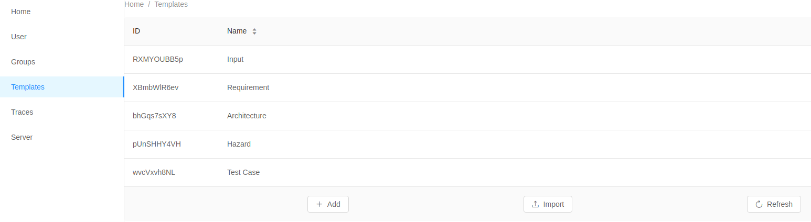

Open the main application at:

https://<server-or-ip>:8443/fidelia/ff/ui

The folder browser where shows up where you can navigate through the sample data.

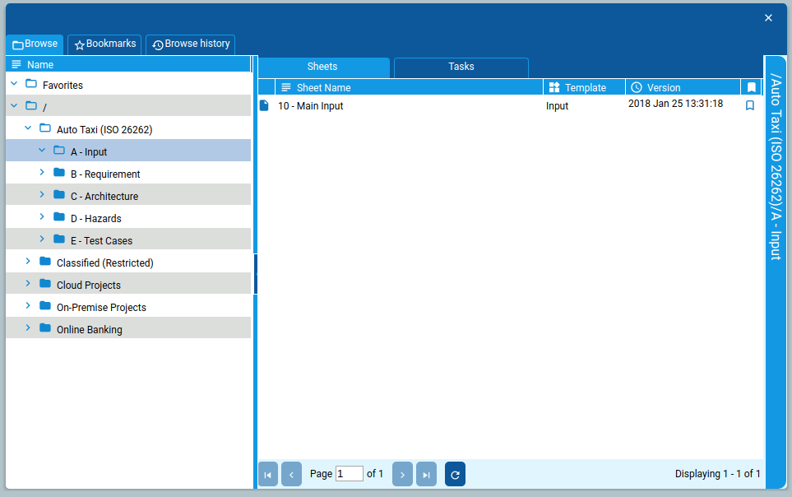

More documentation can be found in the help menu. Just hover over the navigation bar on the left side of the screen.

