**Automation of Electrochemical Square Wave Voltammetry Data Analysis**

**Steps on using the data automation program**

Next

**Step 1:** Open the program labeled “Ideation Automation”

Previous Next

**Step 2:** Click “Browse” and select folder with raw data in “.txt” or “.csv” format.

Previous Next

**Step 3:** Copy headers from the raw data

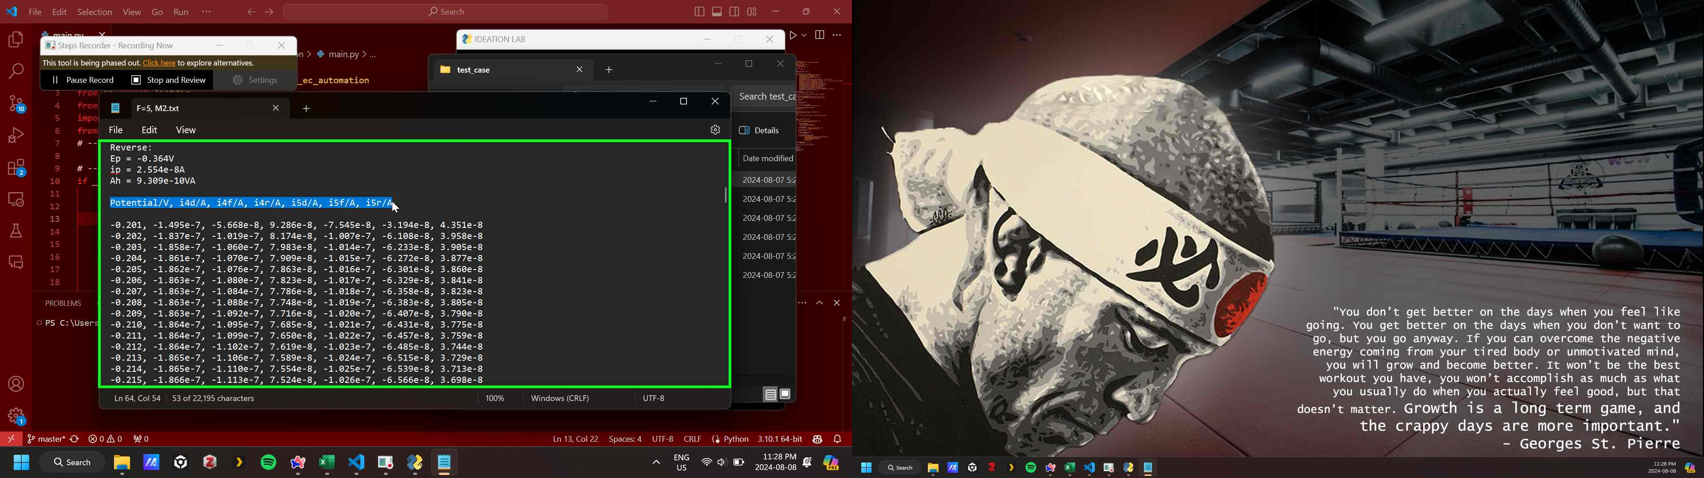

Previous Next

**Step 4:** Paste the headers into the header tap of the document and select the relevant seperator

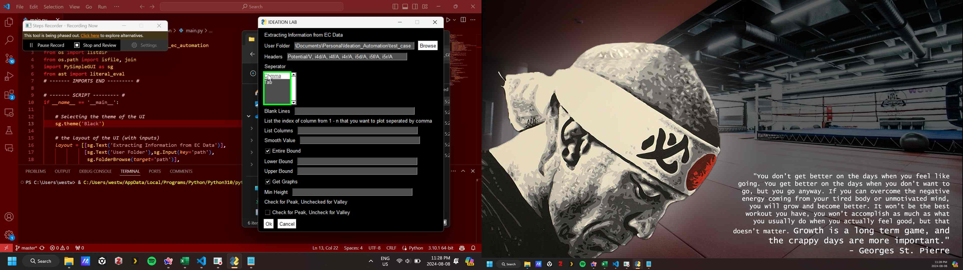

Previous Next

**Step 5:** Counter number of blank lines separating the headers and the data

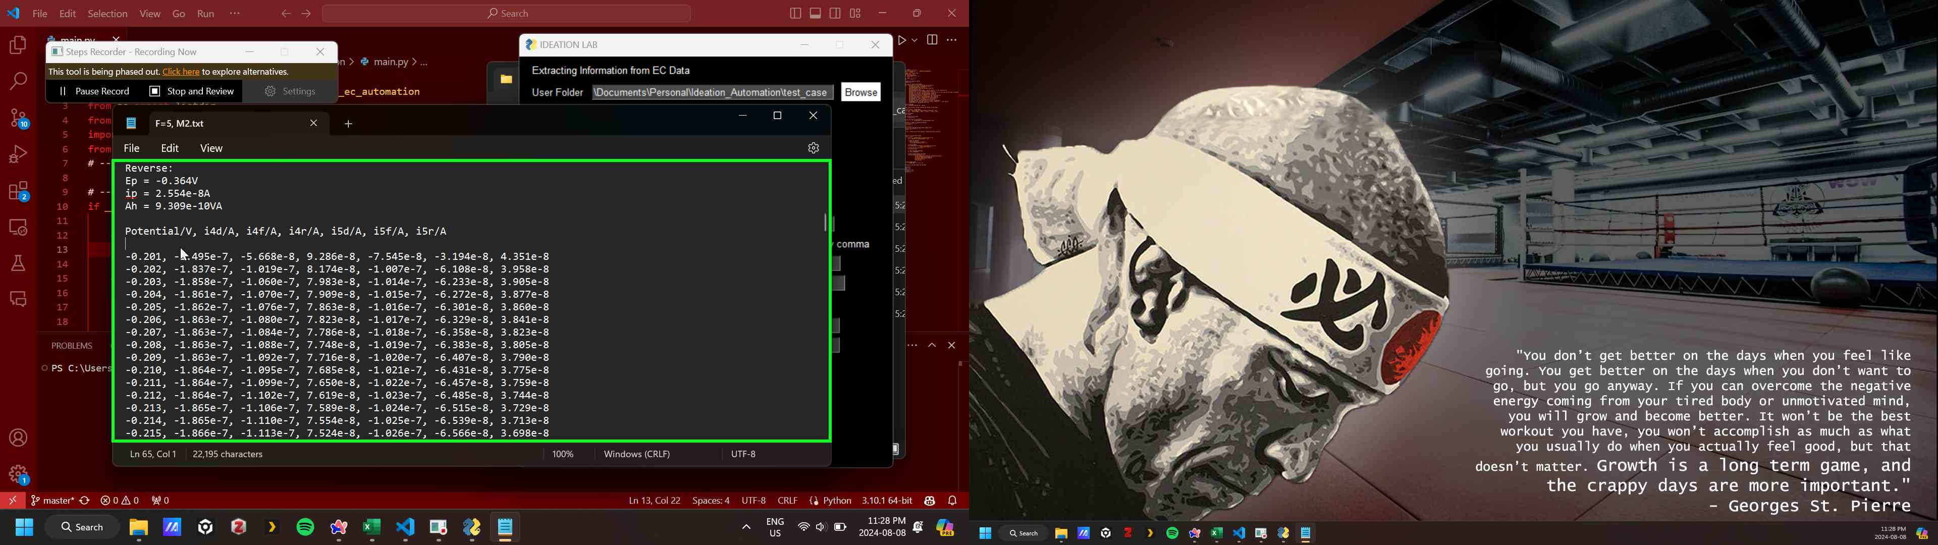

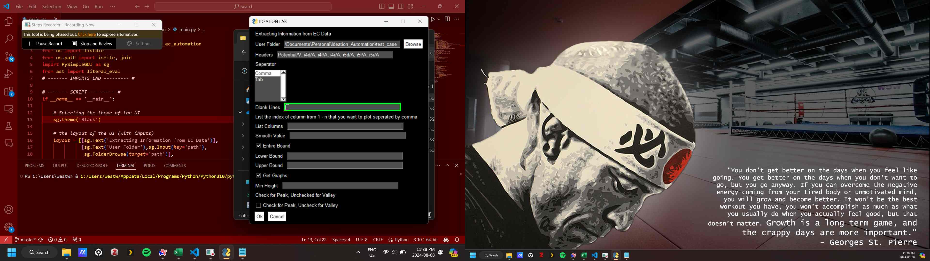

Previous Next

**Step 6: (‎2024-‎08-‎08 11:27:50 PM)** Add the indexes of the columns of interest, separated by commas

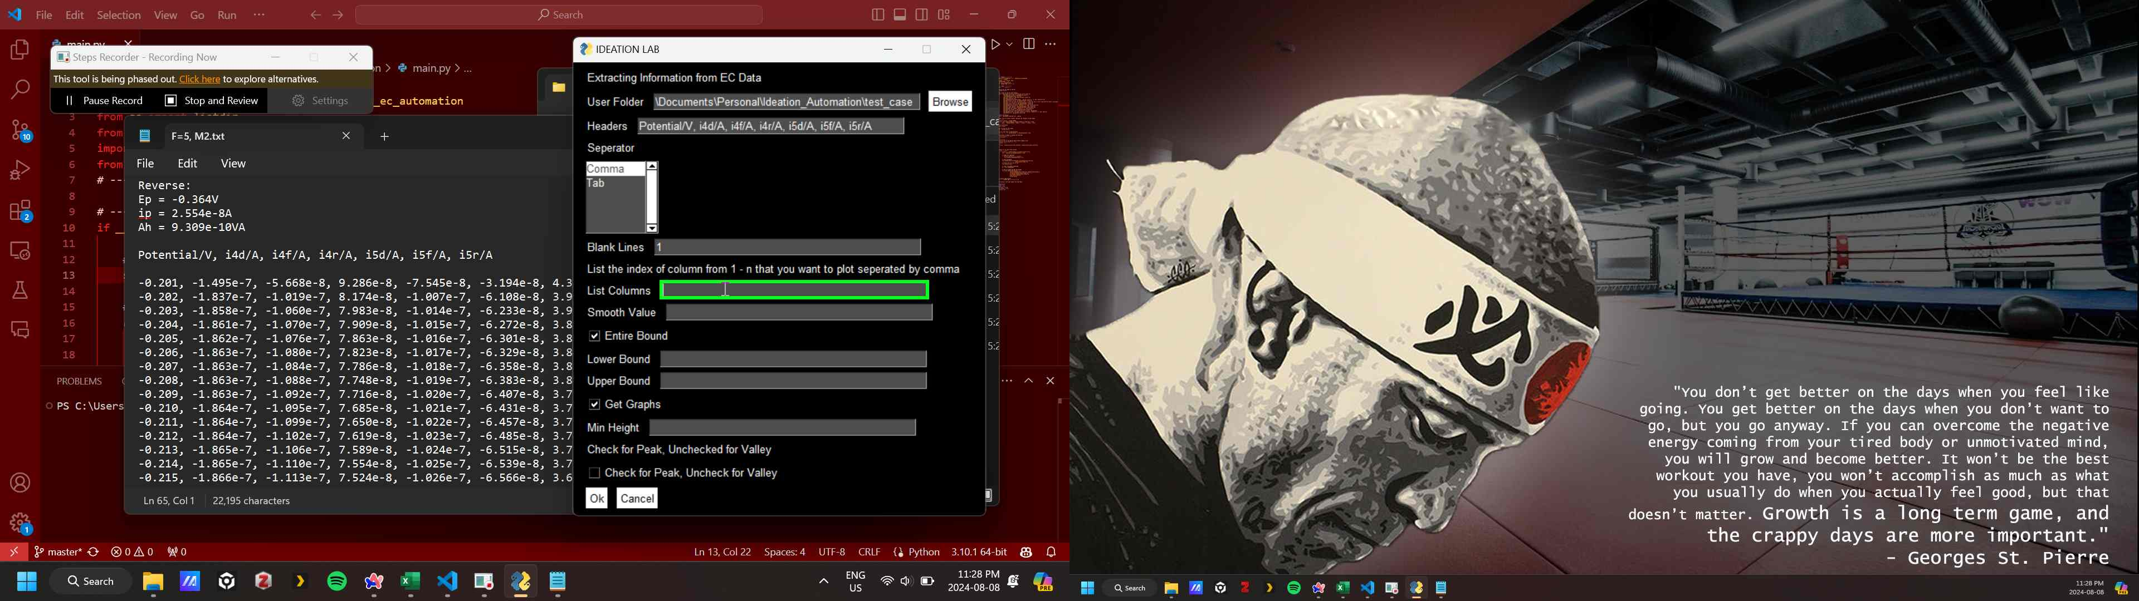

Previous Next

**Step 7:** Add a value for smoothing the curve

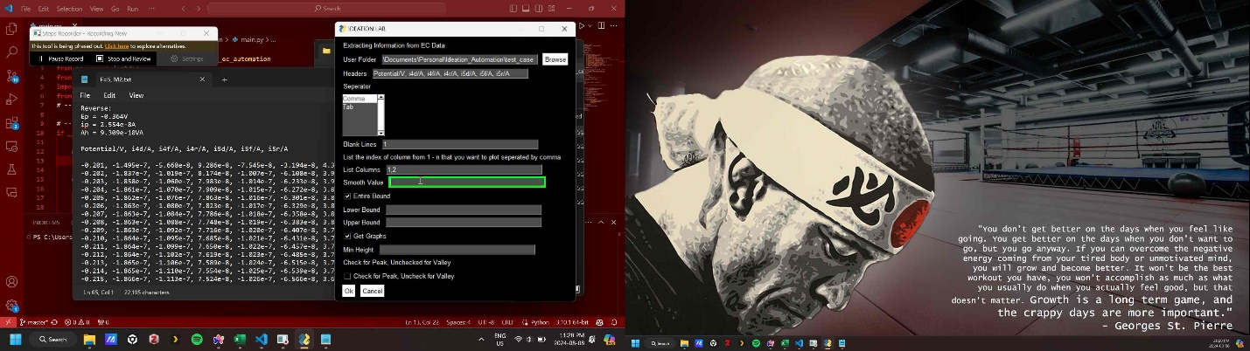

Previous Next

**Step 8: (‎Optional)** Modify the bounds of interest in the data

Previous Next

**Step 9:** Insert the minimum height of the peaks (this value is determined using trail and error and is data dependent)

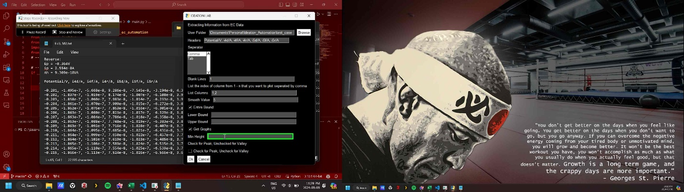

Previous Next

**Step 10: (‎Optional)** Click box to detect peaks instead of minimum values in the graph

Previous Next

**Step 11:** Click “Ok”

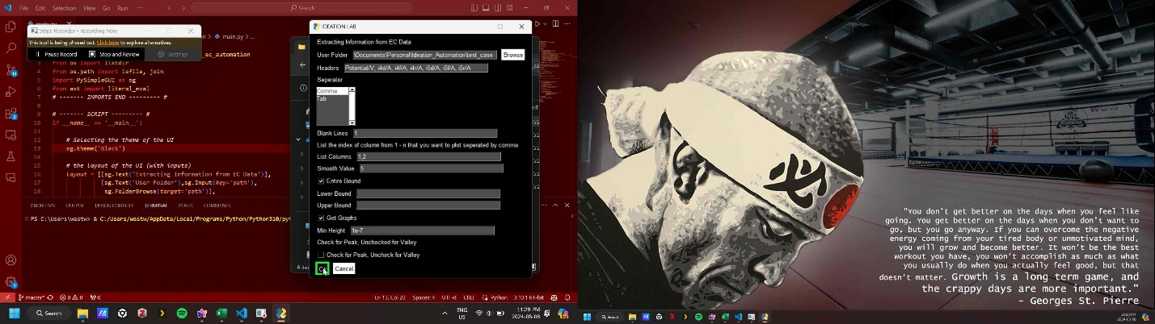

Previous

**Step 12: (‎2024-‎08-‎08 11:27:58 PM)** Figures and summary documents automatically generated in the folder with the data

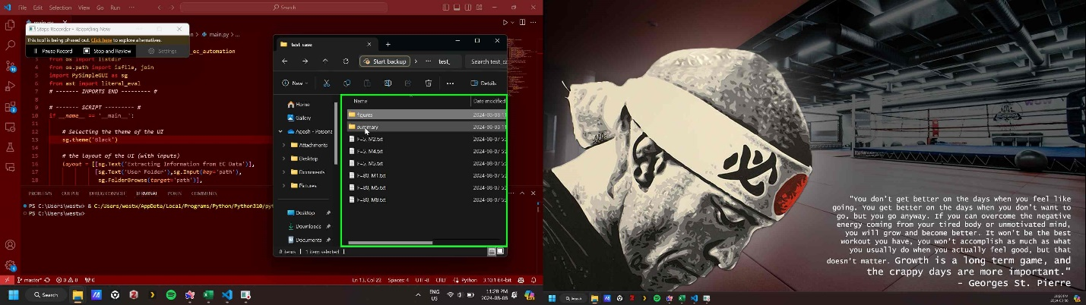

Return to top of page...