**How to create a new portable**

1. Open “Attendance manager” (click OK in the “Display order not set” error message)
2. In the tab *Functions* select *Connect…*

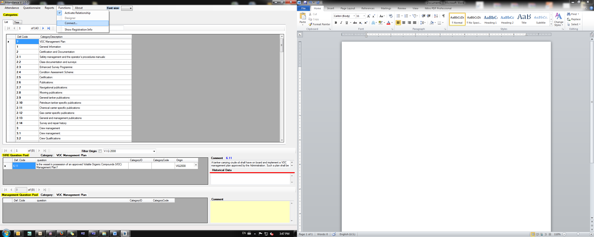

1. In the pop-up window use the below details

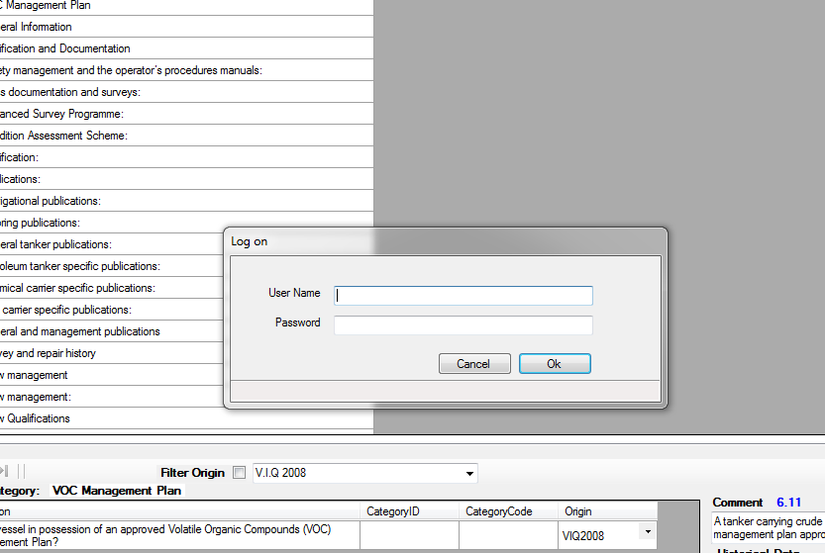

Username: Manager / Password:  ioniamng

1. Click “Designer”.
2. In the tab *Briefcase* select *New…*
3. In the pop up window complete
   1. your name as you wish it to appear in attendance manager
   2. the inspection type (ie attendance, vetting, etc.)
   3. the path where you wish the file to be saved (click on the dots on the right)

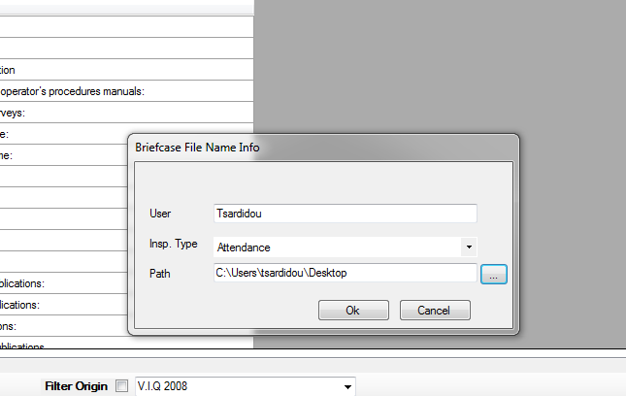

1. press ok and a confirmation will appear

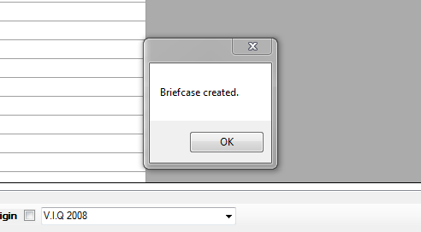

1. Select *Add Questionnaires*

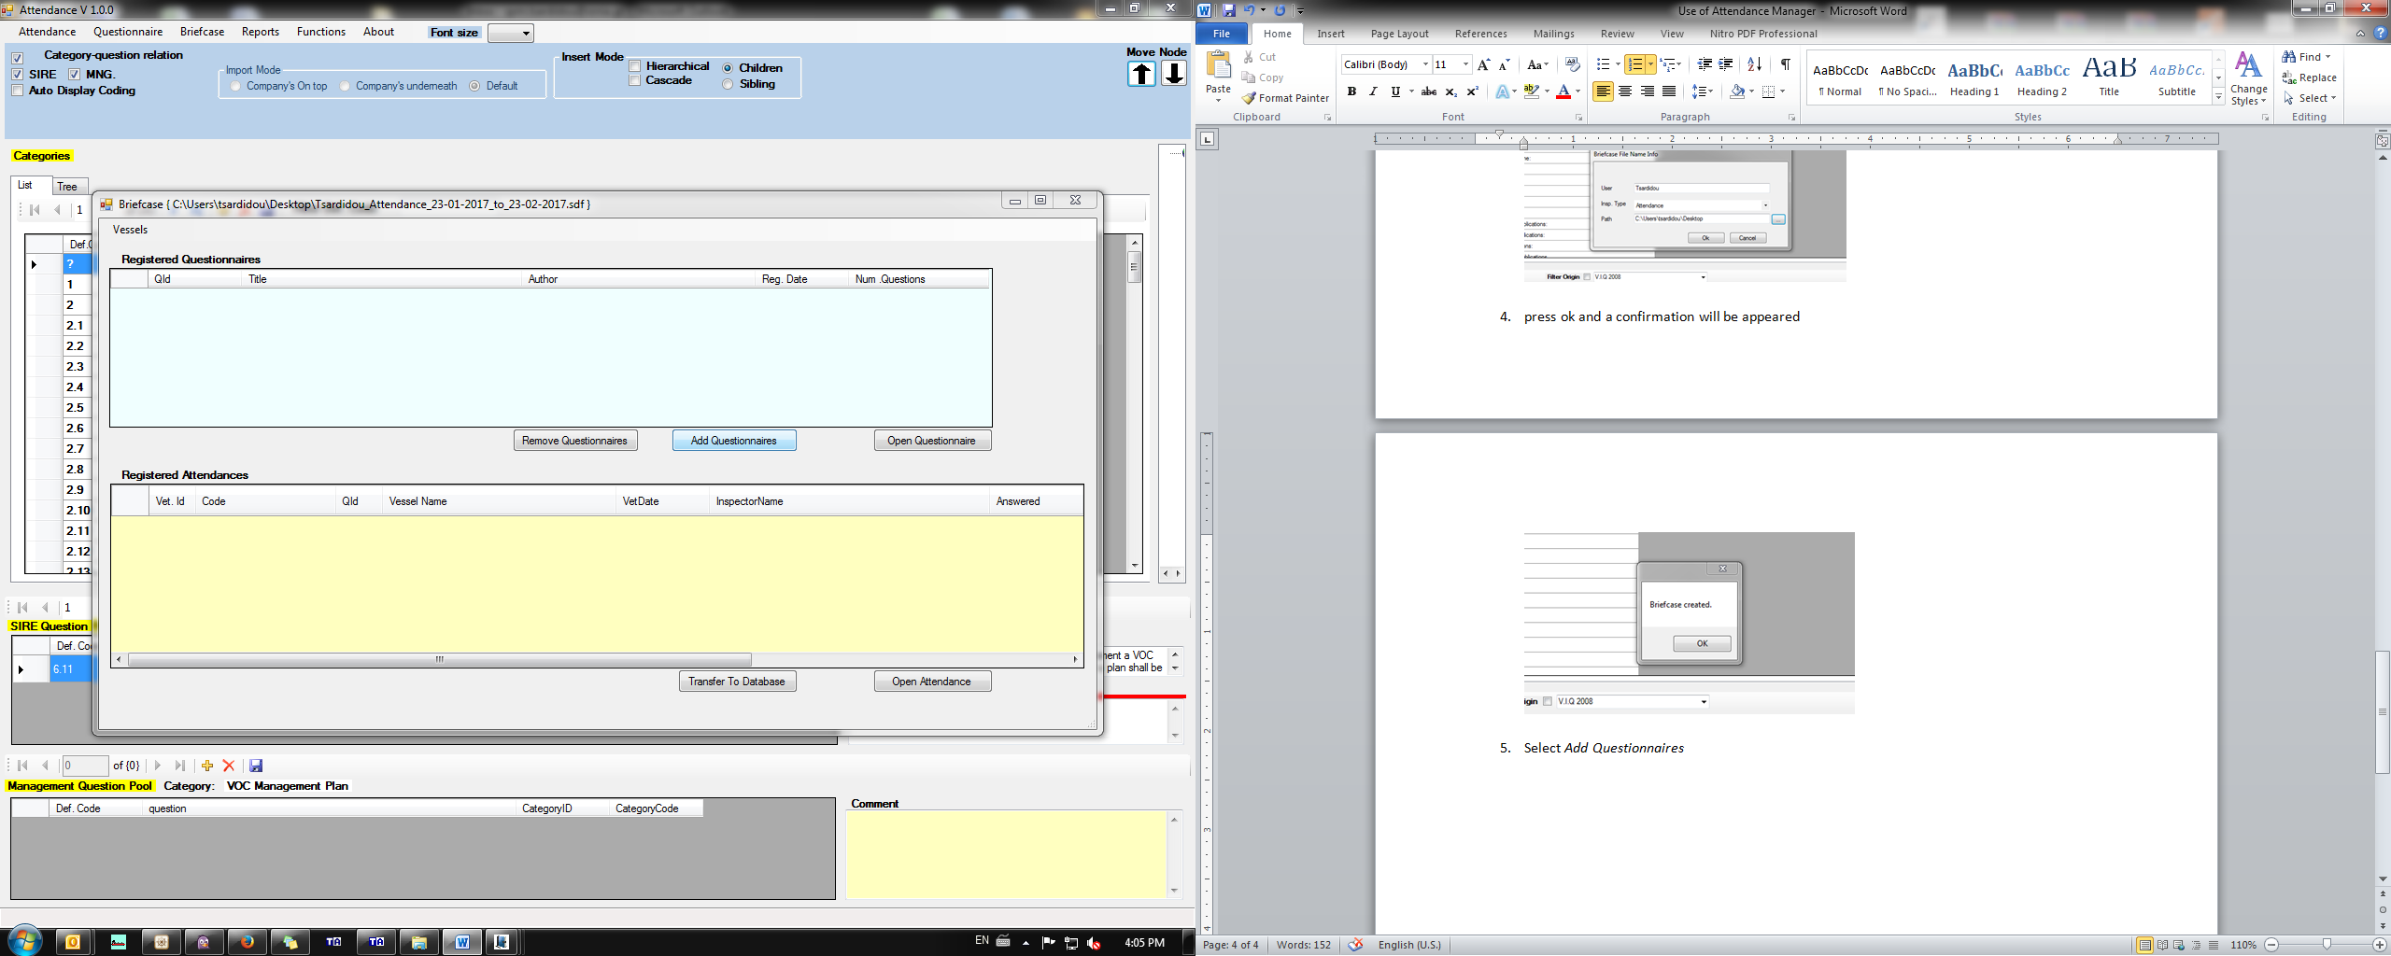

1. If attendance, select the most recent at the bottom, if vetting the 191 or 188 respectively

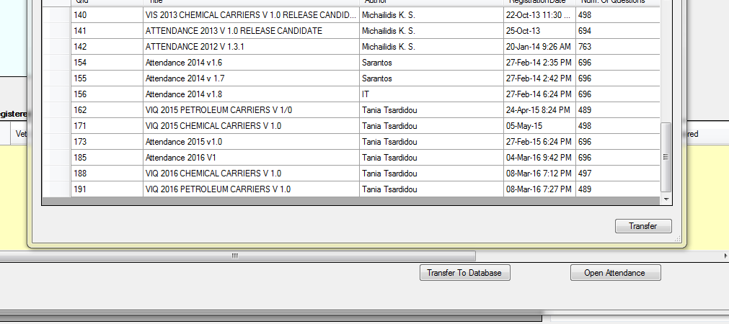

1. Select *Transfer*

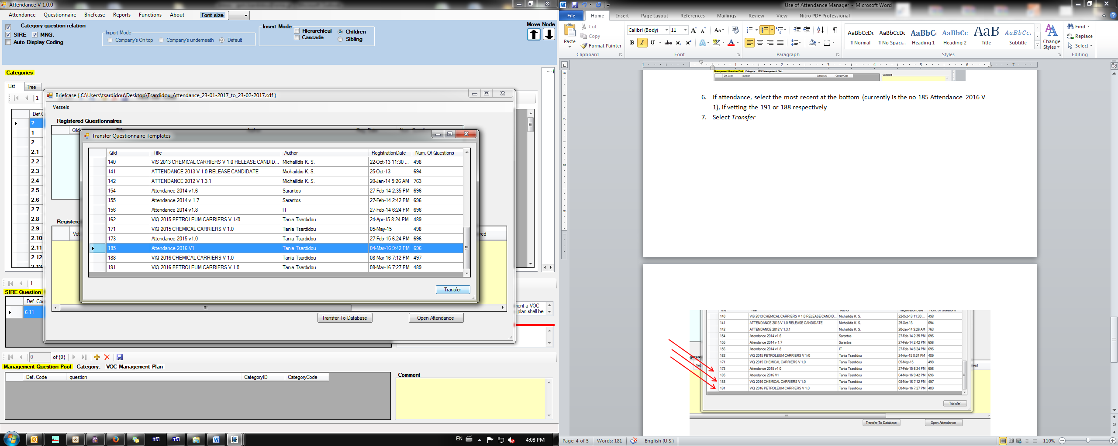

1. And this notification will appear

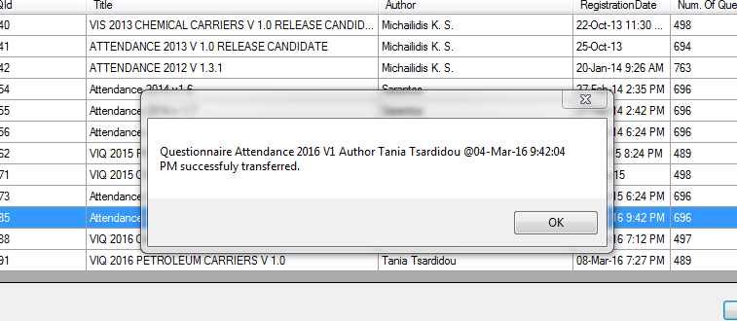

1. You can now close all the windows and the file will be at your selected path.

**How to complete the attendance**

1. Open “Attendance portable”
2. Open your file
3. Click “Open questionnaire”
4. On the top menu you will see the button Attendance. Click it and press New.
5. Fill in the details: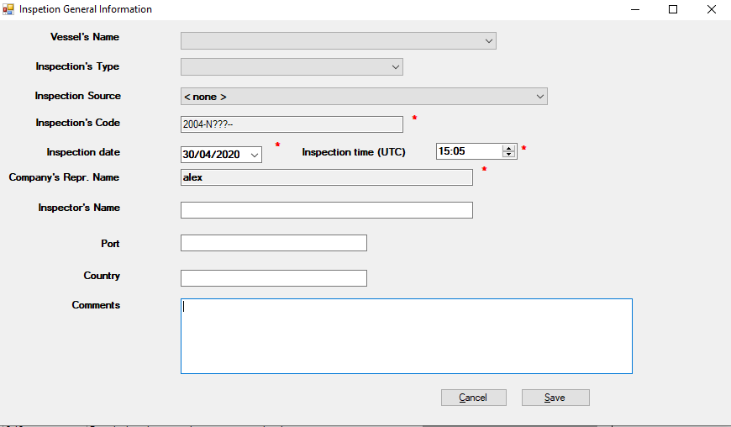
6. The questionnaire opens and you can now answer the questions.
7. Click Attendance -> Save
8. Close the front window and you will see your attendance to the “registered attendances” frame.

**How to upload your attendance**

1. Open “Attendance manager” (click OK in the “Display order not set” error message)
2. In the tab *Functions* select *Connect…*



1. In the pop-up window use the below details



Username: Manager

Password:  ioniamng

1. Select *Designer*

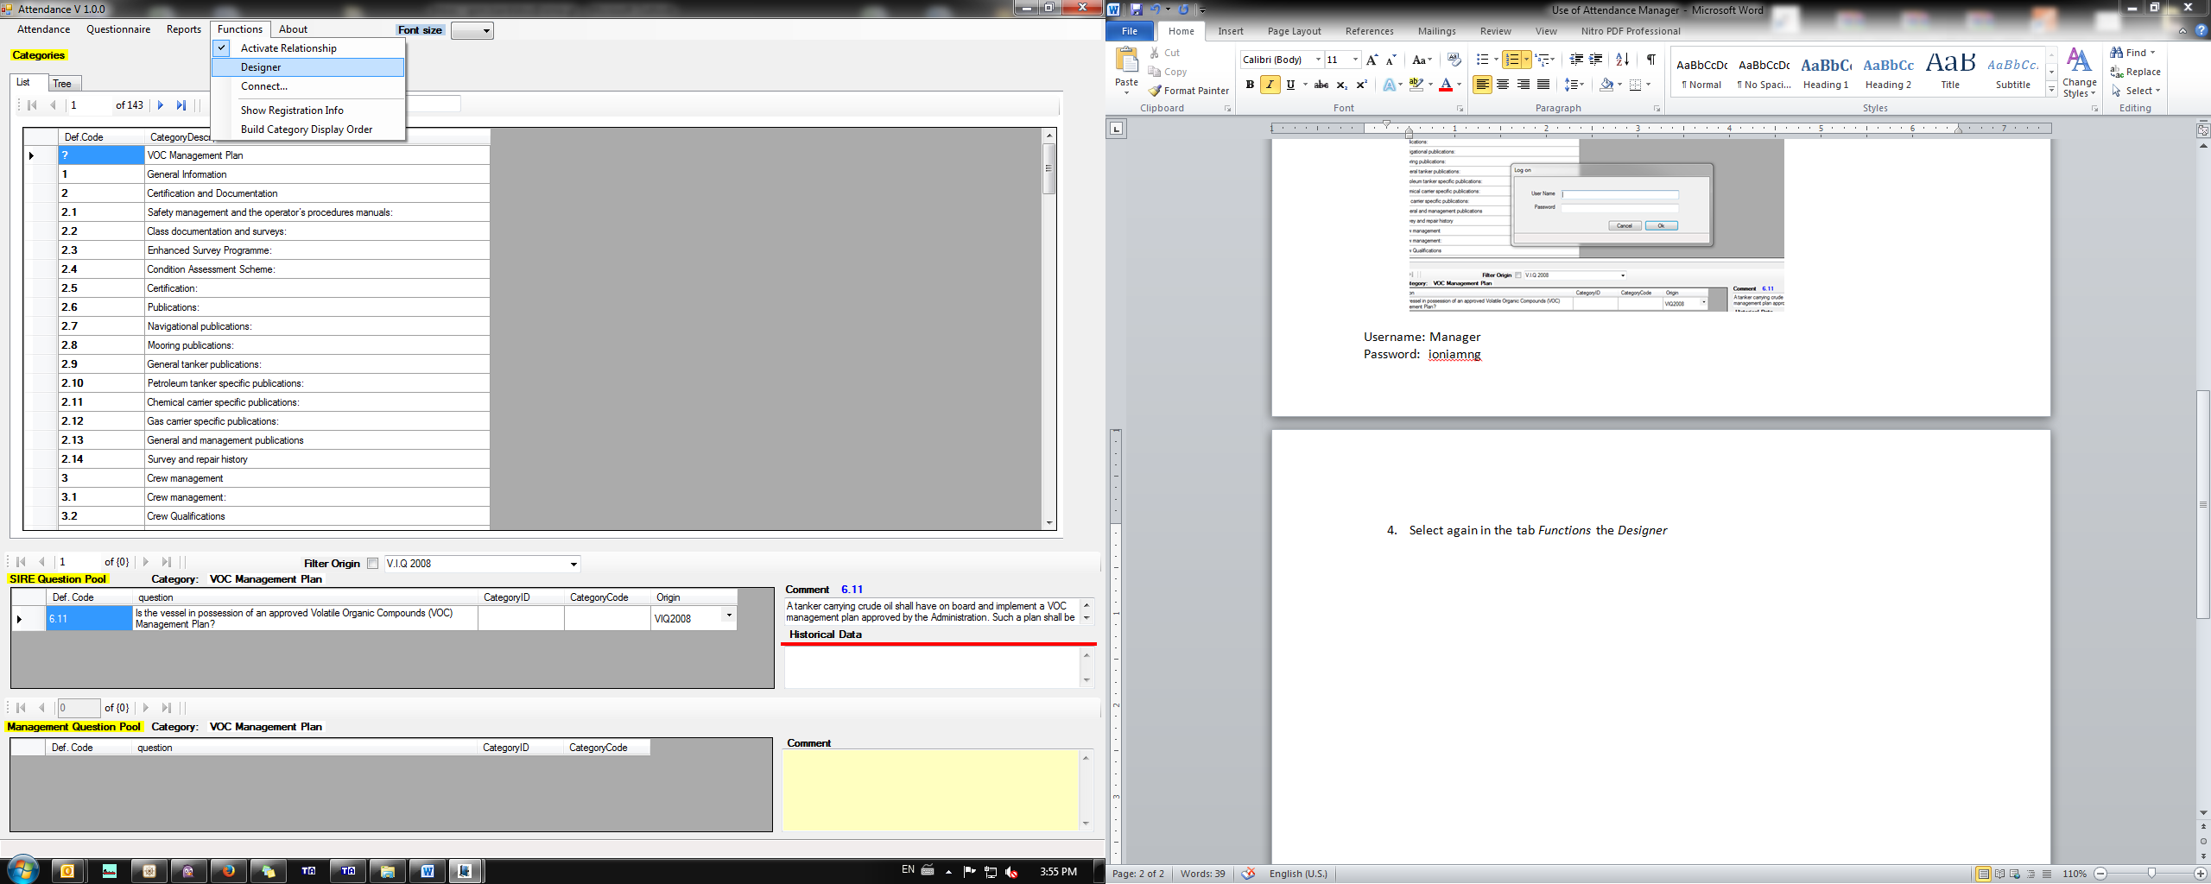

1. In the tab *Briefcase* select *Open*

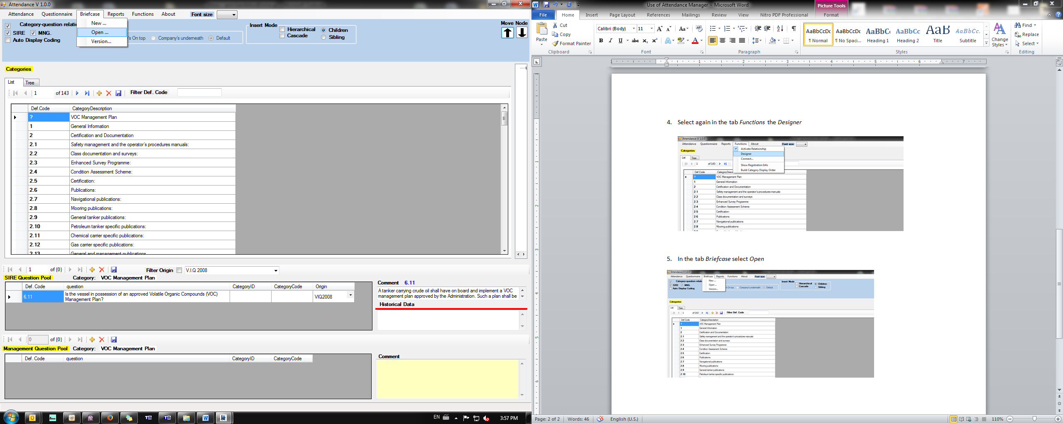

1. Navigate to the folder where your attendance file is located
2. Select the attendance and select *Transfer to Database*

