An Independent European Macroeconomics? A History of European Macroeconomics through the Lens of the European Economic Review

Aurélien Goutsmedt[1]

Alexandre Truc[2]

2023-07-28

Economics in Europe has become more international since the 1970s. To a certain extent, this internationalisation is also an ‘Americanisation’ as many European economists have adopted the standards and approaches of US economics. This prompts an important question: amidst this convergence, are there any fields that have managed to retain a distinctively European character?

In this article, we use topic modelling and bibliometric coupling to identify European specialties between 1969 and 2002. We focus on macroeconomic articles published in the European Economic Review and compare their bibliographic references and textual content to what has been published in the top 5 journals.

Despite economics internationalization since the 1970s, European macroeconomics displayed distinct characteristics across two distinct periods. In the late 1970s and early 1980s, European macroeconomists maintained a certain distance from US debates centered around rational expectations and new classical economics. However, they embraced the concept of microfoundations through the lens of disequilibrium theory, fostering transnational collaborations and offering a unique framework for addressing various macroeconomic issues. Nevertheless, both the prominence of new classical economics in the US and the decline of the disequilibrium approach after the mid-1980s, European macroeconomics shifted towards closer alignment with US approaches. In the 1990s, Political economy, inspired by pioneering US contributions like Kydland and Prescott (1977) and Barro and Gordon (1983a, 1983b), emerged in the 1990s as a new framework offering a common language for many European macroeconomists. However, specific European challenges like high unemployment rates and European integration continued to drive research in distinctive directions.

# 1 Introduction

In 1987 in the *European Economic Review*, the director of the Centre for Economic Policy Research, Richard Portes, assessed the “state and status of economics in Europe”. He regarded “the standard of comparison [as] obvious: the United States, by far the dominant producer” (Portes, 1987, p. 1329). He then asked “whether there is now any economics outside and independent of the United States.” (p. 1330) He listed many clues testifying US domination, ending by the observation that “the leaders of the economics profession in Europe were trained as postgraduates in the United States. Many take from the US their professional standards, their views of what are the interesting problems, and their approaches to them” (*ibid.*).

Indeed, in the early 1970s, economics in many Western European countries experienced a process of internationalisation (Fourcade, 2009, chap. 3 and 4; Fourcade, 2006).[3] This internationalisation was, to some extent, a form of “Americanisation” (Coats, 1996; Goutsmedt et al., 2021): US professional and intellectual standards were progressively adopted in European countries, mimicking the functioning of the US academic field. English emerged as the dominant language in economics (Sandelin and Ranki, 1997), and publications in peer-review journals became the norm for assessing research productivity. The organisation of international events was encouraged to enhance the visibility of research centres (Cherrier and Saïdi, 2021; Goutsmedt et al., 2021). In terms of content, the Americanisation of the discipline in Europe favoured the spreading of intellectual standards that had become widespread in the US during the postwar era (Morgan and Rutherford, 1998): the use of mathematical economics and econometrics, and the reliance on neoclassical theory as a benchmark for modelling.[4]

In parallel to this Americanisation, we observe a process of ‘Europeanisation’: many initiatives from the first issue of the *European Economic Review* (EER) in 1969 to the creation of the *European Economic Association* (EEA) in 1984 promoted the development of intellectual exchanges between European economists—while obviously keeping US economics as a model. The simultaneous spread of US standards in Europe after the 1970s and the promotion of a European economics transcending national traditions brings us back to Portes’s 1987 question: could a distinct European approach to economics develop and maintain a degree of autonomy from the US after the 1970s?

Portes pointed out some European “comparative advantages” (Portes, 1987, p. 1332), even though some of these European specialities had been initially pioneered by US economists. He mentioned the prominence in Europe of “general equilibrium theory,” “international macroeconomic policy coordination,” or “Non-Walrasian macroeconomics” (*ibid*.). Goutsmedt et al. (2021) have also highlighted that within the *International Seminar on Macroeconomics* (ISoM), whose annual proceedings were published in the EER, disequilibrium macroeconomics and large-scale macroeconometric modelling constituted important rallying research programs until the mid-1980s for European economists involved in the ISoM.[5]

The purpose of our article is to investigate systematically and quantitatively the development and persistence of European specificities in macroeconomics. Macroeconomics made up a substantial part of EER publications, even accounting for almost half of all articles in the early 1980s (Figure 1.1). Macroeconomics was also instrumental in fostering collaborations between European economists as evidenced by the ISoM (see Section 2.2). Regarding EER history and its significance in the promotion of a European macroeconomics, we believe that EER publications constitute a compelling perspective from which to examine the evolution of a European “mainstream” macroeconomics, as well as of the emergence and persistence of “European specialities” within the field (see Section 2 for further insights on this point).[6] We define European specialities as *(i)* prevalent research themes (i.e. representing a substantial portion of European macroeconomists’ research), *(ii)* distinct from what US-based economists were doing, and *(iii)* embraced by Europe-based economists affiliated with a diverse array of institutions across different European countries. This final criterion resonates with the idea of a “Europeanisation”: in the subsequent analysis, we take care to differentiate between research areas predominantly established in a single European country and those encompassing multiple countries, fostering collaborations among macroeconomists across Western Europe.[7] Employing a combination of bibliometric coupling, topic modelling and content reading, we pinpoint European specialities in the period spanning 1973 to 2002.[8]

The interplay between the internationalisation of macroeconomics and the persistence of specialities presents a compelling avenue to contribute to the foundation of a history of European macroeconomics, an area that remains largely unexplored. Over the last decade, many historical contributions have documented the evolution of macroeconomics in the 1970s and 1980s. These contributions have identified the major trajectories of the discipline’s transformation (especially the changes brought about by new classical economists’ contributions) and examined the extent to which macroeconomics’ methodology has evolved (De Vroey, 2016; Duarte and Lima, 2012). Historians have also underlined the discontinuities within these transformations, as well as the resistance against them (Goutsmedt, 2021; Goutsmedt et al., 2019; Renault, 2020), their varying impact on applied and empirical works (Boumans and Duarte, 2019; Qin, 2013; Renault, 2022a), but also the existence of alternative theoretical research programmes (Backhouse and Boianovsky, 2013; Cherrier and Saïdi, 2018; Hoover, 2012). Nevertheless, these historical contributions remained generally US-centred. This can be readily attributed to the predominant influence of US macroeconomists on the discipline, bolstered by the internationalisation process previously discussed. Yet, it remains essential to comprehend whether European macroeconomics may have diverged from the dominant US macroeconomics, whether it developed at a distinct pace, pursued alternative trajectories, and focused on differing issues. Furthermore, our article broadens the scope of historical investigation to include the 1990s, a period that has yet not been thoroughly explored by historians.

Our approach identifies different *bibliometric clusters* and *topics* that are more associated with publication in the EER than with top 5 journals) and with Europe-based economists (see Section 3 for details on method).[9] This approach provides insights into the research areas European macroeconomists focused on from the 1970s to the 1990s, in contrast to their US counterparts. A meticulous examination of the detailed findings allows us to paint a broader, albeit not complete, portrait of the evolution of European macroeconomics since the 1970s.[10]

In line with the claims made by Portes (1987) and Goutsmedt et al. (2021), disequilibrium theory emerges as a unifying framework for European macroeconomics between the mid-1970s and the mid-1980s. If initially it served as a theoretical research program aimed at advancing general equilibrium theory, it also became an interpretative framework for explaining stagflation and the European unemployment problem following the 1970s (see Section 4.3). Disequilibrium theory—and notably Malinvaud’s (1977) distinction between Keynesian and classical unemployment—provided a common ground for European macroeconomists when addressing various macroeconomic issues. Even those who disagreed with its relevance made their dissent explicit. Consequently, its influence was far more extended than the contributions of new classical economists like Robert Lucas, Thomas Sargent or Robert Barro, which were largely overlooked by most European macroeconomists (see Section 4.1).

However, the disequilibrium line of research gradually faded after the mid-1980s and issues like European unemployment were tackled using alternative frameworks (see Section 5.1 and 5.2). While no single unifying and consistent theoretical framework replaced disequilibrium theory, the new political economy inspired by Kydland and Prescott (1977) and Barro and Gordon (1983a, 1983b) brought new questions and a shared language for many contributions by European economists (see Section 5.3). Although the pioneering contributions of this literature were conducted by US economists, it became a distinctly European approach for tackling many macroeconomic issues in the 1990s.

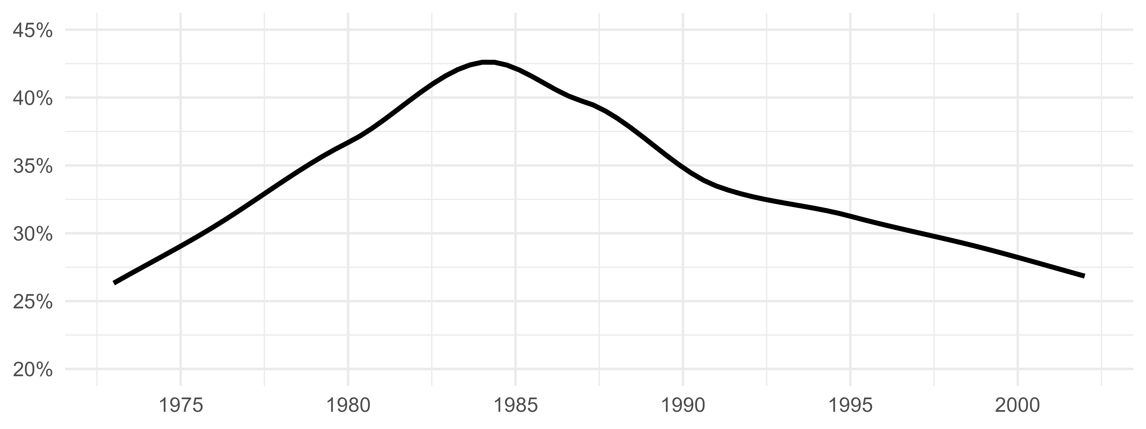

Figure 1.1: Share of articles with at least one macroeconomics JEL code

# 2 The Creation of the EER

## 2.1 The Birth of a European Project

In 1969, Jean Waelbroeck and Herbert Glejser, both from the *Université Libre de Bruxelles* (ULB), launched the *European Economic Review*. The new review was planned to be the official journal of the European Scientific Association of Applied Economics (ASEPELT), which had been created in 1961 by Waelbroeck and another ULB economist: Etienne Kirschen. Before 1969, this association published in English a bulletin gathering research in econometrics and mathematical economics (Waelbroeck and Glejser, 1969, p. 4). The EER took up this torch by publishing the same type of research. Articles had to be published in English, the new “*lingua franca* of economics” triggering the process of “internationalisation of our science” as Waelbroeck and Glejser polemically stated in the introduction of the first issue (*ibid.*).

The birth of such a project in Belgium is far from coincidental as the country exhibited a high effervescence regarding the internationalisation of the discipline. In 1966, Jacques Drèze had established the Center for Operations Research and Econometrics (CORE) at the *Katholieke Universiteit Leuven* (before its split), drawing inspiration from the Cowles Commission and the Carnegie Institute of Technology, which Drèze had visited in the 1950s (Düppe, 2017).[11] CORE developed a research program around macroeconomic modelling and general equilibrium theory, and quickly stimulated the establishment of a European research network of economists, notably through its large visiting programme (Düppe, 2017; Maes and Buyst, 2005). Encouraged by Waelbroeck, the ULB department of economics joined CORE in its first years of existence (Maes and Buyst, 2005, p. 79).

From its inception, the EER was designed as a European initiative, as evident from the composition of the editorial board (Table 2.1). However, as a Belgian-centred initiative, Belgian institutions represented one fifth of authors’ affiliations in EER articles during the initial years (Table 2.2).[12] Nonetheless, the geographical diversity of EER authorship expanded significantly during the 1970s. A comparison of authors’ affiliations data from *The Economic Journal* and *Economica*, as calculated in Backhouse (1997, fig. 7 and 8), reveals that European countries, excluding the UK, were better represented in the EER.[13]

Table 2.1: Share of countries in EER editorial boards (Top 10)

| 1969-1975 | 1976-1982 | 1983-1989 | 1990-1996 | 1998-2002 |
| --- | --- | --- | --- | --- |
| FRANCE (19.01%) | FRANCE (21.81%) | FRANCE (21.16%) | UK (19.49%) | USA (15.71%) |
| UK (12.4%) | BELGIUM (14.36%) | BELGIUM (14.11%) | FRANCE (17.8%) | FRANCE (14.29%) |
| GERMANY (11.16%) | ITALY (9.31%) | ITALY (9.96%) | NETHERLANDS (9.32%) | UK (10%) |
| SWITZERLAND (10.33%) | UK (9.04%) | UK (8.71%) | USA (7.63%) | GERMANY (10%) |
| BELGIUM (9.92%) | GERMANY (6.65%) | GERMANY (7.47%) | GERMANY (6.78%) | ITALY (7.14%) |
| NETHERLANDS (8.68%) | NETHERLANDS (6.12%) | NETHERLANDS (5.39%) | ITALY (5.93%) | NETHERLANDS (7.14%) |
| ITALY (7.85%) | SPAIN (5.05%) | SWEDEN (4.98%) | SPAIN (5.93%) | NORWAY (5.71%) |
| HUNGARY (4.96%) | SWITZERLAND (4.79%) | NORWAY (4.56%) | SWEDEN (5.51%) | SPAIN (5.71%) |
| LUXEMBURG (2.48%) | HUNGARY (4.26%) | SWITZERLAND (4.15%) | NORWAY (4.66%) | ISRAEL (5.71%) |
| IRELAND (2.48%) | AUSTRIA (4.26%) | SPAIN (4.15%) | BELGIUM (4.24%) | SWEDEN (5.71%) |

Table 2.2: Share of countries of authors' affiliations in EER publications (Top 10)

| 1969-1975 | 1976-1982 | 1983-1989 | 1990-1996 | 1997-2002 |
| --- | --- | --- | --- | --- |
| USA (24%) | USA (29.86%) | USA (28.33%) | USA (26.63%) | USA (24.25%) |
| BELGIUM (19.2%) | UK (16.06%) | UK (16.73%) | UK (21.54%) | UK (23.14%) |
| NETHERLANDS (11.2%) | BELGIUM (9.3%) | FRANCE (7.91%) | FRANCE (10.16%) | FRANCE (8.34%) |
| UK (8%) | ISRAEL (7.04%) | BELGIUM (7.25%) | BELGIUM (5.49%) | GERMANY (5.23%) |
| FRANCE (6.4%) | NETHERLANDS (6.48%) | GERMANY (5.4%) | GERMANY (5.49%) | ITALY (5.12%) |
| SWEDEN (4.8%) | FRANCE (5.92%) | NETHERLANDS (4.35%) | CANADA (4.17%) | BELGIUM (4.67%) |
| GREECE (4.8%) | CANADA (5.35%) | ISRAEL (4.22%) | NETHERLANDS (3.76%) | SPAIN (3.89%) |
| NORWAY (4%) | GERMANY (4.79%) | CANADA (4.08%) | ITALY (3.76%) | NETHERLANDS (3.67%) |
| HUNGARY (3.2%) | GREECE (2.25%) | SWEDEN (3.43%) | SWITZERLAND (3.25%) | SWEDEN (3.67%) |
| ISRAEL (3.2%) | AUSTRALIA (1.97%) | ITALY (2.5%) | SPAIN (2.74%) | SWITZERLAND (3.34%) |

The EER was one of these crucial initiatives that contributed to a Europeanisation of economics and the development of intellectual exchanges between European-based economists (Goutsmedt et al., 2021). The centrality of the journal was strengthened in 1984 when the European Economic Association was created, and the EER was established as the official journal of the new association.

## 2.2 A Rising European Journal

Besides offering a common platform for European economists, the journal initial goal was also to encourage the promotion of a US-style approach to economics. An important dimension of the journal’s evolution was thus the rising participation of US-based economists. The “International Seminar on Macroeconomics,” (ISoM) co-organized by the French *Ecole des Hautes Etudes en Sciences Sociales* and the US National Bureau of Economic Research, played a key role in that integration of US economists, as the conference papers were published each year in a special issue (Goutsmedt et al., 2021). The ISoM also contributed to the journal’s major focus on macroeconomics in the 1980s (Figure 1.1).

During the 1970s and early 1980s, the share of US-based authors publishing in the journal grew steadily (Table 2.2). The rising involvement of US economists in the EER signified not just an increase in articles published by US-based authors, but also a rise in collaborations between US and European economists (Figure 2.1). While there were no collaborations in the journal’s inaugural year, by 1980, 10 percent of the published articles featured joint writing between authors from US and European institutions. In parallel, Europeanisation was taking hold through the development of intra-European collaborations: by the end of the 1990s, one fifth of the articles published by European authors brought together economists based in different European countries.[14]

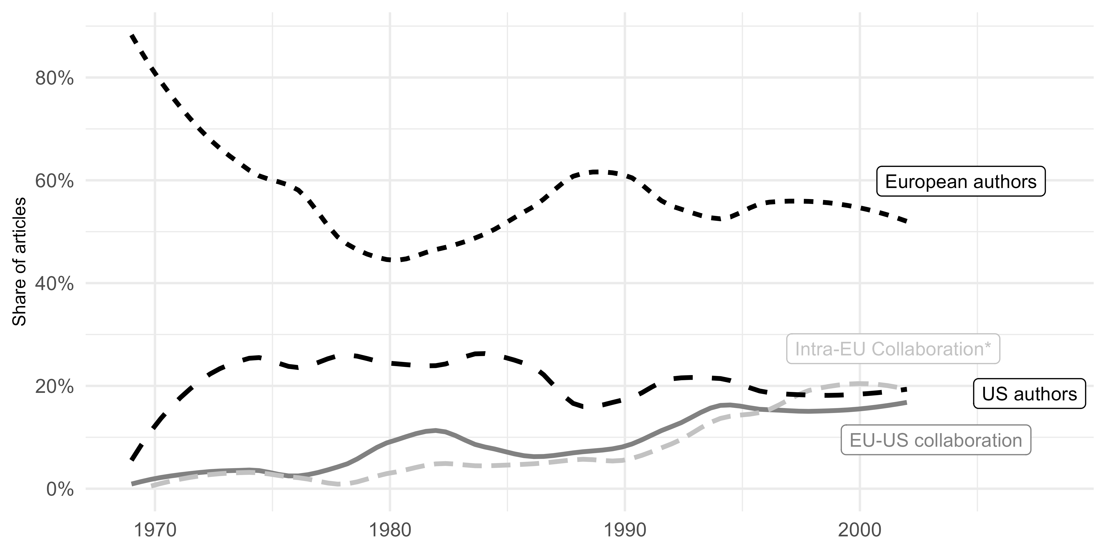

Figure 2.1: Patterns of collaboration between countries in the EER (smoothed using local polynomial regression)

In the mid-1980s, the journal thus emerged as a symbol of a more integrated European economics, taking inspiration from the US standards and enticing numerous US economists to contribute. Also, its intellectual impact has seemingly broadened: the journal ascended as a pre-eminent publication in macroeconomics, gradually surpassing other prominent European journals regarding bibliographic citations (Figure 2.2).[15]

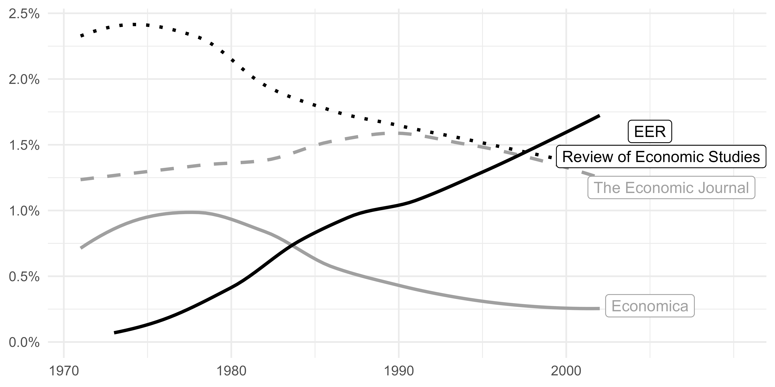

Figure 2.2: Share of citations from macroeconomics articles to the EER and other main European journals (smoothed using local polynomial regression)

The question that remains is whether this process of internationalisation resulted in the complete standardisation of European macroeconomics based on the US model, or if it allowed for the cultivation and persistence of distinctly European specialities.

# 3 Methods for Identifying European Specialities

To identify European specialities, we compare macroeconomics articles published in the EER and in the Top 5 journals (*American Economic Review*, *Journal of Political Economy*, *Econometrica*, *Quarterly Journal of Economics*, *Review of Economic Studies*). Choosing a list of journals for a comparison is always, to a certain extent, arbitrary. However, choosing the Top 5 journals offers certain benefits. First, even though these journals may not have consistently been regarded as the “Top 5” over our entire investigation period, they have maintained their status as major economic journals, where prominent macroeconomists used to publish. Consequently, macroeconomic papers published in these journals are more likely to represent a “mainstream” in macroeconomics, widely accepted and disseminated.[16] Second, these 5 journals are diverse enough to accommodate a broad range of macroeconomic articles, such as highly theoretical or empirical pieces. In sum, the Top 5 journals serve as a stable reference point between 1969 and 2002 to draw comparisons with the EER, facilitating a deeper understanding of EER publications’ main characteristics.[17] Moreover, the EER was founded with the intention of establishing an elite, leading journal for the European community that would mimic the standards of the leading US journals. Therefore, the Top 5 seems a suitable benchmark for comparison with the EER.[18]

We identify macroeconomics articles by using the former and new JEL classifications (JEL, 1991).[19] In addition to data on JEL codes, we have employed three distinct databases to collect various types of information: outside of basic metadata (year of publication, title, authors, *etc.*), we have collected bibliographic references of EER and Top 5 articles, abstracts, and authors’ affiliations.[20] Then, we conduct two types of analysis to identify European specialities: bibliographic coupling and topic modelling.

## 3.1 Bibliographic Coupling

Bibliographic coupling connects articles together depending on the bibliographic references they share. We build different relational networks using EER and Top 5 articles (the nodes of the network), connected by weighted links (the edges of the network), depending on the number of references shared between two articles.[21] To closely examine the evolution of macroeconomic content, we build networks using a moving eight-year window (based on the publication year of the articles). We thus have 23 networks from the 1973-1980 period, through 1974-1981, 1975-1982, and so on, up to 1995-2002. For each network, we employ the Leiden algorithm (Traag et al., 2019) to identify bibliographic clusters, i.e. groups of articles sharing numerous significant references with other articles of their cluster, and fewer with articles outside their cluster. Articles within the same cluster are more likely to share cognitive content (e.g., sharing objects of study, methods, results or theory) even if disagreeing (Claveau and Gingras, 2016; Goutsmedt, 2021; Truc et al., 2021). Finally, we look at the similarity of the clusters two by two for successive networks (i.e. networks of successive time windows), and merge clusters from different networks together when they are sufficiently close.[22]

This process allows us to obtain intertemporal clusters. Academic articles predominantly cite references published in recent years. Building a network spanning the entire period (1973-2002) would likely lead to group articles based on their publication date rather than shared cognitive content. By employing short time windows and then by merging clusters from networks of different time windows, we circumvent this problem and can identify clusters spanning longer periods of time, thus allowing for a comprehensive historical analysis. We identify a total of 154 intertemporal clusters but we confine our investigation to the 33 most prominent clusters, i.e. those that are *(i)* present in at least 2 networks (i.e. 2 successive time windows) and *(ii)* represent more than 4 percent of the nodes of at least one of the network they belong.

A range of indicators helps us to discern the content of these intertemporal clusters—e.g. the words used in abstracts and titles, recurring authors, the most important nodes or the most cited references.[23] These indicators informed our labelling of the clusters.

Subsequently, for each intertemporal cluster, we determine the US or European orientation of its publications (the nodes) and authors. We assess the over/under representation of Europe- and US-based authors in the cluster and the over/under representation of the EER and top 5 journals, using a log of ratios.[24] These two measures inform us on which are the most ‘European’ clusters, meaning those where relatively more articles are published in the EER and by Europe-based economists.[25] Regarding European and US authors, for each time window, we compute the *(i)* share of articles written by Europe-based authors and US-based authors in each cluster, and *(ii)* the overall share of Europe-based and US-based authors. Then, for each cluster, we average its relative shares per time window across all the time windows in which the cluster exists:

We then use a second similar index for the publication venue of the articles in the cluster:

Figure 3.1 displays the position of each cluster relatively to these two measures on a two-dimensional graph with the X-axis for the log of ratios of Europe-based and US-based authors, and the Y-Axis for the log of ratios of Top 5 and EER. The size of the points captures the number of articles in the cluster.[26]

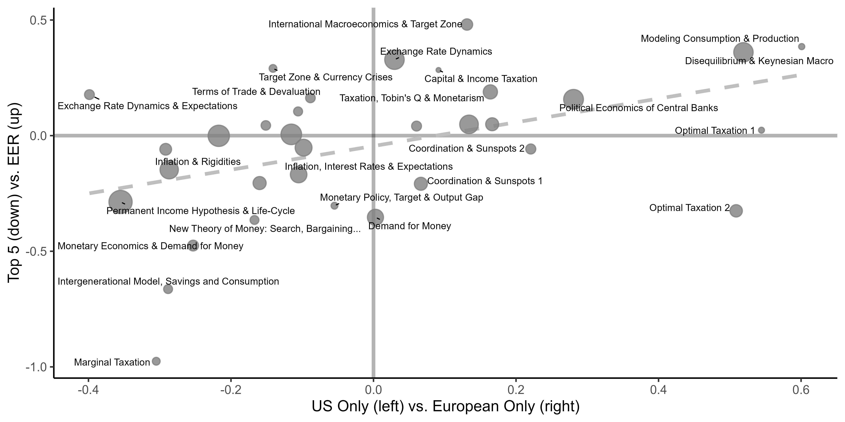

Figure 3.1: The most European clusters

## 3.2 Topic Modelling

We apply topic modelling to our corpus, which is constituted of all the titles and abstracts (when available) of the macroeconomic articles published in the EER and Top 5. As a first step, we extract (or ‘tokenise’) “ngrams”: unique words (or unigrams), bigrams and trigrams. We exclude stop words and other uninformative words and ‘lemmatise’ remaining ngrams.[27] Topic modelling is an unsupervised machine learning method that identifies patterns and themes in the corpus by clustering similar words and phrases into “topics”. Specifically, for each topic, the method returns a set of probabilities for an ngram to be used in the topic. The *ngrams* with the highest for a topic allows us to understand what the topic is about. Second, for each document in the corpus (i.e. each article’s title and abstract), the method returns a set of probabilities for each topic to be mentioned in the document. The topics with the highest for a document allows us to understand what the document is talking about. To estimate our topic model, we use a variant of the Latent Dirichlet Allocation model called the Correlated Topic Model (Blei and Lafferty, 2007). The number of topics *k* is chosen after evaluating different models quantitatively and qualitatively. We choose to run the model with 50 topics, which allows us to better capture the diversity of topics discussed in the corpus.[28]

Table 6.1 lists all the topics identified with their most representative words and expressions.[29] We also use a set of indicators, like the most representative abstracts or the most cited references per topic (crossed with the journal and affiliation variables), to get a better picture of what the topics are and what are their European and non-European dimensions.[30]

Similarly to bibliometric coupling, we are interested in the topics characteristics regarding the publications (EER *vs.* Top 5) and the countries of affiliations of the authors (the US *vs.* European countries). For each topic, we only keep the articles that are the most associated to the topic, with . We then assess the over/under representation of EER articles for each topic, by calculating the log odds ratio in comparison to top 5 articles:

with the number of EER articles in the topic and the total number of articles in the topic. We perform the same calculation for articles written exclusively by Europe-based authors or US-based authors. The two log odds ratios are plotted in a two-dimensional graph (Figure 3.2) to observe which topics are over-represented in the EER and more frequently mentioned by Europe-based authors.[31]

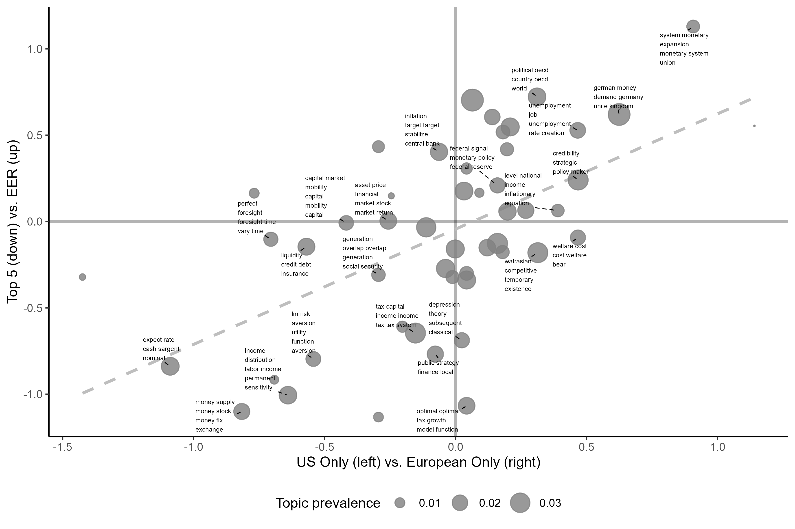

Figure 3.2: The most European topics

The combination of two distinct unsupervised methods enables us to systematically identify potential European specialities.[32] Figures 3.1 and 3.2 provide a synthetic visualisation of our results: the upper right portion of both graphs showcases the topics and clusters that gather articles with both an over-representation of EER article compared to the Top 5 and an over-representation of Europe-based authors compared to US-based authors. The in-depth qualitative analysis of clusters and topics then provide a comprehensive overview of the various issues, methods and theoretical questions investigated by European macroeconomists, in comparison to US macroeconomics. For each cluster and topic, we observe the most influential EER articles, as well as the most cited references by EER articles and Europe-based authors. This allows us to comprehend what is published in the EER and to connect these publications to broader lines of research (and thus to articles by Europe-based authors published in other journals).

In the final two sections, we delve into these more “European” clusters and topics to understand the evolving characteristics of European macroeconomics. The corresponding data has been systematically analysed to build our historical narrative. From this investigation, we identify two main periods: the 1970s to mid-1980s; the mid-1980s to late 1990s).

# 4 The 1970s to Mid-1980s: A Gradual Europeanisation in Opposition to US Macroeconomics

In contrast to the literature in the history of macroeconomics, which emphasizes the transformations of macroeconomics in response to debates on microfoundations and the emergence of new classical economics, European macroeconomics took a distinct path. European macroeconomists remained distant from many of the theoretical debates triggered by microfoundations, including those concerning the rational expectations and the Phillips curve, the demand for money, or the consumption function. Instead, they focused on more empirical studies, but also developed their own microfoundational program through the disequilibrium theory.

## 4.1 Opposition to New Trends in US Macroeconomics

The analysis of topics and clusters allows us to understand first what European macroeconomics *was not* in this period. Several literatures seem to be ignored by the Europeans in the EER. That is the case of the debates around the life-cycle and permanent income hypotheses, influenced by Milton Friedman (1957) and Robert Hall (1978).[33]

Other more US-oriented areas dealt with *(i)* the demand for money—for which William Baumol (1952) and Friedman and Schwartz (1963) were central references—as well as *(ii)* the “new classical monetary theory” (Hoover, 1988, chap. 6) of the 1970s inspired by Sargent’s, John Bryant’s and Neil Wallace’s works (Bryant and Wallace, 1979; Sargent and Wallace, 1982).[34] Hoover (1988, p. 111) offers a good summary of the new classical monetary theory as the research for “microfoundations for the theory of money consistent with general equilibrium and individual optimization” promoted by new classical economists (Lucas, Sargent, Barro, Finn Kydland, Edward Prescott, etc.).

More generally, the works of new classical economists that contributed to reshaping macroeconomics in the late 1970s and early 1980s and that are so central in many histories of macroeconomics (De Vroey, 2016; Snowdon and Vane, 2005), were less influential in Europe at the time. The articles of Lucas (1973; 1972), Sargent and Wallace (1975) or Barro (1976) were constantly under-cited in our corpus by Europe-based macroeconomists in comparison to US economists in the 1970s and 1980s (Figure 4.1).[35] This aligns with the observation that during the late 1970s and early 1980s European macroeconomists favoured an alternative “microfoundational programme” (Hoover, 2012), namely, disequilibrium theory (see Section 4.3).

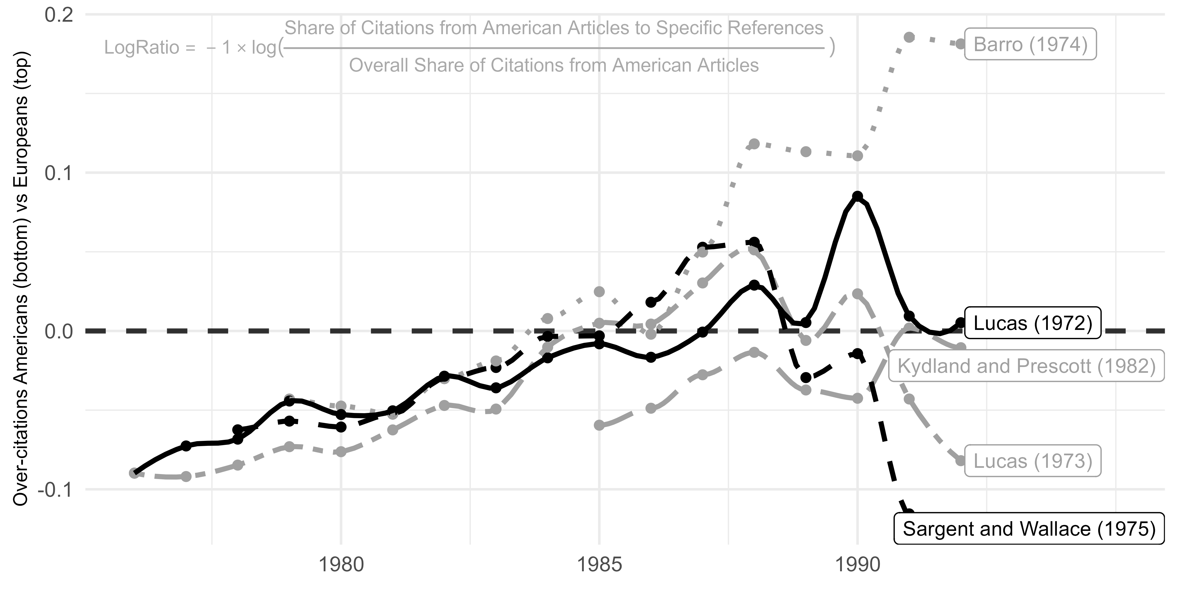

Figure 4.1: Citation of new classical works by Europe-based economists relatively to US-based economists. Log of ratios on EER articles by Europe-based and US-based authors computed on 7-year moving average (the year displayed is the median year of the time window).

The rejection of new theoretical research, originating from the US and in line with the search for microfoundations, may also be related to the fact that European macroeconomics, as represented in the EER, tended to be more oriented towards applied and empirical contributions.

## 4.2 The Importance of Applied and Empirical Works

It is challenging to identify major trends in Europeans publications in the EER during its initial years, as well as to observe any convergence among European macroeconomists. Indeed, fewer papers were published in the first issues and the editorial line may have experiences fluctuations during this period. However, one characteristic does stand out: the inclination to publish applied and empirical works. For instance, in the 1970s issues, we find contributions providing empirical analyses of Dutch pensions funds, UK income distribution, Belgium wage variations, and using principal components analysis, building indicators of capacity utilization or larger macroeconometric models (see Table 6.3).

As an emerging journal in the mid-1970s, the EER was less likely to attract highly influential contributions compared to more established journals. However, some of the early contributions still connected with two significant lines of research that had already gained prominence and influenced these contributions in the EER. [36] These two lines of research were at the juncture of econometrics and macroeconomics.

The first one, known as the “LSE approach” of econometrics, was led by David Hendry, and involved James Davidson, Grayham Mizon and Neil Ericsson among others (Qin, 2013, chap. 4). A major goal of the LSE approach and of Hendry was to secure connections between the Cowles Commission structural approach of econometrics and the Box-Jenkins time-series approach. The LSE approach placed significant emphasis on the search for the appropriate model specification in order to design the best representation of the true “data generation process”.

A significant portion of the LSE approach was dedicated to the modelling of consumption. Davidson and Hendry, along with two co-authors, tackled consumption modelling by inspecting the existing “plethora of substantially different quarterly regression equations” and criticised the “proliferation of non-tested models” (Davidson et al., 1978, pp. 661–662). They elaborated on the key principles of the LSE approach, notably showcasing the use of error-correction (Qin, 2013, pp. 63–64). During the third edition of the ISoM, published in EER in 1981, they revisited the chosen equations of Davidson et al. (1978) to test the integration of the permanent income/life cycle hypothesis in Hall’s -Hall (1978) formulation (Davidson and Hendry, 1981).

British econometric research on demand and consumption was not confined to the LSE. Angus Deaton’s and John Muellbauer’s contributions also appear to have played a significant role in shaping research published in the EER. They addressed the aggregation issue and the limitations of a “representative consumer” (see Cherrier et al., 2023, this issue). In 1980, in the *American Economic Review*, they introduced a new system of demand equations, the “Almost Ideal Demand System” (Deaton and Muellbauer, 1980). The AIDS model aimed to model the intricate relationship between consumer demand, relative prices, and income in a more robust and comprehensive manner. They claimed that AIDS was a superior alternative to competing models such as the translog model, or the Rotterdam model developed by Henri Theil and Anton Barten.

Research around the Rotterdam model constituted a second research program that was central in the 1970s for European contributions published in the EER. Theil had been appointed Professor of Econometrics at the Netherlands School of Economics in Rotterdam in 1953, succeeding Jan Tinbergen (Kloek, 2001). In 1966, he moved to Chicago, a year after publishing “The Information Approach to Demand Analysis” (Theil, 1965), an essential pillar of the Rotterdam model, modelling the role played by marginal budget shares (Clements and Gao, 2015). Another essential contribution was the one of Barten (1964), Theil’s Ph.D. student in Rotterdam (Leuven, 2016).

Barten was recruited by KU Leuven in 1966 to join the newly-established CORE. His most cited paper was the very first article published in the EER (Barten, 1969), where Barten developed a new estimation procedure for a system of demand equations. The article garnered significant attention in the early years of the EER.[37] The Rotterdam model recurrently appeared in EER publications, somewhat culminating in 1984 when two synthesis articles were devoted to it (Barnett, 1984; Byron, 1984).

These two lines of research (the LSE approach and the Rotterdam model) as well as the contributions of researchers gravitating around them, appear as distinct and original compared to developments in macroeconomics occurring on the other side of the Atlantic.[38] Nonetheless, we cannot consider these research lines as properly European specialities. Indeed, they remained predominantly anchored at the national level with limited cross-border collaborations (like between Belgium and the Netherlands for the Rotterdam model). They had not yet contributed to a true process of Europeanisation.[39]

The LSE approach and Hendry had a delayed impact on the development of European specialities. The cointegration concept (Engle and Granger, 1987) had some roots in the LSE approach and in Clive Granger’s and Robert Engle’s discussion with Hendry (Diebold, 2003, pp. 1173–1174; Qin, 2013, p. 68). Both the LSE approach and Granger and Engle’s contributions, as well as the work of University of Copenhagen econometrician, Søren Johansen (Johansen, 1988), would deeply influence research published by European macroeconomists in the EER after the mid-1980s.[40] Many European macroeconomists in the 1990s engaged in empirical research on business cycles, detrending methods and shock identifications. Key figures in this area included the German Horst Entorf, the Italians Marco Lippi and Lucrezia Reichlin, the Spanish Juan José Dolado, or the LSE economist Dany Quah.[41]

However, before this period, the true European speciality and most unifying line of research from the 1970s to the mid-1980s was the disequilibrium theory.

## 4.3 Disequilibrium Theory as a Landmark for European Macroeconomics

Research around the disequilibrium theory represents a significant yet often overlooked milestone in the history of macroeconomics (Backhouse and Boianovsky, 2013; Plassard et al., 2021; Plassard and Renault, 2023, this issue). It played a crucial role in the 1970s in rekindling interest in the research on appropriate microfoundations for macroeconomics.[42] Rooted in the tradition of the general equilibrium theory and influenced by the work of Don Patinkin, Robert Clower and Axel Leijonhufvud, disequilibrium theory investigated the effects of non-walrasian price-setting (i.e. without *tâtonnement*), fixed-price and quantity rationing on macroeconomic outcomes. This approach provided an alternative to the new classical contributions and the Lucas and Sargent’s “representative-agent microfoundational program” (Hoover, 2012), which many proponents of disequilibrium research explicitly rejected (Renault, 2020). Although Barro and Grossman’s (1971) article helped popularising disequilibrium macroeconomics, this research line was deeply anchored in France and Belgium, and it continued to expand throughout the 1970s and 1980s (Plassard and Renault, 2023, this issue).

Bibliometric analysis reveals that the “Disequilibrium and Keynesian economics” cluster constituted the most significant cluster closely associated with the EER and fostered by Europe-based economists. This cluster also encompasses other “alternative research lines” to Lucas and Sargent’s research program (De Vroey, 2016, chap. 14), such as Costas Azariadis’s (1975) implicit contract model, Oliver Hart’s (1982) imperfect competition model or Peter Diamond’s (1982) search model. This testifies that in the late 1970s and in the 1980s, connections existed between US and European macroeconomists regarding the renewal of theoretical macroeconomics and the search for microfoundations, as well as the opposition to new classical macroeconomics. [43]

First of all, part of the literature “arose out of the internal problems within general equilibrium theory” (Backhouse and Boianovsky, 2013, p. 105), notably the need to break with *tâtonnement* and to build general equilibrium model with agents setting prices in the model. Disequilibrium macroeconomics thus contributed to the persistence of a lively research program centred on general equilibrium theory issues.[44] Moreover, disequilibrium macroeconomics also emerged as a pivotal framework for accounting for the 1970s European stagflation (Plassard and Renault, 2023, sec. 5, this issue). Edmond Malinvaud’s *Theory of Unemployment Reconsidered* (1977) marked a decisive development in this direction by opposing “Keynesian unemployment”, which resulted from excess supply in both goods and labour markets, and “classical unemployment”, caused by excess demand for goods but excess supply in the labour market—implying excessively high real wages.[45] The 1973 oil shock and the concurrent decline in productivity would explain the rise of a classical unemployment in the 1970s. Consequently, the primary concern for proponents of the three-regime approach became determining the extent to which European unemployment could be attributed to either Keynesian or classical unemployment.

This framework for understanding unemployment and stagflation was featured, discussed, or at least mentioned in numerous influential works in European macroeconomics in the 1980s.[46] In the EER, Jacques Drèze and Franco Modigliani examined the “current state of underemployment in Belgium” by analysing the trade off between real wages and employment in the context of a small open economy (Drèze and Modigliani, 1981, p. 2). They combined the possibility of classical unemployment, inspired by Malinvaud (1977), with Modigliani and Tommaso Padoa-Schioppa’s argument that, “in an open economy, external balance implies a constraining relationship between the levels of real wages and employment” (*ibid.*). In the early 1980s, Malinvaud’s framework was also connected to the recurring EER debate surrounding the “wage gap”. Question was to determine whether real wages were too high (indicating a positive wage gap). Michael Bruno and Jeffrey Sachs were central figures in this debate and explicitly relied on Malinvaud’s framework.

Outside of unemployment and stagflation, disequilibrium theory was also extended to other macroeconomic issues. For instance, Avinash Dixit, when at University of Warwick, extended Clower’s (1965) dual decision hypothesis and Malinvaud’s framework to international trade theory (Dixit, 1978, p. 393; see also Plassard and Renault, 2023, sec. 4, this issue). According to Dixit, this provided the foundation for a “more satisfactory model of the balance of trade” than Jacob Frenkel and Harry Johnson’s (1976) monetary approach, which “assumes instantaneous attainment of Walrasian equilibrium in commodity and labour markets” (Dixit, 1978, p. 393). Dixit’s model would later form the basis for parts of his joint book with Victor Norman, from the Norwegian School of Economics and Business Administration, on the *Theory of International Trade* (Dixit and Norman, 1980). The book represented a pivotal reference for European economists working on international trade.[47]

This centrality of disequilibrium macroeconomics in European macroeconomics is further evidenced by the need for European macroeconomists to establish their positions in relation to it, especially in the context of the Keynesian versus classical unemployment framework. In May 1985, a conference on European unemployment was convened in Sussex, and the proceedings were subsequently published in *Economica*.[48] Macroeconomists from different countries presented their analyses of national unemployment rates in Europe. Sneessens and Drèze estimated a “two-market macroeconomic rationing (or disequilibirum) model of the economy” (Sneessens and Drèze, 1986, p. S97), while Malinvaud (1986) offered a more descriptive analysis to explain the rise of unemployment in France, although he acknowledged proximities with Sneessens and Drèze’s formalisation. Malinvaud discussed determinants of “the classical component of unemployment” (Malinvaud, 1986, p. S216), but also criticised the use of Phillips curve with a non-accelerating inflation rate of unemployment (NAIRU) to account for the causes of unemployment. In contrast, NAIRU was central to the model proposed by Layard and Nickell to discuss British unemployment. Besides, they argued that the “labour demand function that [they] use cuts through the fruitless debate now raging (especially in Europe) as to whether current unemployment is ‘classical’ or ‘Keynesian’” (Layard and Nickell, 1986, p. S121).

While not completely consensual, disequilibrium theory and the classical/Keynesian unemployment distinction were unavoidable in the mid-1980s. They shaped the treatment of various macroeconomic issues such as international trade, inflation, unemployment, wage-setting, and spurred new theoretical developments, refinements of existing models, as well as econometric innovations (Renault, 2022b). Furthermore, this line of research was embraced by macroeconomists across various European countries and fostered transnational collaborations. In line with the broader disregard or rejection of new trends in US macroeconomics by many Europe-based macroeconomists (Section 4.1), disequilibrium macroeconomics brought forward an alternative theoretical framework to new classical macroeconomics that was emerging in the US during the same period.

# 5 The Mid-1980s to the Late 1990s: Remaining Specialities despite Theoretical Convergence

The relationship of European macroeconomics with its US counterpart, as well as its connection to new classical economics, gradually transformed after the mid-1980s. This shift was likely due to the dwindling dynamism of research surrounding disequilibrium theory. In the late 1980s, disequilibrium theory had lost its ability to build bridges between European macroeconomists and no longer served as a unifying theoretical language. Instead, what brought European macroeconomists together in the 1990s was not a common theoretical framework, but rather distinctly European matters (such as high unemployment or European integration), as well as a new approach to address many macroeconomic issues: political economy. This later trend served as the belated entry point for new classical economics to eventually influence European macroeconomics, and this was achieved not through Lucas and Sargent’s works, or through the Real Business Cycles models, but through the “time consistency” literature based on the contributions of Kydland, Prescott and Barro.

## 5.1 The Fall of Disequilibrium

After the mid-1980s, publications about disequilibrium continued to pop out occasionally in the EER. However, in quantitative terms, we observe a decrease of disequilibrium importance both through the bibliometric and topic modelling analyses. [49] The examination of topic 25 on real wages and employment also provides valuable insights: while Malinvaud (1977) was a major reference for the older articles of the topic, it gradually faded away from the bibliography of most recent works. Part of the research program on disequilibrium seems to have persisted in the 1990s particularly through its most theoretical aspects, and established closer connections with the literature on coordination and sunspots.[50]

The decline of the disequilibrium program can also be observed in the diminishing prominence of the Keynesian/classical unemployment distinction. For instance, we observe that when using the insider-outsider opposition to discuss European unemployment in 1987, Nils Gottfries and Henrik Horn still referred to the Keynesian/classical opposition and argued in their paper that “the present unemployment may originally have arisen for Keynesian reasons, but once unemployment is created it will change the conditions under which wages are formed, thus persisting in a classical form” (Gottfries and Horn, 1987, p. 2). Similarly, Assar Lindbeck and Denis Snower cited Malinvaud (1977) and the “boundary between the ‘Keynesian’ and ‘Classical’ regimes” (Lindbeck and Snower, 1987, p. 408). This reference to Malinvaud’s framework disappear in the following years in similar works (as in Gottfries, 1992, for instance). More generally, the reference to the classical versus Keynesian unemployment was most of the time missing in the large literature that developed after the mid-1980s to understand the problem of high unemployment in Europe.

## 5.2 New Approaches to Explain European Unemployment

After the mid-1980s, unemployment became a significant area of research for European macroeconomists and the EER published multitude of articles on the subject.[51] Following the stagflation and the subsequent disinflation of the early 1980s, unemployment rose to rare quasi unprecedented levels in European countries. However, unlike the US where unemployment eventually returned to levels comparable to those of the early 1970s, European unemployment remained high even after inflation stabilised. This macroeconomic situation was coined the “Eurosclerosis”, presenting a new puzzle for macroeconomists to solve.

The Eurosclerosis puzzle was the starting point for numerous contributions by Europe-based economists. It fostered the Europeanisation of macroeconomics by encouraging comparisons between European countries in order to identify common features that would explain European high unemployment. This process was facilitated notably through the organisation of conferences and special issues, like the May 1985 conference in Sussex, published in *Economica* the next year (Backhouse et al., 2023, this issue). Macroeconomists also proposed empirical studies using data from various OECD countries to understand the peculiarities of the European context. These collaborative efforts and comparative analyses contributed to the development of a more unified European macroeconomic research community.

Such comparison of OECD countries were developed in Bruno and Sachs’ (1985) book, *Economics of Worldwide Stagflation*, which analysed the differences in terms of nominal and real wage rigidities between the US and Europe. They argued that the higher unemployment cost of stagflation in Europe was the result of larger real rigidities. Bruno and Sachs’s approach to the unemployment issue, developed in a series of articles since 1979 and culminating in their book, constituted an influential resource for European economists during the 1980s (see also Goutsmedt et al., 2021, sec. 3).

Their work constituted a point of departure for another important line of research developed by LSE economists Richard Layard, Richard Jackman, Stephen Nickell, and their various co-authors. In a conference held in Cambridge in July 1981, Grubb et al. (1982) proposed an explanation of the “Causes of the Current Stagflation” through a comparison of 19 OECD countries (see also Backhouse et al., 2023, this issue). They argued that high real wages in Europe were “a consequence rather than a prime cause of the difficulty” (Grubb et al., 1982, p. 707). High real wages were the symptom of a rise in the NAIRU, caused by an increase in the relative prices of raw materials and a sharp fall in the rate of productivity growth. Grubb, Jackman and Layard pursued this analysis of real and nominal rigidities in OECD countries the next year during the ISoM in Mannheim, in a paper later published in the EER (Grubb et al., 1983). Over the course of a decade, the LSE team produced a series of articles exploring various specifications and estimations of European unemployment determinants. This research culminated in 1991 with Layard, Nickell and Jackman’s book, *Unemployment: Macroeconomic Performance and the Labour Market* (Layard et al., 1991). The book provided an extensive analysis of unemployment in the OECD, relying on a theoretical framework of inflation dynamics and wage bargaining. Three years later, Charles Bean, also at the LSE and who had collaborated with Layard and Nickell on several occasions, published two surveys in the *Journal of Economic Literature* and the EER about the treatment of European unemployment (Bean, 1994a, 1994b).

Beyond comparing macroeconomic data of different European countries, European macroeconomists began also to focus on institutional comparisons to better understand the differences in wage bargaining organisation, labour market regulations and other factors across European countries. In this regard, Lars Calmfors (University of Stockholm) and John Driffil’s (University of Southampton) analysis of European countries’ corporatism constituted a key study cited in many EER articles (Calmfors and Driffill, 1988). They estimated the impact on wages and unemployment of various measures of corporatism provided by economists or political scientists. Calmfors and Driffil argued that countries with low centralisation of wage bargaining (like the US) and high centralisation (the Nordic Countries) performed better in terms of employment than those with medium centralisation (most countries of the European Community at the time).

Another institutional approach that gained popularity in Europe was the insider-outsider perspective. The approach was crafted by Nils Gottfries, Henrik Horn, Assar Lindbeck (all from the University of Stockholm), in collaboration with Denis Snower from Birkbeck College (Gottfries, 1992; Gottfries and Horn, 1987; Lindbeck and Snower, 1987, 1986). The insider-outsider literature posited that insiders (the employed or unionised workers) have the upper-hand in wage-setting. Employment being determined in function of wages, higher wages could maintain outsiders away from the labour market. In the context of post-stagflation Europe, this means that an increase in labour demand might result in rising wages without a corresponding increase in employment.

The interest in explaining high European unemployment extended beyond the contributions of UK and Swedish macroeconomists. Another influential research path was developed by the Spanish Samuel Bentolila and the French Gilles Saint-Paul (EHESS), in collaboration with Giuseppe Bertola from Princeton. They produced a series of articles examining the role of job security and firing costs in the stock of unemployment and its variation (Bentolila and Bertola, 1990; Bentolila and Saint-Paul, 1992; Bertola, 1990).

All these lines of research were central for European macroeconomists publishing in the EER, as well as they constituted a true specificity in comparison to the US. They spread across European countries and fostered transnational collaborations, even if the UK emerged as a more dynamic producer of contributions on European unemployment. Another influential approach, also partly centred in the UK and the LSE, was stemming from search and matching models, developed by Dale Mortensen from Northwestern University and Christopher Pissarides from the LSE (Mortensen and Pissarides, 1994). Mortensen and Pissarides’ theoretical framework made a significant impact on shaping the research agenda in Europe, whether on job flows, firing costs, skills and geographical mismatching. However, this approach also found resonance among US macroeconomists and Top 5 journals, and so does not exclusively belong to European macroeconomics.

## 5.3 A New Unifying Language: Political Economy

European macroeconomists’ research in the 1980s and 1990s was largely shaped by pressing macroeconomic issues of the period, such as European high rates of unemployment or the challenges presented by the European integration (fiscal convergence, monetary union, etc.). Beyond examining these specific objects, many European macroeconomists also adopted a specific perspective on these problems by utilising a political economy framework.

Political economy, which encompasses various research lines that emerged in the 1970s, can be understood as the application of modern economic analysis techniques (such as optimisation or game theory) to examine the impact of politics on economics.[52] As Allan Drazen defined it in his 2000 handbook, *Political Economy in Macroeconomics*, the “new political economy” focused on understanding “how political constraints may explain the choice of policies (and thus economic outcomes) that differ from optimal policies” (Drazen, 2002, p. 7). In Europe, Torsten Persson and Guido Tabellini (2002) provided a detailed introduction to recent research in political economy.[53] They advocated for a vision of “political *economics*” as connected to the “macroeconomic tradition”, by adopting “a general equilibrium approach” and seeking “explicit microfoundations” (Persson and Tabellini, 2002, p. 3).[54] They traced “political economics” back to three traditions (p. 2): *(i)* “the theory of macroeconomic policy” inspired by Lucas, which focused on the impact of policy decisions on macroeconomic variables; *(ii)* the public choice tradition of James Buchanan, Gordon Tullock and Mancur Olson, which applied economic theories to analyse political decision-making processes; and *(iii)* the formal analysis in political analysis, inspired by Riker, that employs mathematical models especially to study voting and decision-making processes.

That is that first tradition that lies at the core of European macroeconomics in the 1990s. The integration of rational expectations in the 1970s had highlight specific policy problems. The most emblematic example is the time-consistency problem popularized by Kydland and Prescott (1977). The basic idea was that the optimal policy at time *t* differs from the optimal policy at time *t + s*, because policymakers have an interest to deceive economic agents for the very benefit of these same agents. If agents are rational, they will anticipate policymakers’ incentive, rendering the optimal policy unattainable. The article thus prompted the question of whether it is necessary to “tie the hands” of policymakers, leading to numerous extensions, especially regarding central banks and the concepts of credibility and reputation (Barro and Gordon, 1983a, 1983b), or the selection of central bankers as well as the formalisation of authority delegation (Rogoff, 1985). This literature traces its origins to the US academic debates surrounding rational expectations and the efficiency of macroeconomic policies in the 1970s (Hoover, 1988, pp. 80–86). However, the articles cited above experiences an unusual citation trajectory: after an initial surge of popularity and subsequent decline (as is common for many influential articles), they saw a resurgence of popularity in the 1990s (Figure 5.1). This renewed interest can be attributed to European macroeconomists who increasingly cited these references in our corpus more than their US counterparts (Figure 5.2). Prominent European macroeconomists, such as Persson, Svensson, and Horn in Sweden, Daniel Cohen in France, Dolado in Spain, or Francesco Giavazzi and Tabellini in Italy, played a significant role in revitalising these ideas, but in the particular context of European macroeconomic issues.[55]

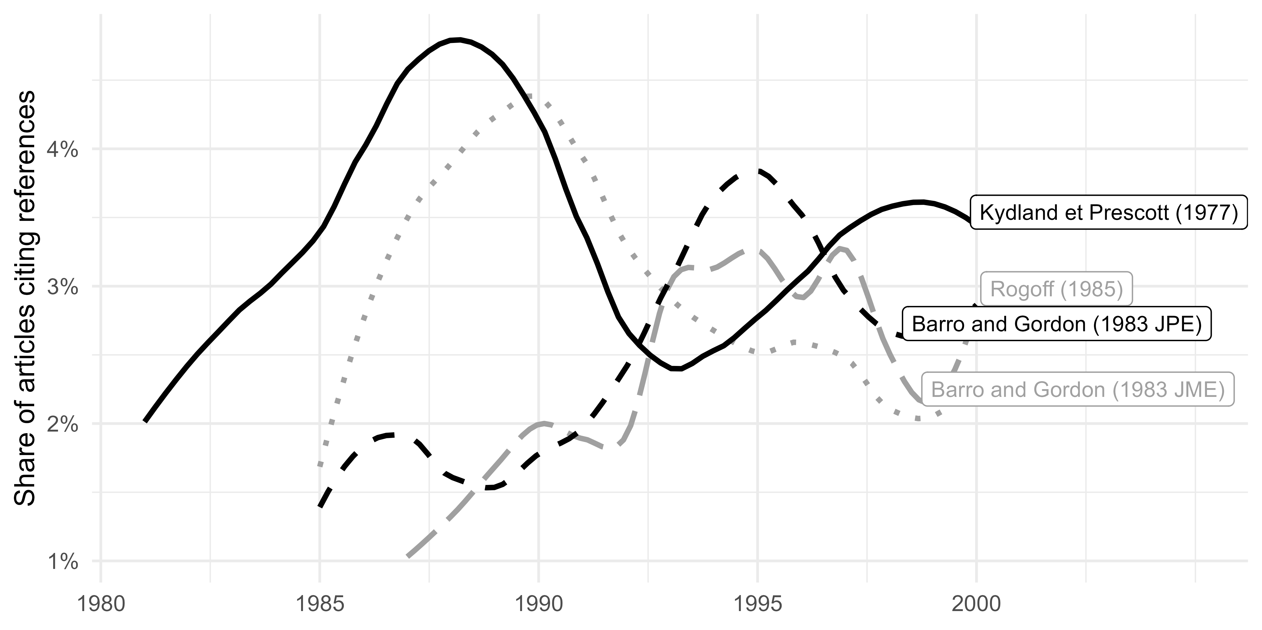

Figure 5.1: Share of articles citing political economy literature (5-year moving average)

This interest of European economists for the new political economy literature of the late 1970s and early 1980s is evidenced by both bibliometric and topic modelling analyses. The fundamental references cited above constitute the most cited references in the EER and by European macroeconomists in various clusters and topics.[56] Through the EER and Top 5 journals, we can distinguish three areas where European macroeconomists employed a political economy framework in the 1990s, setting European macroeconomics apart from its US counterpart.[57]

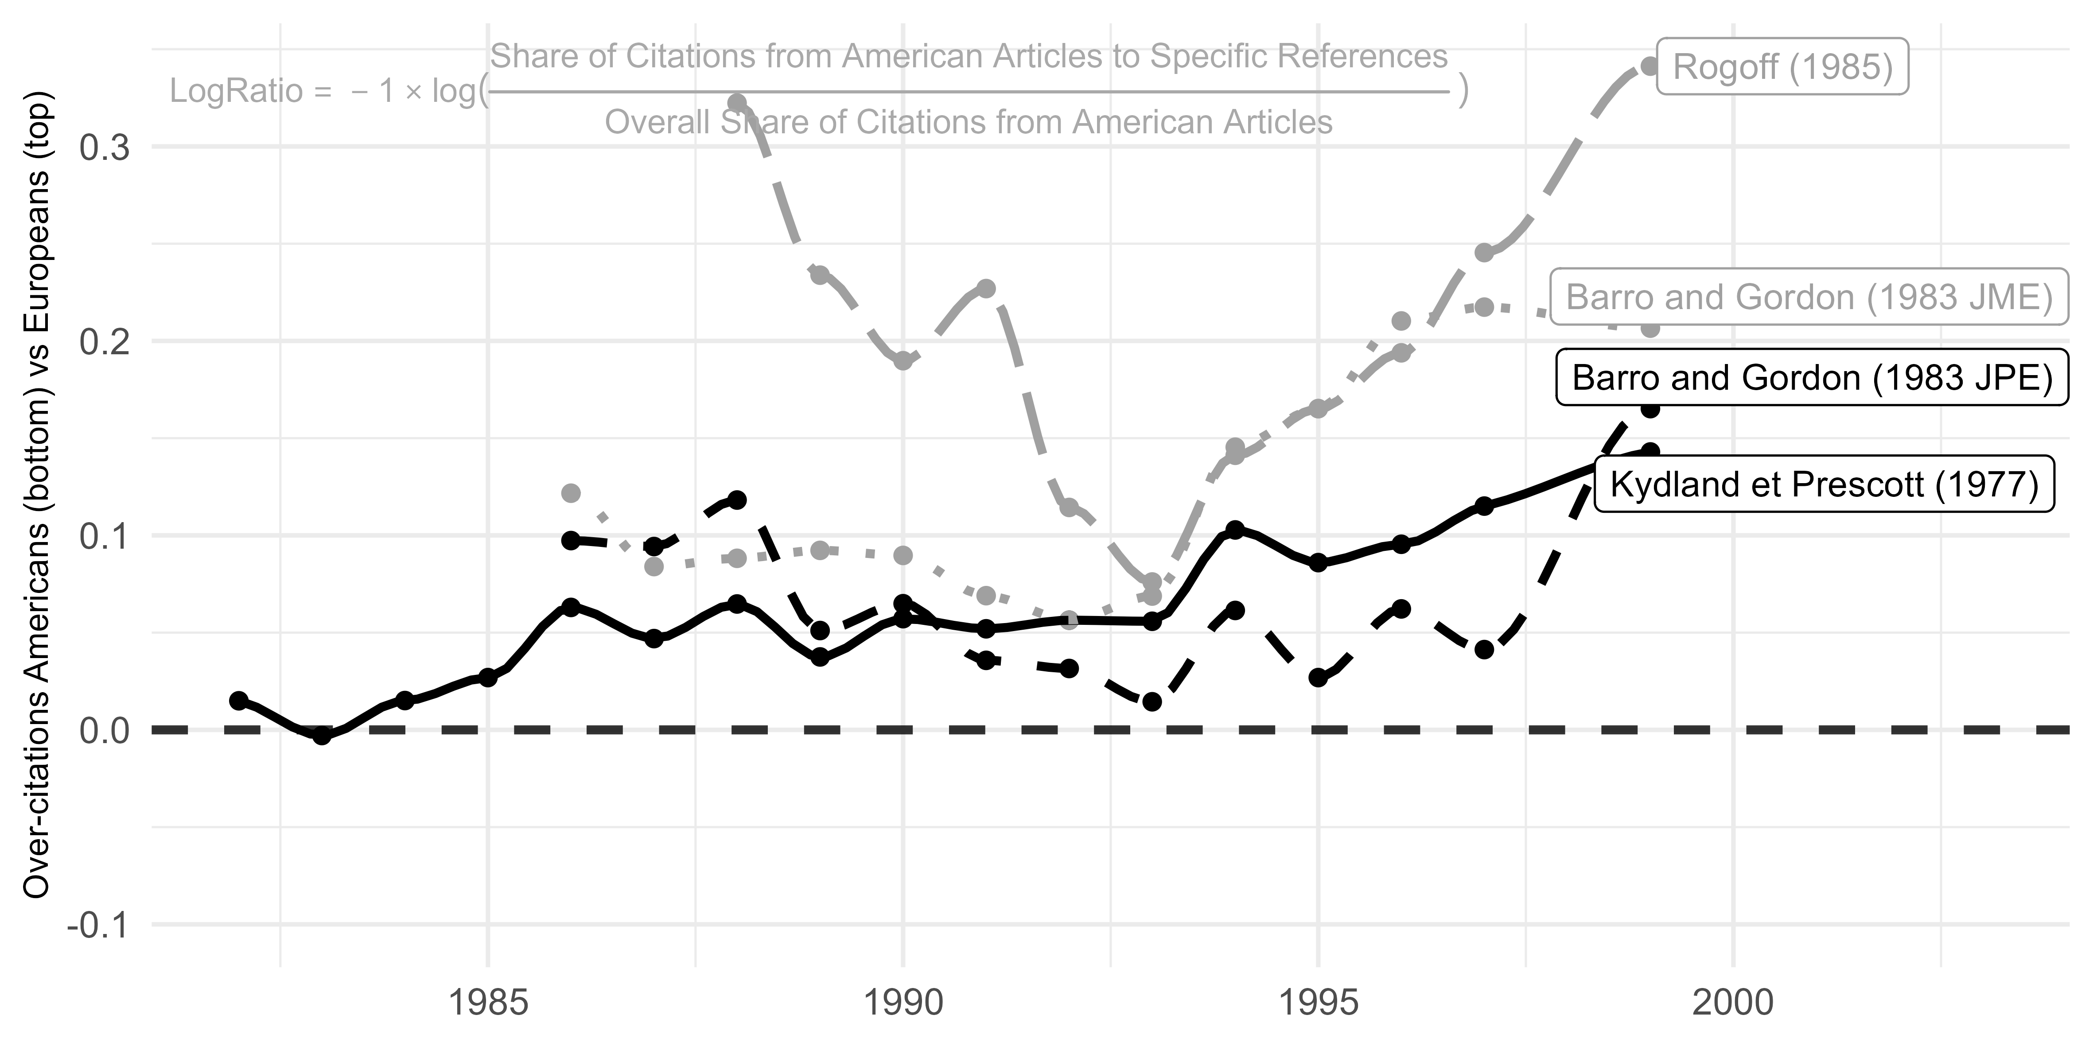

Figure 5.2: Citation of political economy articles by Europe-based economists relatively to US-based economists (log of ratios on articles by Europe-based and US-based economists computed on 7-year moving average)

First, many discussions regarding the appropriate framework for monetary policy incorporated political economy contributions. Giavazzi and Pagano’s (1988) EER article represented a notable contribution in this line of research. The authors examined the advantages of adhering to the European monetary system (EMS) for countries with higher inflation rates. They explored the idea that the EMS could serve as a a solution to the time-consistency problem, by “tying the hands” of high-inflation countries. Forced to maintain a stable exchange rate, these countries would face reduced incentives to generate surprise inflation, thus increasing the credibility of their monetary authorities. The adherence to the EMS, as (Giavazzi and Pagano, 1988, p. 1057) argues, “parallels that in Rogoff (1985), who shows that the non-cooperative rate of inflation can be reduced ‘through a system of rewards and punishments which alters the incentives of the central bank’”.[58] Still in the EER, Daniel Laskar (1989) also built upon Rogoff’s (1985) argument that appointing a conservative central banker could benefit society. He extended the issue to a two-country model to discuss cases in which appointing conservative central bankers in both countries could be either detrimental or beneficial to both.[59]

Still on monetary policy, the monetary union issue also stimulated political economy contributions. In his EER survey about the theoretical justifications for the convergence requirements of the Maastricht treaty, Paul De Grauwe (KU Leuven) distinguished between two types of justification: *(i)* “the traditional theory of optimum currency areas (OCA)” and *(ii)* “the more recent ‘new view’ based on credibility issues” (De Grauwe, 1996, pp. 1091–1092). Unlike the OCA theory, the second approach relied on the intuition of the Barro-Gordon model, analysing “how countries can gain (or loose) credibility by joining a monetary union” and thus how inflation rates would converge.[60] Looking at citation patterns, it appears that European macroeconomists favoured the credibility approach over the OCA theory.[61]

A second area of research where the political economy framework was influential is wage-setting.[62] In the EER, Horn and Persson (1988) investigated the interaction between exchange rate policy and the role of unions in wage-setting. If devaluations intended to maintain or increase competitiveness are followed by compensatory wage increases, the effects on competitiveness are cancelled, and the economy faces a “devaluation-wage spiral” (Horn and Persson, 1988, p. 1621). The authors’ starting point is that “if wage setters are rational and forward-looking and understand the objectives behind the government’s exchange rate policy (…) they will anticipate exchange rate changes and take them into account in their wage decisions” (p. 1622). Their goal was thus to endogenise both wage decisions and policy formation within a game-theoretic framework.

Thorvadur Gylfasson and Lindbeck’s similar work on the links between wage-setting and monetary policy is enlightening on the transformations of European macroeconomics after the mid-1980s. In a 1984 article in the EER, they integrated together cost push and demand pull inflation in a Keynesian framework, considering the behaviour of aggregate supply and the Phillips curve for wage formation (Gylfason and Lindbeck, 1984). As they acknowledged themselves, the issues raised by their model echoed Malinvaud’s (1977) opposition between Classical and Keynesian unemployment (Gylfason and Lindbeck, 1984, pp. 6–7). Their article had a political economy flavour as they dealt with “competing wage claims” and framed their model as a duopoly problem *à la* Cournot. In their subsequent article in the EER, they relied explicitly on game theory to deal with the interaction of wages determination and government spending (Gylfason and Lindbeck, 1986). Years later, revisiting the issue of wage setting and monetary policy, Gylfason and Lindbeck referred to the “wage gaps” debate of the 1970s and the “cases where government efforts to reduce unemployment by bringing real wages down through price inflation were frustrated by subsequent nominal wage increases” (Gylfason and Lindbeck, 1994, p. 34). However, they made no reference to classical and Keynesian unemployment. They proposed a model in which wages are determined “through collective bargaining among strong and well coordinated labor unions” (34) and explored its consequences for monetary policy using a game-theoretic model similar to (Barro and Gordon, 1983a, 1983b). To some extent, the trajectory of Gylfason and Lindbeck’s work is representative of the transformation of European macroeconomics between the 1970s and the 1990s, as observed through the EER.

A third area concerns fiscal policy and European integration. Alesina, Tabellini and Persson advocated for the development of a “positive theory” of fiscal policy in the late 1980s and early 1990s. Alesina and Tabellini explained in the AER that their goal was to “[abandon] the assumption that fiscal policy is set by a benevolent social planner who maximizes the welfare of a representative consumer … [for] an economy with two policymakers with different objectives alternating in office as a result of elections” (Alesina and Tabellini, 1990). Persson and Tabellini (1992) defended a similar “positive public finance” research agenda. Their objective was to understand how the rising European integration and the removal of barriers to the mobility of capital, goods and labour could affect the “politico-economic equilibrium that determines fiscal policy” (Persson and Tabellini, 1992, p. 689).[63].

As the three examples above demonstrate, after the mid-1980s, (new) political economy and its pioneering works (Barro and Gordon, 1983a, 1983b; Kydland and Prescott, 1977; Rogoff, 1985) provided a unifying framework for numerous European macroeconomists for addressing macroeconomic challenges such as the European integration and the construction of a European monetary system.

# Conclusion

This article presents an overview of the evolution of European specificities in macroeconomics in comparison to the US since the 1970s. Naturally, this overview warrants further research and should not be over-generalised. Indeed, the analysis is focused solely on the Top 5 journals and the EER. While this comparison may provide a reasonable representation of the differences between the US and Europe in mainstream macroeconomics, some biases may exist, especially during the initial years of our studied period when the Top 5 were not yet perceived as the “Top 5”, and the EER was a relatively young journal.

Neither is our study exhaustive: due to time and space constraints, we were unable to explore in detail all the clusters and topics, and we had to focus on what seemed to us the most significant ones.[64] Moreover, even when we have devoted our attention to some distinctly European lines of research, a more “micro” exploration may still be necessary to understand their specificity, emergence and institutionalisation as a proper European speciality.

Despite its limitations, our study offers valuable insights about the history of European macroeconomics, revealing important and enduring difference from its US counterpart. Amid the internationalisation and standardisation of economics since the 1970s, European macroeconomics managed to retain distinctive features throughout the 1970s to 1990s. These features were of a different nature and we can distinguish two periods that exhibited varying relationships with US macroeconomics.

In the late 1970s and early 1980s, European macroeconomics kept its distance from US debates, which were driven by the emergence of rational expectations and the contributions of new classical economists. These new theoretical developments did not immediately influence European macroeconomic research. Early publications in the EER often took an empirical approach and seemed to be less aligned with the preoccupations of US macroeconomists. However, the question of microfoundations, which became pivotal in the US, was not entirely disregarded by European macroeconomists. An alternative to the new classical microfoundational programme surfaced and contributed to foster transnational collaborations: disequilibrium theory. This theoretical perspective constituted a significant part of the research undertaken by European macroeconomists, extending beyond general equilibrium theory and offering a unifying framework for addressing various macroeconomic issues (unemployment, stagflation, stabilization policies, international trade, etc.). Although the importance of disequilibrium theory has been acknowledged in recent historiography of macroeconomics (see also Plassard and Renault, 2023, this issue), our analysis outlines the dissemination and life cycle of disequilibrium macroeconomics.

Indeed, after the mid-1980s, as our analysis shows, the disequilibrium line of research waned. Concurrently, new classical economists’ contributions began to find success in Europe: not so much through the adoption Real Business Cycle models, which remained relatively uncommon, but rather through the influence of the new political economy literature of Kydland and Prescott (1977) and Barro and Gordon (1983a, 1983b). In the 1990s, European macroeconomics seemed more aligned with its US counterpart in terms of theoretical and methodological approaches, than in the previous decades.

Indeed, while European macroeconomists may have drawn inspiration from some US contributions, there were significant differences in the subjects they specialized in. European economies faced unique macroeconomic challenges, especially concerning high unemployment rates, economic interdependence among European countries, and the process of constructing the European Union. These specific circumstances likely steered European economists towards different avenues of research and inquiry. Furthermore, the prominence of political economy in European macroeconomics during the 1990s reflects the particularity of European issues. The process of integrating various national economies into a single European economic framework brought political considerations to the forefront. European economists, therefore, delved into the interactions between economic policy, political institutions, and decision-making processes to understand the complexities of the European integration.

# References

Acosta, J., Rancan, A., Sergi, F., 2023. Centralised and Decentralised Approaches to Multi-Country Macroeconometric Modelling at the Commission of the European Communities: The Short-Lived EUROLINK Model. European Economic Review 158.

Alesina, A., Tabellini, G., 1990. A Positive Theory of Fiscal Deficits and Government Debt. The Review of Economic Studies 57, 403–414. doi:[10.2307/2298021](https://doi.org/10.2307/2298021)

Azariadis, C., 1975. Implicit contracts and underemployment equilibria. Journal of Political Economy 83, 1183–1202.

Backhouse, R.E., 1997. The changing character of British economics. History of Political Economy 28, 33–60.

Backhouse, R.E., Boianovsky, M., 2013. Tranforming modern macroeconomics. Exploring disequilibrium microfoundations (1956-2003). Cambridge University Press, Cambdrige.

Backhouse, R., Forder, J., Laskaridis, C., 2023. The Natural Rate of Unemployment and the NAIRU. European Economic Review 158.

Barnett, W.A., 1984. On the flexibility of the Rotterdam model: A first empirical look. European Economic Review 24, 285–289. doi:[10.1016/0014-2921(84)90057-6](https://doi.org/10.1016/0014-2921(84)90057-6)

Barro, R.J., 1976. Rational expectations and the role of monetary policy. Journal of Monetary Economics 2, 1–32. doi:[10.1016/0304-3932(76)90002-7](https://doi.org/10.1016/0304-3932(76)90002-7)

Barro, R.J., Gordon, D.B., 1983a. Rules, discretion and reputation in a model of monetary policy. Journal of Monetary Economics 12, 101–121. doi:[10.1016/0304-3932(83)90051-X](https://doi.org/10.1016/0304-3932(83)90051-X)

Barro, R.J., Gordon, D.B., 1983b. A Positive Theory of Monetary Policy in a Natural Rate Model. Journal of Political Economy 91, 589–610.

Barro, R.J., Grossman, H.I., 1971. A General Disequilibrium Model of Income and Employment. The American Economic Review 61, 82–93.

Barten, A.P., 1964. Consumer demand functions under conditions of almost additive preferences. Econometrica: Journal of the Econometric Society 32, 1–38. doi:[10.2307/1913731](https://doi.org/10.2307/1913731)

Barten, A.P., 1969. Maximum likelihood estimation of a complete system of demand equations. European Economic Review 1, 7–73. doi:[10.1016/0014-2921(69)90017-8](https://doi.org/10.1016/0014-2921(69)90017-8)

Barten, A.P., d’Alcantara, G., Carrin, G.J., 1976. COMET: A medium-term macroeconomic model for the European economic community. European Economic Review 7, 63–115. doi:[10.1016/0014-2921(76)90019-2](https://doi.org/10.1016/0014-2921(76)90019-2)

Baumol, W.J., 1952. The transactions demand for cash: An inventory theoretic approach. The Quarterly journal of economics 66, 545–556. doi:[10.2307/1882104](https://doi.org/10.2307/1882104)

Bean, C.R., 1994a. European unemployment: A retrospective. European Economic Review 38, 523–534. doi:[10.1016/0014-2921(94)90088-4](https://doi.org/10.1016/0014-2921(94)90088-4)

Bean, C.R., 1994b. European unemployment: A survey. Journal of economic literature 32, 573–619.

Bentolila, S., Bertola, G., 1990. Firing costs and labour demand: How bad is eurosclerosis? The Review of Economic Studies 57, 381–402.

Bentolila, S., Saint-Paul, G., 1992. The macroeconomic impact of flexible labor contracts, with an application to Spain. European Economic Review 36, 1013–1047. doi:[10.1016/0014-2921(92)90043-V](https://doi.org/10.1016/0014-2921(92)90043-V)

Bertola, G., 1990. Job security, employment and wages. European Economic Review 34, 851–879. doi:[10.1016/0014-2921(90)90066-8](https://doi.org/10.1016/0014-2921(90)90066-8)

Bischof, J., Airoldi, E.M., 2012. Summarizing topical content with word frequency and exclusivity. Proceedings of the 29th International Conference on Machine Learning (ICML-12) 201–208.

Blei, D.M., Lafferty, J.D., 2007. [A correlated topic model of science](https://www.jstor.org/stable/4537420). The Annals of Applied Statistics 1, 17–35.

Boumans, M., Duarte, P.G., 2019. The History of Macroeconometric Modeling : An Introduction. History of Political Economy 51, 391–400.

Bruno, M., Sachs, J.D., 1985. Economics of worldwide stagflation. National Bureau of Economic Research, Cambridge, Mass.

Bryant, J., Wallace, N., 1979. The inefficiency of interest-bearing national debt. Journal of Political Economy 87, 365–381.

Byron, R.P., 1984. On the flexibility of the Rotterdam model. European Economic Review 24, 273–283. doi:[10.1016/0014-2921(84)90056-4](https://doi.org/10.1016/0014-2921(84)90056-4)

Calmfors, L., Driffill, J., 1988. Bargaining Structure, Corporatism and Macroeconomic Performance. Economic Policy 3, 13. doi:[10.2307/1344503](https://doi.org/10.2307/1344503)

Cherrier, B., Garcia Duarte, P., Saïdi, A., 2023. Household Heterogeneity in Macroeconomic Models: A Historical Perspective. European Economic Review 158. doi:[10.2139/ssrn.4250570](https://doi.org/10.2139/ssrn.4250570)

Cherrier, B., Saïdi, A., 2018. The indeterminate fate of sunspots in economics. History of Political Economy 50, 425–481.

Cherrier, B., Saïdi, A., 2021. Back to Front: The Role of Seminars, Conferences and Workshops in the History of Economics. Preface to the Second Issue. Revue d’economie politique 131, 723–727.

Claveau, F., Gingras, Y., 2016. Macrodynamics of Economics: A Bibliometric History. History of Political Economy 48, 551–592. doi:[10.1215/00182702-3687259](https://doi.org/10.1215/00182702-3687259)

Clements, K.W., Gao, G., 2015. The Rotterdam demand model half a century on. Economic Modelling 49, 91–103. doi:[10.1016/j.econmod.2015.03.019](https://doi.org/10.1016/j.econmod.2015.03.019)

Clower, R., 1965. The Keynesian Counter-Revolution: A Theoretical Appraisal, in: The Theory of Interest Rates.

Coats, A.W., 1996. The Post-1945 Internationalization of Economics. Duke University Press, Durham, NC.

Davidson, J.E.H., Hendry, D.F., 1981. Interpreting econometric evidence. European Economic Review 16, 177–192. doi:[10.1016/0014-2921(81)90058-1](https://doi.org/10.1016/0014-2921(81)90058-1)

Davidson, J.E.H., Hendry, D.F., Srba, F., Yeo, S., 1978. Econometric Modelling of the Aggregate Time-Series Relationship Between Consumers’ Expenditure and Income in the United Kingdom. The Economic Journal 88, 661–692. doi:[10.2307/2231972](https://doi.org/10.2307/2231972)

De Grauwe, P., 1996. Monetary union and convergence economics. European Economic Review, Papers and Proceedings of the Tenth Annual Congress of the European Economic Association 40, 1091–1101. doi:[10.1016/0014-2921(95)00117-4](https://doi.org/10.1016/0014-2921(95)00117-4)

De Vroey, M., 2016. A history of modern macroeconomics from keynes to lucas and beyond. Cambridge University Press, Cambridge.

Deaton, A., Muellbauer, J., 1980. An almost ideal demand system. The American economic review 70, 312–326.

Diamond, P.A., 1982. Aggregate demand management in search equilibrium. Journal of political Economy 90, 881–894.

Diebold, F.X., 2003. The ET interview: Professor robert f. Engle, january 2003. Econometric Theory 19, 1159–1193.

Dixit, A., 1978. The balance of trade in a model of temporary equilibrium with rationing. The Review of Economic Studies 45, 393–404.

Dixit, A., Norman, V., 1980. Theory of International Trade: A Dual, General Equilibrium Approach. Cambridge University Press, Cambridge.

Dramais, A., 1977. Transmission of inflationary pressures between the E.E.C. members. European Economic Review 9, 21–42. doi:[10.1016/0014-2921(71)90008-0](https://doi.org/10.1016/0014-2921(71)90008-0)

Drazen, A., 2002. Political Economy in Macroeconomics. Princeton University Press, New Haven.

Drèze, J.H., Modigliani, F., 1981. The trade-off between real wages and employment in an open economy (Belgium). European Economic Review 15, 1–40. doi:[10.1016/0014-2921(81)90065-9](https://doi.org/10.1016/0014-2921(81)90065-9)

Duarte, P.G., Lima, G.T., 2012. Microfoundations Reconsidered. The Relationship of Micro and Macroeconomics in Historical Perspective. Edward Elgar Publishing, Cheltenham.

Düppe, T., 2017. How modern economics learned french: Jacques drèze and the foundation of CORE. The European Journal of the History of Economic Thought 24, 238–273.

Engle, R.F., Granger, C.W., 1987. Co-integration and error correction: Representation, estimation, and testing. Econometrica: journal of the Econometric Society 55, 251–276. doi:[10.2307/1913236](https://doi.org/10.2307/1913236)

Engle, R.F., Hendry, D.F., Richard, J.-F., 1983. Exogeneity. Econometrica 51, 277–304. doi:[10.2307/1911990](https://doi.org/10.2307/1911990)

Ericsson, N.R., 2004. The ET interview: Professor David F. Hendry: Interviewed by neil R. Ericsson. Econometric Theory 20, 743–804.

Fourcade, M., 2006. The construction of a global profession: The transnationalization of economics. American Journal of Sociology 112, 145–194.

Fourcade, M., 2009. Economists and societies: Discipline and profession in the united states, britain, and france, 1890s to 1990s. Princeton University Press, Princeton.

Frenkel, J.A., Johnson, H.G. (Eds.), 1976. The monetary approach to the balance of payments. G. Allen & Unwin, London.

Friedman, M., 1957. A theory of the consumption function. Princeton University Press, Princeton.

Friedman, M., Schwartz, A.J., 1963. A Monetary history of the United States 1867-1960, Studies in business cycles. Princeton university press, Princeton.

Galvão de Almeida, R., 2021. A Macroeconomic View of Public Choice: New Political Macroeconomics as a Separate Tradition of Public Choice. Œconomia. History, Methodology, Philosophy 11, 77–105. doi:[10.4000/oeconomia.10402](https://doi.org/10.4000/oeconomia.10402)

Giavazzi, F., Pagano, M., 1988. The advantage of tying one’s hands: EMS discipline and central bank credibility. European economic review 32, 1055–1075.

Gottfries, N., 1992. Insiders, outsiders, and nominal wage contracts. Journal of Political Economy 100, 252–270.

Gottfries, N., Horn, H., 1987. Wage formation and the persistence of unemployment. The Economic Journal 97, 877–884.

Goutsmedt, A., 2021. From the Stagflation to the Great Inflation: Explaining the US economy of the 1970s. Revue d’Economie Politique 131, 557–582. doi:[10.3917/redp.313.0239](https://doi.org/10.3917/redp.313.0239)

Goutsmedt, A., Pinzon-Fuchs, E., Renault, M., Sergi, F., 2019. Reacting to the lucas critique: The keynesians’ replies. History of Political Economy 51, 533–556. doi:[10.1215/00182702-7551912](https://doi.org/10.1215/00182702-7551912)

Goutsmedt, A., Renault, M., Sergi, F., 2021. European Economics and the Early Years of the “International Seminar on Macroeconomics.” Revue d’Economie Politique 131, 693–722.

Goutsmedt, A., Truc, A., 2023. [Networkflow: Functions for a workflow to manipulate networks](https://agoutsmedt.github.io/networkflow/).

Goutsmedt, A., Truc, A., Claveau, F., 2023. biblionetwork: An R Package for Creating Different Types of Bibliometric Networks. Zenodo. doi:[10.5281/zenodo.7677369](https://doi.org/10.5281/zenodo.7677369)

Grubb, D., Jackman, R., Layard, R., 1982. Causes of the Current Stagflation. The Review of Economic Studies 49, 707–730. doi:[10.2307/2297186](https://doi.org/10.2307/2297186)

Grubb, D., Jackman, R., Layard, R., 1983. Wage rigidity and unemployment in OECD countries. European Economic Review 21, 11–39.

Gylfason, T., Lindbeck, A., 1984. Competing wage claims, cost inflation, and capacity utilization. European Economic Review 24, 1–21. doi:[10.1016/0014-2921(84)90010-2](https://doi.org/10.1016/0014-2921(84)90010-2)

Gylfason, T., Lindbeck, A., 1986. Endogenous unions and governments: A game-theoretic approach. European Economic Review 30, 5–26. doi:[10.1016/0014-2921(86)90029-2](https://doi.org/10.1016/0014-2921(86)90029-2)

Gylfason, T., Lindbeck, A., 1994. The interaction of monetary policy and wages. Public Choice 79, 33–46.

Hagemann, H., 2011. European émigrés and the “Americanization” of economics. The European Journal of the History of Economic Thought 18, 643–671. doi:[10.1080/09672567.2011.629056](https://doi.org/10.1080/09672567.2011.629056)

Hall, R.E., 1978. Stochastic implications of the life cycle-permanent income hypothesis: Theory and evidence. Journal of political economy 86, 971–987.

Hart, O., 1982. A model of imperfect competition with Keynesian features. The Quarterly Journal of Economics 97, 109–138.

Hesse, J.-O., 2012. The “Americanisation” of West German economics after the Second World War: Success, failure, or something completely different? The European Journal of the History of Economic Thought 19, 67–98. doi:[10.1080/09672567.2010.487283](https://doi.org/10.1080/09672567.2010.487283)

Hoover, K.D. (Ed.), 1988. The new classical macroeconomics, The International library of critical writings in economics. E. Elgar, Aldershot (GB) Brookfield (Vt.).

Hoover, K.D., 2012. Microfoundational programs, in: Duarte, P.G., Lima, G.T. (Eds.), Microfoundations Reconsidered. Edward Elgar Publishing, Cheltenham, pp. 19–61.

Horn, H., Persson, T., 1988. Exchange rate policy, wage formation and credibility. European Economic Review 32, 1621–1636. doi:[10.1016/0014-2921(88)90021-9](https://doi.org/10.1016/0014-2921(88)90021-9)

JEL, 1991. [Classification system: Old and new categories](https://www.jstor.org/stable/2727351). Journal of Economic Literature 29, xviii–xxviii.

Johansen, S., 1988. Statistical analysis of cointegration vectors. Journal of Economic Dynamics and Control 12, 231–254. doi:[10.1016/0165-1889(88)90041-3](https://doi.org/10.1016/0165-1889(88)90041-3)

Kloek, T., 2001. Obituary: Henri Theil, 1924. Statistica Neerlandica 55, 263–269. doi:[10.1111/1467-9574.00169](https://doi.org/10.1111/1467-9574.00169)

Kydland, F.E., Prescott, E.C., 1977. Rules Rather than Discretion: The Inconsistency of Optimal Plans. Journal of Political Economy 85, 473–491.

Laskar, D., 1989. Conservative central bankers in a two-country world. European Economic Review 33, 1575–1595. doi:[10.1016/0014-2921(89)90079-2](https://doi.org/10.1016/0014-2921(89)90079-2)

Layard, R., Nickell, S., 1986. Unemployment in Britain. Economica 53, S121–S169. doi:[10.2307/2554377](https://doi.org/10.2307/2554377)

Layard, R., Nickell, S., Jackman, R., 1991. Unemployment: Macroeconomic Performance and the Labour Market. Oxford University Press, Oxford. doi:[10.1093/acprof:oso/9780199279166.001.0001](https://doi.org/10.1093/acprof:oso/9780199279166.001.0001)

Leuven, K., 2016. Anton Barten (1930-2016). Obituary - KU Leuven.

Lindbeck, A., Snower, D.J., 1986. Wage setting, unemployment, and insider-outsider relations. The American Economic Review 76, 235–239.

Lindbeck, A., Snower, D.J., 1987. Efficiency wages versus insiders and outsiders. European Economic Review 31, 407–416. doi:[10.1016/0014-2921(87)90058-4](https://doi.org/10.1016/0014-2921(87)90058-4)

Lucas, R.E., 1973. [Some international evidence on output-inflation tradeoffs](http://www.jstor.org/stable/1914364). The American Economic Review 326–334.

Lucas, R.E., Jr., 1972. Expectations and the neutrality of money. Journal of Economic Theory 4, 103–124. doi:[10.1016/0022-0531(72)90142-1](https://doi.org/10.1016/0022-0531(72)90142-1)

Maes, I., Buyst, E., 2005. Migration and americanization: The special case of belgian economics. The European Journal of the History of Economic Thought 12, 7388.

Malinvaud, E., 1977. The theory of unemployment reconsidered. Basil-Blackwell, Oxford.

Malinvaud, E., 1986. The rise of unemployment in France. Economica 53, S197–S217.

Morgan, M.S., Rutherford, M., 1998. [American economics: The character of the transformation](http://search.ebscohost.com/login.aspx?direct=true&db=bth&AN=7752144&lang=fr&site=ehost-live). History of Political Economy 30, 1–26.

Mortensen, D.T., Pissarides, C.A., 1994. Job creation and job destruction in the theory of unemployment. The review of economic studies 61, 397415.

Mullen, L.A., Benoit, K., Keyes, O., Selivanov, D., Arnold, J., 2018. Fast, consistent tokenization of natural language text. Journal of Open Source Software 3, 655. doi:[10.21105/joss.00655](https://doi.org/10.21105/joss.00655)

Persson, T., Tabellini, G., 1992. The Politics of 1992: Fiscal Policy and European Integration. The Review of Economic Studies 59, 689–701. doi:[10.2307/2297993](https://doi.org/10.2307/2297993)

Persson, T., Tabellini, G.E., 2002. Political economics: Explaining economic policy. MIT press.

Plassard, R., Renault, M., 2023. General Equilibrium Models with Rationing: The Making of a “European Specialty.” European Economic Review 158. doi:[10.2139/ssrn.4250570](https://doi.org/10.2139/ssrn.4250570)

Plassard, R., Renault, M., Rubin, G., 2021. Modelling market dynamics : Jean-Pascal Bénassy, Edmond Malinvaud, and the development of disequilibrium macroeconomics. Modelling market dynamics : Jean-Pascal Bénassy, Edmond Malinvaud, and the development of disequilibrium macroeconomics 83–114. doi:[10.19272/202106101005](https://doi.org/10.19272/202106101005)

Portes, R., 1987. Economics in europe. European Economic Review 31, 1329–1340. doi:[10.1016/S0014-2921(87)80021-1](https://doi.org/10.1016/S0014-2921(87)80021-1)

Qin, D., 2013. A History of Econometrics: The Reformation from the 1970s. Oxford University Press, Oxford.

Renault, M., 2020. Edmond Malinvaud’s Criticisims of the New Classical Economics: Restoring the Nature and the Rationale of the Old Keynesians’ Opposition. Journal of the History of Economic Thought 42, 563–585. doi:[10.1017/S1053837219000610](https://doi.org/10.1017/S1053837219000610)

Renault, M., 2022b. Theory to the Rescue of the Large-Scale Models: Edmond Malinvaud’s Alternative View on the Search for Microfoundations. History of Political Economy 54.

Renault, M., 2022a. Theory to the Rescue of the Large-Scale Models: Edmond Malinvaud’s Alternative View on the Search for Microfoundations. History of Political Economy 54.

Rinker, T.W., 2018. [textstem: Tools for stemming and lemmatizing text](http://github.com/trinker/textstem). Buffalo, New York.

Roberts, M.E., Stewart, B.M., Tingley, D., 2019. Stm: R Package for Structural Topic Models. Journal of Statistical Software 91, 1–40.

Rogoff, K., 1985. The optimal degree of commitment to a monetary target. Quarterly Journal of Economics 100, 1169–1190.

Rose, A.K., Svensson, L.E.O., 1994. European exchange rate credibility before the fall. European Economic Review 38, 1185–1216. doi:[10.1016/0014-2921(94)90067-1](https://doi.org/10.1016/0014-2921(94)90067-1)

Sandelin, B., Ranki, S., 1997. Internationalization or americanization of swedish economics? The European Journal of the History of Economic Thought 4, 284–298. doi:[10.1080/10427719700000040](https://doi.org/10.1080/10427719700000040)

Sargent, T.J., Wallace, N., 1975. ["Rational" Expectations, the Optimal Monetary Instrument, and the Optimal Money Supply Rule](http://econpapers.repec.org/article/ucpjpolec/v_3A83_3Ay_3A1975_3Ai_3A2_3Ap_3A241-54.htm). Journal of Political Economy 83, 241–54.

Sargent, T.J., Wallace, N., 1982. [The real-bills doctrine versus the quantity theory: A reconsideration](http://www.jstor.org/stable/1830945). The Journal of Political Economy 90, 1212–1236.

Shen, S., Zhu, D., Rousseau, R., Su, X., Wang, D., 2019. A refined method for computing bibliographic coupling strengths. Journal of Informetrics 13, 605–615. doi:[10.1016/j.joi.2019.01.012](https://doi.org/10.1016/j.joi.2019.01.012)

Silge, J., Robinson, D., 2016. Tidytext: Text mining and analysis using tidy data principles in r. JOSS 1. doi:[10.21105/joss.00037](https://doi.org/10.21105/joss.00037)

Sneessens, H.R., Drèze, J.H., 1986. A Discussion of Belgian Unemployment, Combining Traditional Concepts and Disequilibrium Econometrics. Economica 53, S89–S119. doi:[10.2307/2554376](https://doi.org/10.2307/2554376)

Snowdon, B., Vane, H.R., 2005. Modern macroeconomics: Its origins, development and current state. E. Elgar, Cheltenham (GB).

Svensson, L.E.O., 1993. Assessing target zone credibility: Mean reversion and devaluation expectations in the ERM, 1979. European Economic Review 37, 763–793. doi:[10.1016/0014-2921(93)90087-Q](https://doi.org/10.1016/0014-2921(93)90087-Q)

Theil, H., 1965. The information approach to demand analysis, Econometrica.

Traag, V.A., Waltman, L., van Eck, N.J., 2019. From louvain to leiden: Guaranteeing well-connected communities. Scientific reports 9, 112.

Truc, A., Claveau, F., Santerre, O., 2021. Economic methodology: a bibliometric perspective. Journal of Economic Methodology 1–12. doi:[10.1080/1350178X.2020.1868774](https://doi.org/10.1080/1350178X.2020.1868774)

Waelbroeck, J.L., Glejser, H., 1969. Editor’s introduction. European Economic Review 1, 3–6. doi:[10.1016/0014-2921(69)90016-6](https://doi.org/10.1016/0014-2921(69)90016-6)

# 6 Appendices

## A - Summary Tables

Table 6.1: Summary of Topics

| Topics | Terms with highest frex values | Log of ratios EU/US | Log of ratios EER/Top 5 |
| --- | --- | --- | --- |
| Topic 3 | system; monetary expansion; monetary system; union; expansion; stability | 0.907 | 1.129 |
| Topic 4 | macroeconomics; rich; history; robert; divide; lead | 1.141 | 0.554 |
| Topic 46 | german; money demand; germany; unite kingdom; unite; kingdom | 0.624 | 0.620 |
| Topic 22 | political; oecd country; oecd; world; country; index | 0.311 | 0.722 |
| Topic 37 | unemployment; job; unemployment rate; creation; flow; phillips curve | 0.466 | 0.528 |
| Topic 6 | real exchange; real exchange rate; exchange rate; flexible exchange; flexible exchange rate; target zone | 0.064 | 0.703 |
| Topic 25 | real wage; contract; employment; capacity; wage; stickiness | 0.208 | 0.548 |
| Topic 39 | trade balance; trade; wealth; relative price; balance; external | 0.140 | 0.605 |
| Topic 8 | credibility; strategic; policy; maker; economic policy; policy rule | 0.468 | 0.240 |
| Topic 28 | exchange market; foreign exchange market; intervention; foreign exchange; transaction; transaction cost | 0.181 | 0.518 |
| Topic 13 | unanticipated; activity; economic activity; national; economy; gap | 0.196 | 0.418 |
| Topic 44 | level; national income; inflationary; equation; price level; money balance | 0.390 | 0.063 |
| Topic 31 | welfare cost; cost; welfare; bear; survey; household | 0.467 | -0.093 |
| Topic 43 | federal; signal; monetary policy; federal reserve; revision; feed | 0.160 | 0.209 |
| Topic 23 | short run; run; short; burden; indirect; externality | 0.042 | 0.307 |
| Topic 20 | inflation target; target; stabilize; central bank; central; length | -0.063 | 0.403 |
| Topic 26 | inflation; inflation rate; relative; evidence; dispersion; nominal price | 0.268 | 0.065 |
| Topic 45 | power parity; purchase power parity; purchase power; power; purchase; parity | 0.091 | 0.167 |
| Topic 40 | economic growth; growth rate; productivity growth; growth; fast; region | 0.198 | 0.058 |
| Topic 36 | spend; government spend; deficit; fiscal; government; government debt | 0.032 | 0.176 |
| Topic 17 | indexation; distortion; labor market; labor; product; corporate | -0.294 | 0.434 |
| Topic 11 | walrasian; competitive; temporary; existence; search; equilibrium | 0.314 | -0.180 |
| Topic 35 | likelihood; variable; estimation; autoregressive; variance; endogenous variable | 0.160 | -0.127 |
| Topic 24 | term; spread; short term; term structure; premium; structure | 0.179 | -0.177 |
| Topic 15 | production; class; factor; identical; preference; input | 0.121 | -0.152 |
| Topic 50 | budget constraint; constraint; project; budget; bad; loan | -0.246 | 0.149 |
| Topic 30 | business cycle; business; cycle; real business cycle; real business; volatility | -0.112 | -0.034 |
| Topic 47 | investment; monopolistic; dynamic; competition; macroeconomic; replace | -0.001 | -0.159 |
| Topic 38 | asset price; financial market; stock market; return; asset market; stock | -0.257 | 0.004 |
| Topic 21 | process; procedure; property; incentive; build; endogenous | 0.042 | -0.300 |
| Topic 42 | stationary; rational expectation equilibrium; expectation equilibrium; expectation; unique; rational expectation | 0.042 | -0.339 |
| Topic 5 | price adjustment; oil; price; commodity price; sticky; import | -0.038 | -0.272 |
| Topic 9 | skill; asymmetric information; program; change; research; complementarity | -0.012 | -0.321 |
| Topic 29 | capital market; mobility; capital mobility; capital; imperfect; intensity | -0.417 | -0.008 |
| Topic 18 | generation; overlap; overlap generation; social security; live; generation model | -0.294 | -0.308 |
| Topic 34 | plan; stage; multiple equilibrium; option; crisis; currency | -0.769 | 0.164 |
| Topic 33 | depression; theory; subsequent; classical; pure; principle | 0.024 | -0.688 |
| Topic 48 | liquidity; credit; debt; insurance; access; investor | -0.569 | -0.146 |
| Topic 10 | tax; capital income; income tax; tax system; redistribution; income taxation | -0.153 | -0.646 |
| Topic 27 | perfect foresight; foresight; time vary; time; perfect; continuous time | -0.705 | -0.103 |
| Topic 7 | control; stochastic; game; equivalence; equivalent; solution | -0.203 | -0.609 |
| Topic 16 | public; strategy; finance; local; provision; desirable | -0.077 | -0.768 |
| Topic 41 | optimal; optimal tax; growth model; function; optimal policy; optimal taxation | 0.042 | -1.067 |
| Topic 12 | lm; risk aversion; utility function; aversion; intertemporal; risk | -0.543 | -0.796 |
| Topic 49 | report; composition; regime; critique; puzzle; profit | -0.294 | -1.132 |
| Topic 1 | inventory; hold; association; century; create; rationally | -0.692 | -0.916 |
| Topic 14 | income distribution; labor income; permanent; sensitivity; permanent income; income | -0.640 | -1.006 |
| Topic 32 | standard; gold; dollar; reserve; price level; size | -1.424 | -0.321 |
| Topic 2 | money supply; money stock; money; fix exchange; supply; fix exchange rate | -0.816 | -1.100 |
| Topic 19 | expect rate; cash; sargent; nominal; expect inflation; expect | -1.089 | -0.838 |

Table 6.2: Summary of Bibliographic Clusters

| Communities | Log of ratios EU/US | Log of ratios EER/Top 5 |
| --- | --- | --- |
| Modeling Consumption & Production | 0.601 | 0.385 |
| Disequilibrium & Keynesian Macro | 0.519 | 0.360 |
| International Macroeconomics & Target Zone | 0.131 | 0.481 |
| Optimal Taxation 1 | 0.544 | 0.024 |
| Political Economics of Central Banks | 0.281 | 0.157 |
| Capital & Income Taxation | 0.091 | 0.284 |
| Exchange Rate Dynamics | 0.029 | 0.328 |
| Taxation, Tobin’s Q & Monetarism | 0.164 | 0.189 |
| Theory of Unemployment & Job Dynamics | 0.167 | 0.049 |
| Optimal Taxation 2 | 0.509 | -0.325 |
| Business Cycles, Cointegration & Trends | 0.134 | 0.049 |
| Coordination & Sunspots 2 | 0.221 | -0.058 |
| Target Zone & Currency Crises | -0.141 | 0.291 |
| Monetary Policy, Financial Transmission & Cycles 2 | 0.060 | 0.041 |
| Terms of Trade & Devaluation | -0.089 | 0.163 |
| Taxation, Debt & Growth | -0.106 | 0.105 |
| Monetary Policy, Financial Transmission & Cycles 1 | -0.151 | 0.044 |
| RBC | -0.115 | 0.005 |
| Coordination & Sunspots 1 | 0.066 | -0.208 |
| Endogenous Growth | -0.098 | -0.052 |
| REH, Monetary Policy & Business Cycles | -0.217 | -0.001 |
| Exchange Rate Dynamics & Expectations | -0.399 | 0.177 |
| Inflation, Interest Rates & Expectations | -0.105 | -0.168 |
| Demand for Money | 0.003 | -0.353 |
| Monetary Approach of Balance of Payments | -0.292 | -0.059 |
| Monetary Policy, Target & Output Gap | -0.055 | -0.303 |
| Credit Rationing, Rational Expectations & Imperfect Information | -0.160 | -0.205 |
| Inflation & Rigidities | -0.287 | -0.148 |
| New Theory of Money: Search, Bargaining… | -0.167 | -0.365 |
| Permanent Income Hypothesis & Life-Cycle | -0.355 | -0.287 |
| Monetary Economics & Demand for Money | -0.253 | -0.475 |
| Intergenerational Model, Savings and Consumption | -0.288 | -0.664 |
| Marginal Taxation | -0.305 | -0.976 |

Table 6.3: Articles of European authors in the EER between 1973 and 1978

| 1st Author | Year | Title |
| --- | --- | --- |
| HORVAT | 1973 | Fixed Capital Cost, Depreciation Multiplier And The Rate Of Interest |
| GRANDMONT | 1973 | On The Short-Run And Long-Run Demand For Money |
| HORVAT | 1973 | Real Fixed Capital Costs Under Steady Growth |
| BASEVI | 1973 | Balances Of Payments And Exchange Markets. A Lost Correspondence |
| FASE | 1973 | A Principal Components Analysis Of Market Interest Rates In The Netherlands, 1962-1970 |
| JOHANSEN | 1974 | Establishing Preference Functions For Macroeconomic Decision Models - Some Observations On Ragnar Frischs Contributions |
| WOLD | 1974 | Causal Flows With Latent Variables - Partings Of Ways In Light Of Nipals Modelling |
| BABEAU | 1974 | Economies Of Scale In Households Cash Balances - Series Of Empirical Tests |
| HETHY | 1974 | Workperformance, Interests, Powers And Environment - Case Of Cyclical Slowdowns In A Hungarian Factory |
| BIORN | 1974 | Estimating Flexibility Of Marginal Utility Of Money - Errors-In-Variables Approach |
| GEORGAKO | 1974 | Tax Rebating Of Exports And Balance Of Payments |
| KONING | 1974 | Netherlands Company Pension Funds International Portfolio Diversification - An Empirical Analysis 1967i-1972ii |
| DYKER | 1974 | Yugoslav Deficit On Balance Of Payments |
| KIRSCHEN | 1974 | American External Seigniorage - Origin, Cost To Europe, And Possible Defences |
| RUIST | 1975 | Measuring Capacity Utilization And Excess Demand |
| VANDOORN | 1975 | Aggregate Consumption And Distribution Of Incomes |
| VANDERLO | 1975 | Aggregation Of Ces-Type Production Functions |
| STEINHERR | 1975 | Macroeconomic Model For Open Economies With Pegged Exchange Rates |
| BARTEN | 1976 | Comet - Medium-Term Macroeconomic Model For European Economic Community |
| CARRIN | 1976 | Unemployment, Inflation And Price Expectations With Empirical Results For Belgium |
| SANDMO | 1976 | Direct Versus Indirect Pigovian Taxation |
| VERSTRAETE | 1976 | Estimate Of Capital Stock For Belgian Industrial Sector |
| GEARY | 1976 | Wage And Price Determination In A Labor-Exporting Economy - Case Of Ireland |
| PALM | 1976 | Testing Dynamic Specification Of An Econometric-Model With An Application To Belgian Data |
| WHALLEY | 1976 | Some General Equilibrium-Analysis Applied To Fiscal Harmonization In European-Community |
| DRAMAIS | 1977 | Transmission Of Inflationary Pressures Between Eec Members - Tentative Measurement Using Cost-Push And Demand-Pull Formulations |
| PEEL | 1977 | Properties Of Alternative Monetary Rules In An Extension Of Blacks Model |
| MILLS | 1977 | Money Substitutes And Monetary-Policy In Uk 1922-1974 |
| HOLDEN | 1977 | Unemployment And Unanticipated Inflation - Some Empirical Results For 6 Countries |
| BASEVI | 1977 | Vicious And Virtuous Circles - Theoretical-Analysis And A Policy Proposal For Managing Exchange-Rates |
| MOERLAND | 1978 | Optimal Firm Behavior Under Different Fiscal Regimes |
| HAGEN | 1978 | Consumption Externalities And Direct Versus Indirect Corrective Pricing |
| OSTERRIETH | 1978 | Impact Of Less Developed-Countries Trading Position On World Agricultural Prices - Some Experiments With A Condensed Version Of Usda Grain-Oilseeds-Livestock Model |

## B - Information on the Methods

### B.1. Corpus Creation

For the present study we used two different corpora. The first corpus is composed of all EER articles and allows us to track how publications, citations, references and authors affiliations evolved since the creation of the journal in 1969 up to 2002. The second corpus is composed of all macroeconomic articles published in the top five economics journals (*American Economic Review*, *Journal of Political Economy*, *Econometrica*, *Quarterly Journal of Economics*, *Review of Economic Studies*) and the EER. Macroeconomic articles are identified thanks to the former and new classification of the JEL (JEL, 1991). This corpus is used as the basis for topic modelling and bibliographic coupling analysis to contrast macroeconomics publications authored by Europe-based and US-based authors, and/or published in top 5 journals and in the EER.

#### EER Publications

For the creation of the first corpus composed of all EER articles, we used a mix of *Web of Science* (WoS) and *Scopus*. Indeed, WoS lacks the articles published between 1971 and 1973 in the EER. To address this limitation, we complemented the dataset using *Scopus*. This required normalization of the *Scopus* data, and manual cleaning of variables to ensure consistency with the WoS dataset. This mostly involved aligning and matching the *Scopus* references with WoS references, and identification of authors’ affiliation.

#### EER and Top 5 Macroeconomics Articles

The construction of this corpus is made in multiple steps:

1. Identifying macroeconomics articles

* We identified all articles published in macroeconomics using JEL codes related to macroeconomics (we get JEL codes of Top 5 and EER articles thanks to the *Econlit* database). We consider that an article is a macroeconomics article if it has one of the following codes:
  + For old JEL codes (pre-1991): 023, 131, 132, 133, 134, 223, 311, 313, 321, 431, 813, 824.
  + For new JEL codes (1991 onward): all E, F3 and F4.[65].

1. Using these JEL codes, we match *Econlit* articles with WoS articles using the following matching variables:
   * Journal, Volume, First Page
   * Year, Journal, First Page, Last Page
   * Year, Volume, First Page, Last Page
   * First Author, Year, Volume, First Page
   * First Author, Title, Year
   * Title, Year, First Page
2. We then kept articles published in the EER (Corpus 1 improved with Scopus), and in the top five journals between 1973 and 2002. Out of the 3592 articles in *Econlit*, we matched 3428. [66]
3. Finally, we were able to collect abstracts:

* using *Scopus* for the EER. All abstracts have been matched with the EER corpus.
* using *Microsoft Academics* to collect the highest number of available abstracts for the Top 5 as too many abstracts were missing in WoS or *Scopus*. The abstracts extracted from this database are matched with our WoS Top 5 corpus using

Moreover, given that the size of our corpus is modest, we made an extensive semi-automatic cleaning of references to improve references identification by adding the most commonly cited books, book chapters, and articles that are not otherwise identified in WoS when possible.

### B.2. Variable creation

#### Authors’ affiliation

Authors’ affiliations were extracted from WoS. However, the affiliations are not per author, but instead per institutional departments per paper. For example, in the case of an article with two authors from the same department, the department (plus the institution and country associated with it) is only counted once. Similarly, a single-authored article where the author has three affiliations can result in one article having three affiliations. While in some cases we can inferred the institutional affiliation for each author (e.g., one institution, multiple authors), in others we cannot (e.g., two institutions, three authors). For example, in an article with two authors from Princeton and one author from Stanford, we only know that the article was written by at least one author from Princeton and at least one from Stanford, but not that the individual ratio was two third.

For the descriptive analysis we simply use the count of unique combinations of institution and country per article, and use occurrences as an approximation of affiliation. However, for network and topic analyses, we restructured the information: given that we are mostly interested in the relationship between Europe and US economics, we simply looked at the share of papers authored only by Europe-based economists and only by US-based economists. While we do not have individual affiliation, we know with certainty when a paper has only European authors, only American authors, or a mix of the two. For this reason, while the share of institutions within the corpus is only an estimation based on the occurrences of affiliation, the information generated to identify US authored papers and European authored paper is certain.

### B.3. Bibliographic Coupling and Cluster Detection

A first way to identify potential differences between European and American macroeconomics is to find articles written by Europeans and published in a European journal, the EER, resembling each other but dissimilar to American articles. To do that, we used bibliographic coupling techniques. In a bibliographic coupling network, a link is created between two articles when they have one or more references in common. The more references that two articles have in common, the stronger the link. Bibliographic coupling is one way to measure how similar two articles are in a corpus. To normalize and weight the link between two articles, we used the refined bibliographic coupling strength of Shen et al. (2019).[67] This method normalizes the strength between articles by taking into account two elements:

1. The size of the respective bibliography of the two linked articles. When two articles have long bibliographies, their shared references are weighted as less significant, as the likelihood of having common references increases with the size of the bibliography. Conversely, common references between two articles with a short bibliography are considered more significant.
2. The number of occurrences of each reference in the overall corpus. If a reference is commonly cited across the entire corpus, its weight as a shared reference between two articles is considered less significant. Conversely, if a reference is rarely cited in the corpus, its occurrence as a common reference between two articles is given higher significance. The underlying assumption is that a rare common reference indicates a higher content similarity between the two articles, compared to a frequently cited reference that may appear in various contexts throughout the corpus.

For all macroeconomics articles published in the EER and in the Top 5, we build the networks with 8-year overlapping windows. This results in 23 networks with overlapping time windows, from 1973-1980, through 1974-1981, 1975-1982, until 1995-2002.

We use the Leiden detection algorithm (Traag et al., 2019) that optimises the modularity on each network to identify groups of articles that are similar to each other and dissimilar to the rest of the network. We use a resolution of 1 with 1000 iterations. This results in 466 clusters across all the networks. Because networks overlapped, many clusters between two periods are composed of the same articles. To identify these clusters that are very similar between two consecutive time windows, we considered that two clusters belong to the same intertemporal cluster if *(i)* at least 55% of the articles in the first cluster of the first time window were in the second cluster in the second time window, and *(ii)* if the second cluster was also composed by at least 55% of articles of the first cluster. Simply put, if two clusters share a high number of articles, and are both mostly composed by these shared articles, they are considered the same cluster.

This gives us 154 clusters, with 33 that represent at least 4% of a network and are stable enough to exist for at least 2 time windows. We are thus able to project the composition of each network and how nodes circulated between clusters from one time window to the following one.[68] Supplementary information about each cluster can be found in the online appendix.

### Measuring the over/under representation of Europe-based economists and EER

For each cluster, we identify the US or European oriented nature of its publications and authors. A first measure we used to assess the over/under representation of European/US authors in the cluster is the log of ratios presented in the main text in Section 3. We apply the same methods for assessing the over/under representation of the EER/Top 5 in each cluster.

In addition to this main index, we propose a few alternative indexes:

* **Mean of Log of Ratios Index** (see Figure 6.1): this index computes a very similar log ratio than the main index, but the *Author EU/US Orientation* and *Journal EU/US Orientation* scores are computed on each individual window for each clusters, and the overall score of each cluster is the mean of the score across all time windows in which the cluster exists. However, one issue is that the score is not computed for time windows in which the clusters have 0 observations for some modalities.
* **Chi2 Index** (see Figure 6.2): this index is very different from all other indexes. For each time window, we made a chi-square test of independence. We then used the adjusted standardized residuals computed for each time window to investigate the difference between expected and observed frequency for each modality of our variables. A positive residual indicates that the observed frequency is greater than what was expected, while a negative residual indicates that the observed frequency is less than what was expected. For each cluster, we then used the average residual across all time windows in which the cluster exists. For the *Author EU/US Orientation* score with four modalities, the frequency of *European Authored Articles* was used for the residual.

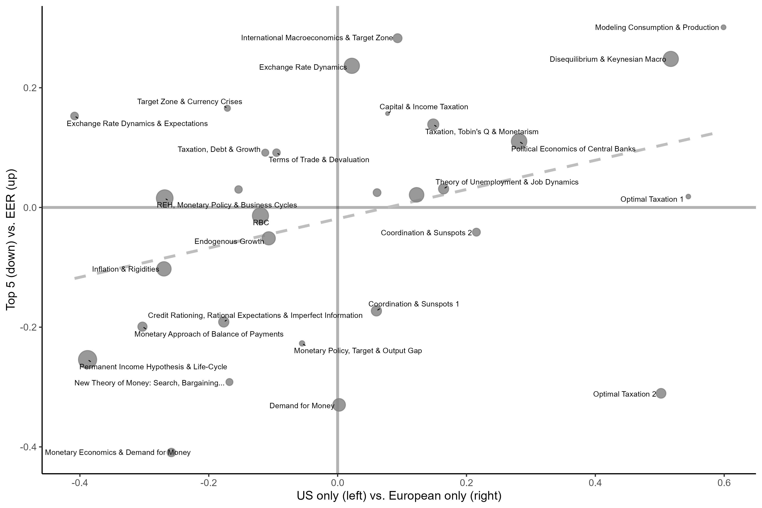

Figure 6.1: The most European clusters using Mean of Log of Ratios Index (the size of the points captures the number of articles in the cluster)

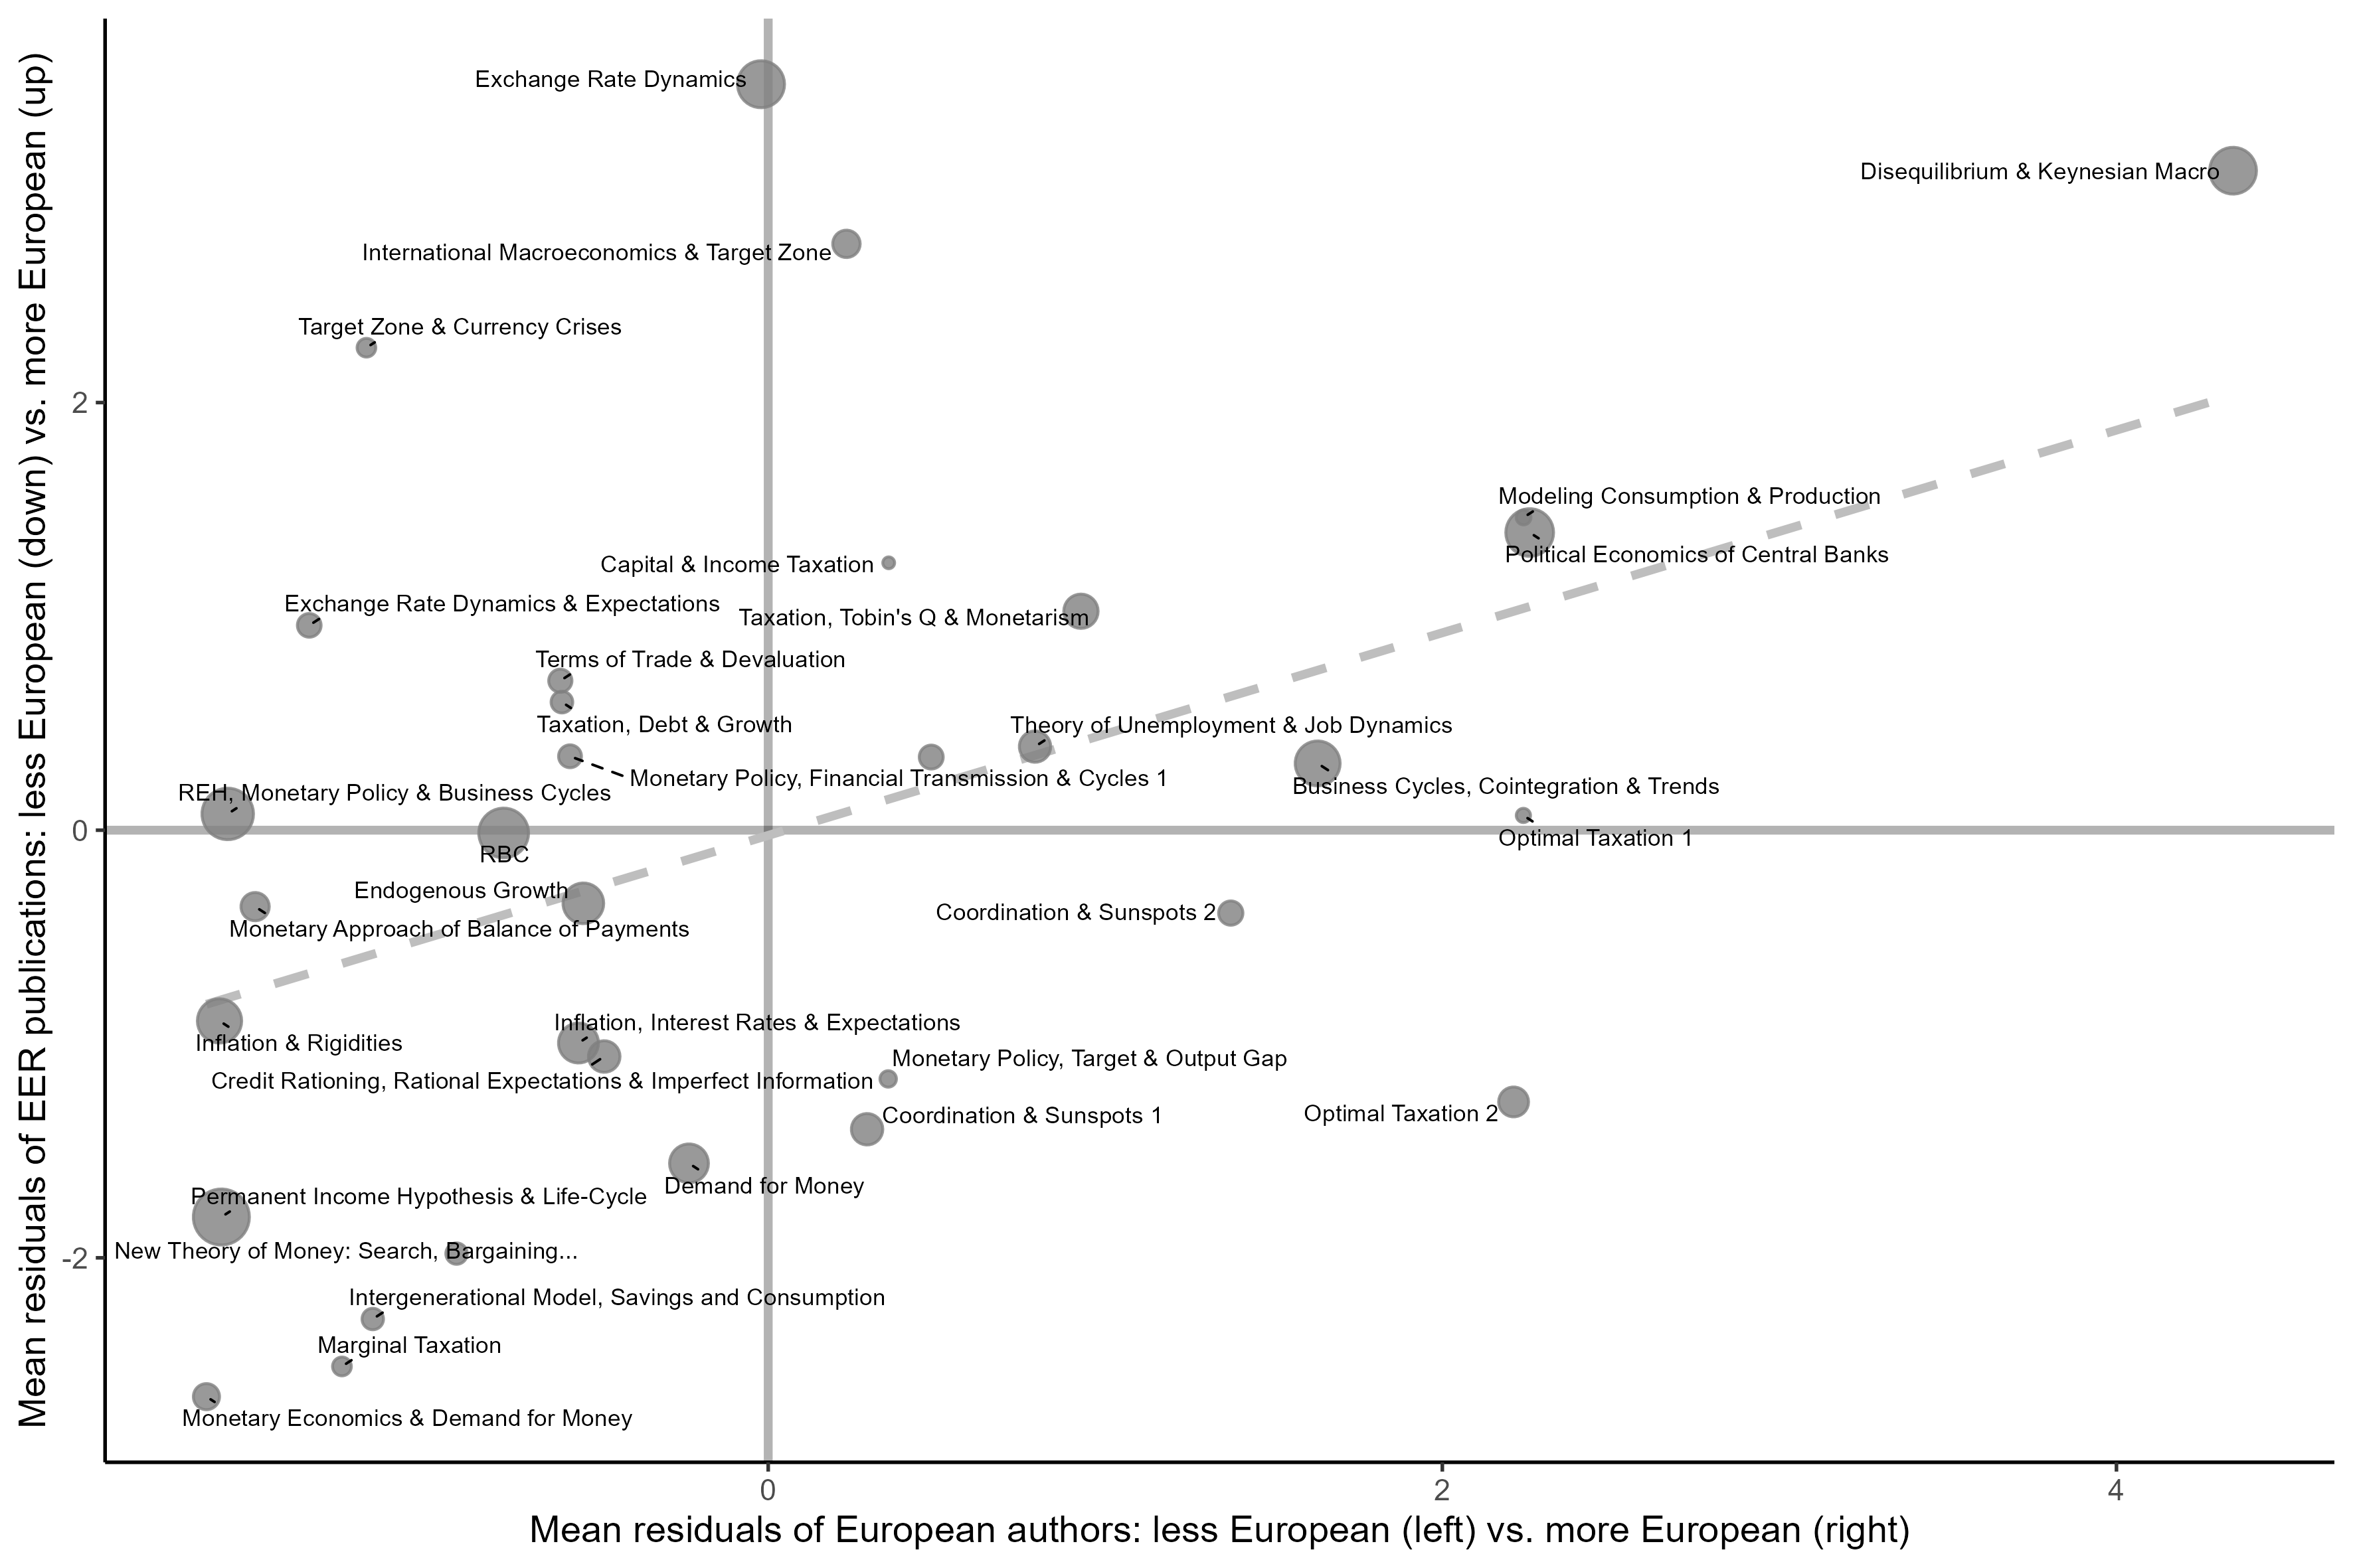

Figure 6.2: The most European clusters using Chi2 Index (the size of the points captures the number of articles in the cluster)

### B.4. Topic Modelling

#### Preprocessing

Our corpus of documents is composed of the titles and abstracts (when available) of macroeconomics articles published in the Top 5 and EER. We have several steps to clean our corpus before running our topic models:

1. Titles and abstracts are merged together for all EER and Top 5 articles.
2. We use the *tidytext* (Silge and Robinson, 2016) and *tokenizers* (Mullen et al., 2018) R packages to ‘tokenise’ the resulting texts (when there is no abstract, only the title is tokenised)? Tokenisation is the process of transforming human-readable text into machine readable objects. Here, the text is split in unique words (unigrams), bigrams (pair of words) and trigrams. In other words, to each article is now associated a list of unigrams, bigrams and trigrams, some appearing several times in the same title *plus* abstract.
3. Stop words are removed using the *Snowball* dictionary.[69] We add to this dictionary some common verbs in abstract like “demonstrate”, “show”, “explain”. Such verbs are likely to be randomly distributed in abstracts, and we want to limit the noise as much as possible.
4. We lemmatise the words using the *textstem* package (Rinker, 2018). The lemmatisation is the process of grouping words together according to their “lemma” which depends on the context. For instance, different forms of a verb are reduced to its infinitive form. The plural of nouns are reduced to the singular.

#### Choosing the number of topics

We use the Correlated Topic Model (Blei and Lafferty, 2007) method implemented in the *STM* R package (Roberts et al., 2019).

From the list of words we have tokenised, cleaned and lemmatised, we test different thresholds and choices by running different models:

* by exluding trigrams or not;
* by removing the terms that are present in less than 0.6% of the Corpus (20 articles), 0.8% (27) and 1% (34);
* by removing articles with less than 8 words or with less than 12 words.[70]

Crossing all these criteria, we thus have 12 different possible combinations. For each of these 12 different combinations, we have run topic models for different number of topics from 20 to 110 with a gap of 5. The chosen model integrates trigrams, removes only terms that appear in less than 0,6% of the documents and keep all articles if they have more than 8 words in their title *plus* abstract. We choose to keep the model with 50 topics.

We have chosen the criteria and the number of topics by comparing the performance of the different models regarding exclusivity, semantic coherence, held-out likelihood and residual dispersion (see Roberts et al., 2019). We have looked closely and qualitatively to a couple of models for which the performance regarding our different indicators were similar. It seemed to us that 50 topics allowed us to have a model with easily understandable topics and an interesting level of granularity. Indeed, increasing the number of topics just splits some topics in two, but did not lead to fundamentally different results.

Finally, we can plot the prevalence over the years of each topic (see the online appendix).

#### Studying the European character of topics

In Figure 3.2 in the text above, we are only keeping, for each topic, articles with a *gamma* value above 0.1. We then calculate the log ratios of both EER and Top 5 articles for each topic, and of European and US authored articles.

For robustness, we have also tested another method. We do not filter the values and keep all articles. For each topic, we calculate the average for articles published in the EER and in the Top 5. We then subtract the two means. We do the same for articles written by Europe-based authors only and by US-based authors only. The two resulting differences are plot in the following Figure 6.3.

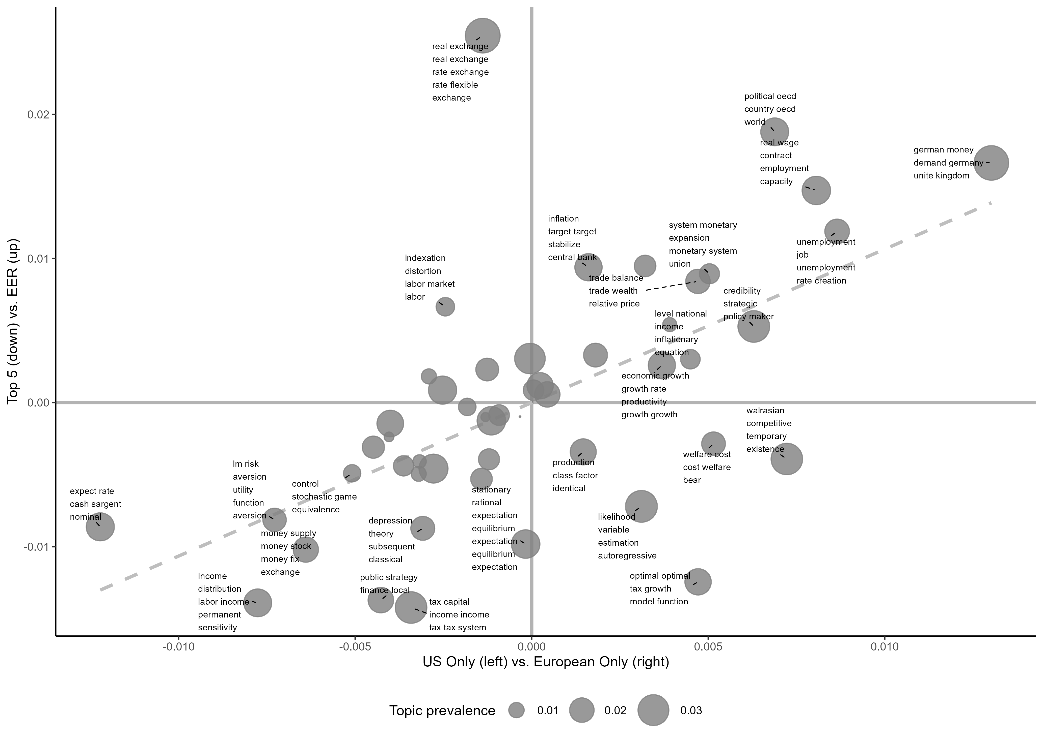

Figure 6.3: The most European topics (Differences of mean method)

1. UCLouvain, ISPOLE; F.R.S.-FNRS.
2. Université Côte d’Azur, CNRS GREDEG France.
3. The circulation of economic ideas has always been relatively internationalised, and examples of the circulation of knowledge and economists prior to the 1970s abound (e.g. Hagemann, 2011; Hesse, 2012). However, we observe a significant acceleration of this process after the 1970s (Coats, 1996), albeit with different national rhythms (e.g. Backhouse, 1997).
4. Of course, this process of Americanisation was not without its share of conflicts: “local conflicts” frequently arose between economists who were “nationally-trained” and those who were “internationally-trained”, particularly in the US (Fourcade, 2006). These conflicts encompassed intellectual issues, such as debates over the relevance of neoclassical theory, as well as institutional matters, including the criteria for evaluating the quality of economists’ work, and thus for determining hiring and promotion decisions.
5. In the rest of the article, we follow Backhouse and Boianovsky and use the expression “disequilibrium macroeconomics” to designate a research program that has been labelled in many ways: “non-Walrasian theory, disequilibrium theory, equilibrium with rationing, *non-tâtonnement* theory, fixed-price models” (Backhouse and Boianovsky, 2013, pp. 8–9).
6. We use “mainstream” as a convenient way to indicate that our focus is on a specific subset of macroeconomics, which adhered to certain standards and fundamental theoretical assumptions, inspired by US economists. Several alternative approaches, such as Marxian and Sraffian economics or British Keynesianism and post-Keynesianism, held strong roots in Europe. Yet, they were considerably less likely to be featured in publications within the EER.
7. Up until 2002, economists from Eastern Europe were scarcely represented. For the sake of simplicity, we will use the term Europe.
8. The corpus we use (see section 3) has very few abstracts between 1969 (the date of the creation of the EER) and 1972. Besides, there is no JEL code for EER articles before 1973, preventing us for identifying macroeconomics articles. After 2002 and the creation of the *Journal of the European Economic Association*, the EER ceased to be the official journal of the EEA.
9. We focus on affiliations rather than nationality. Beyond the fact that data on nationality may be challenging to get, we understand “European macroeconomics” as the macroeconomics developed in Europe. The terms “Europe-based” and “US-based” are used to clarify that the discussion revolves around affiliations. However, for the sake of brevity, we may occasionally employ more concise phrasing such as “Europeans macroeconomists”.
10. The article is also accompanied by a detailed methodological Appendix, as well as an online appendix listing the features of the bibliometric clusters and of the topics identified by our topic model.
11. KU Leuven was split in 1968 into a Flemish and a French-speaking part. The latter gave rise to the *Université Catholique de Louvain* in Louvain-La-Neuve, where CORE eventually moved in the mid-1970s.
12. This is an approximation, as the affiliation per author is not available in our corpus and we only have the affiliations per article (see Appendix B.2. for more details).
13. In contrast to *The Economic Journal* and *Economica*, where British and US affiliations accounted approximately for 80 percent of authors from the 1970s to the 1990s, these affiliations represented merely 30 to 45 percent in the EER. Meanwhile, European countries (excluding the UK) represented between 40 and 50 percent in the EER.
14. In Figure 2.1, the ‘European authors’, ‘US authors’ and ‘EU-US collaboration’ categories are computed on the overall corpus; the ‘Intra-EU Collaboration’ category is computed only on EER papers written by European authors (the ‘European authors’ category).
15. We count only references to articles published after 1969, the inaugural year of the EER. We have also looked at the , , and , which remain steadily under 0.5%. Graphs including these journals can be found in the online appendix.
16. Including more specialised journals would rather reveal emerging trends that have not yet become mainstream.
17. Incorporating more journals might have introduced the risks of adding noise, stemming from significant variations in editorship and primary features of some journals used for comparison.
18. It should be noted that we also examine the content published in macroeconomics in the EER independently of the comparison with the Top 5, meaning the comparison is not the sole driver of our analysis.
19. See Appendix B.1. for the full list of JEL codes used. Using JEL codes as a classification method is more conventional and less arbitrary than creating our own system. This approach occasionally incorporates articles that may not seem overtly “macroeconomic”, either because of misclassification or because old JEL codes mixed subjects that were not “macroeconomics” in the new classification. However, bibliometric coupling and topic modelling isolate articles that deviate significantly from the “average” macroeconomic content or group them based on their similarities. Consequently, articles that are not directly related to macroeconomics can be set aside and do not affect our overall results.
20. Crossing databases has been necessary due to missing years and information in the different databases we have used (*Web of Science*, *Scopus* and *Microsoft Academic Premier*). See Appendix B.1. for more details on the building of our dataset.
21. For more details on the measure of weights, see Appendix B.3.
22. See Appendix B.3. for details on the merging criteria.
23. This information is collected for each cluster in the online appendix.
24. Our assumption is that the content of articles published in the Top 5 by European economists could be more largely influenced by the standards of Top 5 journals and of US macroeconomics, and thus could be less representative of European economics than the articles published in the EER.
25. Table 6.2 lists the 33 most significant clusters with the two measures. Appendix B.3. explains the method in more detail.
26. To verify the robustness of our index, we also produce two alternatives indexes giving similar results (see Appendix B.3.).
27. See the Appendix B.4. for further details on the preprocessing steps we use.
28. Appendix B.4. gives more details on the different models we have tested and how we have set the number of topics.
29. To select the most representative words for each topic, we use *FREX* rather than values (Bischof and Airoldi, 2012). FREX is the weighted harmonic mean of the ngram’s exclusivity and frequency. Exclusivity is a measure of how much a term is used in a topic compared to its frequency in others. By using FREX rather than values, we can highlight the words that most strongly identify each topic, rather than highlighting more common words that may also appear in other topics.
30. This information is collected in the online appendix.
31. Refer to Appendix B.4. for details on the measure and alternative results using a measure that does not employ as a threshold.
32. To our knowledge, this article represents the first attempt to combine both methods to describe the evolution of the state of economics. Utilising both approaches is essential to ensure the robustness of our results and systematically verify if a distinctly “European” cluster can be associated with one or several “European” topics, and conversely.
33. See clusters “Intergenerational model, Savings & Consumption” and “Permanent Income and Life-Cycle Hypotheses”, as well as topics 12 and 14. This literature sought to introduce structural heterogeneity in life cycle or permanent income models (see Cherrier et al., 2023, this issue).
34. See clusters “Monetary Economics & Demand for Money” and “Demand for Money”, as well as Topic 2 on the demand for money and money supply, which is one of the most non-European topic, and Topic 19 on demand for money and term structure of interest rates.
35. We have to wait the 1982-1988 window to see some new classical contributions cited as much by Europeans as by US economists. The integration of these contributions obviously took some time in Europe and lagged behind the US.
36. These contributions are grouped in topic 46 and cluster “Modeling Consumption & Production”, which partially overlap.
37. Barten’s work extended beyond demand equations. Along with other CORE economists, he developed a macroeconometric model of the European Economic Community (EEC), which was presented in the EER (Barten et al., 1976). The following year, André Dramais from the *Université Libre de Bruxelles* presented empirical results on inflation transmission between EEC members, using a competing macroeconometric model, DESMOS (Dramais, 1977). Both models constituted crucial steps in the development of macroeconometric models at the European Commission (see Acosta et al., 2023, this issue).
38. This is especially true for the British side, which devoted time to criticising many new trends in the US. For instance, Deaton and Muellbauer attacked the search for theoretical microfoundations to macroeconomics, which ignored aggregation issues (Cherrier et al., 2023, this issue).
39. Some transnational connections did exist yet. For instance, Hendry visited CORE during 1980-1981, while Angus Deaton was also there (Ericsson, 2004). Hendry started to work with Jean-François Richard, a CORE econometrician, and Robert Engle, then at University of California San Diego. The resulting article developed the concept of “strong exogeneity” and “super exogeneity” (Engle et al., 1983).
40. See Topic 46 and Community “Business Cycles, Cointegration & Trends”.
41. The French Olivier Blanchard was another important researcher in this domain, but was working in the US.
42. See Duarte and Lima (2012) for a history of microfoundations in macroeconomics.
43. As a complement, topic modelling demonstrates the extent to which disequilibrium theory pervaded European macroeconomics in the 1980s, unifying the treatment of diverse macroeconomic issues (see notably Topic 25, Topic 39, and Topic 11.
44. See topic 11.
45. Malinvaud (1977) proposed a third regime, “repressed inflation”, resulting from excess demand on both markets.
46. “Influential” means here highly cited by European economists in one or several clusters or topics.
47. See topic 39.
48. On this episode, see Backhouse et al. (2023) as well as Plassard and Renault (2023), both in this issue.
49. See the destiny of the disequilibrium cluster and of topic 11 in the summary figures in the online appendix.
50. Many articles of the disequilibrium cluster are to be found in the cluster “Coordination & Sunspots 2” after the disappearance of the former (see the summary flow chart in the online appendix). The cluster “Coordination & Sunspots 2” was only slightly over-represented by European economists, but gathered articles mainly published in the Top 5.
51. See Topic 37 and Community “Theory of Unemployment and Job Dynamics”
52. For a history of the emergence of the “new political economy” or “new political macroeconomics” label, see Galvão de Almeida (2021).
53. Torsten Persson obtained his PhD in 1982 at the Institute for International Economic Studies in Stockholm under the supervision of Lars Svensson and became professor in Stockholm in 1987. Tabellini graduated from Torino before moving to UCLA for his PhD. After an initial position at Stanford, he returned to Italy in 1990.
54. They used the term “political economics” rather than “political economy” to avoid a supposed association with “an alternative analytical approach” that considered that “the traditional tools of analysis in economics were not appropriate to study political phenomena” (Persson and Tabellini, 2002, p. 2).
55. Italian economists were overly represented in this line of research, not only in Europe but also in the US, the most famous example being Alberto Alesina in Harvard.
56. See the cluster “Political Economics of Central Banks” and the topic 8 on credibility, optimal policy and policy rule. Beyond these very “European” cluster and topic, the examination of other topics allows us to observe that the new political economy literature infused many subjects. In many prevalent topics in the 1990s, the difference in the references cited by Europe-based and US-based economists is explained by the fact that Europeans refer more to political economy contributions (see Topic 3, 20, 22 and 36).
57. The interest for political economy in the EER may have been encouraged by the fact that many economists advocating this line of research such as Marco Pagano, Personn, Drazen, Giavazzi or Alesina were associate editors or editors of the EER in the 1990s. Nonetheless, this inclination of Europe-based macroeconomists for political economy is not limited to the EER, as a similar trend was observable in the Top 5 journals.
58. Giavazzi and Pagano’s article constitutes a major reference for topics 3 and 8.
59. We also observe another important approach to the EMS issue (see Topic 6), which is more empirical and somewhat less framed in political economy terms, but still deals with “credibility”: the expectations of exiting the EMS and the credibility associated with certain exchange rates in a target zone regime (Rose and Svensson, 1994; Svensson, 1993).
60. The OCA theory, on the other hand, focused on the divergence in output and employment trends.
61. In topic 3 on the monetary union, both Europe-based authors and EER articles refer more to the Barro-Gordon model or to Giavazzi and Pagano (1988) than to Mundell’s and McKinnon’s pioneering contributions on the OCA.
62. See topics 3 (on monetary union), 6 (on exchange rate dynamics), 25 (on real wages, employment and contracts) and 8 (on strategic policy making issues).
63. These references were important for Europe-based economists in comparison to US-based economists, in Topic 36.
64. For instance, in our analysis, we have intentionally omitted topics and clusters related to international macroeconomics, despite occasionally mentioning some relevant articles. The reason is that while international macroeconomics topics and clusters are often associated with the EER, they do not exhibit an over-representation of Europe-based economists. Additionally, we have excluded from our analysis clusters that were too small in size and topics that exhibited low prevalence. We also excluded topics and clusters that seemed too distant from the core domain of macroeconomics—this latter issue is a consequence of the different JEL code classification before 1991.
65. The new classification has a clear categorisation of Macroeconomics (the letter ‘E’), but we added F3 and F4 as they deal with international macroeconomics. For the older JEL codes, we used the table of correspondence produce by the *Journal of Economic Literature* itself (JEL, 1991).
66. Most of the unmatched articles are not ‘articles’ properly speaking: in most cases, they are reply and comments on other published articles. We start collecting articles in 1973 as there was no JEL codes for EER article before this date.
67. We have implemented this method in the *biblionetwork* R package (Goutsmedt et al., 2023).
68. See the online appendix for a graph summarising the evolution of the clusters and the flows of nodes between clusters. The whole method of building consecutive networks, finding intertemporal clusters and projecting a summary of clusters evolutions is implemented in the *networkflow* package in R (Goutsmedt and Truc, 2023).
69. See <http://snowball.tartarus.org/algorithms/english/stop.txt>.
70. Here, only articles with no abstract are impacted.