Lexi Gover

BS723/(730) Spring 2026
Homework 5

Read in the dataset spear4.sas7bdat (spear4.csv). The dataset contains the following variables on infants and young children in the SPEAR study:
Variable Name | Description | Coding/Units
ptid | Patient ID | ---
Agemo | Age | Months
B1_sex | Sex | F(emale), M(ale)
b_temp_f | Body temperature at enrollment | Degrees Fahrenheit
pulseox | Pulse Oximetry | % Oxygen saturation
First_resprate | Baseline respiratory rate | Breaths per min
Final_resprate | Final respiratory rate | Breaths per min
b_heart_rate | Baseline heart rate | Beats per min
treat | Treatment indicator | Chloramphenicol = 1, Ampicillin & Gentamicin = 2

The cut-off for normal respiratory rates differs by age. The cut-off for normal breath rates for infants (0-11 months) is 50 breaths per minute and for children (12-59 months) is 40 breaths per minute. You will determine whether there is a statistically significant difference in baseline respiratory rate (first_resprate) between the infants and the young children enrolled in the SPEAR study. (You will need to create a new variable defining which age group the subjects belong to.)
- What test is suitable to answer the investigator’s question? What are your null and alternative hypotheses? (2 points)
Two sample t test
H₀: infants (0-11mo) and young children (12-59mo) have same baseline respiratory rate.
H₁: infants (0-11mo) and young children (12-59mo) do not have same baseline respiratory rate.

- Read in the data. Then create a new variable from age called “young” as follows (3 points)
young = 1 if age is 0-11 months
young = 2 if age is 12-59 months
spear_data = read.csv("spear4.csv", header=TRUE)
spear_data$young = rep(0, length(spear_data$agemo))
spear_data$young[spear_data$agemo <= 11] = 1
spear_data$young[spear_data$agemo >= 12 & spear_data$agemo <= 59] = 2

- By hand, calculate the point-estimate of the difference in baseline respiratory rate between the age categories you created. You can use SAS/R to compute the mean respiratory rate separately for each age category. (2 points)
round(tapply(spear_data$first_resprate, spear_data$young, mean),2)
69.98 - 66.48 = 3.45
The point-estimate of the difference in baseline respiratory rate between the age categories (0-11mo and 12-59mo) is 3.5 breaths per min.
- Assuming the two age groups have equal variance, hand calculate the pooled variance and the standard error of the point estimate in c. Write out the formulas you used and show all your work. Calculate the 95% confidence interval for the difference in means (again, show all your work). Given that the sample size is large, let us assume t_{α/2}=1.96. You can use SAS/R to compute the mean and standard deviation separately for each age category. (3 points)
tapply(spear_data$first_resprate, spear_data$young, sd)
table(spear_data$young)

$s_{p}^{2}=\frac{\left(673-1\right)\left({11.54}^{2}\right)+(184-1)({12.34}^{2})}{673+184-2}=$ 137.26
$SE\left({\overline{X}}_{1}-{\overline{X}}_{2}\right)=\sqrt{137.26}\sqrt{\frac{1}{673}+\frac{1}{184}}=$ 0.97

3.45 – 1.96(0.97) = 1.55
3.45 + 1.96(0.97) = 5.35
The confidence interval is [1.55, 5.35]

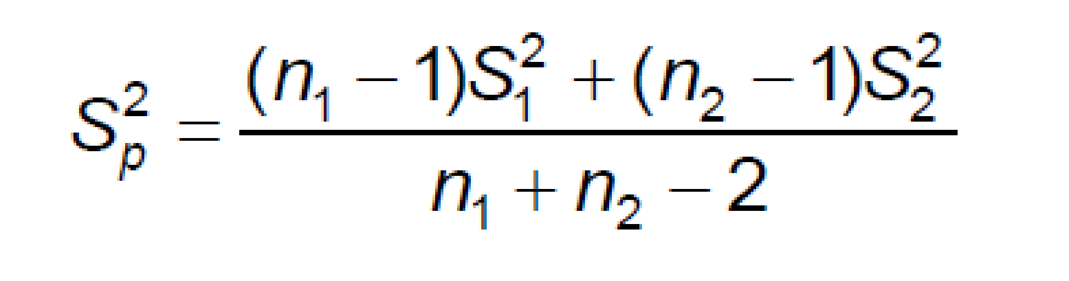
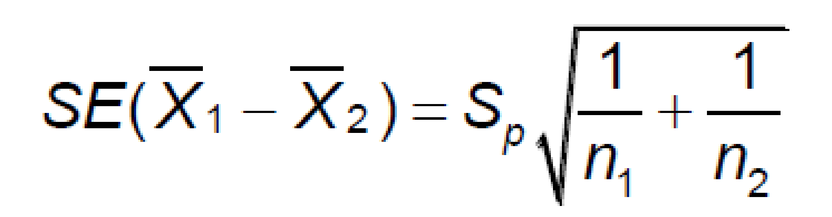

- Calculate the t-statistic by hand. Is the difference in means significantly different from 0 at significant level of 0.05? You do not have to calculate the exact p-value. Rather assume t_{α/2}=1.96. (2 points)
$t=\frac{{(\overline{X}}_{1}-{\overline{X}}_{2})-0}{SE({\overline{X}}_{1}-{\overline{X}}_{2})}$

$t=\frac{(3.45)-0}{0.97}$ = 3.56
- Using SAS/R, confirm your calculations above. Include your program in the answer. Is the assumption for equal variance across groups appropriate? (2 points)
t.test(first_resprate ~ young, data = spear_data, var.equal = TRUE)
Two Sample t-test
data: first_resprate by young
t = 3.5874, df = 855, p-value = 0.0003529
alternative hypothesis: true difference in means between group 1 and group 2 is not equal to 0
95 percent confidence interval:
1.583046 5.407958
sample estimates:
mean in group 1 mean in group 2
69.9792 66.4837

mean_tap = tapply(spear_data$first_resprate, spear_data$young, mean)
sd_tap = tapply(spear_data$first_resprate, spear_data$young, sd)

x1_bar = mean_tap[1]
x2_bar = mean_tap[2]

sd1 = sd_tap[1]
sd2 = sd_tap[2]

n_tab = table(spear_data$young)
n1 = n_tab[1]
n2 = n_tab[2]

sp2 = ((n1-1)*sd1^2 + (n2-1)*sd2^2) / (n1+n2-2)
sp2

SE = sqrt(sp2) * sqrt(1/n1 + 1/n2)
SE

sp2 = 137.1856
SE = 0.9743796

It is appropriate to assume equal variance since the standard deviation of the two groups are similar (11.54 and 12.34) and the variance ratio is close to 1.
** Slight differences in output between hand-calculated and r possibly due to rounding throughout and t_{α/2}=1.96 assumption. Will use r output for conclusion because it is more accurate.
- Write up your results and conclusions from your test, using a 0.05 level of significance. Include the null and alternative hypothesis (written in words), the level of significance, the difference in means, an interpretation of the difference in means, the 95% CI for the difference in means; report the test statistic, degrees of freedom and pvalue (for the test of equal means and equal variances) along with the conclusion for both tests. (6 points)
H₀: infants (0-11mo) and young children (12-59mo) have same baseline respiratory rate.
H₁: infants (0-11mo) and young children (12-59mo) do not have same baseline respiratory rate.
Level of significance: 0.05
Difference in means: 3.5
Interpretation of difference of means: Infants (0–11 months) have an average baseline respiratory rate 3.5 breaths per minute higher than children aged 12–59 months.
95% CI for the difference in means: [1.58, 5.41]
test statistic: 3.59
degrees of freedom: 855
pvalue: 0.0003529
The sample mean baseline respiratory rate for infants aged 0–11 months was 69.98 breaths per minute (n = 673, SD = 11.54) compared to a mean of 66.48 breaths per minute (n = 184, SD = 12.34) for children aged 12–59 months.
Since the p-value < 0.05 (or t > critical value), we reject the null hypothesis that the mean baseline respiratory rate is the same for the two age groups.
We conclude that the average baseline respiratory rate of the population is statistically higher for infants aged 0-11 months compared to children aged 12–59 months.

