Article

Maximum Spherical Mean Value (mSMV) for Shadow Reduction in Quantitative Susceptibility Mapping

|  |
| --- |
| **Citation:** Roberts, A.G..; Spincemaille, P.; Nguyen, T.; Wang, Y. Maximum Spherical Mean Value (mSMV) for Shadow Reduction in Quantitative Susceptibility Mapping. *Tomography* **2022**, *8*, Firstpage–Lastpage. https://doi.org/10.3390/xxxxx  Academic Editor: Firstname Lastname  Received: date  Accepted: date  Published: date  **Publisher’s Note:** MDPI stays neutral with regard to jurisdictional claims in published maps and institutional affiliations.  A picture containing text, clipart  Description automatically generated  **Copyright:** © 2022 by the authors. Submitted for possible open access publication under the terms and conditions of the Creative Commons Attribution (CC BY) license (https://creativecommons.org/licenses/by/4.0/). |

Alexandra G. Roberts1,2,*, Pascal Spincemaille 2 , Thanh Nguyen, and Yi Wang 1,2

1 Department of Electrical and Computer Engineering, Cornell University, Ithaca, NY.

2 Department of Radiology, Weill Medical College of Cornell University, New York, NY.

**\*** Correspondence: agr78@cornell.edu; Tel.: +1-607-255-0389

**Abstract:** The maximum corollary of Green’s theorem can be exploited to remove residual background field that generates shadow artifacts in quantitative susceptibility mapping. The maximum value property of a harmonic function and mean value theorem resulting from Green’s theorem form the basis of this shadow reduction algorithm, referred to as Maximum Spherical Mean Value (mSMV). Applying mSMV to the local field prior to dipole inversion significantly reduces shadows in comparison to other background field removal methods. The mSMV method is applied to numerical simulations and healthy subjects to significantly reduce shadow artifacts.

**Keywords:** Magnetic Resonance Imaging**;** Quantitative Susceptibility Mapping; Artifact Reduction; Background Field Removal; Image Reconstruction; Signal Representation.

1. Introduction

1.1 Background

Quantitative Susceptibility Mapping (QSM) generates a magnetic resonance imaging (MRI) contrast in tissue magnetic susceptibility from the measured local or relative difference field (RDF) . In image space described by spatial coordinate , the RDF is described by a convolution between the dipole kernel and susceptibility [1]. The inverse problem of dipole deconvolution is ill-posed due to the presence of zero in the dipole kernel. The partial differential equation corresponding to dipole deconvolution has the wave propagator as its fundamental solution in image space [2, 3], and dipole incompatibilities (such as noise) in the RDF cause severe artifacts in the susceptibility solution [3-5].

Bayesian inference approaches such as Morphology Enabled Dipole Inversion (MEDI) [6] use a prior knowledge, such as an edge weighted gradient under an L1 norm, to penalize the streaking artifacts arising from dipole-incompatible sources in the phase of the gradient echo data. However, shadowing artifacts over larger contiguous areas may exist, due to field errors in low signal regions, such as in bone or near air-tissue interfaces, or from residual background field generated by sources outside the region of interest (ROI). These field errors induce shadow artifacts that are less effectively suppressed by regularization designed for reducing streaking. Other efforts to reduce shadow artifacts during dipole inversion do so at the expense of accuracy [7] or require total field inversion [8], or the use of a field estimation error map [9].

Exploiting the Spherical Mean Value (SMV) property of the harmonic background field and including it in the dipole kernel (MEDI-SMV) suppress many of these artifacts at the cost of an eroded brain mask. Many variations of this idea, Sophisticated Harmonic Artifact Reduction for Phase data (SHARP) [10-13] have sought to reduce artifacts while preserving the boundary of the brain. Additionally, the brain is eroded by assuming the local field to be zero at the boundary in the Laplacian Boundary Value (LBV) [14] background method. This is required to obtain the accurate boundary condition needed for a unique solution.

Each of these methods employ some degree of uniform brain erosion while removing shadows. Here, an algorithm based on the maximum corollary of Green’s theorem is proposed to remove shadows while preserving the edge of the brain. This method is referred to as maximum Spherical Mean Value, or mSMV.

1.2 Motivation

In local field QSM reconstructions, the background field is removed by some method that can be categorized by assumption following the convention in [15]. Such assumptions are “No sources close to the boundary” (NOS), “No harmonic internal and boundary fields in the boundary region” (NOHA) and “Minimization of an objective function involving a norm” (MOIN). In all these methods, residual background field at the boundary generates shadows in the QSM reconstruction. For NOS methods (SHARP, VSHARP, SMV), the residual field results from the limitations of the SMV operator at the boundary. For NOHA (LBV, iSMV), the entire boundary is assumed to be background field and is therefore set the zero in the local field, making some erosion inevitable. For MOIN (RESHARP, PDF) methods, the assumption that the local and background fields are orthogonal fails near the boundary, resulting in residual background field. While some of the boundary is indeed background field due to an oversized mask [16] and/or use of MOIN methods, it will be demonstrated that uniform erosion of the local field boundary is not required, and shadow reduction can be achieved without eroding the brain.

1.3 Theory

The image space RDF is described by a convolution between the dipole kernel and susceptibility. In k-space, the RDF is the product between the dipole kernel and susceptibility frequency content, . This problem is ill-posed due to the presence of in the dipole kernel. The domain can be restricted to for truncated k-space division. An image-space solution can be found by solving the partial differential equation

. Given an ROI , let the total field map resulting from unwrapped phase data be . The background field is generated by sources outside of and the local field by sources within . Note that the background field within is harmonic, or where is the Laplacian operator . The implications of this property will now be discussed.

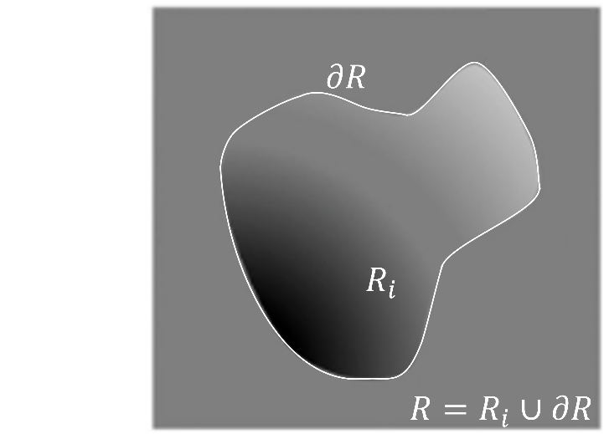Let be the boundary of shown in Figure 1.

Figure 1. Region enclosed by on which harmonic functions are defined. Note that can be partitioned into the interior region and the boundary region . Figure adapted from [15].

Define the total field as

|  |  |  |
| --- | --- | --- |
|  | , | (1) |

A corollary of Green’s theorem is the mean value principle, [17] which is the basis of many of the methods discussed in this work, and states

|  |  |  |
| --- | --- | --- |
|  | , | (2) |

Indicating that the value of the harmonic function describing the background field, at the center of a sphere with volume ν is equal to the mean of the function values within the sphere. In terms of the background field, Equation 2 becomes

*,* where is the spherical mean value (SMV) operator with radius and is the spatial coordinate. Erosion of the local field occurs at points near the boundary where the kernel extends beyond the ROI. In practice, discretization imposes a minimum on the radius of the sphere for which the average can accurately be computed. In practice, this results in an eroded mask when . However, another corollary of Green’s theorem states  can be found on the boundary

|  |  |  |
| --- | --- | --- |
|  | , | (3) |

Or, generally, the maximum value of the harmonic function , is on the boundary of the ROI [18]. The proof of Equation 3 from Equation 2 is given in the Appendix.

1.4 Maximum SMV (mSMV) algorithm

Since the background field is typically an order of magnitude larger than the local field , the field the location of the maximum is assumed to contain background field, such that the local field in this location is assumed to be zero.

An initial SMV filtering operation is performed, such that

|  |  |
| --- | --- |
|  | (4) |

Where the SMV operator is

|  |  |
| --- | --- |
|  | (5) |

Here denotes the Fourier transform and the point-wise multiplication with , which is the Fourier transform of the spherical kernel with radius . An estimate of the background field at the edge is permitted since these voxels will be considered shortly, so no erosion takes place. Let be the mask eroded by . Further assume that the local field at locations in nearby is zero as well. Region-growing is used to obtain such as region resulting in a binary mask . Then, a normal distribution is fit to . The mean is shifted such that . The standard deviation of this distribution is scaled by the region-growing parameter to create the threshold to generate a global binary mask . The threshold is acquired by taking the minimum between .

|  |  |
| --- | --- |
|  | (7) |

Where Note that the region-growing parameter is set such that the initial background field mask contains at least half of the minimum matrix size of the input local field. The region-growing parameter is initialized at

and until this condition is fulfilled. Each neighboring voxel is included in if , or if it falls within the current region defined by average and . The seed point of this region is the single voxel . Assume that the local field within the resulting is zero. The mSMV estimate of the local field is then taken to be

|  |  |  |  |
| --- | --- | --- | --- |
|  |  |  | (8) |

Equation 8 removes residual background field that generates shadow artifacts prior to reconstruction. After removing the residual background field, the reconstructed maximum likelihood estimation of the QSM can infer valid susceptibilities at these points. This process is illustrated in Figure 2 and an example of the sampled background field distribution is given in Figure 3. The spatial dependence on is omitted for clarity.

Figure 2. The mSMV algorithm.

2. Materials and Methods

2.1. Numerical brain

To simulate errors in the frequency map, the total field was simulated as the sum of the background field and the local field . The background field was assigned a value of , the susceptibility of air. The local field was computed by dipole convolution , where is the dipole kernel. The true susceptibilitywas obtained from the MEDI toolbox sample data and is described in [19]. Multi-gradient echo data was simulated such that the signal at the echo is with frequency map , central frequency and total field . The simulated signal consisted of echoes with spacing with additive complex Gaussian white noise at , following the guidelines described by [20]. The phase was unwrapped using ROMEO [21] and the background field was removed using the previously described PDF method [22]. The residual background field after application of PDF was removed using mSMV (proposed here) with a region-growing parameter of . Spatially connected voxels within the range of were included in the region. This process is repeated forsamples, i.e., the largest values of the local field magnitude. Each grown region is inclusive of previously grown regions. The spatial connectivity of each region was distance limited to for efficiency. A Gaussian distribution was fit to each region with mean-shifted values normalized by the maximum. Finally, the distribution with the smallest standard deviation was selected, such that is the residual background field mask threshold.

This was compared to SMV with the MEDI implementation [6], SHARP [10], RESHARP [11], VSHARP [12], iSMV [13], LBV [14], each with an erosion radius of . Additionally, SHARP (truncation value of ), RESHARP (regularization parameter of ), and VSHARP (kernel radii varying from to ) with the SEPIA implementation [23] was used alongside a control with no residual background field removal. Parameters for SHARP and RESHARP were chosen from the range outlined in [24] and the truncation value and regularization parameter (respectively) for each method was chosen by maximizing the fit of the result with the ground truth local field. The local fields were then reconstructed using MEDI-L1 with regularization parameter . Methods which divide out the SMV kernel or do not feature it (SHARP, RESHARP, and LBV) used the unit dipole kernel in reconstruction. Methods which retain the SMV kernel (SMV, iSMV, mSMV, and the SEPIA implementation of VSHARP) in the filtered local field were reconstructed with a filtered dipole kernel . The extent of shadow reduction (where shadow is measured by the gray matter variance) and by the goodness of fit and slope between the ground truth and reconstructed gray matter. The brain ROIs fit and slope is also a measure of reconstruction quality. The impact of low SNR regions in the phase uncertainty map was assessed by binarizing this map and comparing to mSMV.

2.2. In vivo healthy subjects

Ten patients were scanned at (GE Healthcare) using a 3D multi-echo spoiled gradient echo sequence. Acquisition parameters were FOV of , partial FOV factor of 0.8, acquisition matrix size of , flip angle , slice thickness of , repetition time , number of echoes of , the first echo at , echo spacing , parallel imaging factor of , and a scan time of . All local fields were obtained via PDF and then subjected to mSMV, SMV, LBV, and VSHARP to remove residual background field causing shadow artifacts. The optimized parameters outlined in the *Numerical brain* section were used and the QSMs were reconstructed using MEDI-L1 with the default regularization parameter . All studies were approved by the Weill Cornell Institutional Review Board.

3. Results

3.1. Numerical brain

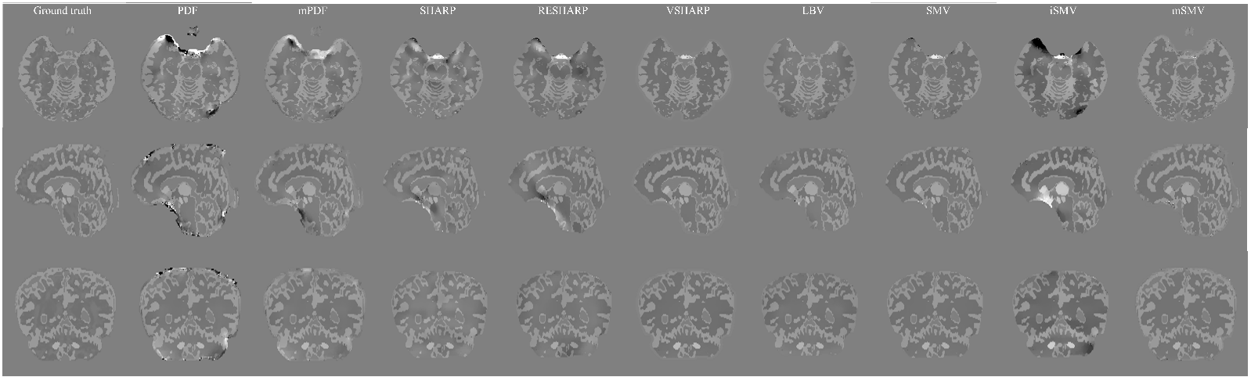Shadow reduction and overall reconstruction quality of mSMV and other methods is quantified in Table 1. The results are displayed in Figure 3 with relevant reconstruction methods in Table 1.

Figure 3. Numerical brain reconstructions.

Table 1. Reconstruction metrics for various shadow reduction methods.

|  |  |  |  |  |
| --- | --- | --- | --- | --- |
| **Method** | **Brain ROI** | | **Gray matter** | |
| PDF | 0.9965 | 1.0490 | 0.3014 | 0.9071 |
| mPDF | 0.9973 | 1.0763 | 0.7124 | 0.8871 |
| SHARP | 0.9129 | 0.7033 | 0.5861 | 0.6705 |
| RESHARP | 0.9636 | 0.8516 | 0.5172 | 0.5824 |
| VSHARP | 0.9967 | 1.0960 | 0.7837 | 0.6986 |
| SMV | 0.9991 | 0.9816 | 0.6983 | 0.6783 |
| iSMV | 0.9718 | 1.7487 | 0.4596 | 0.7397 |
| **\*mSMV** | **0.9994** | 0.9901 | **0.9633** | 0.9147 |

The use of the phase uncertainty map as a background field mask is compared in Figure 4 below.

Figure 4. Shadow reduction in QSM reconstructions using the phase uncertainty map and the mSMV method (background field mask).

3.2. In vivo healthy subjects

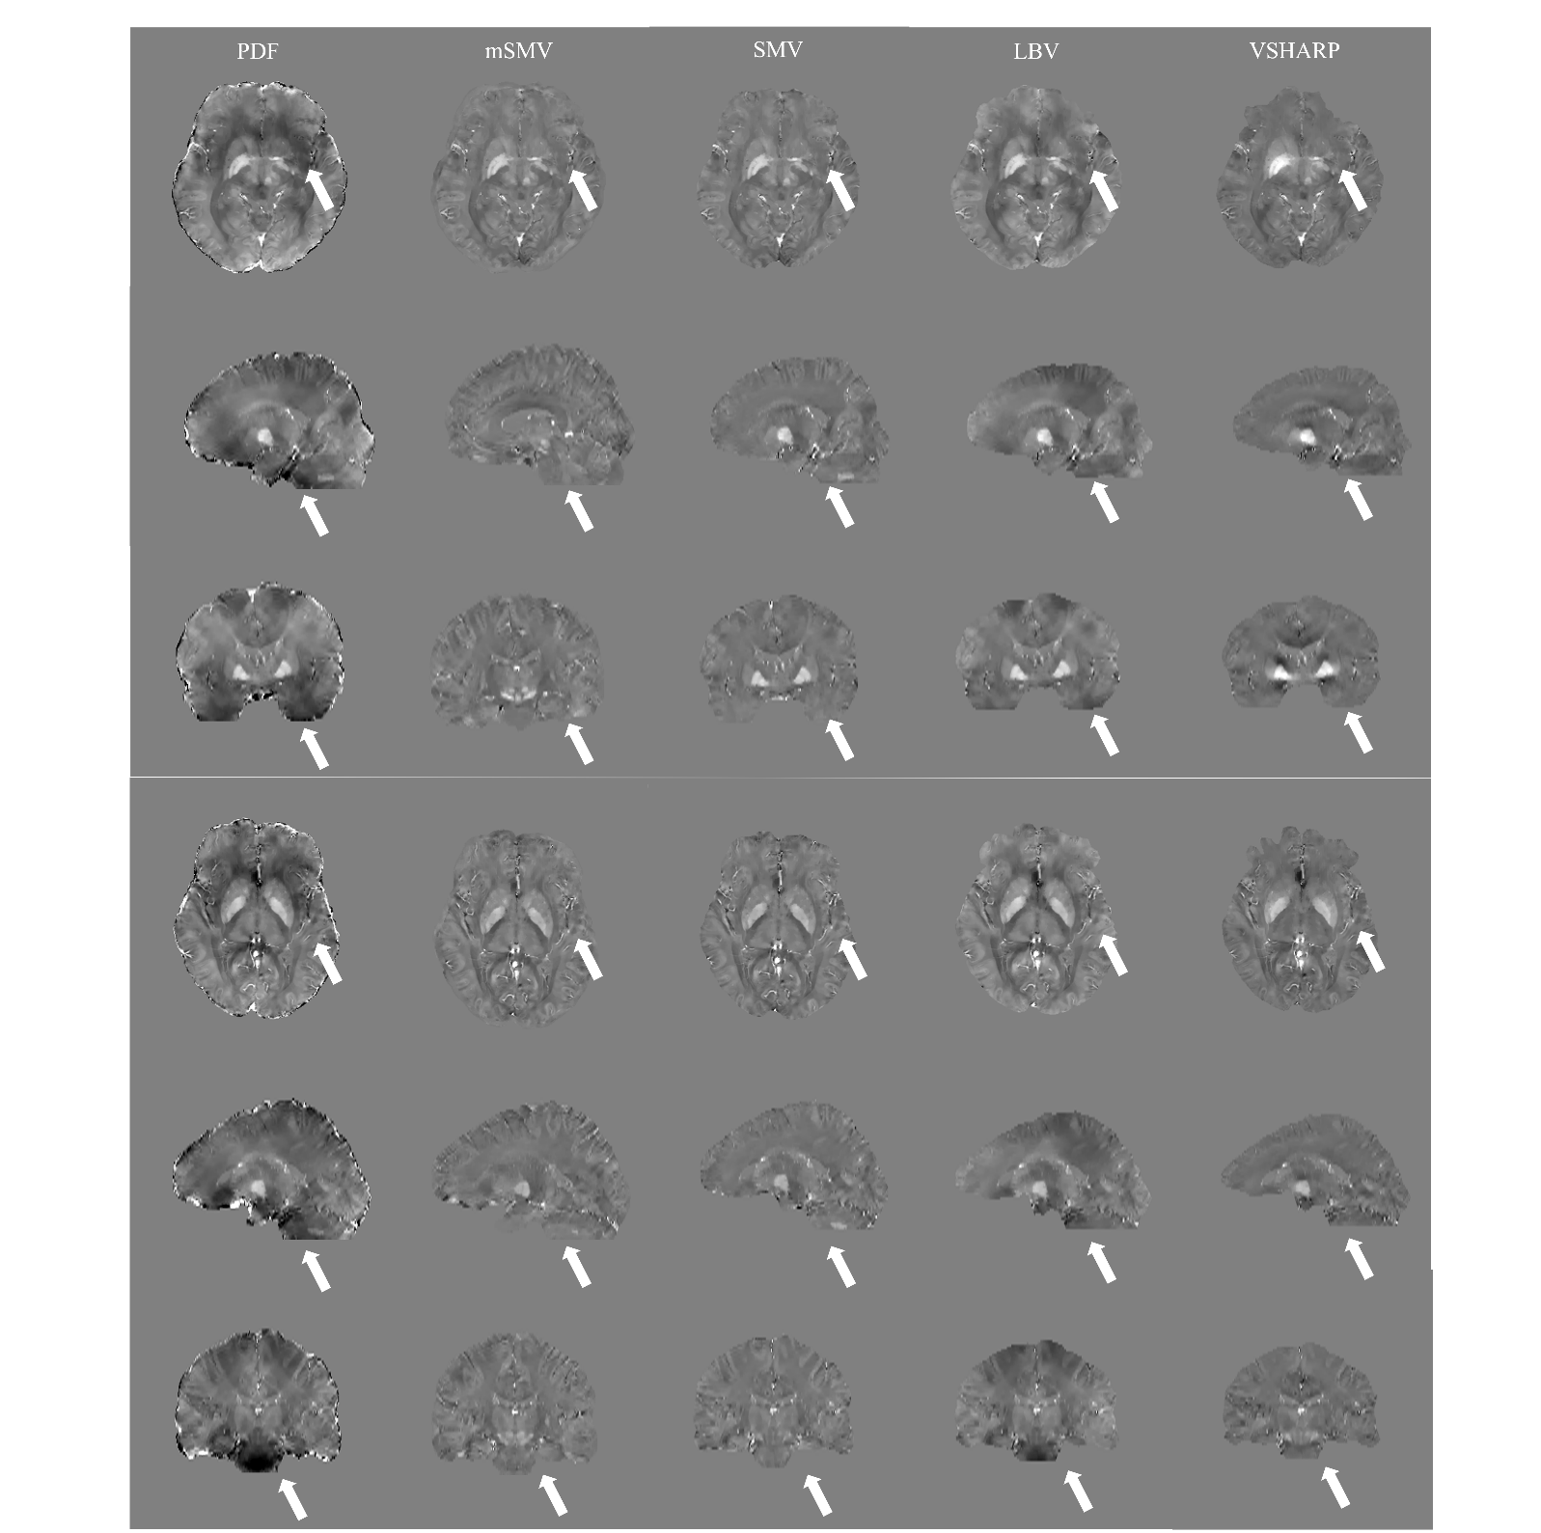Shadow reduction for mSMV and the other methods is compared in healthy subjects in Figure 5. The strong correlation between mSMV and SMV is demonstrated in Figure 6.

Figure 5. Sample QSMs, mSMV both reduces shadows and preserves the edge of the brain.

Figure 6. a) Correlation between SMV and mSMV with slope and fit and b) Bland-Altman plot with bias and limits of agreement of to

|  |  |
| --- | --- |
| (**a**) | (**b**) |
|  |  |

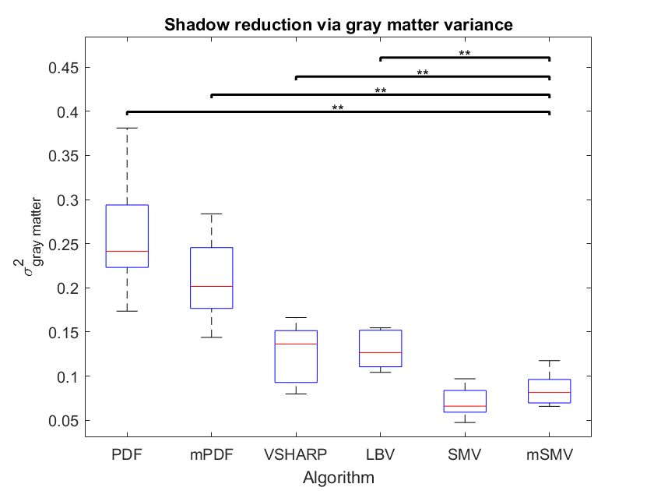Shadow scores [21] using the SMV mask were calculated for each of the healthy subject reconstructions and are plotted in Figure 7. The shadow reduction between mSMV and all methods except SMV was found to be significant above a confidence level. The effect of multiple comparisons was addressed with a Bonferroni correction.

Figure 7. Gray matter variance within healthy subject reconstructions. Minimal shadow artifacts correspond to minimal gray matter variance, as seen with mSMV.

4. Discussion

4.1 Summary

The results in this work show the feasibility of using the SMV property of harmonic fields without eroding the brain mask for background field removal in QSM. Reduced shadow is demonstrated in *Numerical brain* as measured by the fit and slope with respect to the ground truth, and in *In vivo healthy subjects* as measured by the gray matter variance.

Like LBV, mSMV identifies and removes points at the edge of the brain as suspect due to low SNR. At the edge of the brain, the local field signal is corrupted by residual background field, a dipole incompatibility with low frequency characteristics. This correlation is demonstrated in Figure 8, which depicts the generated background field mask and the field fit uncertainty map.

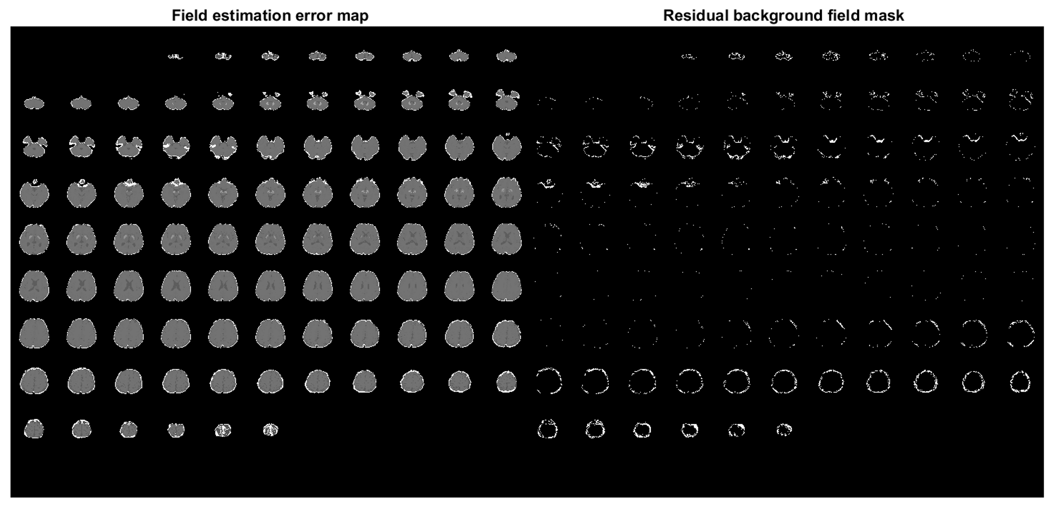

Figure 8. Comparison of field error map and residual background field mask. Notice the similarity between the high uncertainty at the edge of the field error map and the mask.

However, the maximum value property of a harmonic function allows points with large values to be identified as likely belonging to the background field. Since the edge is not uniformly eroded as with other methods, dipole inversion using a maximum a posteriori estimator (MEDI-L1) allows the entire brain volume to be preserved. The field error map captures dipole-incompatibilities corresponding to both shadow and streak artifacts. Since the distribution of these incompatibilities determines which artifact presents, mSMV provides better shadow reduction than the use of the field error map as a phase uncertainty mask, without erosion as seen in the *Results* section.

4.2 Limitation

This work relies on several assumptions. First, the local field is assumed to zero at the maximum point of the RDF. Second, the local field is assumed to be zero at the sample generated by region-growing. Third, the fit distribution standard deviation is an empirical measure of the background field threshold, imposing the value of zero to all voxels with a combined local and residual background field above this value.

Additionally, mSMV is limited to healthy subjects where there is no large local field, as with hemorrhage patients.

4.3 Future work

Large local field sources can be identified via the data and excluded from the background field mask . More patient data is needed to verify the clinical value of mSMV, particularly in the correlation between existing methods and pathologies such as elevated ROI susceptibilities in Parkinson’s disease patients or multiple sclerosis lesions.

4.4 Conclusion

Due to the harmonic quality of the background field, the maximum corollary of Green’s theorem can be used to sample and remove residual background field. Applying this method, known as mSMV, prior to QSM reconstruction, effectively reduces shadows and preserves brain volume. This method compares favorably to existing algorithms. While the number of PDF iterations can be increased to remove more residual background field, the resulting local field still benefits from mSMV. The mSMV method removes shadows in numerical simulations and healthy subjects.

5. Notes

**Author Contributions:** “Conceptualization, A.R. and P.S..; methodology, A.R..; software, A.R..; validation, A.R..; formal analysis, A.R. and P.S.; investigation, A.R.; resources, Y.W.; data curation P.S., T.N.; writing—original draft preparation, A.R..; writing—review and editing, A.R., P.S., T.N., Y.W.; visualization, A.R.; supervision, Y.W.; project administration, Y.W.; funding acquisition, Y.W.

All authors have read and agreed to the published version of the manuscript.

**Funding:** This research was funded by The National Institutes of Health, grant number R01 NS095562, R01 NS105144, R01 NS090464, and R01 HL151686.

**Institutional Review Board Statement:** The study was conducted in accordance with the and approved by the Institutional Review Board of Weill Cornell Medicine (protocol code 0909010639 and date of approval 11/3/2021.).

**Informed Consent Statement:** Informed consent was obtained from all subjects involved in the study.

**Data Availability Statement:** Data and software can be found at<https://github.com/agr78/mSMV>

**Conflicts of Interest:** Yi Wang and Pascal Spincemaille are inventors on QSM-related patents issued to Cornell University. Yi Wang and Pascal Spincemaille hold equity in Medimagemetric LLC. The remaining authors declare that they have no disclosures.

**Appendix**

Proof of the Maximum Principle

Proof. Given the mean value theorem following from Green’s theorem [], let

|  |  |  |
| --- | --- | --- |
|  | , | (A1) |

As φ is continuous, this can be re-written as

|  |  |  |
| --- | --- | --- |
|  |  | (A2) |

Note that by nature of averages, for every point in the volume, there exists a field

value in the region

|  |  |  |
| --- | --- | --- |
|  | , | (A3) |

Since and , for any arbitrary point in

|  |  |  |
| --- | --- | --- |
|  | , | (A4) |

Meaning any point on the interior can be considered the center of some sphere with

mean value . By A3, so

|  |  |  |
| --- | --- | --- |
|  | , | (A5) |

Which, according to A4, must be on the boundary, and 173

|  |  |  |
| --- | --- | --- |
|  |  | (A6) |

This concludes the proof.□

6. References

[1] L. Li and J. S. Leigh, "Quantifying arbitrary magnetic susceptibility distributions with MR," Magnetic Resonance in Medicine, vol. 51, no. 5, pp. 1077-1082, 2004, doi: 10.1002/mrm.20054.

[2] S. Wharton, A. Schäfer, and R. Bowtell, "Susceptibility mapping in the human brain using threshold-based k-space division," Magnetic Resonance in Medicine, vol. 63, no. 5, pp. 1292-1304, 2010, doi: 10.1002/mrm.22334.

[3] Z. L. Youngwook Kee, L. Zhou, A. Dimov, J. Cho, L. de Rochefort, J. Keun Seo, and Y. Wang, "Quantitative Susceptibility Mapping (QSM) Algorithms: Mathematical Rationale and Computational Implementations," *IEEE Transactions on Biomedical Engineering,* vol. 64, no. 11, pp. 2531-2545, 2017, doi: 10.1109/tbme.2017.2749298.

[4] J. K. Choi, H. S. Park, S. Wang, Y. Wang, and J. K. Seo, "Inverse Problem in Quantitative Susceptibility Mapping," *SIAM Journal on Imaging Sciences,* vol. 7, no. 3, pp. 1669-1689, 2014, doi: 10.1137/140957433.

[5] L. Zhou, J. K. Choi, Y. Kee, Y. Wang, and J. K. Seo, "Dipole Incompatibility Related Artifacts in Quantitative Susceptibility Mapping," arXiv: Medical Physics, 2017.

[6] L. De Rochefort *et al.*, "Quantitative susceptibility map reconstruction from MR phase data using Bayesian regularization: Validation and application to brain imaging," *Magnetic Resonance in Medicine,* vol. 63, no. 1, pp. 194-206, 2010, doi: 10.1002/mrm.22187.

[7] A. Roberts, P. Spincemaille, T. D. Nguyen, and Y. Wang, “MEDI-d: Downsampled morphological priors for shadow reduction in Quantitative Susceptibility Mapping,” in *International Society of Magnetic Resonance in Medicine*, 2021. Available: <https://www.researchgate.net/publication/349602485_MEDI-d_Downsampled_Morphological_Priors_for_Shadow_Reduction_in_Quantitative_Susceptibility_Mapping>

[8] P. S. Balasubramanian, P. Spincemaille, L. Guo, W. Huang, I. Kovanlikaya, and Y. Wang, "Spatially Adaptive Regularization in Total Field Inversion for Quantitative Susceptibility Mapping," *iScience,* vol. 23, no. 10, p. 101553, 2020, doi: 10.1016/j.isci.2020.101553.

[9] A. Roberts, P. Spincemaille, T. D. Nguyen, and Y. Wang, “MEDI-FM: Field Map Error Guided Regularization for Shadow Reduction,” in *International Society of Magnetic Resonance in Medicine*, 2022. Available: https://www.researchgate.net/publication/360320838_MEDI-FM_Field_Map_Error_Guided_Regularization_for_Shadow_Reduction

[10] F. Schweser, A. Deistung, B. W. Lehr, and J. R. Reichenbach, "Quantitative imaging of intrinsic magnetic tissue properties using MRI signal phase: An approach to in vivo brain iron metabolism?," *NeuroImage,* vol. 54, no. 4, pp. 2789-2807, 2011, doi: 10.1016/j.neuroimage.2010.10.070.

[11] H. Sun and A. H. Wilman, "Background field removal using spherical mean value filtering and Tikhonov regularization," *Magnetic Resonance in Medicine,* vol. 71, no. 3, pp. 1151-1157, 2014, doi: 10.1002/mrm.24765.

[12] W. Li, B. Wu, and C. Liu, "Quantitative susceptibility mapping of human brain reflects spatial variation in tissue composition," *NeuroImage,* vol. 55, no. 4, pp. 1645-1656, 2011, doi: 10.1016/j.neuroimage.2010.11.088.

[13] Y. Wen, D. Zhou, T. Liu, P. Spincemaille, and Y. Wang, "An iterative spherical mean value method for background field removal in MRI," *Magnetic Resonance in Medicine,* vol. 72, no. 4, pp. 1065-1071, 2014, doi: 10.1002/mrm.24998.

[14] D. Zhou, T. Liu, P. Spincemaille, and Y. Wang, "Background field removal by solving the Laplacian boundary

value problem," *NMR in Biomedicine,* vol. 27, no. 3, pp. 312-319, 2014, doi: 10.1002/nbm.3064.

[15] F. Schweser, S. D. Robinson, L. De Rochefort, W. Li, and K. Bredies, "An illustrated comparison of processing methods for phase MRI and QSM: removal of background field contributions from sources outside the region of interest," *NMR in Biomedicine,* vol. 30, no. 4, p. e3604, 2017, doi: 10.1002/nbm.3604.

[16] S. M. Smith, "Fast robust automated brain extraction," *Human Brain Mapping,* vol. 17, no. 3, pp. 143-155, 2002, doi: 10.1002/hbm.10062.

[17] K. K. Roy, "Green’s Theorem in Potential Theory," Springer Berlin Heidelberg, pp. 307-327.

[18] D. Rolfsen. "Harmonic Functions." *Theory of Linear Algebra*. University of British Columbia.

[19] C. Wisnieff, T. Liu, P. Spincemaille, S. Wang, D. Zhou, and Y. Wang, "Magnetic susceptibility anisotropy: Cylindrical symmetry from macroscopically ordered anisotropic molecules and accuracy of MRI measurements using few orientations," *NeuroImage,* vol. 70, pp. 363-376, 2013, doi: 10.1016/j.neuroimage.2012.12.050.

[20] H. Gudbjartsson and S. Patz, "The Rician distribution of noisy MRI data," *Magnetic Resonance in Medicine,* vol. 34, no. 6, pp. 910-914, 1995, doi: 10.1002/mrm.1910340618.

[21] B. Dymerska *et al.*, "Phase unwrapping with a rapid opensource minimum spanning tree algorithm (ROMEO)," *Magnetic Resonance in Medicine,* vol. 85, no. 4, pp. 2294-2308, 2021, doi: 10.1002/mrm.28563.

[22] T. Liu *et al.*, "A novel background field removal method for MRI using projection onto dipole fields (PDF)," *NMR in Biomedicine,* vol. 24, no. 9, pp. 1129-1136, 2011, doi: 10.1002/nbm.1670.

[23] K.-S. Chan and J. P. Marques, "SEPIA—Susceptibility mapping pipeline tool for phase images," *NeuroImage,* vol. 227, p. 117611, 2021, doi: 10.1016/j.neuroimage.2020.117611.

[24] P. S. Özbay, A. Deistung, X. Feng, D. Nanz, J. R. Reichenbach, and F. Schweser, "A comprehensive numerical analysis of background phase correction with V-SHARP," *NMR in Biomedicine,* vol. 30, no. 4, p. e3550, 2017, doi: 10.1002/nbm.3550.

Uncategorized References

[1] L. Li and J. S. Leigh, "Quantifying arbitrary magnetic susceptibility distributions with MR," *Magnetic Resonance in Medicine,* vol. 51, no. 5, pp. 1077-1082, 2004, doi: 10.1002/mrm.20054.

[2] S. Wharton, A. Schäfer, and R. Bowtell, "Susceptibility mapping in the human brain using threshold-based k-space division," *Magnetic Resonance in Medicine,* vol. 63, no. 5, pp. 1292-1304, 2010, doi: 10.1002/mrm.22334.

[3] J. K. Choi, H. S. Park, S. Wang, Y. Wang, and J. K. Seo, "Inverse Problem in Quantitative Susceptibility Mapping," *SIAM Journal on Imaging Sciences,* vol. 7, no. 3, pp. 1669-1689, 2014, doi: 10.1137/140957433.

[4] Z. L. Youngwook Kee, Liangdong Zhou, Alexey Dimov, Junghun Cho, Ludovic de Rochefort, Jin Keun Seo, and Yi Wang, "Quantitative Susceptibility Mapping (QSM) Algorithms: Mathematical Rationale and Computational Implementations," *IEEE Transactions on Biomedical Engineering,* vol. 64, no. 11, pp. 2531-2545, 2017, doi: 10.1109/tbme.2017.2749298.

[5] L. Zhou, J. K. Choi, Y. Kee, Y. Wang, and J. K. Seo, "Dipole Incompatibility Related Artifacts in Quantitative Susceptibility Mapping," *arXiv: Medical Physics,* 2017.

[6] L. De Rochefort *et al.*, "Quantitative susceptibility map reconstruction from MR phase data using bayesian regularization: Validation and application to brain imaging," *Magnetic Resonance in Medicine,* vol. 63, no. 1, pp. 194-206, 2010, doi: 10.1002/mrm.22187.

[7] P. S. Alexandra Roberts, Thanh Nguyen, Yi Wang, "MEDI-d: Downsampled Morphological Priors for Shadow Reduction in Quantitative Susceptibility Mapping," in *International Society for Magnetic Resonance in Medicine*, 05/2021 2021, no. Signal Representation, 2021. [Online]. Available: <https://cds.ismrm.org/protected/21MPresentations/abstracts/2599.html>. [Online]. Available: <https://cds.ismrm.org/protected/21MPresentations/abstracts/2599.html>

[8] P. S. Balasubramanian, P. Spincemaille, L. Guo, W. Huang, I. Kovanlikaya, and Y. Wang, "Spatially Adaptive Regularization in Total Field Inversion for Quantitative Susceptibility Mapping," *iScience,* vol. 23, no. 10, p. 101553, 2020, doi: 10.1016/j.isci.2020.101553.

[9] P. S. Alexandra Roberts, Thanh Nguyen, Yi Wang, "MEDI-FM: Field Map Error Guided Regularization for Shadow Reduction in Quantitative Susceptibility Mapping," in *International Society for Magnetic Resonance in Medicine*, 05/2022 2022, no. Signal Representation, 2022.

[10] W. Li, B. Wu, and C. Liu, "Quantitative susceptibility mapping of human brain reflects spatial variation in tissue composition," *NeuroImage,* vol. 55, no. 4, pp. 1645-1656, 2011, doi: 10.1016/j.neuroimage.2010.11.088.

[11] F. Schweser, A. Deistung, B. W. Lehr, and J. R. Reichenbach, "Quantitative imaging of intrinsic magnetic tissue properties using MRI signal phase: An approach to in vivo brain iron metabolism?," *NeuroImage,* vol. 54, no. 4, pp. 2789-2807, 2011, doi: 10.1016/j.neuroimage.2010.10.070.

[12] H. Sun and A. H. Wilman, "Background field removal using spherical mean value filtering and Tikhonov regularization," *Magnetic Resonance in Medicine,* vol. 71, no. 3, pp. 1151-1157, 2014, doi: 10.1002/mrm.24765.

[13] Y. Wen, D. Zhou, T. Liu, P. Spincemaille, and Y. Wang, "An iterative spherical mean value method for background field removal in MRI," *Magnetic Resonance in Medicine,* vol. 72, no. 4, pp. 1065-1071, 2014, doi: 10.1002/mrm.24998.

[14] D. Zhou, T. Liu, P. Spincemaille, and Y. Wang, "Background field removal by solving the Laplacian boundary value problem," *NMR in Biomedicine,* vol. 27, no. 3, pp. 312-319, 2014, doi: 10.1002/nbm.3064.

[15] F. Schweser, S. D. Robinson, L. De Rochefort, W. Li, and K. Bredies, "An illustrated comparison of processing methods for phase MRI and QSM: removal of background field contributions from sources outside the region of interest," *NMR in Biomedicine,* vol. 30, no. 4, p. e3604, 2017, doi: 10.1002/nbm.3604.

[16] S. M. Smith, "Fast robust automated brain extraction," *Human Brain Mapping,* vol. 17, no. 3, pp. 143-155, 2002, doi: 10.1002/hbm.10062.

[17] K. K. Roy, "Green’s Theorem in Potential Theory," Springer Berlin Heidelberg, pp. 307-327.

[18] D. Rolfsen. "Harmonic Functions." University of British Columbia. (accessed 07/19, 2022).

[19] C. Wisnieff, T. Liu, P. Spincemaille, S. Wang, D. Zhou, and Y. Wang, "Magnetic susceptibility anisotropy: Cylindrical symmetry from macroscopically ordered anisotropic molecules and accuracy of MRI measurements using few orientations," *NeuroImage,* vol. 70, pp. 363-376, 2013, doi: 10.1016/j.neuroimage.2012.12.050.

[20] H. Gudbjartsson and S. Patz, "The Rician Distribution of Noisy MRI Data," *Magnetic Resonance in Medicine,* vol. 34, no. 6, pp. 910-914, 1995, doi: 10.1002/mrm.1910340618.

[21] B. Dymerska *et al.*, "Phase unwrapping with a rapid opensource minimum spanning tree algorithm (ROMEO)," *Magnetic Resonance in Medicine,* vol. 85, no. 4, pp. 2294-2308, 2021, doi: 10.1002/mrm.28563.

[22] T. Liu *et al.*, "A novel background field removal method for MRI using projection onto dipole fields (PDF)," *NMR in Biomedicine,* vol. 24, no. 9, pp. 1129-1136, 2011, doi: 10.1002/nbm.1670.

[23] K.-S. Chan and J. P. Marques, "SEPIA—Susceptibility mapping pipeline tool for phase images," *NeuroImage,* vol. 227, p. 117611, 2021, doi: 10.1016/j.neuroimage.2020.117611.

[24] P. S. Özbay, A. Deistung, X. Feng, D. Nanz, J. R. Reichenbach, and F. Schweser, "A comprehensive numerical analysis of background phase correction with V-SHARP," *NMR in Biomedicine,* vol. 30, no. 4, p. e3550, 2017, doi: 10.1002/nbm.3550.