CVIP- HW Set-4

by Sahil Dureja

50168872

Problem 1  
a) Obtain and display the DoG image by applying the following DoG mask to the test image

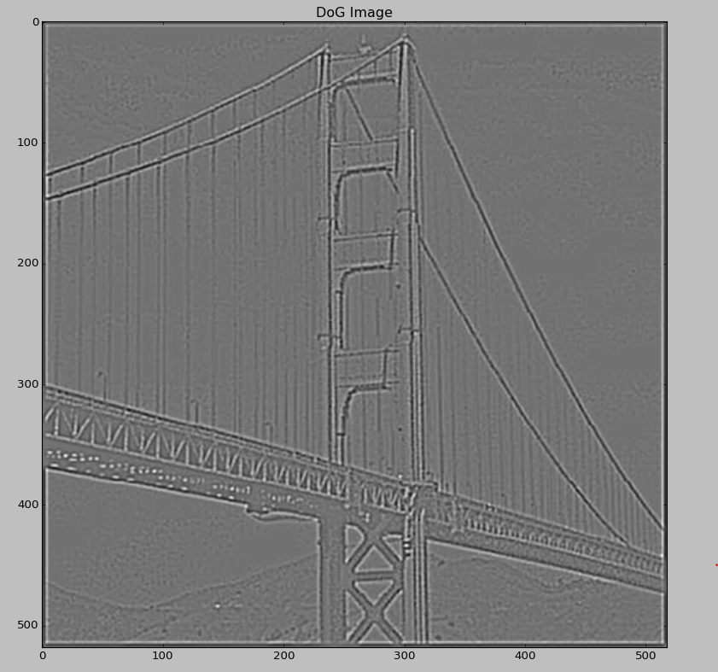

(b) Compute and display the zero-crossing of the DoG image obtained in (a)

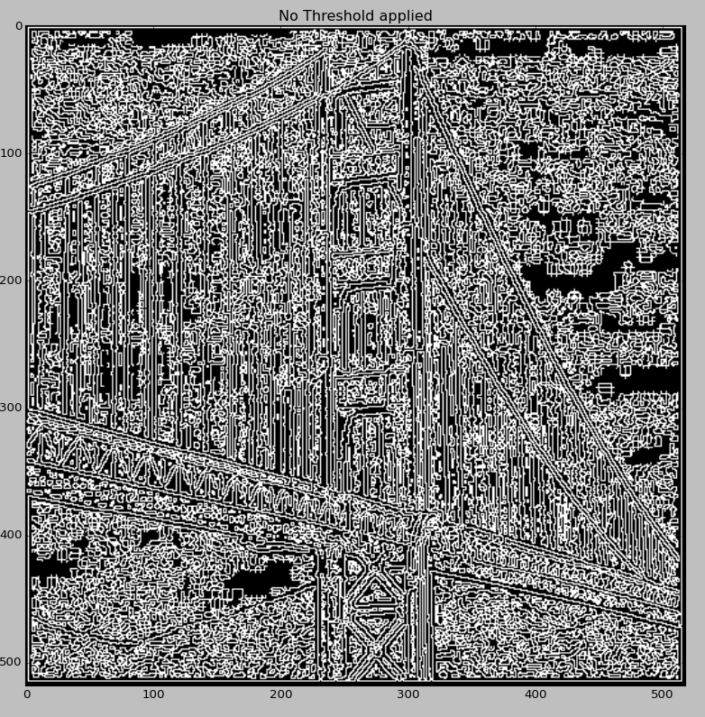

(c) Compute and display the zero-crossing strong edges by removing weak edges that do not have first derivative support in (b)

Threshold of 800 applied  
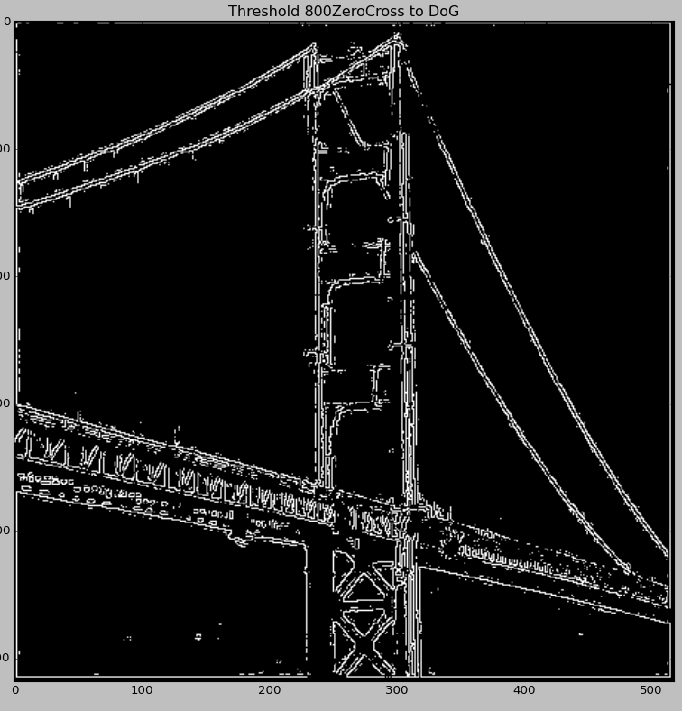

(d)Compute and display the LoG zero-crossing edges by applying the following LoG mask to the test image

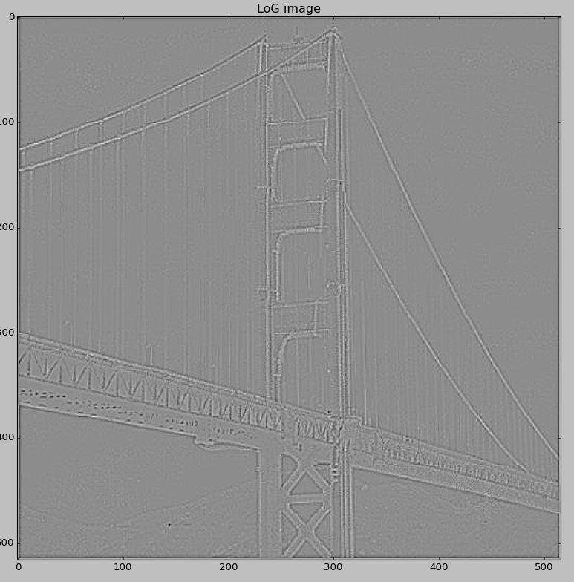

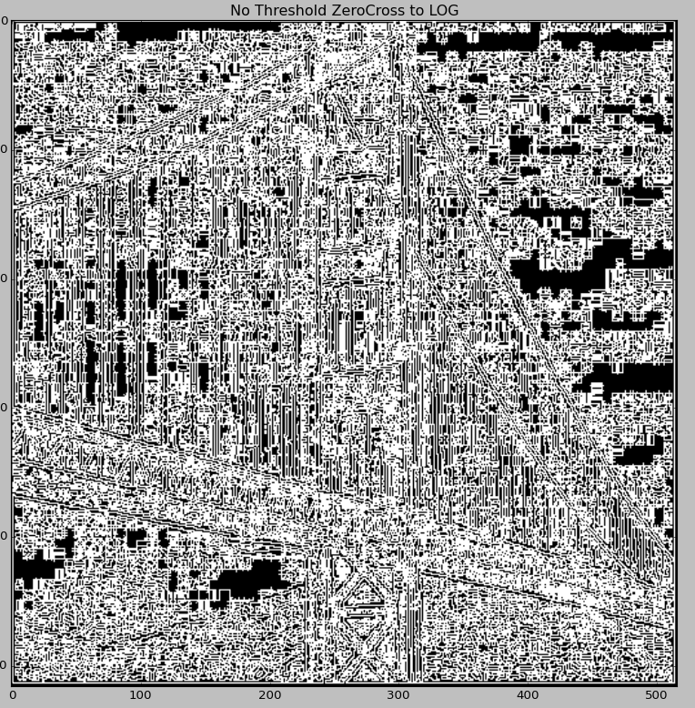

Keeping same threshold of 800

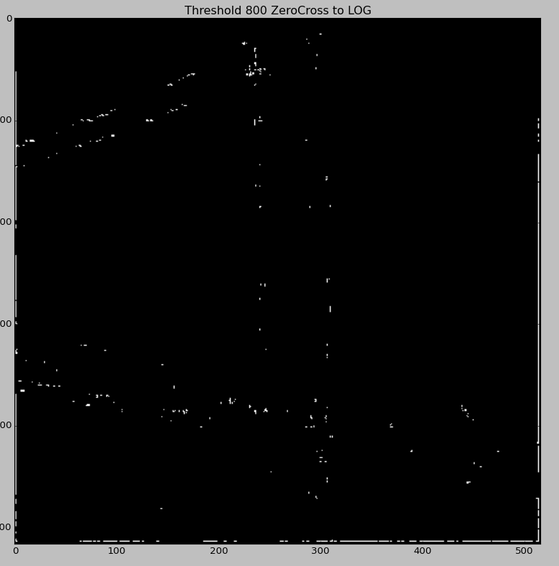

Threshold of 270 applied to LOG

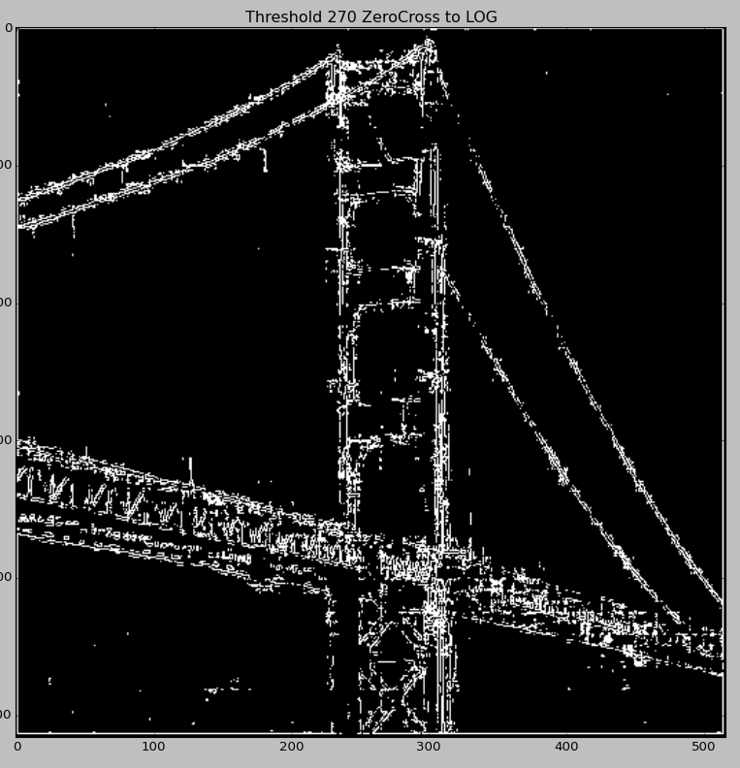

e) Compare the results in (c) and (d) and explain why the edges obtained in (c) and (d) are different. Is there any way that we may obtain the same results? Please explain in detail.

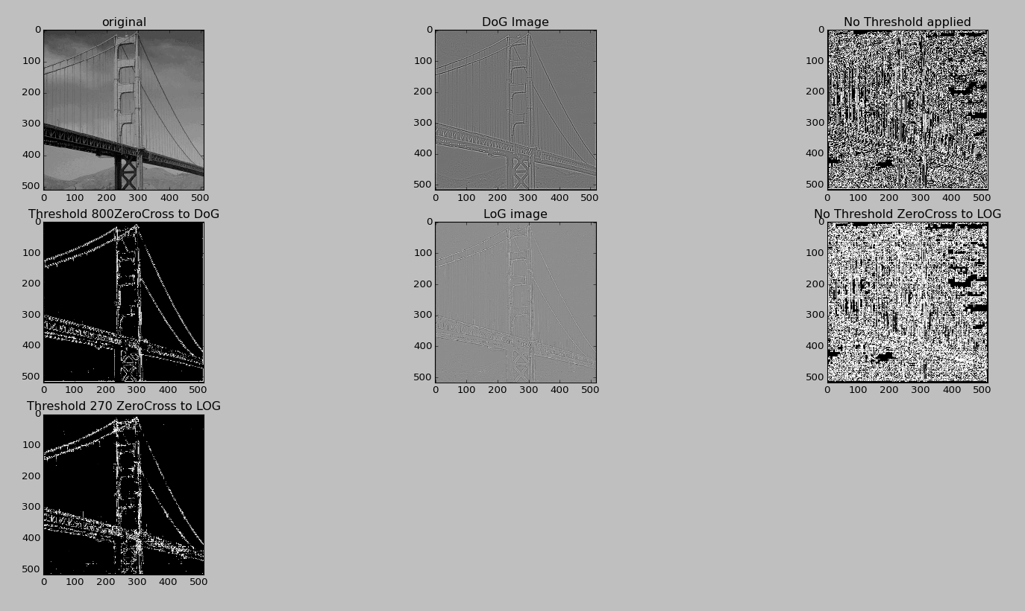

To remove weak edges threshold used in c) is 800 and in d) is 270 to obtain clear edges.  
Image in DoG weak edge removal are sharp as there is higher range for threshold

But that is a relative term as threshold is a relative term which is the measure of percentage of gap between zero crossing over maximum removed, considered as weak edge.

In DoG more noise is removed as compared to LoG which makes the DoG image sharper. The ratio of Sigma(Standard Deviation) of the two near to 1 will represent the similar result.

**2) Region Merging Segmentation**

(a) Perform Algorithm 6.17 – Region merging recursively and display the results of recursive region merging. Each student is required to set their own criterion and explain why such criterion is selected

Criterion followed

1) Initial regions are marked as ‘r1’ , ‘r2’

2) Tree adjacency list is used to store regions as a tree

3) Regions are merged if there is a difference between the means above a threshold value were means are calculated using masks

4) Regions with smaller number of pixels are ignored (less than 1200)

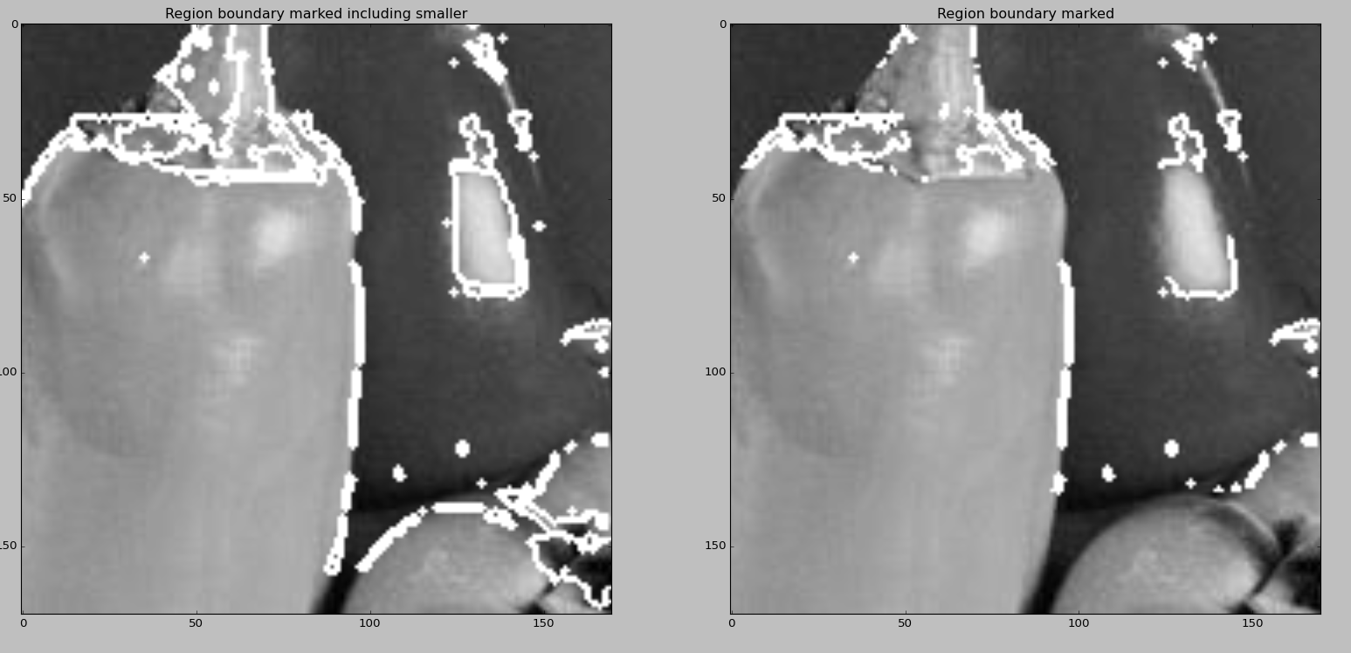

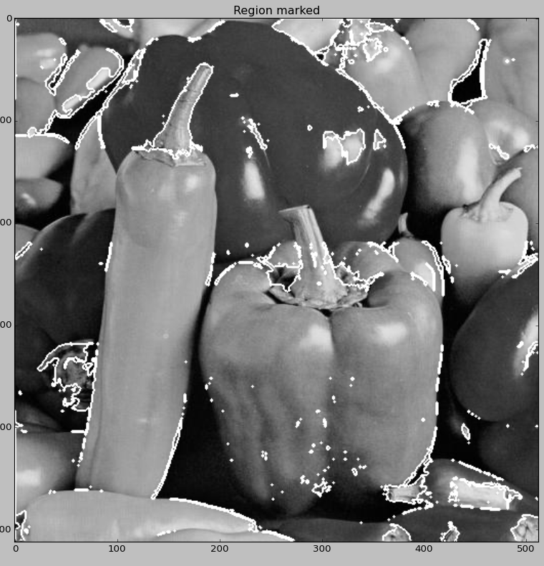

Noise removed threshold 3000

