**Beer Preference Trends: Recommendations and Analysis**

**Midterm**

Andrew Graham

Ritchie School of Engineering and Computer Science, University of Denver

COMP 444: Data Science Capstone

Prof. Claudio Delrieux

February 3, 2023

**Beer Preference Trends: Recommendations and Analysis**

**Purpose**

The purpose of this project is to analyze and develop recommendation models for beer preferences from data obtained through scraping BeerAdvocates.com. The goal is to determine the feasibility of providing insightful beer recommendations to users based on both content-based and collaborative filtering models. The data collected will be used to analyze beer preferences and to generate accurate and relevant beer recommendations.

**Significance**

The development of a recommendation model for beer preferences can greatly benefit the beer industry by providing personalized recommendations to consumers based on their individual tastes and preferences. This can lead to increased sales, higher levels of customer satisfaction, allowing for a competitive advantage to companies that use those systems.

**Research Question**

What is the effectiveness of collaborative and content-based recommendation models in predicting beer preferences?

**Data Description**

The dataset is the result of scrapping the website BeeAdvocates.com for user reviews on various beers. The data includes simple beer descriptions and the ratings each beer received. The original data set contains 1,586,251 datapoints, each a single review. The data has 7 continuous feature and 6 nominals. All 6 nominal features are categorical.

**Data Preprocessing**

**Data Preparation**

The analysis of the dataset revealed the presence of null values in the features brewery_name, review_profilename, and beer_abv. The null values in brewery_name and review_profilename, which were less than 400, were removed. The 67,785 null values in beer_abv were imputed using the mean beer_abv of the beer style, as alcohol content is typically related to beer styles. The mismatch in the count of brewery names and brewery ids, with a higher count of ids, was due to multiple locations of the same brewery. This issue was resolved by collecting the location of each brewery through web scraping and attaching it to the dataset. The same solution was applied to the individual beers.

**Exploratory Data Analysis**

***Continuous***

The 7 continuous features consist of the review scores and the beer abv. The beer abv represents the alcohol content level which is measured by percentage. The scores are split into an overall score and individual scores for aroma, appearance, palate, and taste. These are subjective ratings of the beers on a scale of 1-5. The overall score is a sperate score from the individual scores and there is not a direct formulaic connection between them. The date feature is a DateTime code that ranges from 1996-2012.

**Nominal**

The nominal features consist of the profile name of each reviewer, the name and id of each beer, and the name and id of each brewery. Both id’s relate to the id on the BeerAdvocates site. Finally, the is beer style which categorizes each beer into different styles such as IPA, Ale, etc. In the dataset, there are 5838 unique brewery IDs and 5742 unique brewery names, 33387 unique reviewers, 104 unique beer styles, 66040 unique beer IDs and 56847 unique beer names. When grouped by reviewer, the data is rather sparse with 33% of reviewers rating only beer, and 66% rating <10

***Overall Score and Individual Scores***

All scores are fairly normally distributed around the score of 4 indicating a bias of users reviewing mostly beers they liked versus ones they did not. All are on the 0-5 scale with the exceptions of Aroma, Taste, and Palate, which were 1-5

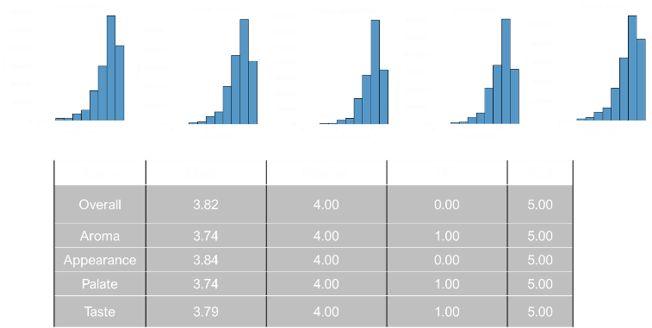

In determining the relation between the individual and overall scores, a correlation analysis was done. The Pearson Correlation showed that Taste and Palate have the most impact followed by Aroma then Appearance. The Spearman Correlation was also used and produced similar results.

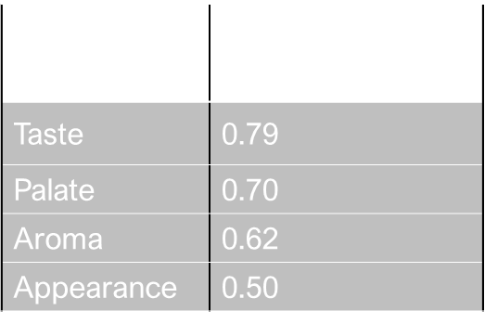

***Aggregating Reviews***

When aggregating ratings for evaluation based on beers, styles, or any other group, it is important to consider both the proportion of positive ratings and the uncertainty associated with a small number of observations. To address this challenge, the Wilson Score Confidence Interval [1] will be applied to provide more reliable scores that consider the number of reviews. The Wilson Score Confidence Interval provides a balance between the proportion of positive ratings and the uncertainty of a small number of observations. In this context, scores equal to or greater than 3 are considered positive.

***Grouping Reviews***

When grouping the reviews by beers. One interesting result is the number of reviews a beer had correlated with the overall score (and thus the individual scores as well). This would make sense as Beer Advocates is an enthusiast site and people are more like to rate beers they like versus ones the don’t.

**Clustering**

In order to help with the content-based recommendation systems, a cluster analysis was performed to determine if there were groups that could aid in differentiating the beers. Firstly, we took the data on the overall score and number of reviews (using the square root of the overall score). The data was scaled using the StandardScaler function from scikit-learn to normalize the data in the data frame. This was done since the two features had widely different scales while MinMaxScaler would have led to data bias. Finally, an elbow plot was used to determine the optimal k number to be used in the K-means algorithm.

From this plot a k number of 4 was used. As seen in the charts below 4 groups were found. Group 0: Low score, Low reviews, Group 1: Mid Score, Low Reviews, Group 2: High Score, High Reviews, Group 3: High Reviews

From this we can use groups 2 and 3 as representative of more well-known beers and less well known beers in recommendation systems.

**Recommendation Models**

**Content Based Recommendations**

If we do not know anything about how the user rates certain beers, we can use a recommendation model that is a content-based filtering model, which makes recommendations based on the characteristics of the beers the user has liked in the past. In this case, the model created is making recommendations for beers to try based on the user's preference for IPAs.

For this we use the dataset grouped by beers with the overall scores aggregated by the Lower bound of Wilson score confidence interval as described earlier. From this, the first step in the model is to select all the beers in the data that belong to the IPA style. Since there are multiple types of IPAs, and style with the text IPA will be filtered.

Next, the selected beers are sorted based on the 'review_overall' column, which represents the average overall review rating of each beer. Finally, the top 3 beers with the highest 'review_overall' values are selected from the highly reviewed group and the lower number of review group. So that the user can choose from more well known and less well known beers.

**Collaborative Filtering Model**

Since the dataset is of user reviews, a collaborative filtering model, which makes recommendations based on the preferences of similar users, was developed. In this case, the model is making recommendations for beers that users who enjoy a specific type of beer might also like. For this case the individual beer used was Shiner Bock. The first step in the model is to select all users who have rated Shiner Bock with a score of 4 or higher. This score was chosen as it represents those who greatly enjoyed the beer. The reviews are then filtered to only include reviews from these users. The final step in the model is to group the filtered reviews, aggregate the overall scores, and sort in descending order based on the overall review score, and the top beers from this list are selected as recommendations.

This model makes recommendations based on the preferences of similar users and is useful for making personalized recommendations when the user's preferences are not well understood. If a user likes Shiner Bock, they may also like:

**ALS Recommendation System**

When considering the large amount of data (over 1.5 million reviews) and the fact that approximately 33% of reviewers left only 1 review, this represents a high level of sparsity and presents challenges in the traditional recommendation models in recommendation accuracy. A collaborative ALS model was chosen due to its ability to handle sparse data effectively and the ability to scale to large-scale datasets with implicit feedback.

We construct the Collaborative ALS Model using PySpark to be compatible with distributed computing. This model uses a review dataset consisting of three columns: username, beer, and overall score. To reduce the sparsity of the data, we filter out users and beers with less than 10 reviews. Due to computational limitations hyperparameters were unable to be tuned at this time.

The analysis revealed a Root Mean Squared Error (RMSE) of 0.6 in the ALS recommendation model. This when considering a rating scale of 0 to 5, shows an average deviation of approximately 0.6 between the predicted ratings and the actual ratings. This result suggests that the model's predictions are not highly accurate with a relatively large average deviation compared to the rating scale.

**Conclusion**

The objective of this study was to create a recommendation system for recommend beers to users. The resulting models are simplistic, and the ALS model left a relatively large error rate, so there is much room for improvement. To achieve this, there a few steps we could take. First, update our data by conducting a web scraping operation for more recent information Second we can integrate beer profile data if it is available, thereby increasing the robustness of the content-based recommendation systems. To further enhance the accuracy of our ALS model, additional computing power can be used to fine tune the ALS hyperparameters. A distributed network will need to be used. Finally we can implement a hybrid model that combines both content-based and collaborative filtering models. This new hybrid model can then allow the development of an application that will allow users to access these recommendations with ease.

**References**

1. Miller, Evan. “How Not to Sort by Average Rating.” *EvanMiller.org*, Evan Miller, 9 Feb. 2009, https://www.evanmiller.org/how-not-to-sort-by-average-rating.html.

‌