**MINOR PROJECT**

**Malware Detection Tool**

**Working on a basic python script that scan a directory for suspicious file based on file hash comparison (using SHA-256)**

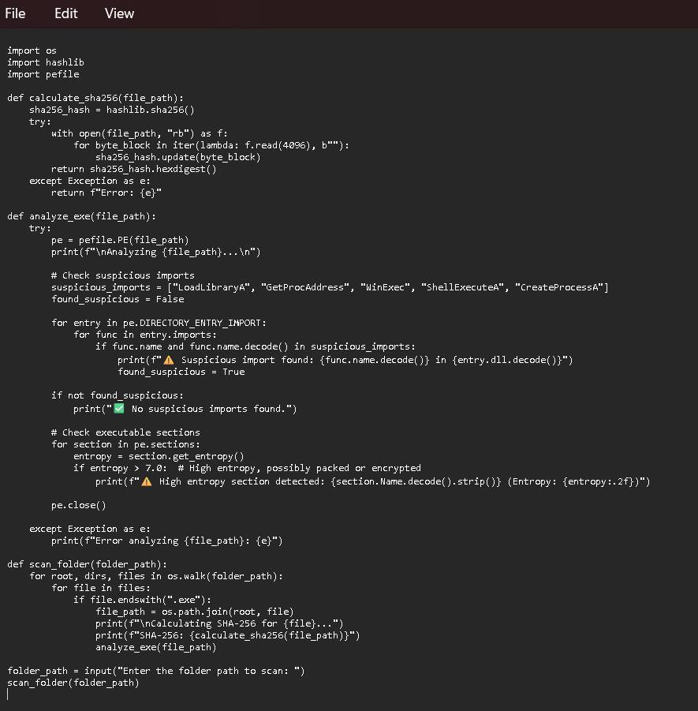

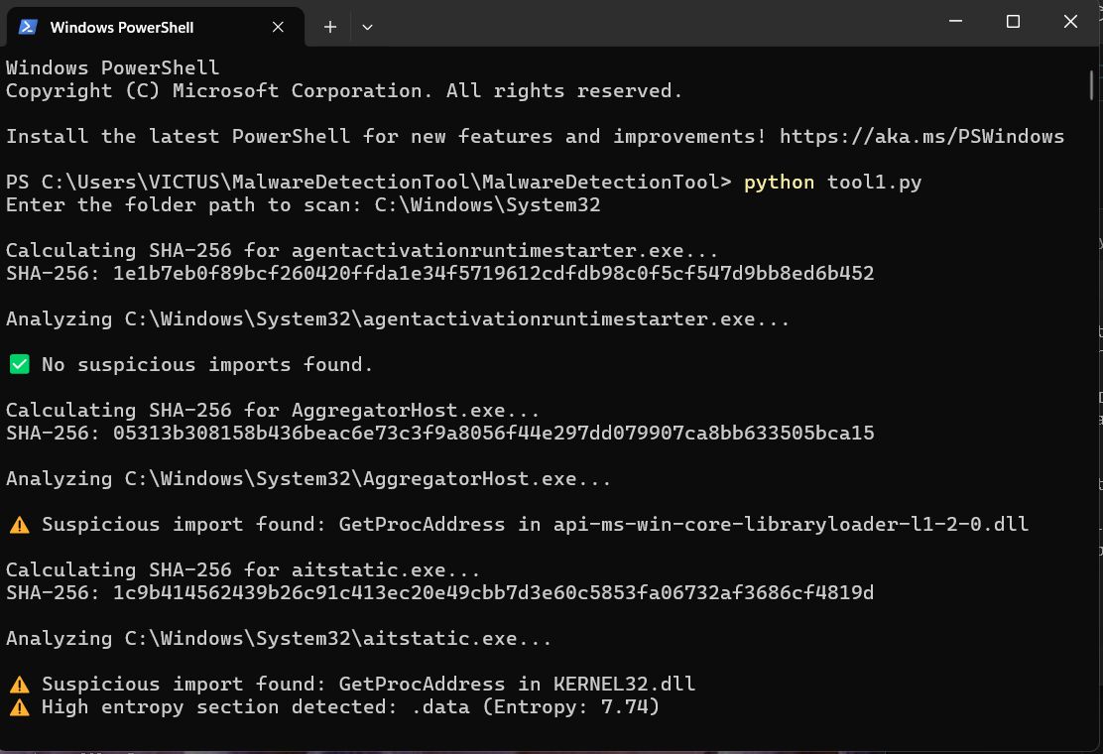output(Identifying executable files with suspicious behaviours.)

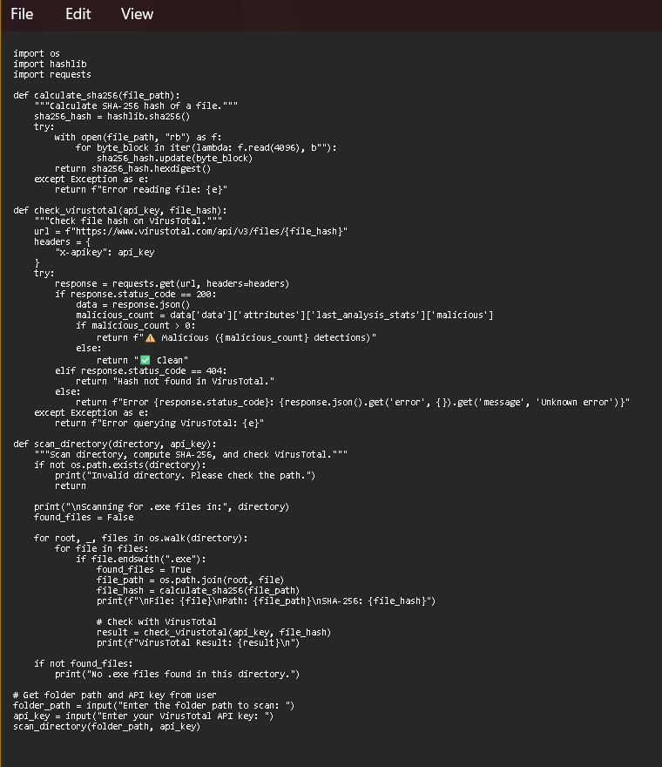**Checking VirusTotal API**

Output(Identifying executable files with suspicious behaviours.