**MANUAL TEST**

**STEPS FOR BROKAGE FIRM APPLICATION VIA POSTMAN**

1)     You need to login first. All endpoints are protected by basic auth. For test purposes available in-memory table user name and password are:

admin – 1234

customer1 – 1234

customer2 – 1234

Here is a screenshot for how to call login endpoint via postman. You should receive “Authentication is completed” message id request is successful:

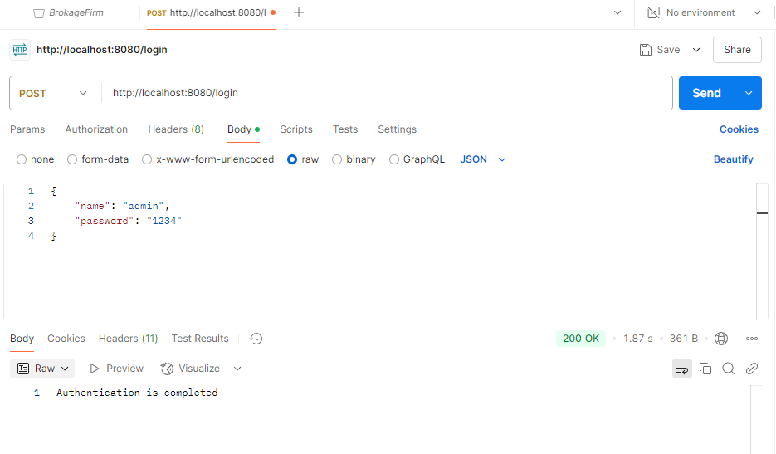

2)     You can list all assets via asset/all endpoint.If you request with admin user then all user assets are listed, if you request with standard user then only that user’s assets are listed. Please check basic auth section at the screenshot below. This request is done with a standard userand you can see only that user’s assets:

By default here are the assets defined in memory table:

For customer1: 100 TRY WITH 100 USABLE SIZE

10 ING WITH 10 USABLE SIZE

 For customer2: 100 TRY WITH 100 USABLE SIZE

 10 ING WITH 10 USABLE SIZE

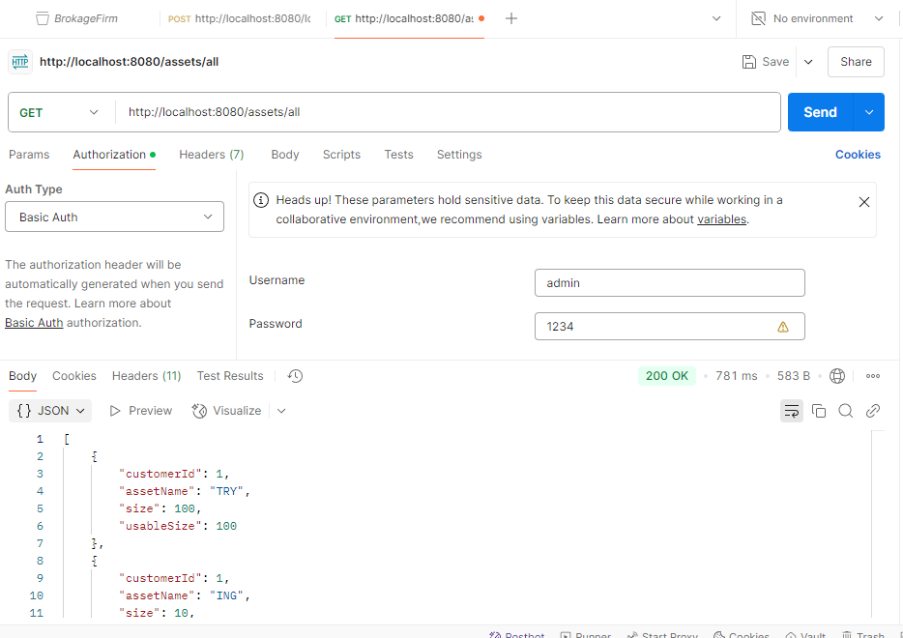

3)     Orders are sent via orders/create endpoint. Here is a sample for this request:

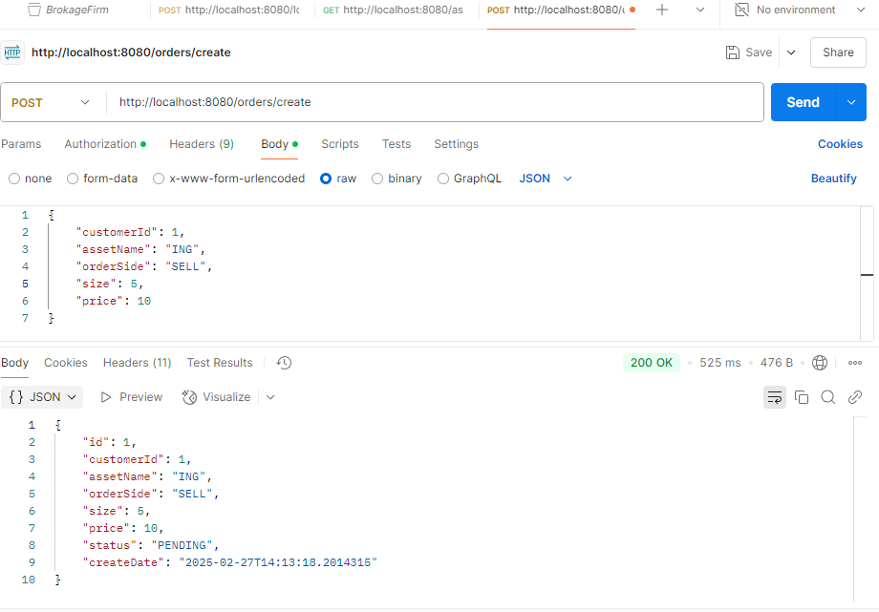

Please note that you need to select basic authentication at Authorization tab and enter user password for selected user. If you are an admin user you can create order for all customers but if you are a standard user then you can create orders for yourself only.

4)After creating an order now we are ready to list orders. Order/list endpoint can be used for this purpose. You need the correct date format as seen below. If you use admin user then you can see all orders of users but if you are standard user then you can list only your orders :

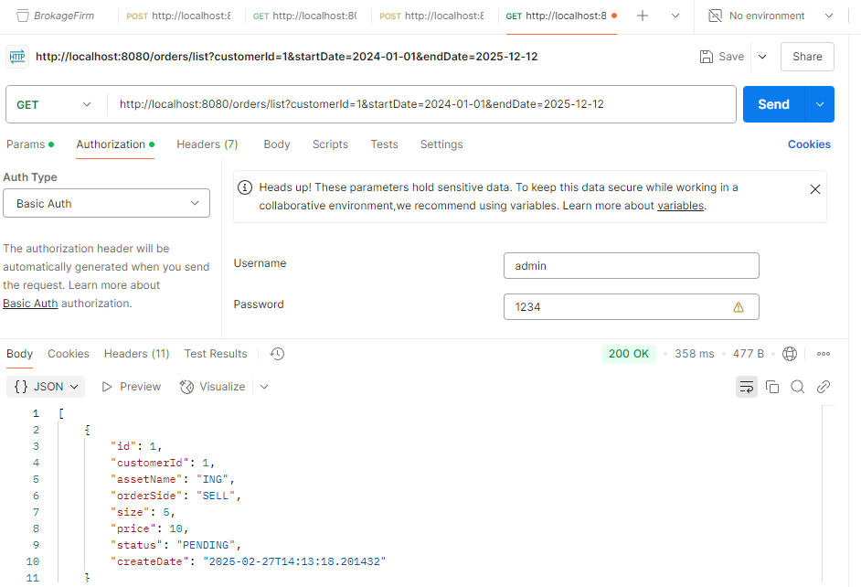

5)     You can cancel order by orders/cancel endpoint. If you are an admin user you can cancel any order but if you are a standard user then you can cancel only that user’s orders. Also only pending orders can be canceled:

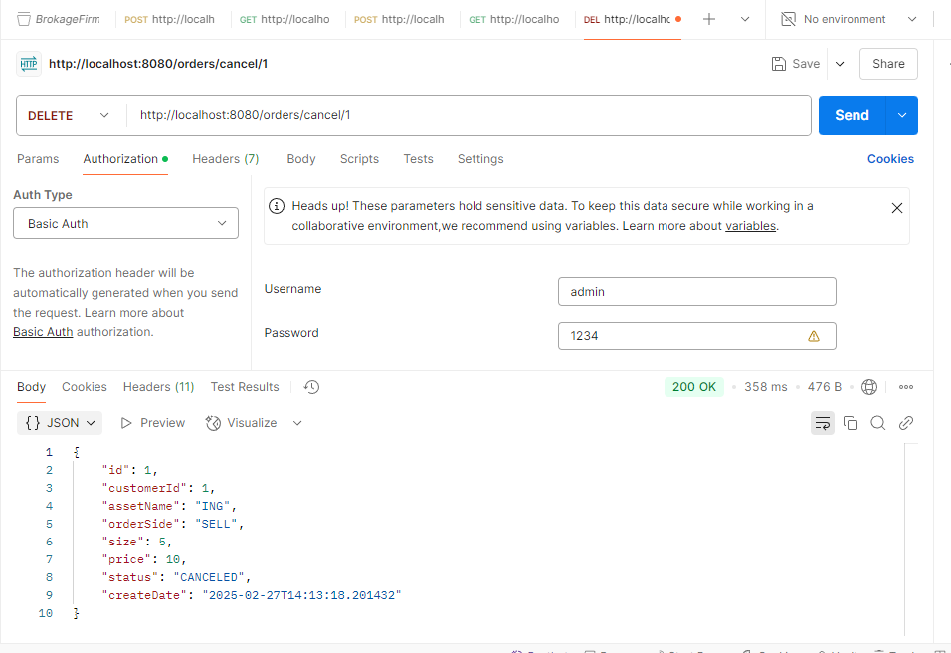

1. You can match orders so that order transaction recalculates related user balances. Only admin user can call this endpoint. Standard users are not allowed:

