Sensor Data Interpreter
This poc project is a springboot application that consumes messages from Kafka and processes them based on their types.
Features
- Kafka consumer for sensor data
- Two in-memory H2 databases: sensor and remote
- Processing of 3 different types of JSON messages
- REST API to retrieve location history
Prerequisites
- Docker and Docker Compose(Docker Desktop is better)
- Java 17 (for development without Docker)
- Maven (for development without Docker)
Running the Application
Just run below command at Project folder to start application:
docker-compose up -d –build
Just run below command to stop application:
docker-compose down -v
API Usage
GET /api/devices/{deviceId}/location-history?begin={beginTime}&end={endTime}
Parameters:
- deviceId: The ID of the device
- begin: The start timestamp in ISO format (e.g., 2025-05-06T10:00:00)
- end: The end timestamp in ISO format (e.g., 2025-05-06T18:00:00)
Example:
curl "http://localhost:8080/api/devices/device_2/location-history?begin=2024-05-01T00:00:00&end=2026-05-07T23:59:59"
Database Access
The H2 console is enabled and can be accessed at:
http://localhost:8080/h2-console
Use the following details to access the database:
- JDBC URL: jdbc:h2:mem:sensor or jdbc:h2:mem:remote
- Username: sa
- Password: (leave empty)
Message Formats
The application processes 3 types of messages:
- Statistical message with airport information:
{
"id": "TK01",
"device_id": "device_1",
"type": "CargoSensor",
"stat_changes": [
{
"airport": "IST"
}
]
}
- Statistical message with location information:
{
"id": "TK02",
"device_id": "device_2",
"type": "CargoSensor",
"stat_changes": [
{
"location": "29.35"
}
]
}

- Operational message with temperature information:
{
"id": "TK03",
"device_id": "device_3",
"type": "CargoSensor",
"op_changes": [
{
"temperature": "25"
}
]
}

Test Steps:
After running application with docker-compose up -d –build
First you can check created tables(H2 in-memory database is used). There are 3 tables created for sensor database(this database is assumed our local application database)
and 1 table is created at remote database(this database is used for reference to make realtime calculations).
Sensor Database Tables:
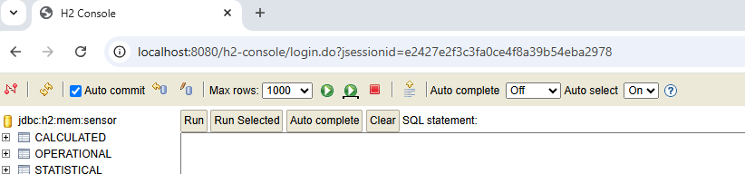

Remote Database Table:
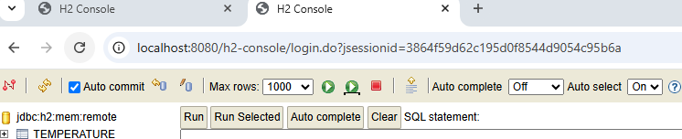

I assume that temperature is operational data so json messsages that include temperature information are processed with simple subtract operation. Reference table is the temperature table which is considered a remote database. Temperature table has 100 predefined values. You may prefer to write a select query to check its content. This table is filled during application startup for poc purpose. Related file is under infrastructure/init folder.
Also there is a KafkaJsonProducer file under infrastructure/init to send json messages for demo. After application starts this file send 5 messages to kafka and consumer app processes this 5 messages based on their types.
If message is statistical(location or airport) then data is inserted into statistical table of sensor database.
If message is operational(temperature) then data is inserted into operational table of sensor database. And also a subtraction operation is done by using temperature table of remote database and then result is saved into calculated table of sensor database.
You can change number of messages(5 is default value) and content of messages by updating KafkaJsonProducer file. No need to use any other script files etc. After running application, all table & message tasks are done for this demo.

Here are the contents of tables after a sample application run:
Statistical table:
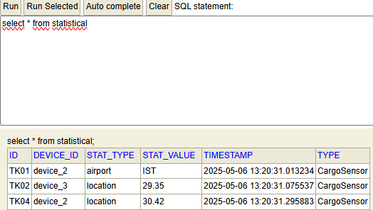
Operational table:
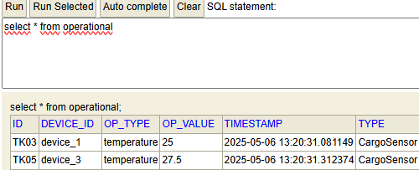
Since we have 2 rows at operational table we expect 2 calculation results in calculated table.
Calculated table:
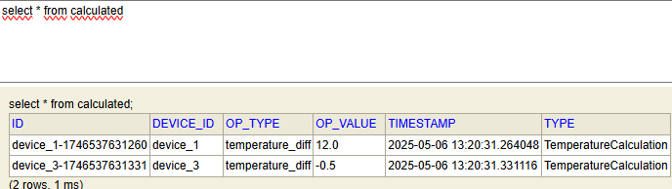

Lets check if calculated temperature diff values are correct with remote temperature table:
Temperature table:
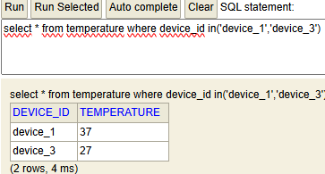

For device_1: (37-25) = 12 and for device_3: (27-27.5) = -0.5. Calculated values are correct.
Lets check location history with rest endpoint:
At statistical table we have 1 location row for device_2 and device_3. Lets query device_2 via postman:
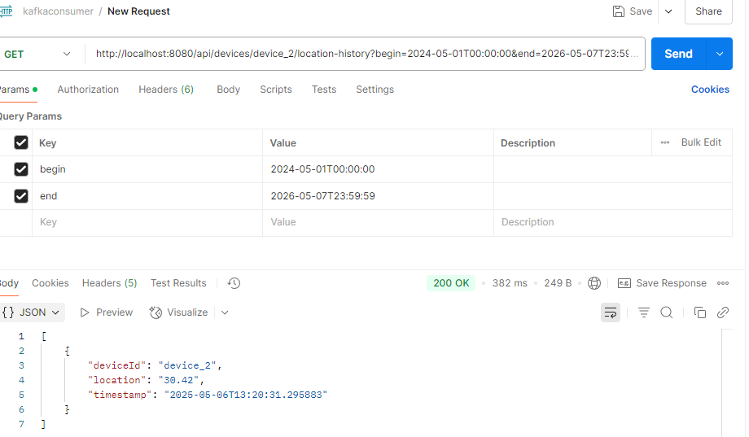

Please do not hesitate to reach me at agrasmehmet@gmail.com for any questions.
Thanks for your time.

