Spring Core - Maven

# Exercise 01

BookRepository.java

package com.library.repository;

public class BookRepository {

    public void saveBook(String bookName) {

        System.out.println("Book '" + bookName + "' saved to database.");

    }

}

BookService.java

package com.library.service;

import com.library.repository.BookRepository;

public class BookService {

    private BookRepository bookRepository;

    public void setBookRepository(BookRepository bookRepository) {

        this.bookRepository = bookRepository;

    }

    public void addBook(String bookName) {

        System.out.println("Processing book: " + bookName);

        bookRepository.saveBook(bookName);

    }

}

MainApp.java

package com.library;

import com.library.service.BookService;

import org.springframework.context.ApplicationContext;

import org.springframework.context.support.ClassPathXmlApplicationContext;

public class MainApp {

    public static void main(String[] args) {

        ApplicationContext context = new ClassPathXmlApplicationContext("applicationContext.xml");

        BookService bookService = (BookService) context.getBean("bookService");

        bookService.addBook("The Alchemist");

    }

}

applicationContext.xml

<?xml version="1.0" encoding="UTF-8"?>

<beans xmlns="http://www.springframework.org/schema/beans"

       xmlns:xsi="http://www.w3.org/2001/XMLSchema-instance"

       xsi:schemaLocation="http://www.springframework.org/schema/beans

       http://www.springframework.org/schema/beans/spring-beans.xsd">

    <bean id="bookRepository" class="com.library.repository.BookRepository"/>

    <bean id="bookService" class="com.library.service.BookService">

        <property name="bookRepository" ref="bookRepository"/>

    </bean>

</beans>

Pom.xml

<project xmlns="http://maven.apache.org/POM/4.0.0"

         xmlns:xsi="http://www.w3.org/2001/XMLSchema-instance"

         xsi:schemaLocation="http://maven.apache.org/POM/4.0.0

         http://maven.apache.org/xsd/maven-4.0.0.xsd">

    <modelVersion>4.0.0</modelVersion>

    <groupId>com.library</groupId>

    <artifactId>LibraryManagement</artifactId>

    <version>1.0-SNAPSHOT</version>

    <dependencies>

        <dependency>

            <groupId>org.springframework</groupId>

            <artifactId>spring-context</artifactId>

            <version>5.3.34</version>

        </dependency>

    </dependencies>

</project>

Output:

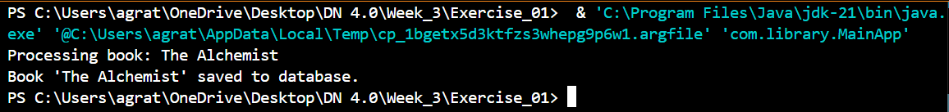

# Exercise 02

BookRepository.java

package com.library.repository;

public class BookRepository {

    public void saveBook(String bookName) {

        System.out.println("Book '" + bookName + "' saved to database.");

    }

}

MainApp.java

package com.library;

import com.library.service.BookService;

import org.springframework.context.ApplicationContext;

import org.springframework.context.support.ClassPathXmlApplicationContext;

public class MainApp {

    public static void main(String[] args) {

        ApplicationContext context = new ClassPathXmlApplicationContext("applicationContext.xml");

        BookService bookService = (BookService) context.getBean("bookService");

        bookService.addBook("Sapiens: A Brief History of Humankind");

    }

}

applicationContext.xml

<?xml version="1.0" encoding="UTF-8"?>

<beans xmlns="http://www.springframework.org/schema/beans"

       xmlns:xsi="http://www.w3.org/2001/XMLSchema-instance"

       xsi:schemaLocation="http://www.springframework.org/schema/beans

       http://www.springframework.org/schema/beans/spring-beans.xsd">

    <bean id="bookRepository" class="com.library.repository.BookRepository"/>

    <bean id="bookService" class="com.library.service.BookService">

        <property name="bookRepository" ref="bookRepository"/>

    </bean>

</beans>

Pom.xml

<project xmlns="http://maven.apache.org/POM/4.0.0"

         xmlns:xsi="http://www.w3.org/2001/XMLSchema-instance"

         xsi:schemaLocation="http://maven.apache.org/POM/4.0.0

         http://maven.apache.org/xsd/maven-4.0.0.xsd">

    <modelVersion>4.0.0</modelVersion>

    <groupId>com.library</groupId>

    <artifactId>LibraryManagement</artifactId>

    <version>1.0-SNAPSHOT</version>

    <dependencies>

        <dependency>

            <groupId>org.springframework</groupId>

            <artifactId>spring-context</artifactId>

            <version>5.3.34</version>

        </dependency>

    </dependencies>

</project>

Output:

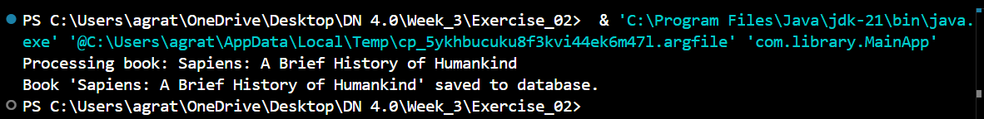

# Exercise 04

App.java

package com.library;

public class App {

    public static void main(String[] args) {

        System.out.println("Library Management System - Maven Setup Test");

    }

}

Pom.xml

<project xmlns="http://maven.apache.org/POM/4.0.0"

         xmlns:xsi="http://www.w3.org/2001/XMLSchema-instance"

         xsi:schemaLocation="http://maven.apache.org/POM/4.0.0

         http://maven.apache.org/xsd/maven-4.0.0.xsd">

    <modelVersion>4.0.0</modelVersion>

    <groupId>com.library</groupId>

    <artifactId>LibraryManagement</artifactId>

    <version>1.0-SNAPSHOT</version>

    <properties>

        <maven.compiler.source>1.8</maven.compiler.source>

        <maven.compiler.target>1.8</maven.compiler.target>

    </properties>

    <dependencies>

        <!-- Spring Context -->

        <dependency>

            <groupId>org.springframework</groupId>

            <artifactId>spring-context</artifactId>

            <version>5.3.34</version>

        </dependency>

        <!-- Spring AOP -->

        <dependency>

            <groupId>org.springframework</groupId>

            <artifactId>spring-aop</artifactId>

            <version>5.3.34</version>

        </dependency>

        <!-- Spring Web MVC -->

        <dependency>

            <groupId>org.springframework</groupId>

            <artifactId>spring-webmvc</artifactId>

            <version>5.3.34</version>

        </dependency>

        <!-- Servlet API for Spring MVC -->

        <dependency>

            <groupId>javax.servlet</groupId>

            <artifactId>javax.servlet-api</artifactId>

            <version>4.0.1</version>

            <scope>provided</scope>

        </dependency>

    </dependencies>

    <build>

        <plugins>

            <plugin>

                <groupId>org.apache.maven.plugins</groupId>

                <artifactId>maven-compiler-plugin</artifactId>

                <version>3.11.0</version>

                <configuration>

                    <source>1.8</source>

                    <target>1.8</target>

                </configuration>

            </plugin>

        </plugins>

    </build>

</project>

Output:



# Exercise 05

BookRepositor.java

package com.library.repository;

public class BookRepository {

    public void save(String bookName) {

        System.out.println("Book '" + bookName + "' saved to the library database.");

    }

}

BookService.java

package com.library.service;

import com.library.repository.BookRepository;

public class BookService {

    private BookRepository bookRepository;

    public void setBookRepository(BookRepository bookRepository) {

        this.bookRepository = bookRepository;

    }

    public void issueBook(String bookName) {

        System.out.println("Issuing book: " + bookName);

        bookRepository.save(bookName);

    }

}

MainApp.java

package com.library;

import com.library.service.BookService;

import org.springframework.context.ApplicationContext;

import org.springframework.context.support.ClassPathXmlApplicationContext;

public class MainApp {

    public static void main(String[] args) {

        ApplicationContext context = new ClassPathXmlApplicationContext("applicationContext.xml");

        BookService service = (BookService) context.getBean("bookService");

        service.issueBook("Clean Code");

    }

}

applicationContext.xml

<?xml version="1.0" encoding="UTF-8"?>

<beans xmlns="http://www.springframework.org/schema/beans"

       xmlns:xsi="http://www.w3.org/2001/XMLSchema-instance"

       xsi:schemaLocation="http://www.springframework.org/schema/beans

       http://www.springframework.org/schema/beans/spring-beans.xsd">

    <bean id="bookRepository" class="com.library.repository.BookRepository"/>

    <bean id="bookService" class="com.library.service.BookService">

        <property name="bookRepository" ref="bookRepository"/>

    </bean>

</beans>

pom.xml

<project xmlns="http://maven.apache.org/POM/4.0.0"

         xmlns:xsi="http://www.w3.org/2001/XMLSchema-instance"

         xsi:schemaLocation="http://maven.apache.org/POM/4.0.0

         http://maven.apache.org/xsd/maven-4.0.0.xsd">

    <modelVersion>4.0.0</modelVersion>

    <groupId>com.library</groupId>

    <artifactId>LibraryManagement</artifactId>

    <version>1.0-SNAPSHOT</version>

    <dependencies>

        <dependency>

            <groupId>org.springframework</groupId>

            <artifactId>spring-context</artifactId>

            <version>5.3.34</version>

        </dependency>

    </dependencies>

</project>

Output:

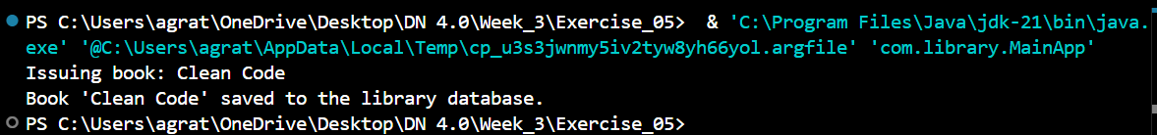

# Exercise 07

BookRepository.java

package com.library.repository;

public class BookRepository {

    public void save(String bookName) {

        System.out.println("Book '" + bookName + "' saved to the repository.");

    }

}

BookService.java

package com.library.service;

import com.library.repository.BookRepository;

public class BookService {

    private String librarianName;

    private BookRepository bookRepository;

    // Constructor Injection

    public BookService(String librarianName) {

        this.librarianName = librarianName;

    }

    // Setter Injection

    public void setBookRepository(BookRepository bookRepository) {

        this.bookRepository = bookRepository;

    }

    public void issueBook(String bookName) {

        System.out.println("Librarian " + librarianName + " is issuing the book: " + bookName);

        bookRepository.save(bookName);

    }

}

MainApp.java

package com.library;

import com.library.service.BookService;

import org.springframework.context.ApplicationContext;

import org.springframework.context.support.ClassPathXmlApplicationContext;

public class MainApp {

    public static void main(String[] args) {

        ApplicationContext context = new ClassPathXmlApplicationContext("applicationContext.xml");

        BookService service = (BookService) context.getBean("bookService");

        service.issueBook("Effective Java");

    }

}

applicationContext.xml

<?xml version="1.0" encoding="UTF-8"?>

<beans xmlns="http://www.springframework.org/schema/beans"

       xmlns:xsi="http://www.w3.org/2001/XMLSchema-instance"

       xsi:schemaLocation="http://www.springframework.org/schema/beans

       http://www.springframework.org/schema/beans/spring-beans.xsd">

    <bean id="bookRepository" class="com.library.repository.BookRepository"/>

    <bean id="bookService" class="com.library.service.BookService">

        <constructor-arg value="Ms. Sharma"/>

        <property name="bookRepository" ref="bookRepository"/>

    </bean>

</beans>

Pom.xml

<project xmlns="http://maven.apache.org/POM/4.0.0"

         xmlns:xsi="http://www.w3.org/2001/XMLSchema-instance"

         xsi:schemaLocation="http://maven.apache.org/POM/4.0.0

         http://maven.apache.org/xsd/maven-4.0.0.xsd">

    <modelVersion>4.0.0</modelVersion>

    <groupId>com.library</groupId>

    <artifactId>LibraryManagement</artifactId>

    <version>1.0-SNAPSHOT</version>

    <dependencies>

        <dependency>

            <groupId>org.springframework</groupId>

            <artifactId>spring-context</artifactId>

            <version>5.3.34</version>

        </dependency>

    </dependencies>

</project>

Output:

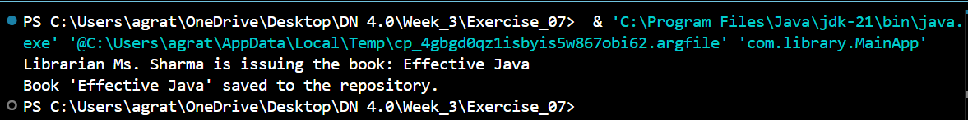

# Exercise 09

Book.java

package com.example.library;

import jakarta.persistence.Entity;

import jakarta.persistence.GeneratedValue;

import jakarta.persistence.Id;

@Entity

public class Book {

    @Id

    @GeneratedValue

    private Long id;

    private String title;

    private String author;

    // Getters and Setters

    public Long getId() { return id; }

    public void setId(Long id) { this.id = id; }

    public String getTitle() { return title; }

    public void setTitle(String title) { this.title = title; }

    public String getAuthor() { return author; }

    public void setAuthor(String author) { this.author = author; }

}

BookController.java

package com.example.library;

import org.springframework.beans.factory.annotation.Autowired;

import org.springframework.web.bind.annotation.*;

import java.util.List;

@RestController

@RequestMapping("/books")

public class BookController {

    @Autowired

    private BookRepository bookRepository;

    @GetMapping

    public List<Book> getAllBooks() {

        return bookRepository.findAll();

    }

    @GetMapping("/{id}")

    public Book getBookById(@PathVariable Long id) {

        return bookRepository.findById(id).orElse(null);

    }

    @PostMapping

    public Book createBook(@RequestBody Book book) {

        return bookRepository.save(book);

    }

    @PutMapping("/{id}")

    public Book updateBook(@PathVariable Long id, @RequestBody Book bookDetails) {

        Book book = bookRepository.findById(id).orElse(null);

        if (book != null) {

            book.setTitle(bookDetails.getTitle());

            book.setAuthor(bookDetails.getAuthor());

            return bookRepository.save(book);

        }

        return null;

    }

    @DeleteMapping("/{id}")

    public void deleteBook(@PathVariable Long id) {

        bookRepository.deleteById(id);

    }

}

BookRepository.java

package com.example.library;

import org.springframework.data.jpa.repository.JpaRepository;

public interface BookRepository extends JpaRepository<Book, Long> {

}

LibraryManagementApplication.java

package com.example.library;

import org.springframework.boot.SpringApplication;

import org.springframework.boot.autoconfigure.SpringBootApplication;

@SpringBootApplication

public class LibraryManagementApplication {

    public static void main(String[] args) {

        SpringApplication.run(LibraryManagementApplication.class, args);

    }

}

pom.xml

<project xmlns="http://maven.apache.org/POM/4.0.0"

         xmlns:xsi="http://www.w3.org/2001/XMLSchema-instance"

         xsi:schemaLocation="http://maven.apache.org/POM/4.0.0

         http://maven.apache.org/xsd/maven-4.0.0.xsd">

    <modelVersion>4.0.0</modelVersion>

    <groupId>com.example</groupId>

    <artifactId>LibraryManagement</artifactId>

    <version>0.0.1-SNAPSHOT</version>

    <packaging>jar</packaging>

    <name>LibraryManagement</name>

    <description>Library Management Spring Boot App</description>

    <parent>

        <groupId>org.springframework.boot</groupId>

        <artifactId>spring-boot-starter-parent</artifactId>

        <version>3.2.0</version>

    </parent>

    <dependencies>

        <dependency>

            <groupId>org.springframework.boot</groupId>

            <artifactId>spring-boot-starter-web</artifactId>

        </dependency>

        <dependency>

            <groupId>org.springframework.boot</groupId>

            <artifactId>spring-boot-starter-data-jpa</artifactId>

        </dependency>

        <dependency>

            <groupId>com.h2database</groupId>

            <artifactId>h2</artifactId>

            <scope>runtime</scope>

        </dependency>

    </dependencies>

    <build>

        <plugins>

            <plugin>

                <groupId>org.springframework.boot</groupId>

                <artifactId>spring-boot-maven-plugin</artifactId>

            </plugin>

        </plugins>

    </build>

</project>

Output:

