# Creating Microservices for Account and Loan

Project structure

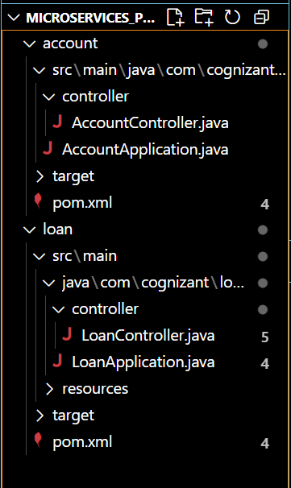

Account:

AccountController.java

package com.cognizant.account.controller;

import org.springframework.web.bind.annotation.*;

import java.util.Map;

@RestController

@RequestMapping("/accounts")

public class AccountController {

    @GetMapping("/{number}")

    public Map<String, Object> getAccountDetails(@PathVariable String number) {

        return Map.of(

            "number", number,

            "type", "savings",

            "balance", 234343

        );

    }

}

AccountApplication.java

package com.cognizant.account;

import org.springframework.boot.SpringApplication;

import org.springframework.boot.autoconfigure.SpringBootApplication;

@SpringBootApplication

public class AccountApplication {

    public static void main(String[] args) {

        SpringApplication.run(AccountApplication.class, args);

    }

}

pom.xml

<project xmlns="http://maven.apache.org/POM/4.0.0"

         xmlns:xsi="http://www.w3.org/2001/XMLSchema-instance"

         xsi:schemaLocation="http://maven.apache.org/POM/4.0.0

         http://maven.apache.org/xsd/maven-4.0.0.xsd">

    <modelVersion>4.0.0</modelVersion>

    <parent>

        <groupId>org.springframework.boot</groupId>

        <artifactId>spring-boot-starter-parent</artifactId>

        <version>3.1.0</version>

        <relativePath/> <!-- lookup parent from repository -->

    </parent>

    <groupId>com.cognizant</groupId>

    <artifactId>account</artifactId>

    <version>0.0.1-SNAPSHOT</version>

    <name>account</name>

    <description>Account microservice</description>

    <properties>

        <java.version>17</java.version>

    </properties>

    <dependencies>

        <dependency>

            <groupId>org.springframework.boot</groupId>

            <artifactId>spring-boot-starter-web</artifactId>

        </dependency>

        <dependency>

            <groupId>org.springframework.boot</groupId>

            <artifactId>spring-boot-devtools</artifactId>

            <scope>runtime</scope>

            <optional>true</optional>

        </dependency>

    </dependencies>

    <build>

        <plugins>

            <plugin>

                <groupId>org.springframework.boot</groupId>

                <artifactId>spring-boot-maven-plugin</artifactId>

            </plugin>

        </plugins>

    </build>

</project>

Output:

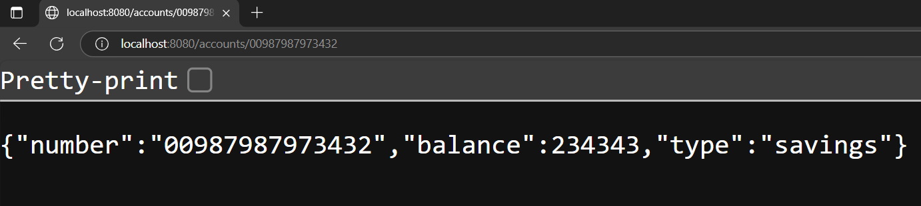

Loan:

LoanController.java

package com.cognizant.loan.controller;

import org.springframework.web.bind.annotation.*;

import java.util.Map;

@RestController

@RequestMapping("/loans")

public class LoanController {

    @GetMapping("/{number}")

    public Map<String, Object> getLoanDetails(@PathVariable String number) {

        return Map.of(

            "number", number,

            "type", "car",

            "loan", 400000,

            "emi", 3258,

            "tenure", 18

        );

    }

}

LoanApplication.java

package com.cognizant.loan;

import org.springframework.boot.SpringApplication;

import org.springframework.boot.autoconfigure.SpringBootApplication;

@SpringBootApplication

public class LoanApplication {

    public static void main(String[] args) {

        SpringApplication.run(LoanApplication.class, args);

    }

}

pom.xml

<project xmlns="http://maven.apache.org/POM/4.0.0"

         xmlns:xsi="http://www.w3.org/2001/XMLSchema-instance"

         xsi:schemaLocation="http://maven.apache.org/POM/4.0.0

         http://maven.apache.org/xsd/maven-4.0.0.xsd">

    <modelVersion>4.0.0</modelVersion>

    <parent>

        <groupId>org.springframework.boot</groupId>

        <artifactId>spring-boot-starter-parent</artifactId>

        <version>3.1.0</version>

        <relativePath/> <!-- lookup parent from repository -->

    </parent>

    <groupId>com.cognizant</groupId>

    <artifactId>account</artifactId>

    <version>0.0.1-SNAPSHOT</version>

    <name>account</name>

    <description>Account microservice</description>

    <properties>

        <java.version>17</java.version>

    </properties>

    <dependencies>

        <dependency>

            <groupId>org.springframework.boot</groupId>

            <artifactId>spring-boot-starter-web</artifactId>

        </dependency>

        <dependency>

            <groupId>org.springframework.boot</groupId>

            <artifactId>spring-boot-devtools</artifactId>

            <scope>runtime</scope>

            <optional>true</optional>

        </dependency>

    </dependencies>

    <build>

        <plugins>

            <plugin>

                <groupId>org.springframework.boot</groupId>

                <artifactId>spring-boot-maven-plugin</artifactId>

            </plugin>

        </plugins>

    </build>

</project>

Output:

