# Set up a react environment

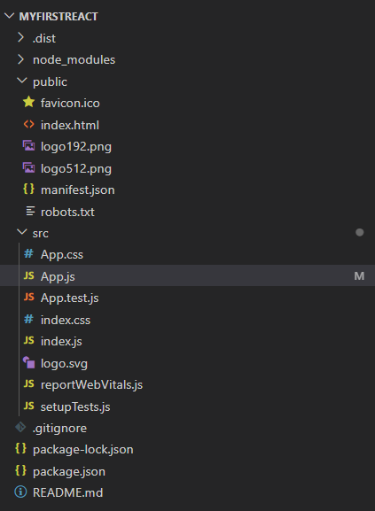Project structure

App.js

App.test.js

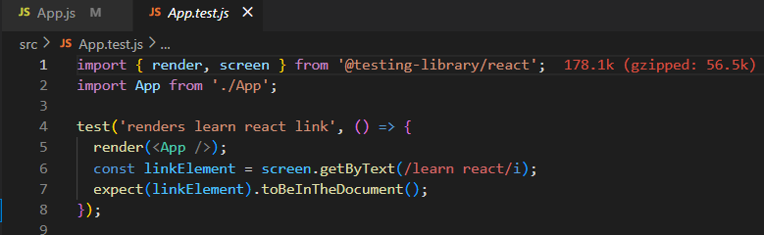

App.css

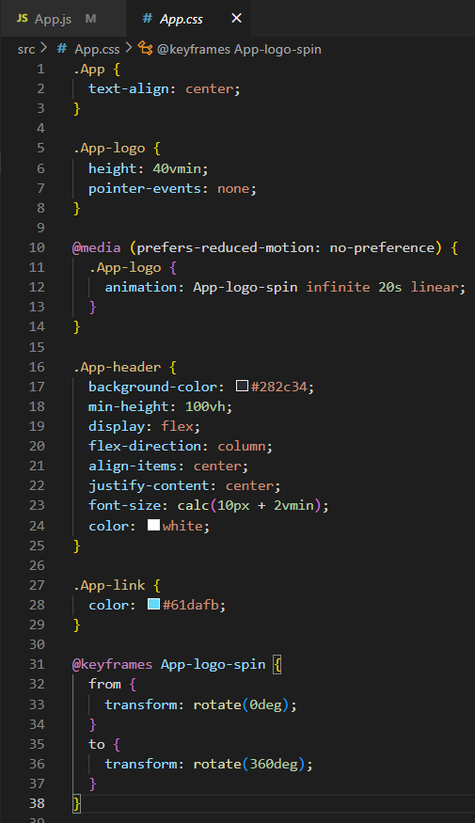

Output

# Create a class component, Create multiple components, Render a component

Project structure

About.js

Contact.js

Home.js

App.css

App.js

Output

# Create a function, Apply style to components, Render a component

Project structure

CalculateScore.js

mystyle.css

App.css

App.js

App.test.js

Output

# Implement componentDidMount() hook, Implementing componentDidCatch() life cycle hook

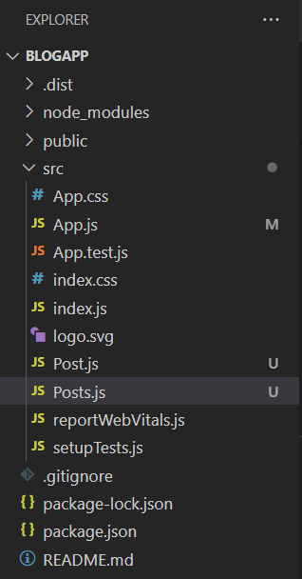Project structure

App.css

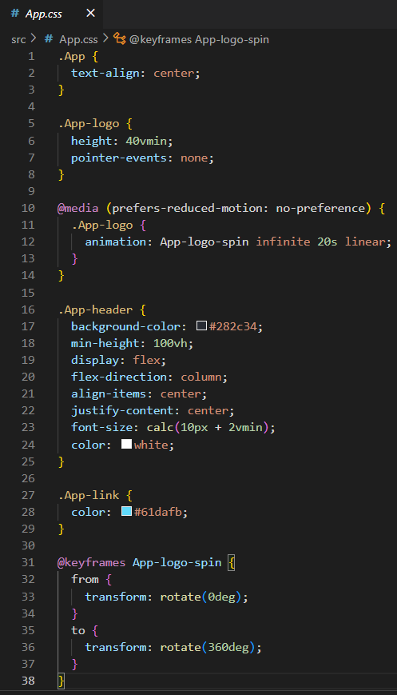

App.js

App.test.js

Post.js

Posts.js

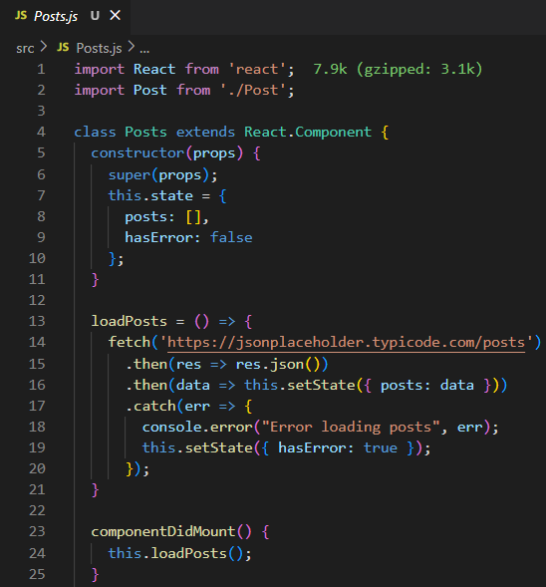

Output

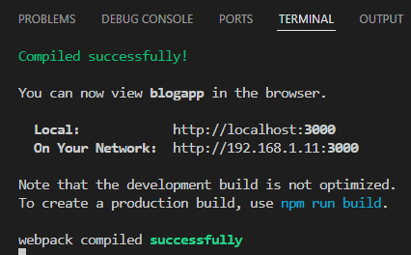

# Implement Style a react component, Define styles using the CSS Module, Apply styles to components using className and style properties

Project structure

CohortDetails.js

CohortDetails.module.css

App.test.js

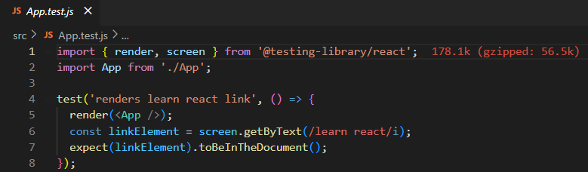

App.css

App.js

Output

