# Use map() method of ES6, Apply arrow functions of ES6, Implement Destructuring features of ES6

Project structure

App.js

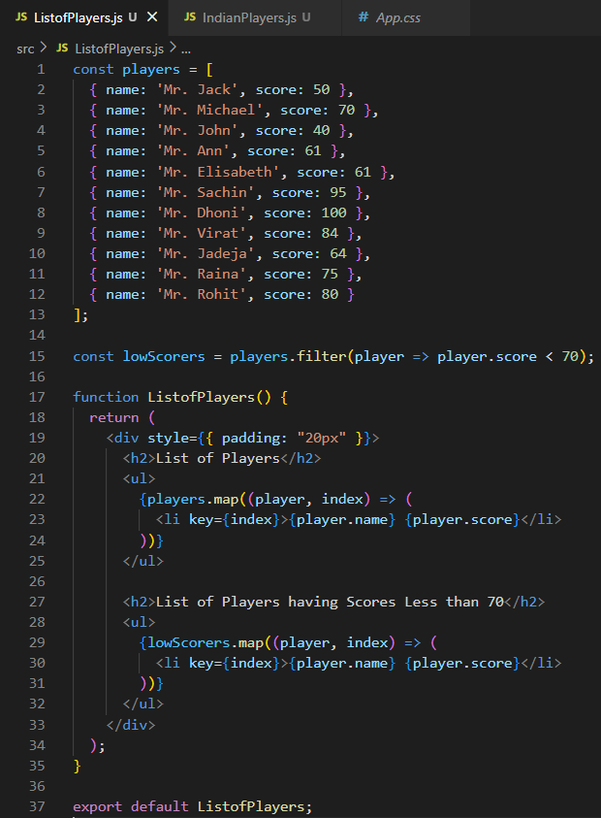ListofPlayers.js

IndianPlayers.js

App.css

Output

# Use JSX syntax in React applications, Use inline CSS in JSX

Project structure

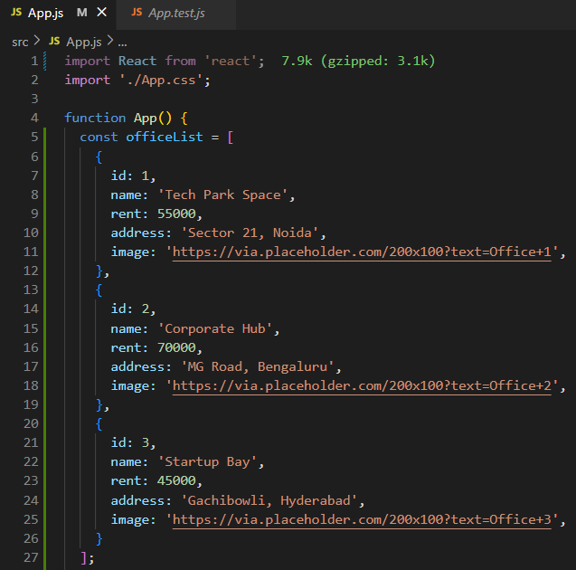App.js

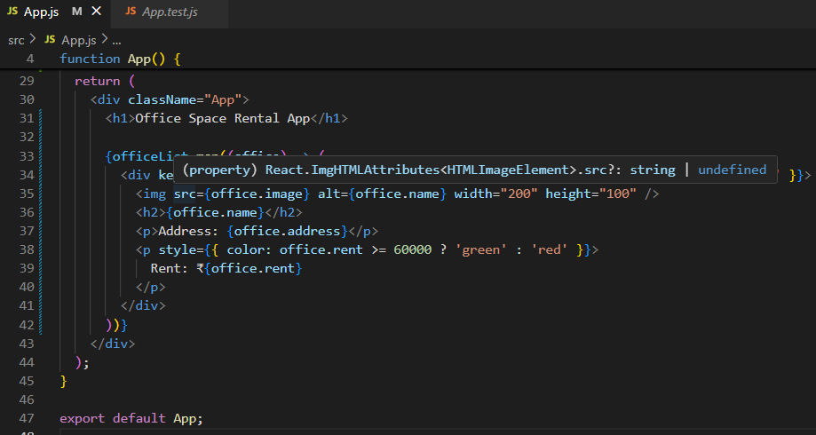

Output

# Implement Event handling concept in React applications, Use this keyword, Use synthetic event

Project structure

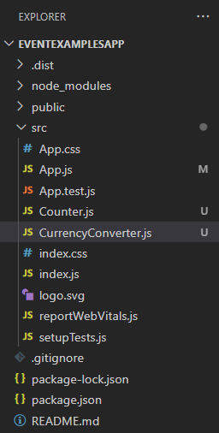

App.js

Counter.js

CurrencyConverter.js

Output

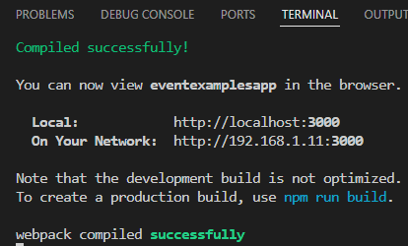

Increment

Decrement

Say Welcome

Currency Converter (INR to EUR)

# Implement conditional rendering in React applications

Project structure

App.js

Output

Login

Logout

# Implement conditional rendering in React applications

Project structure

App.js

BookDetails.js

BlogDetails.js

CourseDetails.js

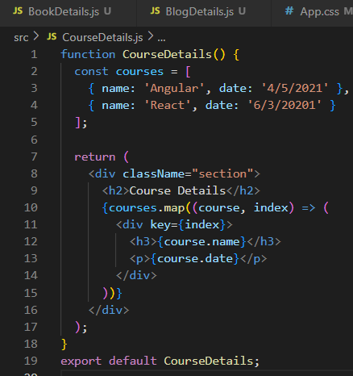

CourseList.js

App.css

Output

