**Homework 3**

***Shruti Agrawal(sxa178830)***

1. **Regular Expressions (50 points)**
2. Trellis is added below. Calculations for each state follow.

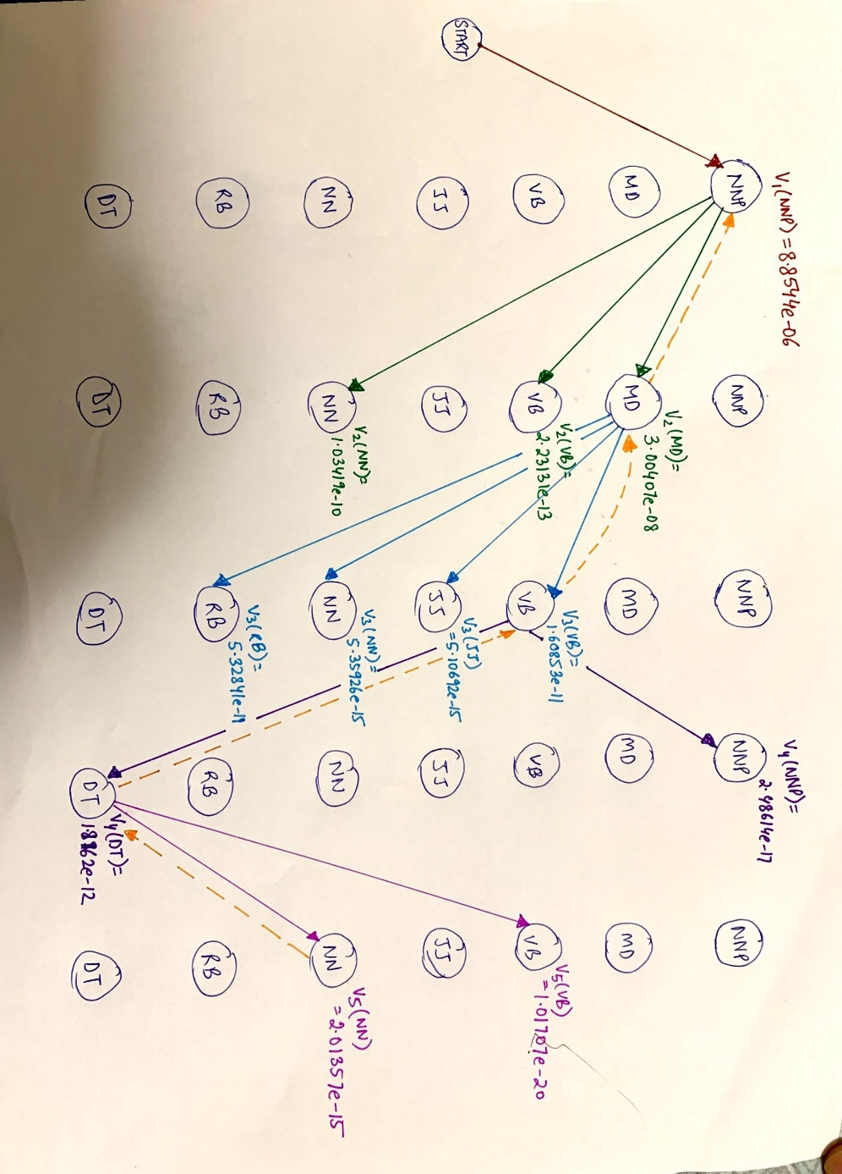

The calculations shown are for the max obtained at each state for every observation state. Bij indicates the backtracking state for the state j at observation i

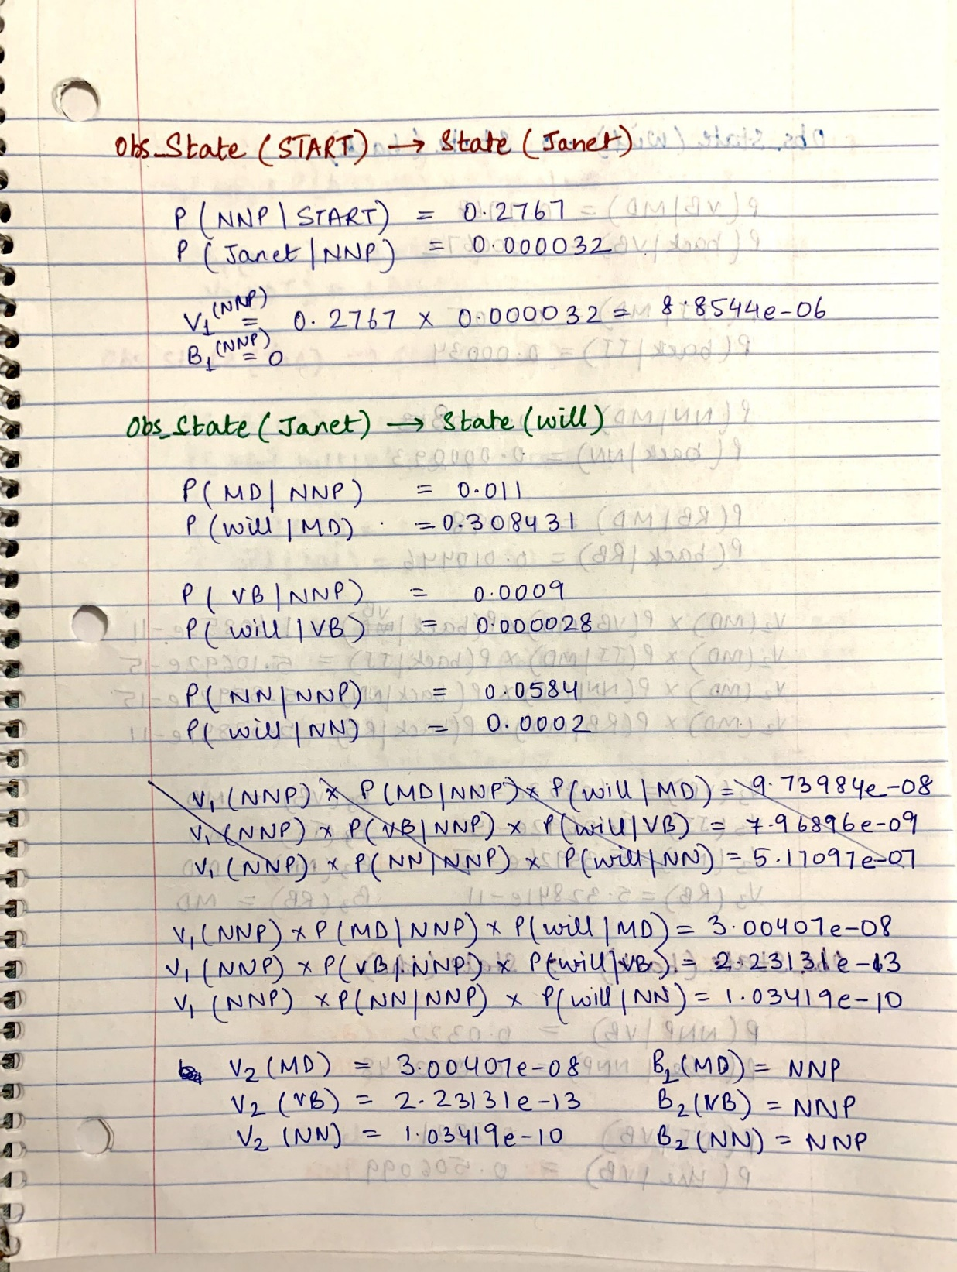

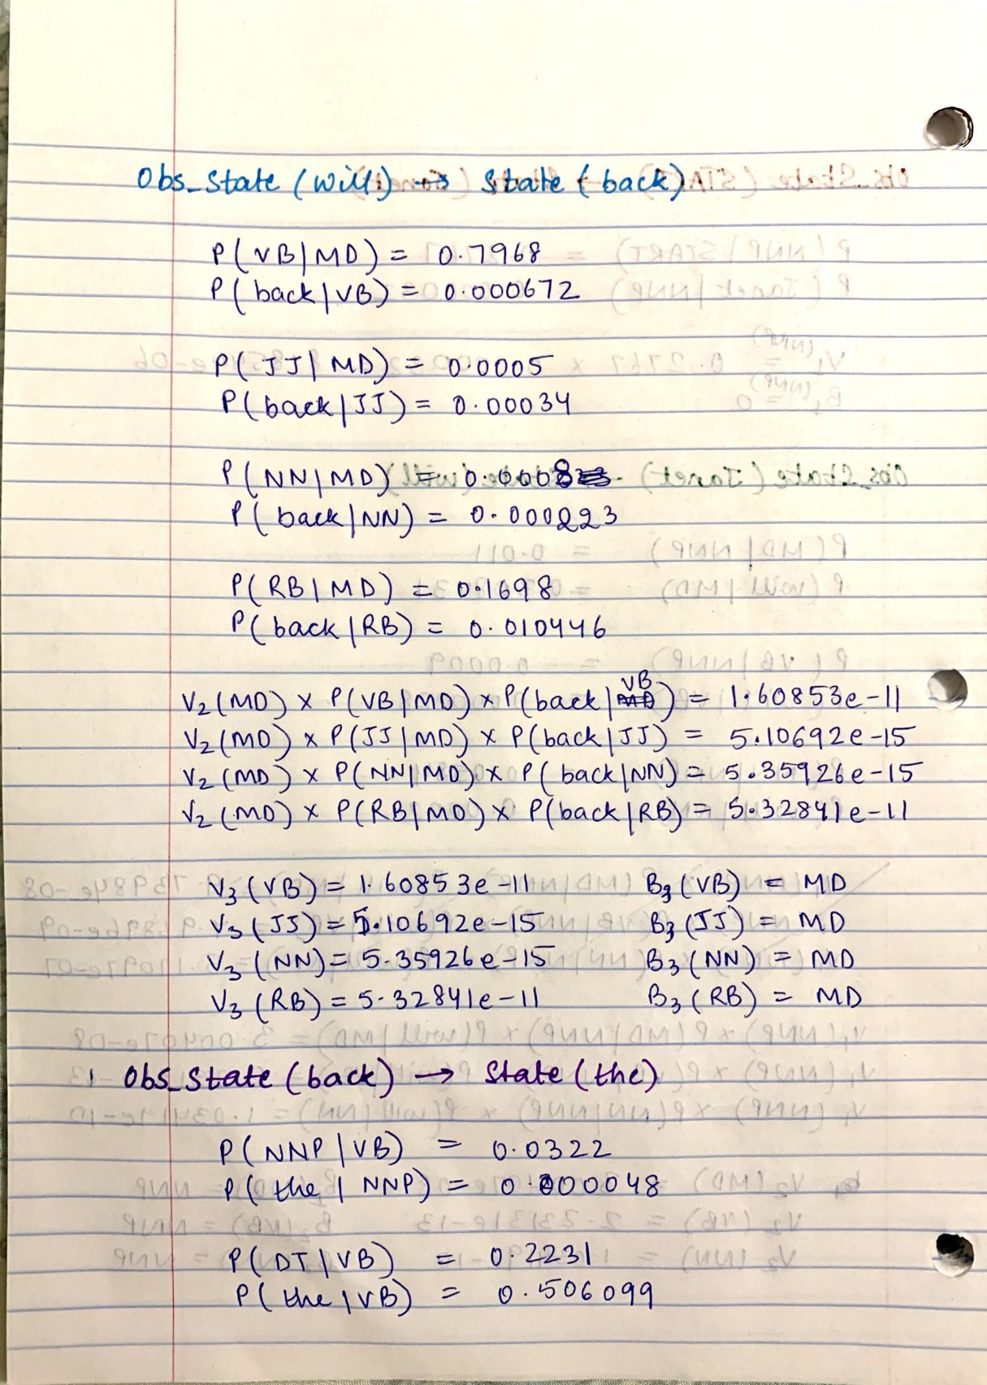

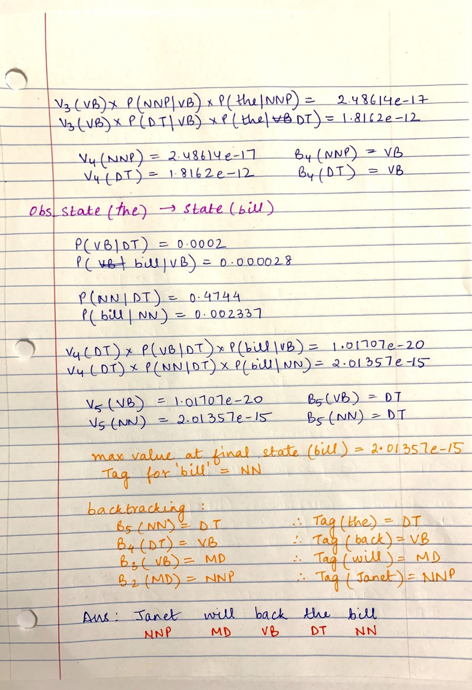

1. The code along with instructions and output file is attached.
2. **Telephone Number (50 points)**
3. Secretariat/NNP is/VBZ expected/VBN to/TO race/?? tomorrow/NN

For NN|race, features satisfied are f1, f6

For VB|race, features satisfied are f2, f4, f5

Also,

Thus, we choose VB as the POS Tag for race.

1. the/DT race/?? for/IN outer/JJ space/NN

For NN|race, features satisfied are f1, f3

For VB|race, features satisfied are f4, f5

Also,

Thus, we choose NN as the POS Tag for race.