Pre-MQL Lead Handling Tool

Complete User Guide

Version 1.0

Table of Contents

- What is this tool?
- What can this tool do?
- Before you start
- Installation (One-time setup)
- Part 1: Extracting Emails
- Part 2: Reviewing and Filling Excel
- Part 3: Automated Form Submission
- Part 4: Moving Emails to Folders
- Understanding the Excel File

What is This Tool?
This is a complete automation tool for processing Pre-MQL (Marketing Qualified Lead) emails from Outlook.
The problem it solves:
- Manually copying data from emails is time-consuming
- Filling web forms repeatedly is tedious
- Moving emails to correct folders takes effort
- Tracking which emails are processed is difficult

The solution: This tool automates all of these tasks!

What Can This Tool Do?
Part 1: Email Extraction
- Connects to your Outlook Finds Pre-MQL emails from specific dates
- Extracts all important information
- Creates a formatted Excel file with two sheets (Validation & Review)
Part 2: Smart Analysis
- The tool automatically identifies:
- University contacts (marks them automatically)
- Mass market accounts
- Free email providers (Gmail, Yahoo, etc.)
- Company domain validation
- Contact sales form submissions
Part 3: Manual Review
- You review the Excel file and: Select "Take Action" for each lead
- Choose rejection reasons if needed
- Add additional scoring information
- Decide which folder to move emails to
Part 4: Automated Form Submission
- The tool can:
- Open each PreMQL link automatically
- Fill in the web form with your decisions
- Submit the form
- Track success/failure for each row
Part 5: Email Organization
The tool can:
- Move emails to the correct Outlook folders
- Organize by distribution partner (Arrow, Future, Rutronik, etc.)
- Track which emails were moved

Before You Start
What You Need:
Computer Requirements:
- Windows 10 or 11 Microsoft Outlook installed and configured
- Internet connection
Software to Install:
- Python 3.11 or higher
- Google Chrome browser (version 143)
- ChromeDriver (version 143)
- Project files (Github Link: https://github.com/agrawalapurw/LM_Automation.git)
Please do not make any code changes in github.
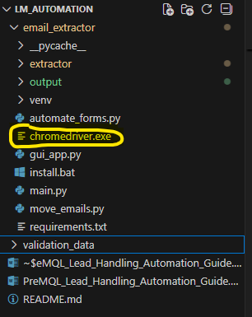
Access Requirements:
- Access to your Outlook mailbox and MAT Sales Inbox
- Permissions to move emails in Outlook
- Access to Eloqua
- Note: If you need to download anything, please Enable the local Admin rights in iARM
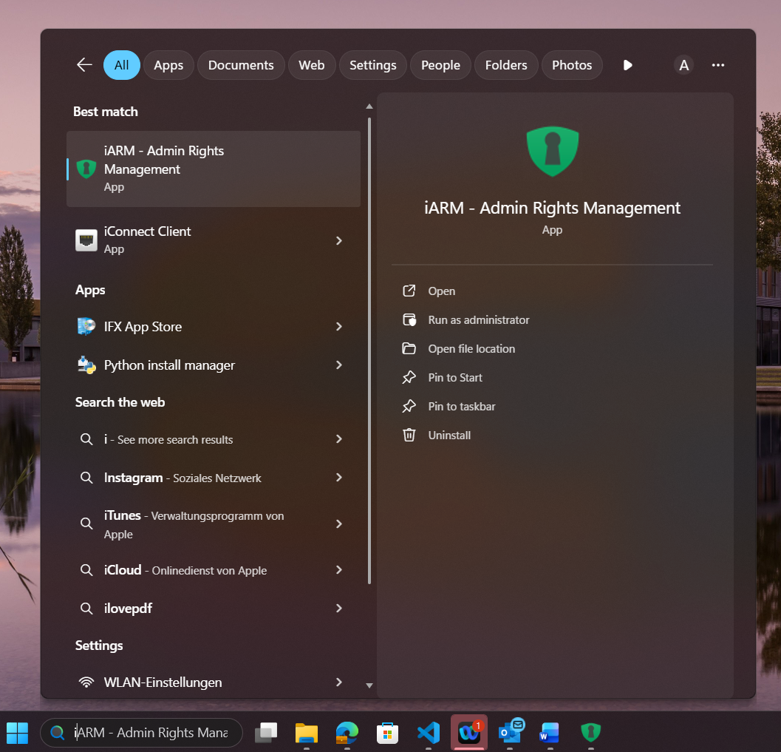
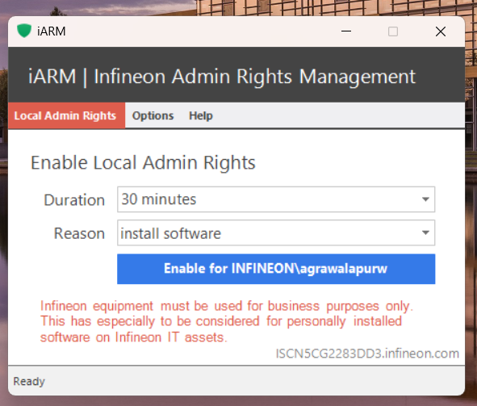

Installation (One-Time Setup)
Step 1: Install Python
- Go to: https://www.python.org/downloads/
- Click "Download Python 3.11.x" (download the latest python version)
- Run the installer
CRITICAL: Check the box "Add Python to PATH"
- Click "Install Now"
- Wait for completion (2-3 minutes)
- Click "Close"
- Restart your computer
Verify installation:
- Press Windows + R
- Type: cmd
- Press Enter
- Type:
python --version
- Should show: Python 3.11.x (or the latest python version that was installed)
Step 2: Get the Project Files
- Clone the GitHub project:
  - In command prompt type:
git clone https://github.com/agrawalapurw/LM_Automation.git
- You should receive a folder: email_extractor or LM_Automation. If you are in the folder LM_Automation, then navigate to email_extractor using “cd email_extractor” command

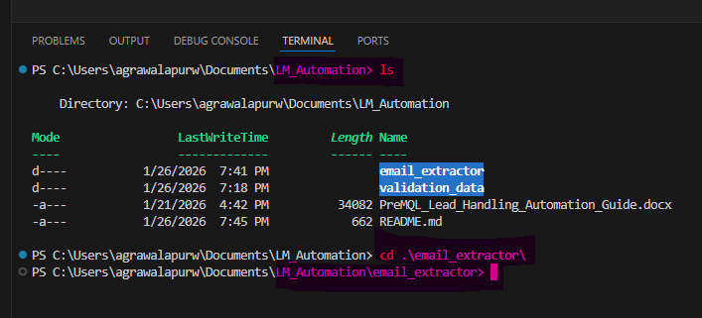
Step 3: Install Python Packages
- Enable Local Admin Rights from iARM
- Press Windows + R
- Type: cmd
- Press Enter
- Type and press Enter:
cd C:\email_extractor
- Type and press Enter:
pip install -r requirements.txt
- Wait 2-5 minutes for installation
- You'll see packages being downloaded
Step 4: Install Chrome Browser (Version 143)
- Important: You need a specific Chrome version for automation.
- Download Chrome 143 from:
https://storage.googleapis.com/chrome-for-testing-public/143.0.7499.192/win64/chrome-win64.zip
- Right-click the ZIP → "Extract All"
- Extract to: C:\Chrome143\
- You should have: C:\Chrome143\chrome-win64\chrome.exe
- Note: You can keep your regular Chrome. This is just for automation.
Step 5: Download ChromeDriver (Version 143)
- Download ChromeDriver 143 from: https://storage.googleapis.com/chrome-for-testing-public/143.0.7499.192/win64/chromedriver-win64.zip
- Extract the ZIP file Copy chromedriver.exe to: C:\email_extractor\chromedriver.exe
- Verify: File location: C:\email_extractor\chromedriver.exe
Note: You can install latest version of chrome and chromedriver, but it is very important to match the versions of both chrome and chromedriver
Step 6: Test Installation
- Open Command Prompt
- Type:
cd C:\email_extractor python main.py
- If you see the tool start, installation is successful!
- Press Ctrl+c to exit
- You're now ready to use the tool!

Part 1: Extracting Emails
This is the first step - extracting emails from Outlook to Excel.
Step 1: Open Command Prompt
- Press Windows + R
- Type: cmd
- Press Enter
Step 2: Navigate to Project
- Type: cd C:\email_extractor
- Press Enter
Step 3: Run the Extractor
- Type: python main.py
- Press Enter
Step 4: Open the extracted excel file and process it
- The extracted file will have two sheets to be worked on:
  - Validation sheet
  - Review sheet

Part 2: Reviewing and Filling Excel

Now you need to open the Excel file and make decisions.
Step 1: Open the Excel File
- Open File Explorer
- Go to: `C:\email_extractor\output\`
- Find your file: `Extraction_13Jan24.xlsx`
- Double-click to open in Excel
Step 2: Understand the Two Sheets
The Excel file has two sheets:
- Sheet 1: Validation
  - Emails with "validation" in subject
  - More detailed options for decision-making

- Sheet 2: Review
  - Emails with "review" in subject
  - Simpler options
Step 3: Understand the Color-Coded Headers
Headers are color-coded to help you:
Color | What It Means | Columns
🔵 Blue | Data extracted from emails | Subject, Sender, Company, Email, Country, etc.
🔴 Light Red | Use these to filter | Has Contact Sales Form, Company Domain Validation, Status
🟠 Light Orange | YOU fill these | Take Action, Reject Reasons, Additional Info, Send to, Move to Folder
🟢 Light Green | Automation results | Action Taken, Form Submission Status, Email Move Status
Step 4: Review Auto-Detected Information
Before you start filling, check these columns:
- Status Column (Light Red):
  - `University Contact` = Automatically identified as university
  - `Mass Market` = Mass market account (Review sheet only)
  - `Not Started` = Needs your review

- Company Domain Validation Column (Light Red):
  - `Valid Company Domain` = Email domain matches company
  - `Free Mailer` = Using Gmail/Yahoo/etc
  - `Domain Mismatch` = Company and email don't match

- Has Contact Sales Form Column (Light Red):
  - `Yes` = Contact sales form was submitted
  - `No` = No form submission
Step 5: Fill the Orange Columns (Your Decisions)
For each row, you need to fill:
- A: Take Action Column (Required)
  - For Validation Sheet:
Click the dropdown and select:
    - `Valid Company → MQL` = Lead is valid, send to sales
    - `Valid Company → Reject` = Lead is valid but reject
    - `Invalid Company` = Company is invalid
  - For Review Sheet:
Click the dropdown and select:
    - `MQL Send to Sales` = Send to sales team
    - `Reject` = Reject this lead

- B: Conditional Columns (Fill Based on Take Action)
- 1. If you selected "Valid Company → MQL":
  - Cells turn green (highlighted)
  - Fill "Additional Scoring Information" (e.g., "High engagement score")
  - Fill "Send to" (e.g., "Sales Team EMEA")
- 2. If you selected "Valid Company → Reject":
  - Cell turns yellow (highlighted)
  - Fill "Valid Company → Reject Reason" dropdown:
    - Not able to contact
    - Not a Disti lead
    - Contacted - no general potential
    - Contacted - no current potential
    - Not contacted - no general potential
    - Insufficient lead profile information
    - Lead already known
    - University Contact
    - Distribution Partner
- 3. If you selected "Invalid Company":
  - Cell turns yellow (highlighted)
  - Fill "Invalid Company Reason" dropdown:
    - University Contact
    - Distribution Partner
    - Company - with no potential
    - Agency
    - Free-mailer with no potential
    - Competitor
- C: Move to Folder Column (Optional)
  - Select where the email should be moved:
    - Arrow
    - EBV/Avnet
    - Future
    - Non-EBV Leads
    - Other Distribution Partners
    - Rutronik
    - Rejected Marketing

  - Visual Helper:
When you select a folder, the entire row changes color:
    - 🟧 Orange = Arrow
    - 🟦 Blue = EBV/Avnet
    - 🟩 Green = Future
    - 🟨 Yellow = Rutronik
    - 🟪 Purple = Other Distribution Partners
    - 🟥 Salmon = Rejected Marketing
Step 6: Tips for Filling Excel
- ✅ DO:
  - Fill "Take Action" for every row you want to process
  - Use the color highlighting as a guide
  - Save the file frequently (`Ctrl+S`)
  - Use Excel filters to focus on specific rows
- ❌ DON'T:
  - Don't change the blue column data (extracted from emails)
  - Don't delete rows
  - Don't rename the sheet tabs
  - Don't change column headers
Step 7: Save the Excel File
- Press `Ctrl+S` or click File → Save
- Close the Excel file before running automation

Part 3: Automated Form Submission

After filling in the Excel file, the tool can automatically fill web forms.
Important: Before You Start
Make sure:
- Excel file is closed (not just minimized)
- You've filled in "Take Action" for rows you want to process
- Chrome 143 and ChromeDriver are installed
- You have internet connection

Step 1: Open Command Prompt
- Press `Windows + R`
- Type: `cmd`
- Press `Enter`
Step 2: Navigate to Project
- Type: cd C:\email_extractor
- Press Enter
Step 3: Run the Extractor
- Type: python automate_forms.py
- Press Enter
All the forms will be filled with respective actions to be taken.

Part 5: Version control using Git

Step 1: Open Command Prompt
- Press `Windows + R`
- Type: `cmd`
- Press `Enter`
Step 2: Pull latest changes
- Type: git pull

