PROJECT TOPIC: American Sign Language Recognition

# Group No.: 184

**Project Group Members:**

**1.** Disha Agrawal (A-25/201500225) **2.** Deepa Agrawal (H-22/201500204)

**Project Supervisor:** Parul Choudhary (Assistant Professor)

**About the Project:** Hand Gesture Recognition Specifically ASL recognition is one of the active research areas. The gesture recognition technique is used to develop a system that is used to convey information among disabled people or for controlling a device.

The objective of this project is to study human sign language, specifically with officially accepted standard of ASL, thus exploring the field of recognition, detection and verification.

The proposed project is divided in 3 components. A) Dataset Formation B) Model Training C) Detecting the Gesture

1. Dataset Formation
   1. Building a custom dataset with the help of python libraries.
   2. Classifying the data into various classes required for easy execution
2. Model Training
   1. Selecting the appropriate model to gain better accuracy and desired output
   2. Training the model on dataset to calculate accuracy and get results
3. Detecting the gesture
   1. Line detection of hand and recognition of the hand gesture with live webcam
   2. Presenting the result on the screen with better layout along with predicted accuracy

The primary objective of the project is to develop a robust system that facilitates communication between individuals proficient in American Sign Language (ASL) and those who are not. By recognizing ASL gestures in real-time, the system aims to bridge the communication gap and promote inclusivity. The project focuses on achieving high accuracy and reliability in ASL gesture recognition. By enabling seamless communication between ASL users and mainstream individuals, the project fosters inclusivity and diversity in various social and professional settings. The project showcases the potential of advanced technologies

# Motivation:

* + - This project holds significant importance as it addresses the communication barriers faced by the hearing-impaired community, facilitating their integration into mainstream society.
    - Access to education is a fundamental right, yet individuals with hearing impairments often face barriers to accessing educational resources and opportunities due to communication challenges This will help them learn better
    - The Scope of this project can be used in diversified manner implementing this for especially abled person lately it can be used to implement various fields related to operations and robotics

# Project Planning:

**Objective: -** Detecting the gesture made in webcam and thus representing the type of sign or alphabets according to sign language standards formed with accurate results.

Steps: -

1. Dataset formation 2. Model Selection 3. Model Training 4. Recognition

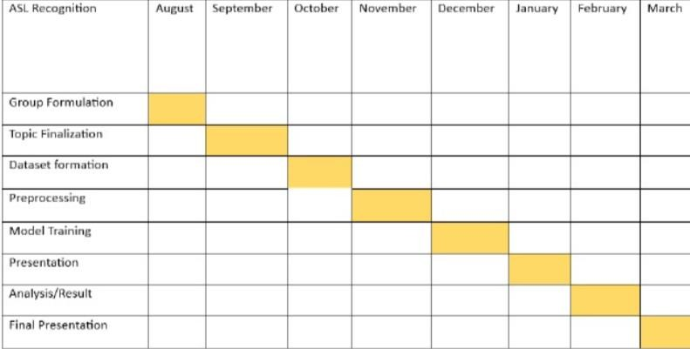

# Tools required:

* **Hardware Requirements:** Webcam, Computer with sufficient processing power and memory
* **Software Requirements:** Python, Python libraries for computer vision and machine learning (e.g., OpenCV, TensorFlow), Integrated Development Environment (IDE) for coding

**Signature of Project Supervisor:**