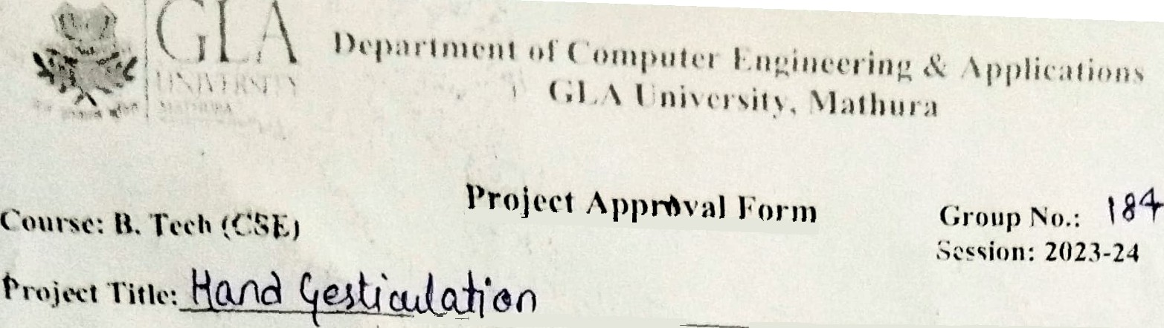

' ’to I Çb O lO

4.

h1ub. N‹›.

' ° “° ’"! zrl77›sK1 o'!*°

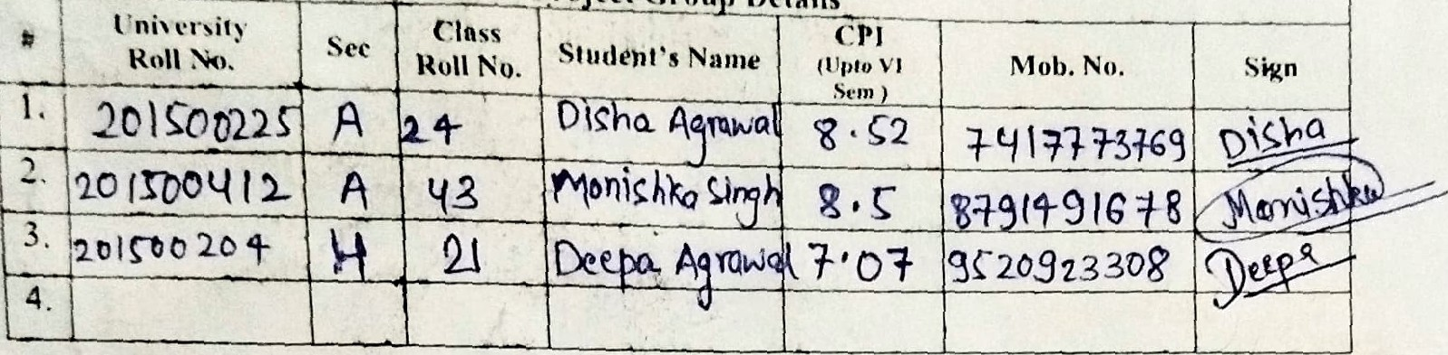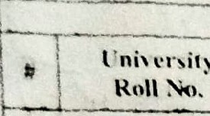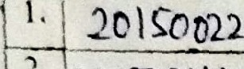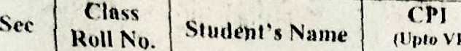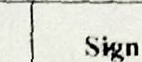

” *°“ 9 •.r *ex 1sN* 18 h•+•

§f20di33T je



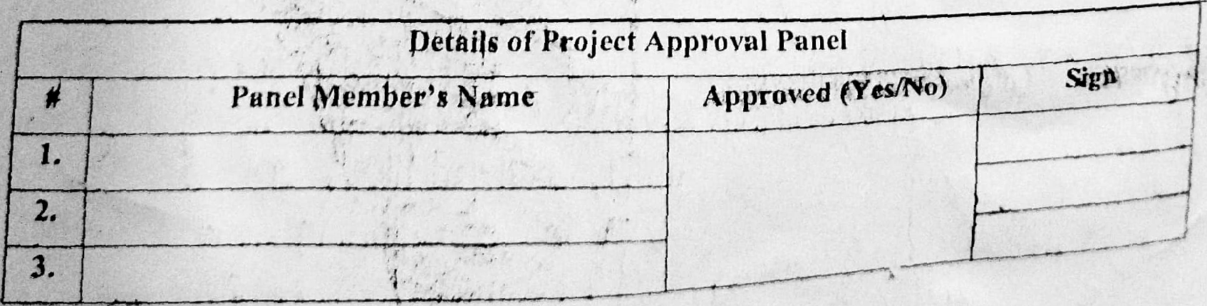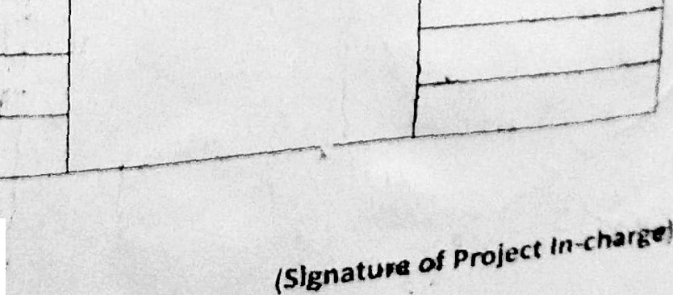

@et8j|s of” Projccf AppJ‘c› ul Pancl

/’anrJ 1ember's Namc Appro$Cd f+

°!

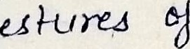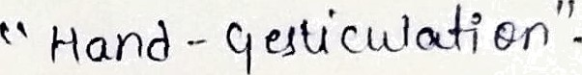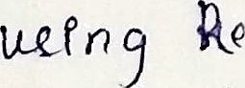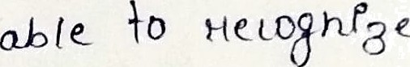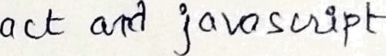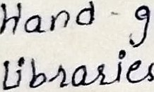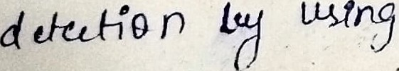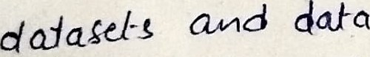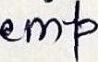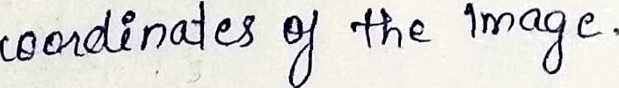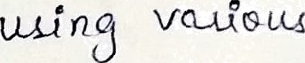

Jhe @°j'^ °“

aít

|  |  |  |  |
| --- | --- | --- | --- |
| fiupci 'ls0r's í7ctalls | | | |
| ï't ame | Desigiiatiòn | Contact No. | Project Mcctin 4’iine  i |
|  |  |  | 2. |

*,ABS TRACT*

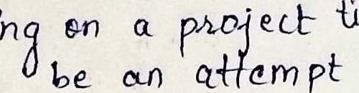





Supervisor's Si n:

Panel's Sugpestions/itpmarks: