
Department of Computer Engineering and Technology
MINI PROJECT REPORT
Computer Networks Laboratory
(CSE20110)
Laboratory Continuous Assessment 3

College Campus Network Design and Security

Submitted by
Sr. No. | Student Name | PRN
1. | Raghav Singh | 1262241452
2. | Mitali Agrawal | 1262241467
3. | Hrushikesh Kapre | 1262241493
4. | Aarushi Tyagi | 1262241597

Group No. Panel A Batch A-2
Third Year B.Tech. Computer Engineering and Technology
Under the guidance of
Susheel Kumar
Academic Year 2026–2027
22/10/2026

/
Department of Computer Engineering and Technology
CERTIFICATE

This is to certify that the mini-project entitled “College Campus Network Design and Security” has been carried out by the following students of Third Year B.Tech. Computer Science and Engineering, Panel A, Batch A2, Group No. , under my guidance during the academic year 2026–2027.

Student Name | PRN
Raghav Singh | 1262241452
Mitali Agrawal | 1262241467
Hrushikesh Kapre | 1262241493
Aarushi Tyagi | 1262241597

The report is submitted towards the mini-project component of Laboratory Continuous Assessment 3 for the Computer Networks Laboratory course.

Faculty Signature __________________________
Mr. Susheel Kumar
Project Guide and Course Faculty
Date ____________________ Place: Pune

Acknowledgement
We express our gratitude to our course faculty and the Department of Computer Engineering and Technology for providing the academic framework for this Computer Networks Laboratory mini-project. Cisco Packet Tracer provided the environment to design, configure, and test the simulated campus network. We also acknowledge the technical documentation consulted during implementation. The project team remains responsible for the final configuration and reported test results.
Group No.

Abstract
This mini-project designs and simulates a college campus network using Cisco Packet Tracer. It organizes student, faculty, and shared server devices into separate logical networks while retaining required communication. The expanded design uses one Cisco 2911 router, three Cisco 2960 switches, seven PCs (PC0–PC6, with PC3–PC6 added during expansion), and two servers. VLAN 10 serves students, VLAN 20 serves faculty, and VLAN 40 hosts the servers. Router subinterfaces and 802.1Q trunking provide inter-VLAN routing. Server0 provides DHCP and DNS, while Server1 hosts an HTTP website. DHCP relay allows clients in different VLANs to obtain settings from the central DHCP server. The DNS record maps www.collegenetwork.com to 192.168.40.3. Security features include a student-specific extended ACL, SSH version 2 for router administration, sticky MAC port security on user-facing switch ports, and shutdown of unused ports. Tests confirmed DHCP assignment on the added PCs, website access by domain name from student and faculty clients, SSH access from PC0, and sticky MAC learning. Student ICMP ping to Server0 was blocked as expected by the ACL. Simulation Mode was used to observe website-related packet events. The project demonstrates campus network segmentation, essential services, expansion, and basic security controls within a simulation.
Keywords: VLAN, DHCP, DNS, Access Control List, SSH, Cisco Packet Tracer

Table of Contents
Acknowledgement ............................................................... 3
Abstract ...................................................................... 3–4
Table of Contents ............................................................. 5
List of Figures ............................................................... 6
List of Tables ................................................................ 6
1 Introduction and Project Objectives ......................................... 7
1.1 Introduction and Background ........................................... 7
1.2 Problem Statement ..................................................... 7
1.3 Scope ................................................................. 7
1.4 Objectives ............................................................ 7
2 Proposed Design and Requirements ............................................ 8
2.1 Architecture and Network Topology ..................................... 8
2.2 Tools and System Requirements ......................................... 8
2.3 Addressing and Protocol Selection ..................................... 9
3 Implementation and Technical Working ........................................ 11
3.1 Methodology ........................................................... 11
3.2 Configuration or Code Implementation .................................. 11
3.3 Protocols and Technical Working ....................................... 12
3.4 Execution Procedure ................................................... 12
4 Testing and Results ......................................................... 12
4.1 Test Plan ............................................................. 12
4.2 Results and Execution Evidence ........................................ 13–17
4.3 Objective Achievement ................................................. 17
5 Discussion and Conclusion ................................................... 18–19
5.1 Discussion and Comparative Analysis ................................... 18
5.2 Advantages and Applications ........................................... 18
5.3 Limitations ........................................................... 18
5.4 Challenges and Troubleshooting ........................................ 18
5.5 Future Scope .......................................................... 19
5.6 Conclusion ............................................................ 19
References .................................................................... 20
AI Usage Declaration .......................................................... 20
Appendix A: Code and Configuration ............................................ 21
Appendix B: Additional Evidence ............................................... 21
Appendix C: Individual Contributions .......................................... 21

List of Figures
Figure 2.1 Proposed topology ................................. 8
Figure 2.2 Proposed architecture ................................. 9
Figure 3.1 Router interface status and configured VLAN gateway subinterfaces .... 11
Figure 4.1 Successful DHCP address assignment to a student client ............ 14
Figure 4.2 Successful access to the campus website through DNS and HTTP ...... 15
Figure 4.3 Student access control list and traffic-match counters ............ 16
Figure 4.4 Successful SSH remote login from PC0 to router R1 ................. 16
Figure 4.5 Sticky MAC addresses learned through switch port security ......... 17

List of Tables
Table 1.1 Project objectives and verification methods ........................ 7
Table 2.1 Tools and system requirements ...................................... 9
Table 2.2 Addressing and protocol selection .................................. 9
Table 4.1 Network testing and results ........................................ 12-13
Table 4.2 Objective achievement summary ...................................... 17
Table 4.3 Troubleshooting and corrective actions ............................. 18-19
Table C.1 Individual contributions ........................................... 21

1 Introduction and Project Objectives

1.1 Introduction and Background
Campus networks must support multiple user groups and shared services while remaining manageable and secure. VLANs divide a switched network into logical broadcast domains, while IEEE 802.1Q tagging identifies VLAN traffic on trunk links [1]. Inter-VLAN routing allows devices in different IP subnets to communicate through a router. DHCP automates host configuration, DNS maps human-readable names to IP addresses, and HTTP delivers web content. Extended ACLs filter traffic based on source, destination, protocol, and port [2]. SSH provides encrypted remote command-line management [3]. This project applies these concepts in a Packet Tracer simulation rather than measuring a production network.

1.2 Problem Statement
The project addresses the need for a simple campus LAN that separates student, faculty, and server traffic, provides automatic client configuration and a named website, and demonstrates basic network access and device-management protections.

1.3 Scope
The scope includes PC0 and PC1 as original student endpoints, PC2 as the original faculty endpoint, added PCs PC3–PC6, Server0 for DHCP/DNS, Server1 for HTTP, three Cisco 2960 switches, and one Cisco 2911 router. PC3 and PC4 are assigned to the student VLAN, while PC5 and PC6 are assigned to the faculty VLAN. The network is simulated in Packet Tracer. No external ISP, WAN, or public Internet connectivity is configured. The student ACL is applied to VLAN 10 only.

1.4 Objectives
Objectives and verification methods are listed in Table 1.1.
Table 1.1: Project Objectives and Verification Methods
Objective ID | Objective | Verification Method
O1 | Segment student, faculty, and server devices using VLANs. | VLAN/port configuration and gateway tests.
O2 | Provide automatic addressing and name-based website access. | DHCP client settings and domain website test.
O3 | Apply basic access and management security. | ACL behavior, SSH login, and port-security output.

2 Proposed Design and Requirements

2.1 Architecture and Network Topology
The router provides inter-VLAN routing and hosts the student ACL and SSH management. Switch0 connects the original student/faculty PCs, Switch1 connects both servers, and Switch2 expands the network with four additional PCs. Switch2 uses a trunk link to Switch0, carrying VLANs 10, 20, and 40. PC3 and PC4 are assigned to VLAN 10 (students), while PC5 and PC6 are assigned to VLAN 20 (faculty). Server0 provides DHCP and DNS; Server1 provides the website.
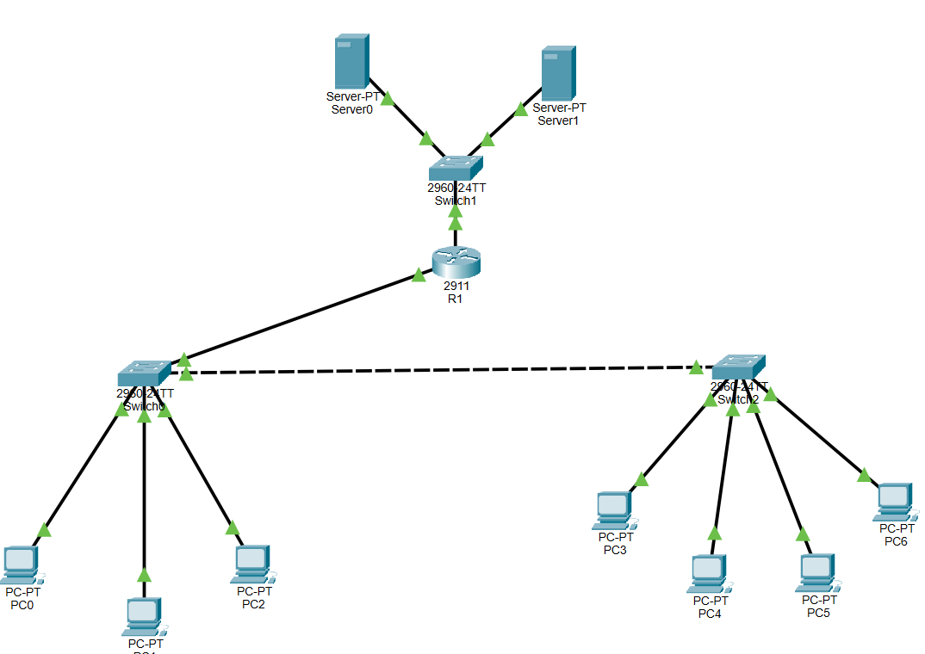
Figure 2.1 Proposed Topology
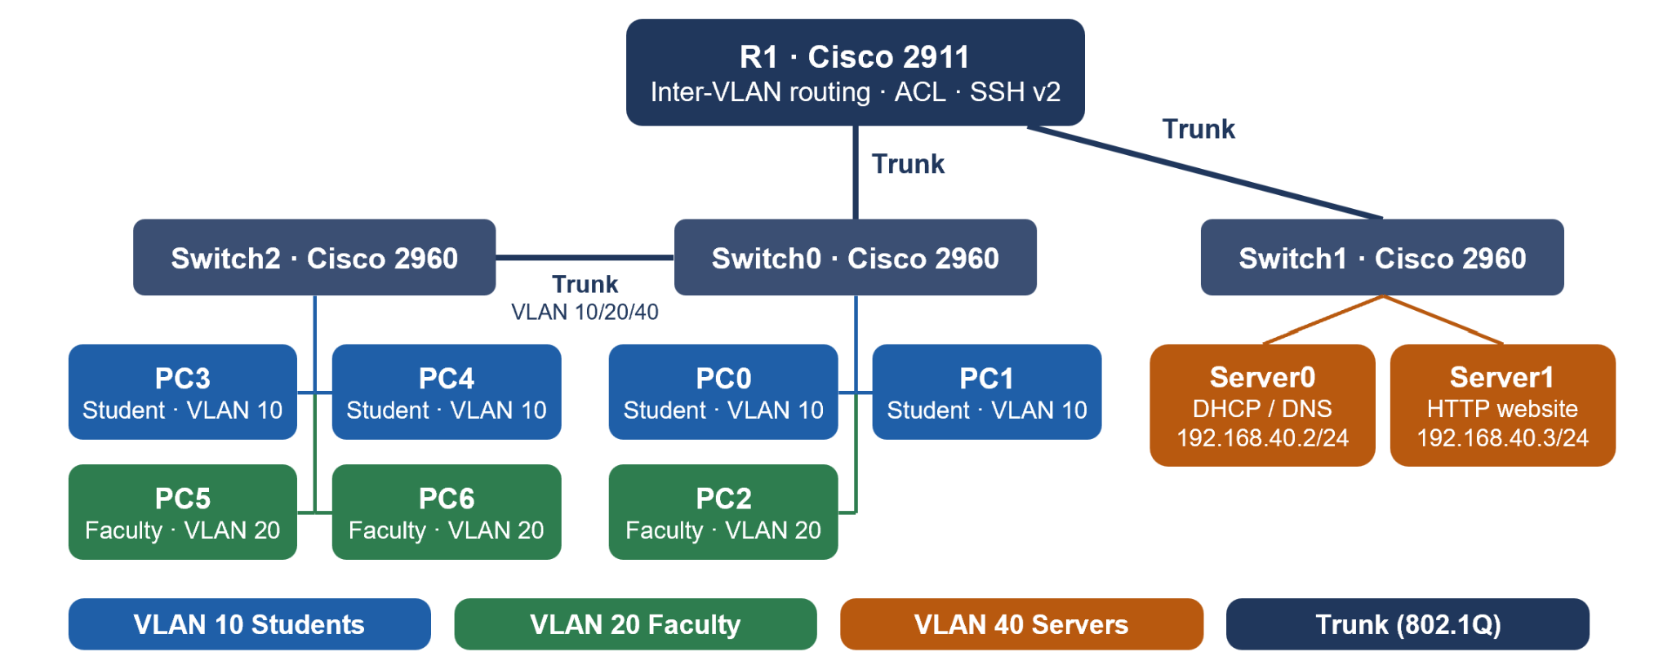
Figure 2.2 Proposed architecture

2.2 Tools and System Requirements
The project was implemented in Cisco Packet Tracer 9.0.1 using one simulated Cisco 2911 router and three Cisco 2960 switches. Seven PCs (PC0–PC6, with PC3–PC6 added during expansion) and two Packet Tracer servers are used. Client and server services were configured through Packet Tracer device interfaces and CLI. No external libraries were required.
Table 2.1: Tools and System Requirements
Tool or Resource | Version or Specification | Purpose
Cisco Packet Tracer | 9.0.1 | Topology design and simulation.
Cisco 2911 router | Simulated device | Inter-VLAN routing, DHCP relay, ACL, SSH.
Cisco 2960 switches | Three simulated devices | VLAN access ports, trunks, port security.
Server0 / Server1 | Packet Tracer servers | DHCP/DNS and HTTP services.

2.3 Addressing and Protocol Selection
Table 2.2: IP Addressing and VLAN Design
Device / Interface | IP / Prefix | Gateway | Role
R1 VLAN 10 subinterface | 192.168.10.1/24 | — | Student default gateway
R1 VLAN 20 subinterface | 192.168.30.1/24 | — | Faculty default gateway
R1 VLAN 40 subinterface | 192.168.40.1/24 | — | Server default gateway
Server0 | 192.168.40.2/24 | 192.168.40.1 | DHCP + DNS
Server1 | 192.168.40.3/24 | 192.168.40.1 | HTTP website
Student clients (PC0, PC1, PC3, PC4) | 192.168.10.0/24 via DHCP | 192.168.10.1 | VLAN 10 endpoints
Faculty clients (PC2, PC5, PC6) | 192.168.30.0/24 via DHCP | 192.168.30.1 | VLAN 20 endpoint

Each user group has a separate /24 IP subnet. VLAN 20 intentionally uses 192.168.30.0/24; VLAN ID and subnet number do not need to match. DHCP is centralized on Server0 and relayed by R1. DNS and HTTP are placed in the dedicated server subnet. The ACL permits required student DNS/web access before denying other student traffic to the server subnet.

3 Implementation and Technical Working

3.1 Methodology
Implementation proceeded in stages: (1) build the original topology and verify baseline links; (2) create VLANs, access ports, trunks, and router subinterfaces; (3) configure DHCP/DNS/HTTP; (4) move servers to VLAN 40 and update addressing, DNS, and DHCP relay; (5) add ACL, SSH, port security, and unused-port shutdown; (6) expand the topology with Switch2 and PCs PC3–PC6, assign the added PCs to the existing student and faculty VLANs, and configure port security on Switch2; and (7) test behavior and save configurations.

3.2 Configuration or Code Implementation
Key router elements include dot1Q subinterfaces with gateway addresses, ip helper-address 192.168.40.2 on client VLAN subinterfaces, the STUDENT-RESTRICTIONS extended ACL inbound on G0/0.10, and SSH version 2 with local VTY authentication. On Switch0 Fa0/1–Fa0/3 and Switch2 Fa0/1–Fa0/4, port security uses maximum 1, sticky MAC learning, and violation restrict. Switch2 Fa0/24 is configured as a trunk allowing VLANs 10, 20, and 40; its link connects to Switch0 Fa0/4 in the current topology. Unused access ports were shut down. The final device configurations should be checked in the supplied expanded .pkt file; passwords are deliberately omitted from this report.
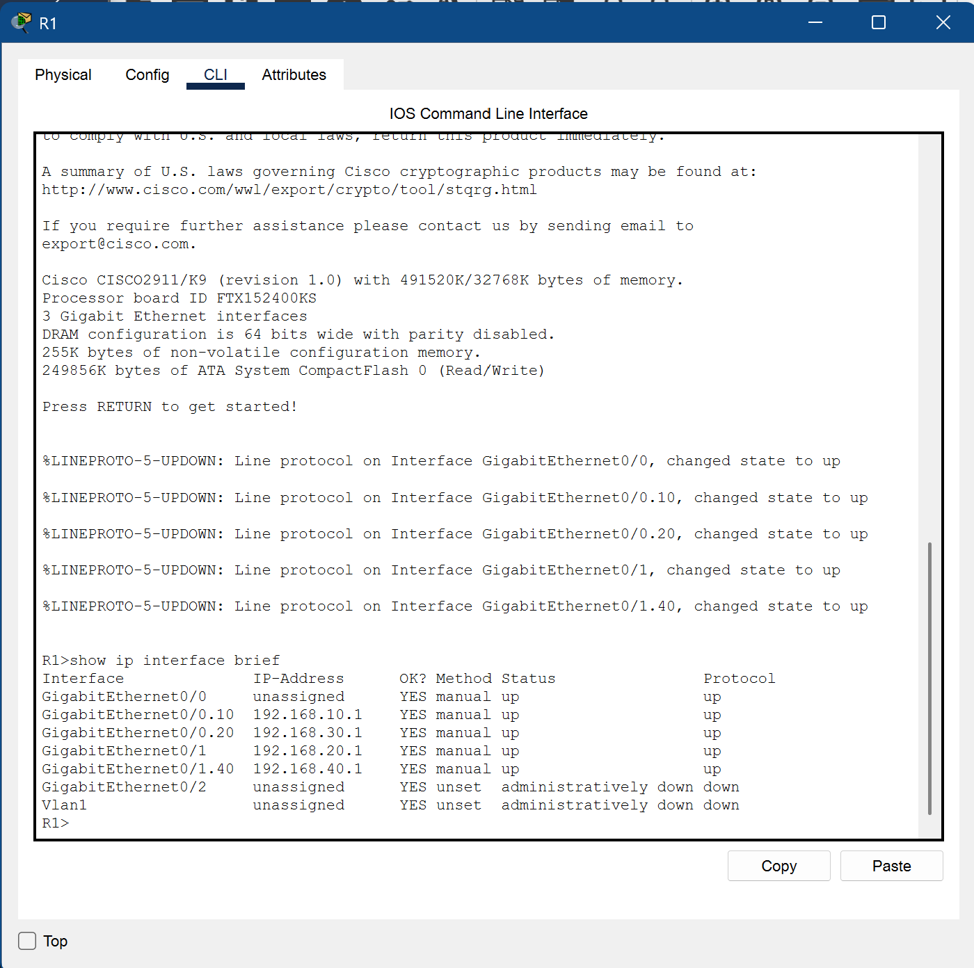
Figure 3.1: Router interface status and configured VLAN gateway subinterfaces.

3.3 Protocols and Technical Working
When PC0 requests an address, DHCP messages are relayed by R1 to Server0. When a user enters www.collegenetwork.com, DNS on Server0 returns 192.168.40.3. PC0 sends an HTTP request toward its default gateway; R1 routes it to VLAN 40 and checks the inbound student ACL. TCP port 80 traffic to Server1 is permitted, and Server1 returns the page. Other student IP traffic to the server subnet is denied by the ACL.

3.4 Execution Procedure
Open the expanded college-campus-network Packet Tracer file in Cisco Packet Tracer 9.0.1. Confirm Server0 DHCP and DNS are on and Server1 HTTP is on. On PC3 and PC5, verify the DHCP-assigned address, gateway, and DNS. PC3 and PC5 should receive addresses from the student and faculty subnets respectively. Open a PC browser and visit http://www.collegenetwork.com. Simulation Mode can be used to observe DNS and HTTP packet events. To demonstrate management security, connect from PC0 to R1 by SSH at 192.168.10.1 using the configured lab account. Do not expose lab credentials in public submissions.

4 Testing and Results

4.1 Test Plan
Tests were conducted in the Packet Tracer simulation. A test was considered successful when observed behavior matched the expected service or policy. The results below summarize tests reported during project work; add actual screenshots or CLI outputs where required by the instructor.
Table 4.1: Network Testing and Results
Test ID | Test and Input | Expected Result | Observed Result | Status
T1 | Obtain DHCP lease on student/faculty client. | Correct subnet, gateway, DNS. | Correct pool/gateway behavior reported. | Pass (reported)
T2 | Open www.collegenetwork.com. | DNS resolves to 192.168.40.3 and HTTP page loads. | Website resolved and loaded by domain name. | Pass (reported)
T3 | SSH from PC0 to 192.168.10.1. | R1 authenticates local user and opens CLI. | SSH login successful. | Pass (reported)
T4 | Check Switch0 port-security table. | One sticky secure MAC per configured port. | SecureSticky entries shown. | Pass (reported)
T5 | Ping Server0 from PC0. | ICMP not permitted by current student ACL. | Ping failed, consistent with ACL policy. | Expected policy outcome
T6 | Check faculty gateway/server reachability. | PC2 reaches gateway and server subnet. | Gateway and servers reported reachable. | Pass (reported)

4.2 Results and Execution Evidence
The reported outcomes are summarized in Table 4.1. The domain-name website test from PC3 and PC5 demonstrates DNS, routing, ACL permits, and HTTP working together. DHCP assignment was also checked on the added PCs. Simulation Mode was used to observe website-related packet events. SSH demonstrates remote router management, while the sticky MAC table demonstrates port-security learning.
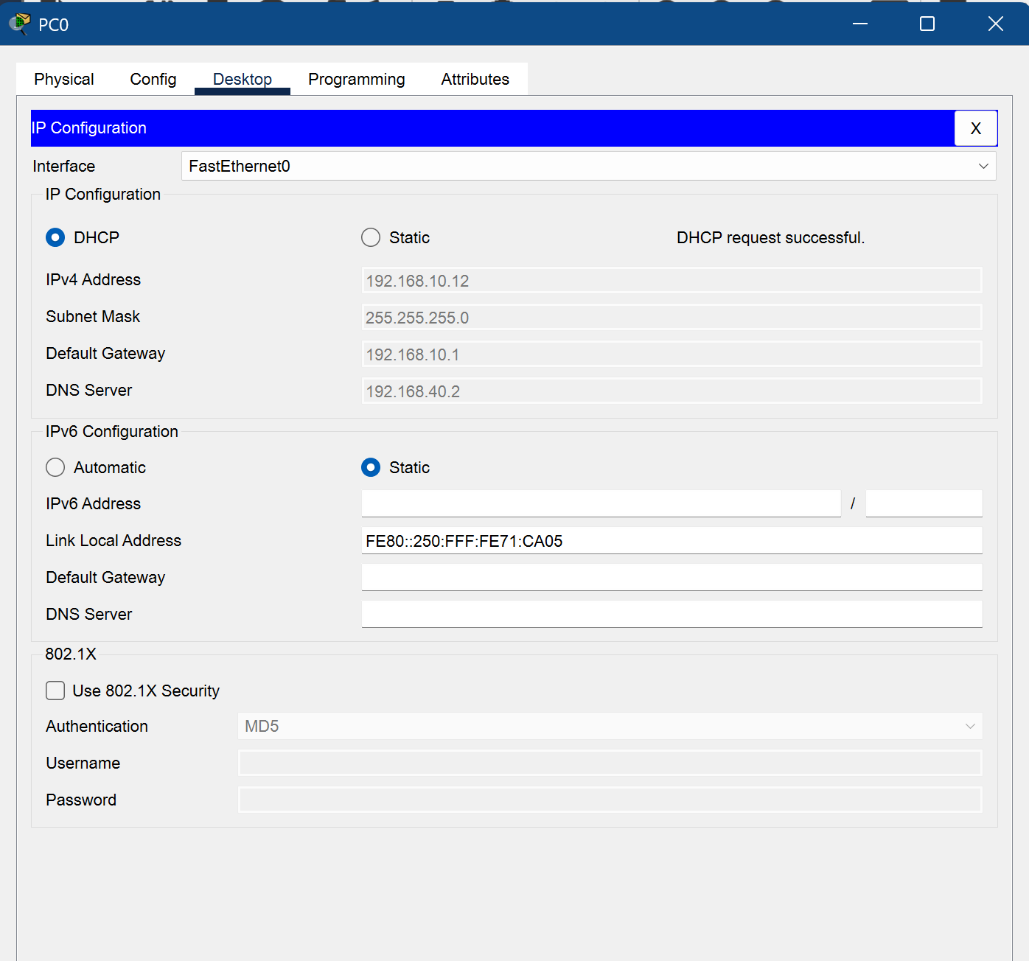Figure 4.1: Successful DHCP address assignment to a student client.
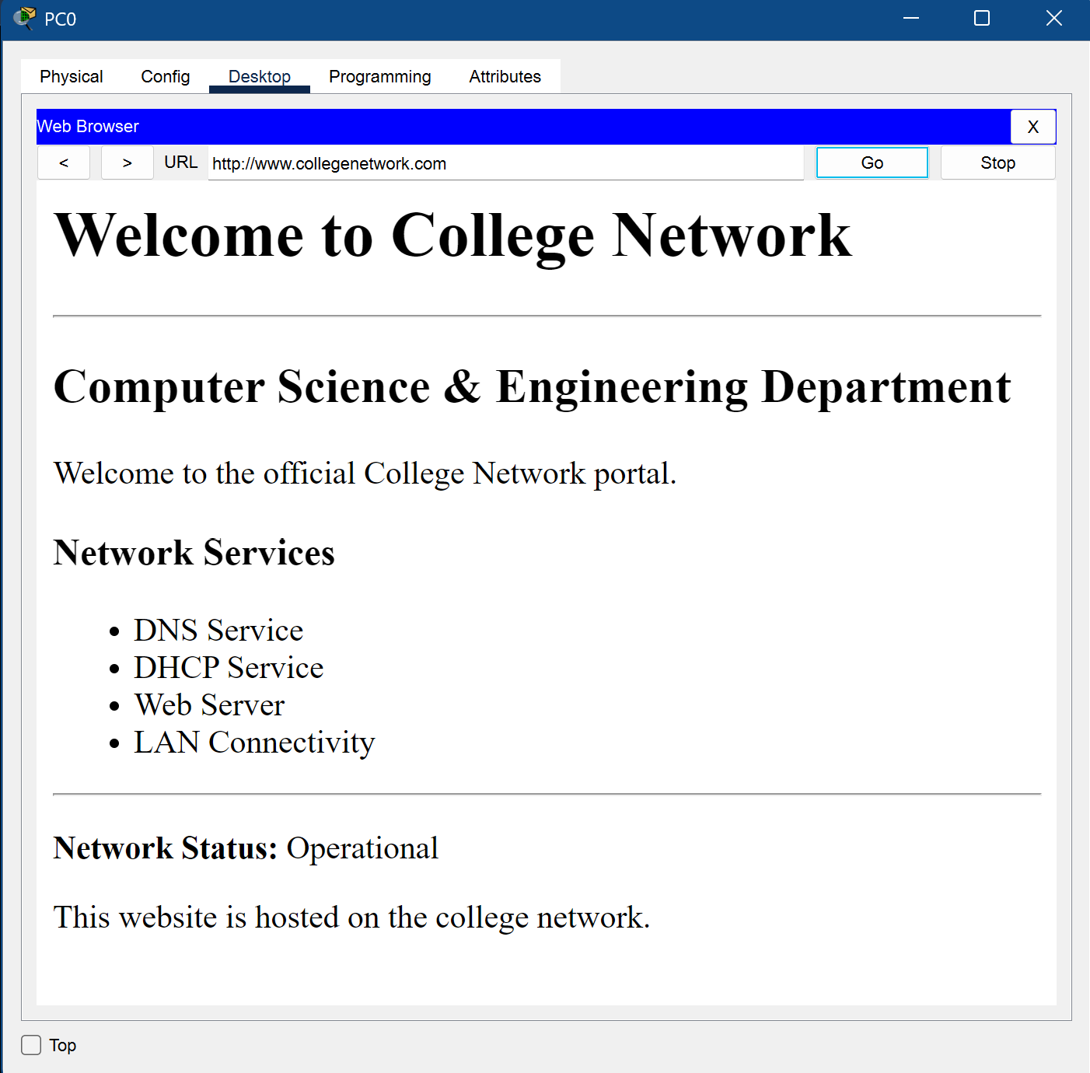
Figure 4.2: Successful access to the campus website through DNS name resolution and HTTP.
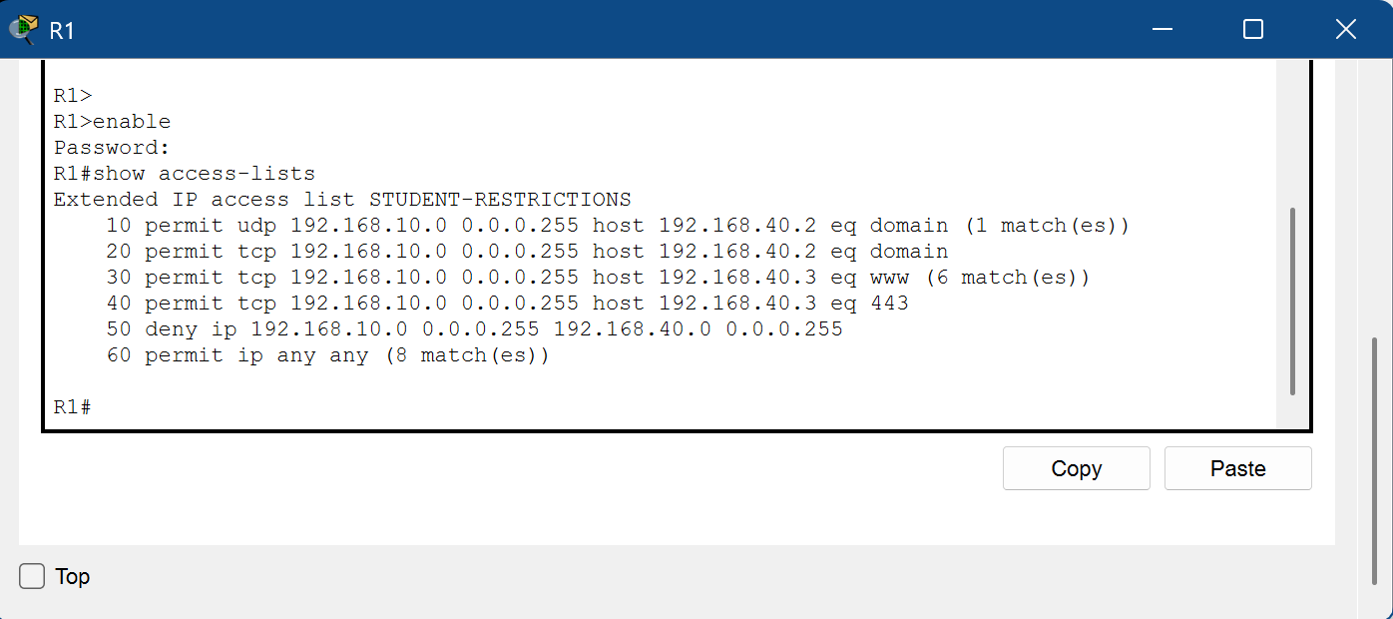
Figure 4.3: Student access control list and traffic-match counters.
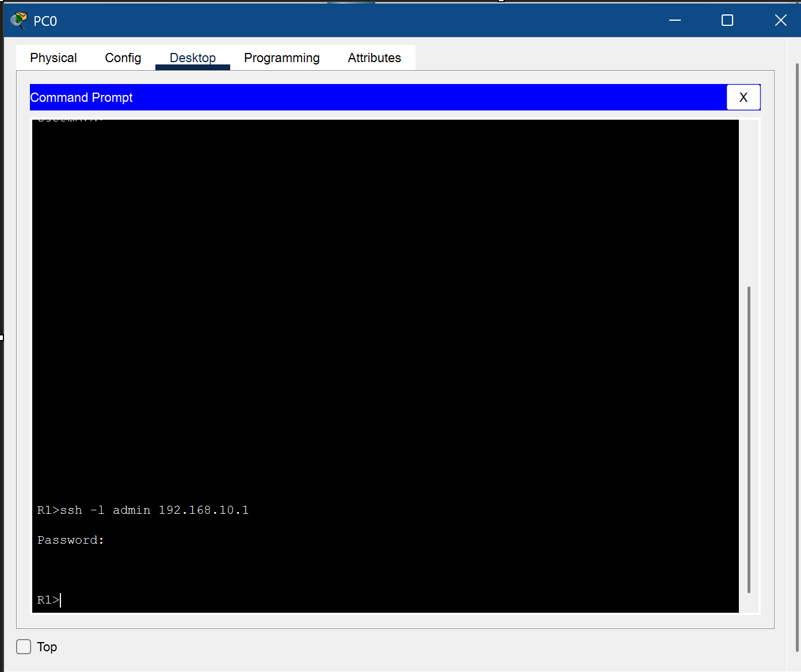
Figure 4.4: Successful SSH remote login from PC0 to router R1.
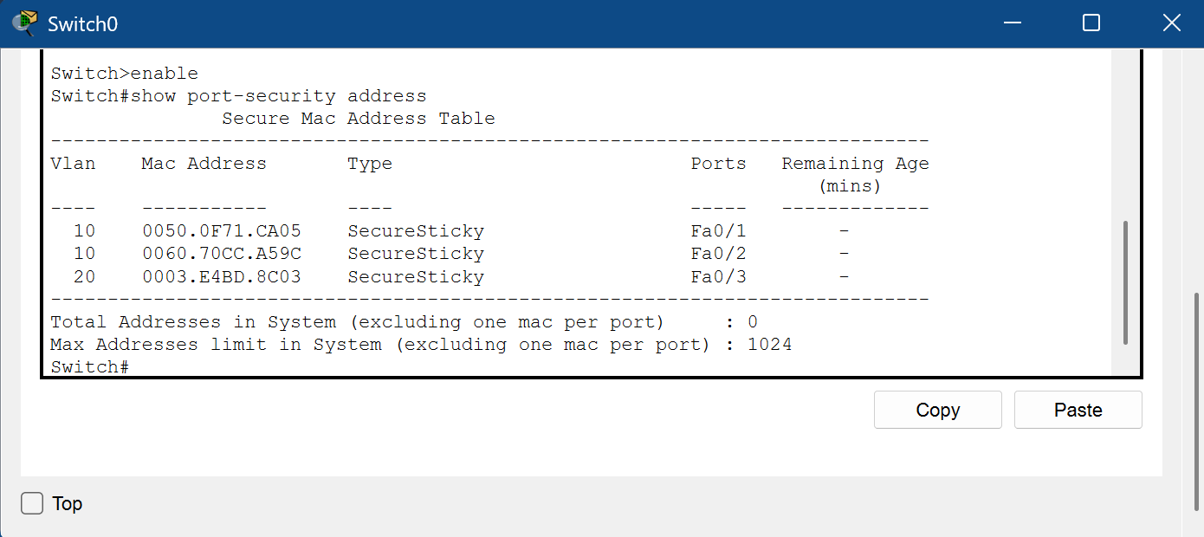
Figure 4.5: Sticky MAC addresses learned through switch port security.

4.3 Objective Achievement
Table 4.2 maps each objective to reported evidence. No quantitative throughput or latency benchmark was performed, so no performance claim is made.
Table 4.2: Objective Achievement Summary
Objective ID | Evidence or Test ID | Outcome
O1 | VLAN/IP table; T1 and T6 | Achieved (reported)
O2 | DHCP settings; T2 | Achieved (reported)
O3 | T3, T4, T5 | Implemented controls demonstrated; ACL is student-specific

5 Discussion and Conclusion

5.1 Discussion and Comparative Analysis
The segmented design supports group-specific policy more clearly than a single flat LAN because students, faculty, and servers occupy separate broadcast domains. The expanded topology adds four PCs through a third switch while reusing the existing student and faculty VLANs and subnets. Central DHCP reduces manual host configuration, while DNS makes the web service easier to access. ACL, SSH, and port security add controls, but this simulation is not a complete production security architecture. No quantitative performance comparison was conducted.

5.2 Advantages and Applications
Benefits include clearer network organization, centralized addressing and name resolution, a dedicated server subnet, selective access control, encrypted management, and reduced exposure from unused switch ports. Similar concepts are used in college departments, small offices, training labs, and enterprise access networks.

5.3 Limitations
The design has no external WAN/Internet connection. The ACL applies only to students; faculty traffic is not filtered by this ACL. HTTP was demonstrated, but HTTPS service was not confirmed on Server1 even though TCP port 443 is permitted in the ACL. A legacy 192.168.20.1 address was noted on physical R1 GigabitEthernet0/1 after server migration and should be reviewed if obsolete. The network has no redundancy, dedicated management VLAN, or production monitoring.

5.4 Challenges and Troubleshooting
The faculty DHCP pool gateway was corrected to 192.168.30.1 to match the faculty subnet. The student ping to Server0 fails because ICMP is not explicitly permitted by the ACL. This was treated as expected policy behavior; DNS and HTTP were tested separately. Reported faculty gateway/server reachability, domain-based website access, SSH login, and sticky MAC learning were successful.
Table 4.3: Troubleshooting and Corrective Actions
Issue | Cause or Diagnosis | Solution and Verification
Faculty DHCP pool gateway mismatch | Gateway needed to match 192.168.30.0/24. | Corrected to 192.168.30.1; faculty connectivity retested.
Student ping to Server0 failed | ICMP not explicitly permitted by student ACL. | Treated as expected policy behavior; DNS/HTTP tested separately.
Legacy 192.168.20.1 on R1 G0/1 | Address remained after server migration. | Flagged for review; confirm no dependency before removal.

5.5 Future Scope
Future work could remove obsolete interface addressing after confirming the topology, configure and test HTTPS, define a faculty access policy, add a dedicated management VLAN, improve credential management, enable logging/monitoring, and add a WAN edge or redundancy if required.

5.6 Conclusion
The project implemented and expanded a simulated campus network with VLAN-based segmentation, inter-VLAN routing, DHCP, DNS, HTTP, student ACL restrictions, SSH v2, port security, and shutdown of unused switch ports. Four additional PCs were added through Switch2 and assigned to the existing student and faculty VLANs. Tests confirmed DHCP assignment on the added PCs, domain-based website access from student and faculty clients, SSH management, and sticky MAC learning. Simulation Mode was used to observe website-related packet events. The project met its main educational objectives for segmentation, essential services, network expansion, and foundational network security.

References
[1] IEEE, “IEEE Standard for Local and Metropolitan Area Networks—Bridges and Bridged Networks,” IEEE Std 802.1Q. https://standards.ieee.org/standard/802_1Q-2022.html (accessed 20 Oct. 2026).
[2] Cisco Systems, “IP Access Lists Configuration Guide, Cisco IOS XE.” https://www.cisco.com/ (accessed 20 Oct. 2026).

AI Usage Declaration
ChatGPT assisted with explanations and drafting of documentation. Project-specific technical details were based on the described Packet Tracer configuration and reported tests.
Declaration: We take responsibility for the accuracy of this report and understand the submitted implementation and results. Sources and assistance used have been acknowledged.
Sr. No. | Student Name | Signature
1. | Raghav Singh
2. | Mitali Agrawal
3. | Hrushikesh Kapre
4. | Aarushi Tyagi

Appendices

Appendix A Code and Configuration
The implementation is saved in the expanded Packet Tracer project file. Configuration features are summarized in Section 3.2. Attach sanitized router and switch configuration excerpts from the actual file; do not include passwords, RSA private keys, or other secrets.

Appendix B Additional Evidence
Recommended evidence: updated full Packet Tracer topology showing Switch2 and PC3–PC6; DHCP IP configuration from a new student PC and a new faculty PC; browser page at www.collegenetwork.com from PC3 or PC5; Simulation Mode Event List showing DNS/HTTP events; successful SSH session; show access-lists counters; show vlan brief and show interfaces trunk on Switch2; and show port-security address output from Switch2. Add only screenshots captured from the actual project.

Appendix C Individual Contributions
Student Name and PRN | Work Completed | Evidence or Deliverable
Raghav Singh -1262241452 | Designed the network topology and configured the router, VLAN gateways, trunk links, and inter-VLAN routing | Packet Tracer topology; router interface and routing configuration.
Mitali Agrawal - 1262241467 | Configured DHCP pools, DHCP relay, DNS records, and the HTTP website; tested domain-based website access. | DHCP pool configuration; DNS A record; website access screenshot.
Hrushikesh Kapre -1262241493 | Implemented network security using the student ACL, SSH version 2, switch port security, and shutdown of unused ports. | ACL output; successful SSH login; port-security MAC address output.
Aarushi Tyagi -1262241597 | Performed connectivity and service testing, documented test results and troubleshooting, and prepared the project report and presentation. | Test-results table; Packet Tracer screenshots; report and presentation.

