USER FLOW DIAGRAM
Vehicle Rental System – Online Vehicle Booking Platform
A Responsive Web Application for Browsing, Booking and Managing Rental Vehicles

Project | Vehicle Rental System – Online Vehicle Booking Platform
Student | Naman Agarwal
Roll No | 22515000081
Program | B.Tech CSE
University | GLA University
Project Guide | Mr. Gautam Mukherjee
Document | User Flow Diagram
Based On | Vehicle Rental System SRS – Version 1.0
About This Diagram
This document presents the primary User Flow Diagram for the Vehicle Rental System, illustrating how a user moves through the application — from opening the website and logging in or signing up, through browsing, searching and filtering vehicles and viewing their details, to selecting rental dates, automatic rent calculation and booking confirmation. It also covers saving vehicles to the wishlist, viewing booking history, submitting the contact form and logging out. All user, wishlist and booking data is stored in the browser’s Local Storage. The flow is based directly on the modules and project workflow defined in the Vehicle Rental System SRS (Version 1.0). The diagram is on the next page, followed by a step-by-step explanation.

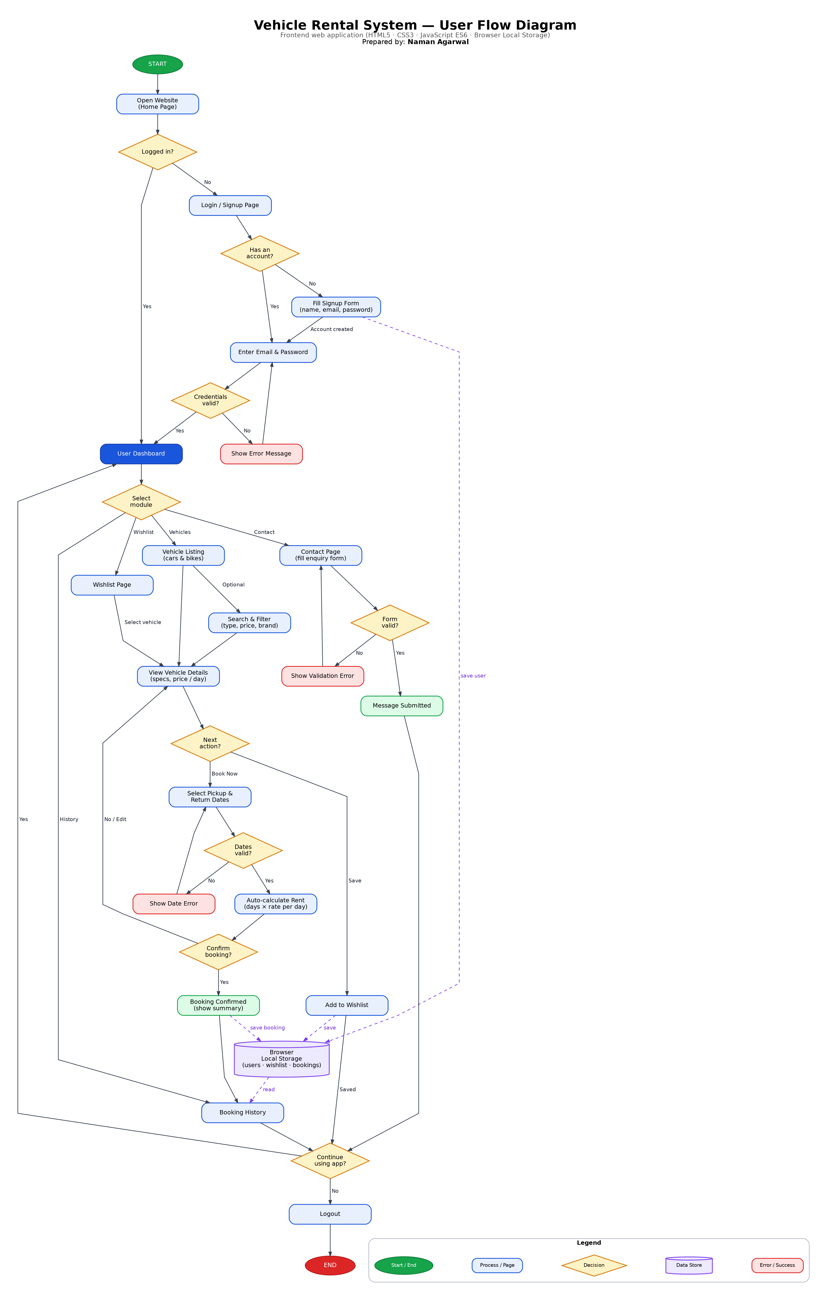
Figure 1: User Flow Diagram of the Vehicle Rental System

Explanation of the User Flow
Project: Vehicle Rental System
Prepared by: Naman Agarwal
The diagram above shows the path a user follows through the Vehicle Rental System, from opening the website to logging out. Each part of the flow is described below.

1. Authentication
When the user opens the website, the system checks whether the user is already logged in. If not, the Login / Signup page is shown. A new user fills the signup form, and the account details are saved in the browser's Local Storage. The user then enters an email and password. If the credentials are invalid, an error message is shown and the user tries again; if they are valid, the user reaches the Dashboard.

2. Dashboard and Modules
From the Dashboard the user selects one of the main modules: Vehicles, Wishlist, Booking History or Contact.

3. Browsing and Booking
- Vehicle Listing: The user views the vehicle listing and can optionally search and filter by type, price or brand.
- Vehicle Details: The user opens a vehicle to see its specifications and price per day.
- Wishlist: The user can save the vehicle to the wishlist, which is stored in Local Storage.
- Booking: The user selects pickup and return dates. Invalid dates show an error; valid dates lead to automatic calculation of the rent (number of days × rate per day).
- Confirmation: If the user confirms, the booking is saved in Local Storage and a summary is shown. If not, the user goes back to the vehicle details.

4. Booking History and Contact
Booking History reads all saved bookings from Local Storage and displays them. On the Contact page the user fills an enquiry form; if the form is invalid, a validation error is shown, otherwise the message is submitted.

5. Exit
After any task, the user can return to the Dashboard to continue, or log out, which ends the flow.

Symbols Used
- Green / red oval: Start and end of the flow
- Blue rounded rectangle: A page or a process step
- Yellow diamond: A decision with Yes / No paths
- Purple cylinder: Browser Local Storage (data store)
- Dashed purple arrow: Data being saved to or read from Local Storage
- Red / green box: Error message / successful result

