TRILLET
Homepage
Proposed page copy and layout
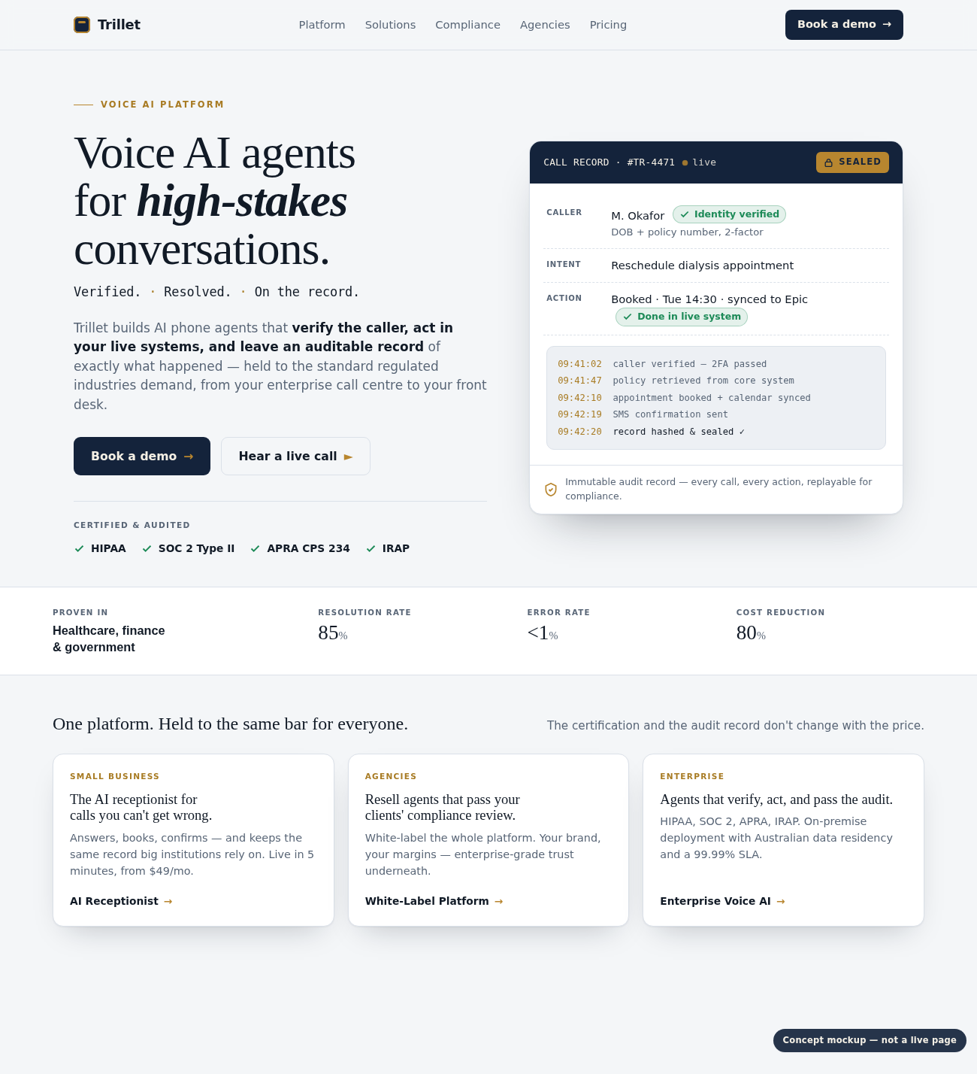
Concept mockup of the homepage hero.

VOICE AI PLATFORM
Voice AI agents for high-stakes conversations. Verified, resolved, audited.
Trillet builds AI phone agents that verify the caller, act in your live systems, and leave an auditable record of exactly what happened. Held to the standard regulated industries demand, across voice, SMS and chat.
Book a demo → |  | Hear a live call ▶
✓ HIPAA ✓ SOC 2 Type II ✓ APRA CPS 234 ✓ IRAP

One platform. Held to the same bar for everyone.
The certification and the audit record don’t change with the price.
SMALL BUSINESS  The AI receptionist for calls you can’t get wrong.  Answers, books, confirms, and keeps the same record big institutions rely on. Live in 5 minutes, from $49/mo.  AI Receptionist → | AGENCIES  Resell agents that pass your clients’ compliance review.  White-label the whole platform. Your brand, your margins, enterprise-grade trust underneath.  White-Label Platform → | ENTERPRISE  Agents that verify, act, and pass the audit.  HIPAA, SOC 2, APRA, IRAP. On-premise deployment with Australian data residency and a 99.99% SLA.  Enterprise Voice AI →

PROVEN IN HEALTHCARE, FINANCE AND GOVERNMENT
Measurable results in regulated environments
85%  of complex calls resolved | 80%  reduction in cost to serve | 10×  lower call abandonment | 32%  reduction in no-shows
In a Google Cloud customer case study, Trillet held error rates under 1% and cut call escalations to under 15%, resolving high-stakes calls end to end in a regulated environment.
Read the case study →

MEET THE PRODUCT
What is a Trillet voice AI agent?
A voice AI agent answers the phone and holds a real conversation. It listens, understands what the caller needs, and replies in a natural voice. No menus. No hold music.
A Trillet agent also acts. It connects to your CRM, calendar, phone system and payment tools, confirms who it is speaking to, and completes the task on the call: books the appointment, sets up the payment plan, updates the case, sends the confirmation. It works across voice, SMS and chat, and writes every step to an audit trail.
It is built for calls that can’t go wrong. Verified before it acts. Resolved in your live systems. Audited end to end.
Book a demo → |  | Hear a live call ▶

HOW TRILLET WORKS
Every call verified, resolved and audited
Verify  Identity is confirmed to your compliance standard before any action is taken. Name and date of birth, reference number, callback-number match. | Resolve  Bookings, payments, case updates and recovery happen in your live tools during the call. It works with the systems you already run. | Audit trail  Every action is timestamped to a complete audit trail. A summary goes out after the call. Recordings and transcripts are held with Australian data residency.
See it on a live call →

WHAT THE AGENT CAN DO
What a Trillet agent handles on the call
From answering and identity checks to booking, payments and CRM updates. Across voice, SMS, chat and email.
Answer and engage  Inbound answering and outbound campaigns, day and night. Voice, SMS, web chat and email in one thread. Natural voice, with cloning available. Warm transfer to your team, and call forwarding with no number porting. | Verify before it acts  Confirms identity to your compliance standard before acting. Role-based access on every workspace.
Resolve in your live systems  Books and reschedules appointments, sets up payments and plans, captures and qualifies leads, updates cases, runs recovery. Written to your CRM, PMS, telephony, payments and calendars on the call. | Keep the audit trail  Every action timestamped. Post-call summaries and confirmations by SMS and email. Recordings and transcripts held in-country.
Build and deploy
Build an agent by scanning your website and go live in minutes. Start from templates. Orchestrate calls, SMS and email from one trigger. Deploy in cloud, private cloud or on-premise.
Explore the platform →

Built for the industries where calls can’t go wrong
Healthcare  Intake, booking, insurance verification and follow-ups under full HIPAA control. 32% fewer no-shows.  Healthcare → | Legal  After-hours enquiries and new-matter intake, qualified and booked to the right lawyer.  Legal → | Finance  Identity verification, payments and recovery at scale. Every step audited.  Finance →
Government  Resident enquiries, service requests, rates and payments, resolved on the call.  Government → | Utilities  Billing, payment plans, outages and service requests, handled at volume.  Utilities →

What makes it different
Conversations end in real outcomes  Reads from and writes to your live tools, so every call ends in a completed action, not a note or a ticket. | Built for regulated industries  Designed from the start for the compliance, audit and operational requirements of healthcare, legal and financial services. | Continuous across channels  High-stakes calls stay connected across voice, SMS, chat and messaging. Context is never lost.

FITS YOUR STACK
Works with the systems you already run
Trillet connects to your telephony, CRM, practice-management, payment and calendar platforms. It reads and writes on the call. No parallel systems to maintain.
Telephony CRM Practice management Payments Calendars Case files
See all integrations →

“It meets our compliance requirements without a six-month integration. It runs inside our infrastructure — fully.”
Tim Close · Founder, CommsChannel
4.6  rated on Trustpilot | 1,200+  businesses trust Trillet | 99.97%  uptime SLA

Runs where your compliance team needs it to
Enterprise deployment including on-premise and private cloud. Full audit logs and role-based access. HIPAA, GDPR, ACMA and TCPA compliant. SOC 2 Type II and ISO 27001 certified. Australian data residency — recordings, transcripts and backups stored in Australia, with in-country LLM hosting available.
HIPAA GDPR ACMA TCPA SOC 2 Type II ISO 27001 AU Data Residency
Visit the security & trust center →

Frequently asked questions
What is an AI voice agent?
A voice AI agent answers the phone, understands what the caller needs, and takes action. It books, verifies and resolves calls without menus or scripts.
How do AI voice agents work?
They combine speech recognition, a language model and text-to-speech to understand and reply in real time, and connect to your systems to complete tasks on the call.
How are they different from a traditional IVR?
An IVR routes you through a menu. A voice AI agent listens, answers follow-up questions, and completes the request itself.
Is Trillet HIPAA and SOC 2 compliant?
Yes. HIPAA, SOC 2 Type II, ISO 27001, GDPR, TCPA and ACMA, on every plan, not only enterprise.
Can Trillet book appointments and take payments?
Yes. Agents book and reschedule appointments and set up payments and payment plans in your live systems during the call.
Does it integrate with my CRM?
Trillet connects to your telephony, CRM, practice-management, payment and calendar tools, and reads and writes in real time.
Can I keep my existing phone number?
Yes. Trillet forwards your calls with no number porting, so you keep your existing number.
How fast can I go live?
Build an agent by scanning your website and go live in minutes. Small-business plans start from $49/mo.
Can I white-label and resell Trillet?
Yes. Agencies run Trillet under their own brand in isolated workspaces, and keep the margin.
Where is my data stored?
Recordings, transcripts and backups can be held in Australia, with in-country LLM hosting and on-premise or private-cloud deployment available.

Still have questions? Speak to sales →

Ready to resolve high-stakes conversations inside your environment?
Speak to sales to review how Trillet integrates with your systems and meets your compliance requirements.
Book a demo → |  | Hear a live call ▶
A working session with the team that builds the platform, not a scripted demo.

