Postgres replication setup on k8s local cluster

Table of Contents
Objectives 2
Overview 2
Pre requisites/System Requirements 2
Configuration files 3
Configuration steps: 8
Verification of Replication: 9
Useful Commands 10
Troubleshooting 10
Useful Links 10

Objectives

Setup Postgresql replication on kubernetes pod for data syncronization over all replicas.

Overview

Postgresql replication feature provided for data synchronization over all replicas servers. We can achieve this using postgresql build-in replication feature so that whenever/whatever changes made over primary server will reflect over all replicas. There are basically two types of replication synchronous and asynchronous. Below document guide us to perform this on k8s environment.

Pre requisites/System Requirements

1) Kubernetes and docker installed and master/slave cluster setup.

Configuration Files:

Storageclass:
Storage class needed to allocate disk space to persistent volume, which we will assign to pod/container to store data on local. We can create storage class of basically two types of VolumeBindingMode: WaitForFirstConsumer and Immidiate. This define wheather our volume bind should be immediate or assign one by one. Here as we have single master and slave configuration we will use immediate.

Config storageclass.yaml
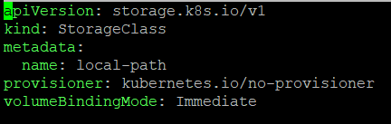

Persistent Volume:
Persistent volume is needed and assigned to pod/container to keep data on local storage. This basically used for databases container. Also, for this setup we are need to create two statefulsets.yaml file one for primary and one for all replicas. Also, we need to create number of persistent volume based on number of replicas we needed because statefulsets uses saperate PVs. In our scenario we are creating one primary and one replica, that’s why we need atleast two PVs.

Config postgres-pv.yaml
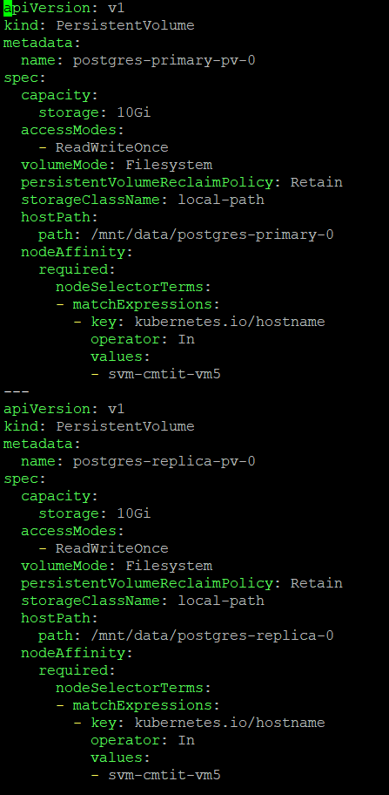

FYI: In above config we need to update nodeSelectorTerms values field according to our slave node name.

Persistent Volume Claim:
Same as two PVs we need to create two PVCs, one for primary and one for replica statefulset. PVCs claim PVs mapped to localstorage to our statefulsets.

Config postgres-pvc.yaml
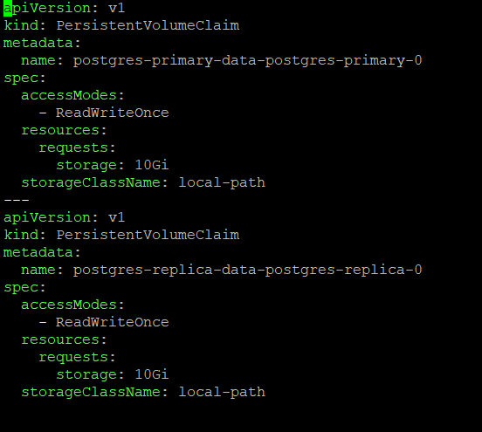

Postgres ConfigMap:
We need to create this configmap file to update postgresql configuration for both accordingly as we need to open connection from primary to replica for data synchronization.

Config postgres-configmap.yaml
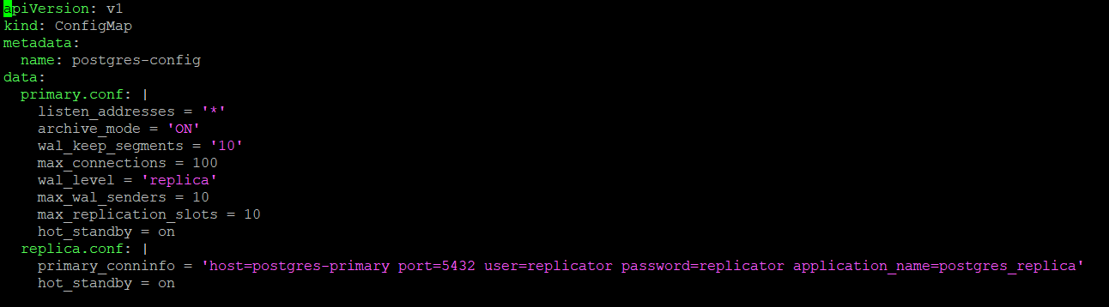

Postgres Secret:
We need to create postgres secret file so that we can securely pass our database credentials in encrypted form to our setup. (Postgres cred provided are base64 encoded)

Config postgres-secret.yaml
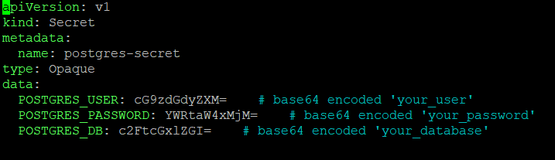

Primary service:
As we are creating two statefulset for both primary and replica, We need to create service file as well for service discovery.

Config service.yaml
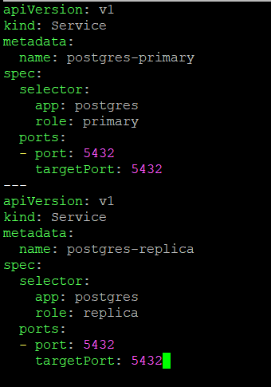

Primary Statefulset:
We need to create statefulset file defining volume mount, appname for service discovery, config file, storageclass name, secret filename, number of replicas and image.

Config primary-statefulset.yaml
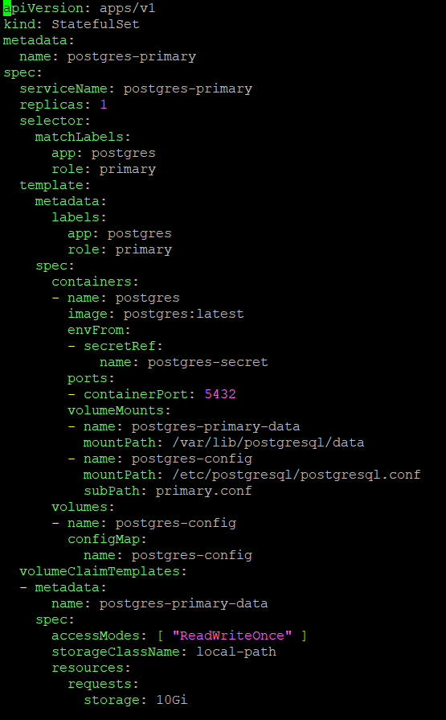

Replica Statefulset:
For replica statefulset we need to additionally define pg_basebackup cmd on runtime.

Config replica-statefulset.yaml
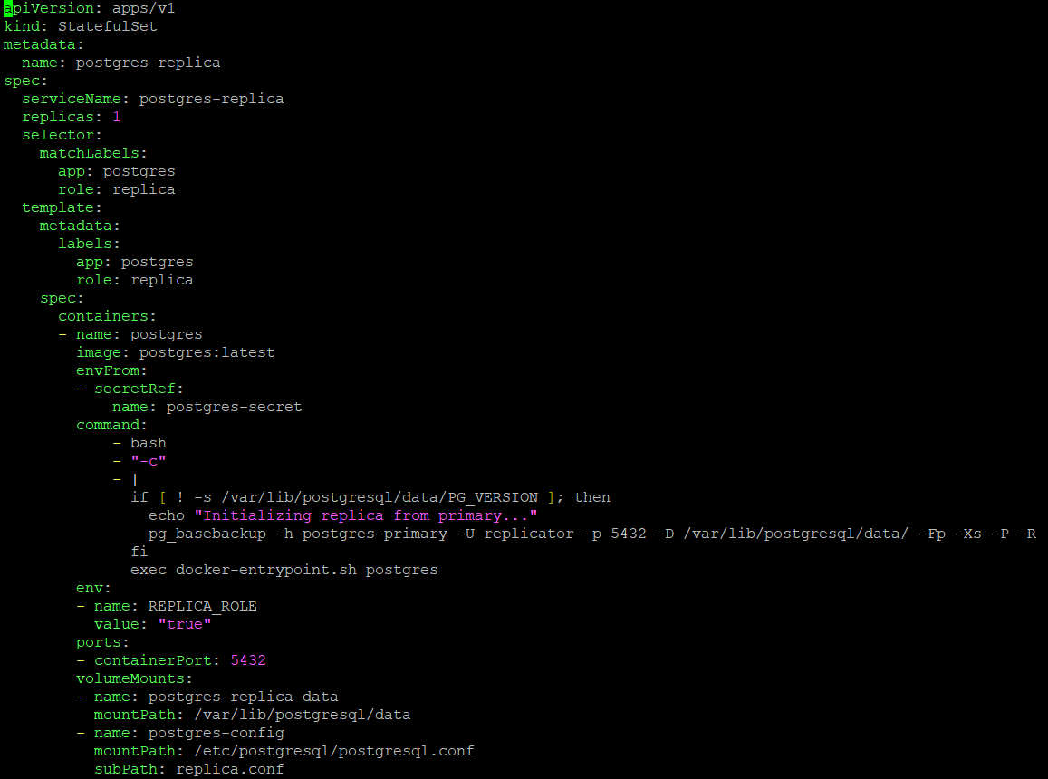
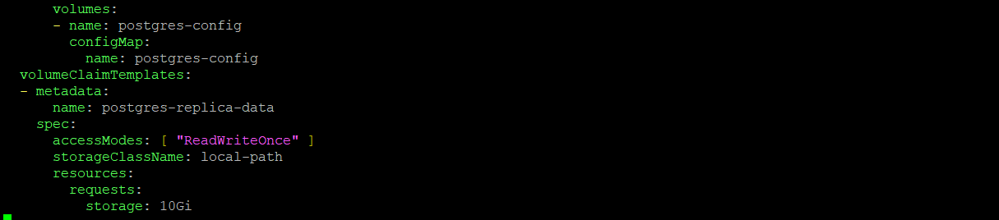

Configuration steps:
First of all create folder and provide appropriate access which we’ll map to our persistent volume for out setup using below cmds:
sudo mkdir -p /data/postgres-primary-0
sudo mkdir -p /data/postgres-replica-0
sudo chmod 777 /data/postgres-primary-0
sudo chmod 777 /data/postgres-replica-0

Secondly apply storageclass, PVs and PVCs verify these are created successfully and mounted successfully to respective using below cmds:
kubectl apply –f storageclass.yaml
kubectl apply –f postgres-pv.yaml
kubectl apply –f postgres-pvc.yaml

After successful creation of above, apply postgres-configmap.yaml and postgres-secret.yaml.

Once above steps successfully completed, proceed with creation of primary statefulset by applying primary-statefulset.yaml file.

As primary container is up, login to primary pod and verify postgres.conf as mentioned in postgresql-configmap.yaml file. Also update pg_hba.conf file to update connection for replica pod by adding below content to EOF.
“host replication replicator all md5”

Also, create replica user in primary postgresql server by logging in to postgres server and executing below query:
CREATE USER replicator WITH REPLICATION ENCRYPTED PASSWORD 'replicator';

Also, execute below sql query to update/enable server values for replication:
ALTER SYSTEM SET wal_level TO 'replica';
ALTER SYSTEM SET archive_mode TO 'ON';
ALTER SYSTEM SET max_wal_senders TO '10';
ALTER SYSTEM SET wal_keep_size TO '10';
ALTER SYSTEM SET listen_addresses TO '*';
ALTER SYSTEM SET hot_standby TO 'ON';
ALTER SYSTEM SET archive_command TO 'test ! -f /mnt/server/archivedir/%f && cp %p /mnt/server/archivedir/%f';

Now, restart primary pod by deleting pod (as we have defined replicas it will automatically create new pod for same inshort restart our primary server).

Once successfully restart primary pod apply replica statefulset and login to replica pod once started successfully.

After login go to postgres default directory and copy existing data directory or main file to same folder and remove content of the directory. Now, you need to executed “pg_basebackup” cmd which will definitely going to fail because it’ll interepted as it will restart postgres and since we are using postgres image it will stop pod and recreate using replica-statefulset.yaml file with automatically execution of pg_basebackup cmd as mentioned at entrypoint in replica-statefulset.yaml file

Once replica pod restart successfully login to replica pod and you will see standby.signal file this ensure successful execution of pg_basebackup cmd (if not repeat previous step).

Verification of replication:
Verify the replication from primary using below sql query, it’ll result replica server details on successful replication:
SELECT * FROM pg_stat_replication;
Verify the replication from replica using below sql query, it’ll result true on successful replication:
SELECT pg_is_in_recovery();
Also, Verify by creating database on primary and checking on replica.

Useful Commands

kubectl exec –it <pod name> -- bash

kubectl get all

Troubleshooting

NA

Useful Links

https://www.percona.com/blog/setting-up-streaming-replication-postgresql/

Important Note: This setup will create replica servers read-only which means we can’t make any changes from replica server.

