Two tier app setup on K8s using Minikube

Table of Contents
Objectives 2
Overview 2
Pre requisites/System Requirements 2
Services we are monitoring 2
Installation: 3
Bonus: 8
Useful Commands 10
Troubleshooting 10
Useful Links 10

Objectives

Setup kubernetes environment for deploying two tier application using minikube.

Overview

Minikube is a free tool used with kubectl tool for testing kubernetes infrastructure for dev/qa environment. It saves the resource consumption and managing different VMs for multiple applications or using too much cloud resources which makes you pay a lot. It also enhance the functionality as it only uses minimum resource and management is easy. However, this is not suited for production environments.

Pre requisites/System Requirements

1) Ubuntu machine with root previleges.
2) Atleast 2GB RAM, 2 core CPU or more and 20GB free space available on machine.
3) Docker installed on machine for running containers
4) Docker hub account for managing and maintaining images same as Git.

Installation:

Installation of minikube and Kubectl
Note: We are creating document with ubuntu 22.04 version please choose correct version while installing as steps maybe differ for Windows or mac machine.

Check OS version using below cmds:
lsb_release -a
cat /etc/os-release

First check os version and follow guide as per recommendation.

Use below cmds to start installation of minikube (install as per os version):

curl -LO https://storage.googleapis.com/minikube/releases/latest/minikube-linux-amd64
sudo install minikube-linux-amd64 /usr/local/bin/minikube && rm minikube-linux-amd64

verify installation using “minikube status” and start the tool.

Use below cmds to start installation of kubectl (install as per os version):

Install dendencies using:

curl -LO https://dl.k8s.io/release/$(curl -L -s https://dl.k8s.io/release/stable.txt)/bin/linux/amd64/kubectl

To download a specific version, replace the $(curl -L -s https://dl.k8s.io/release/stable.txt) portion of the command with the specific version.

Install kubectl using:

sudo install -o root -g root -m 0755 kubectl /usr/local/bin/kubectl

Verify installation using:

kubectl version --client

Now, as both the required tools installed, build the docker file using below cmd:

docker build –t <username>/<repo name>:<tag name> <path to docker file>

example:

docker build –t raagrawal/demorepo:latest . (dot in the last considering we are in same directory as dockerfile)

After building the image lets push it over docker hub using below cmd:

docker push <username>/<repo name>:<tag name>

Now, we need to create deployment.yaml to deploy our application to pod and service.yaml file for load balancing. You can refer to provided link in the end to get tamplate for the same or refer to SS below.

Deployment.yaml for backend:

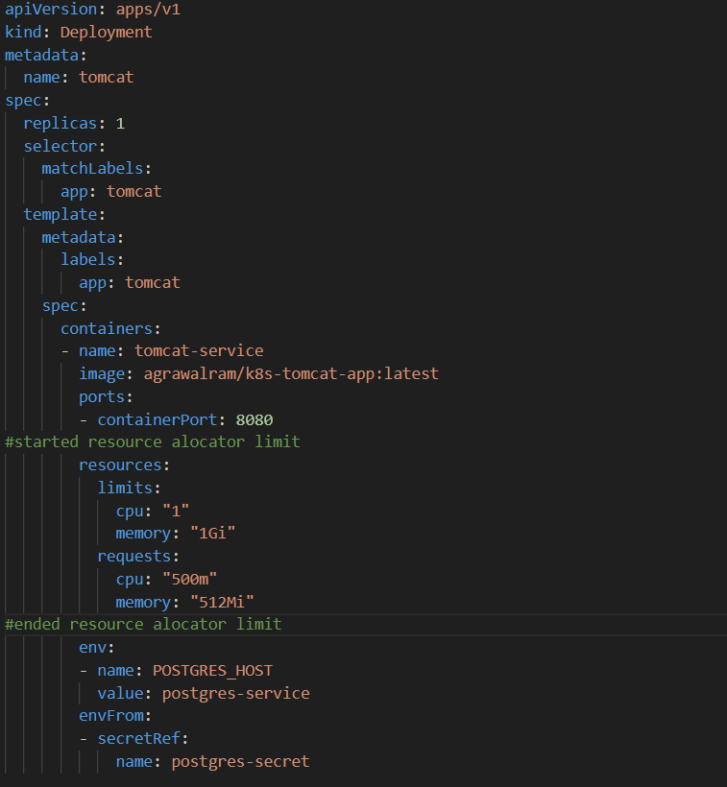

Deployment.yaml for database:

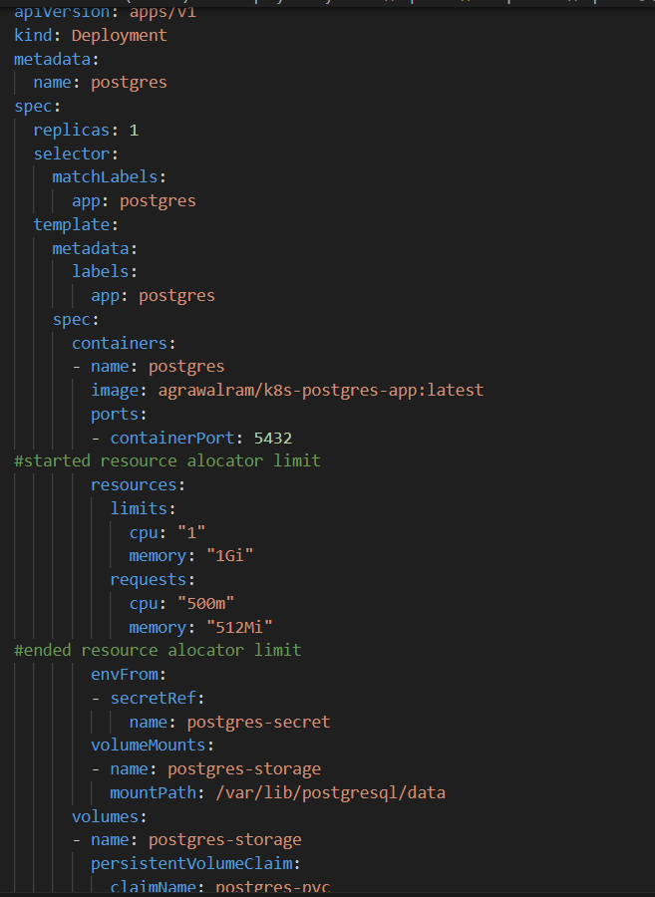

Service.yaml for frontend:

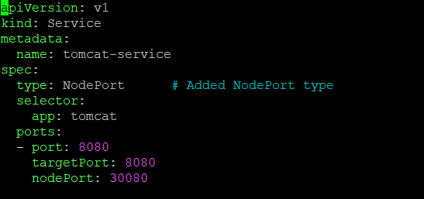

Service.yaml for database:
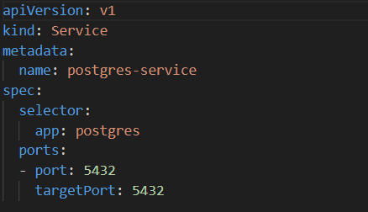

Here we are using persistant volume and secret for database credentials to prevent our data from accidental deletion due to pod restart. So we need to create the same before applying deployment.yaml file. Refer to below SS for persistant volume

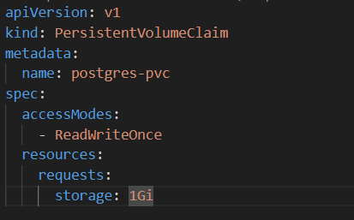

Create postgres secret using cmd:

kubectl create secret generic postgres-secret --from-literal=POSTGRES_DB=<your_database> --from-literal=POSTGRES_USER=<your_user> \ --from-literal=POSTGRES_PASSWORD=<your_password>

Now apply our storage file then deployment file and then service file respectively using cmd:

kubectl apply –f <yaml filename>

Bonus:

To manage configuration files using ConfigMaps in the Kubernetes setup refer below:

For example Tomcat configuration:

tomcat-configmap.yaml:

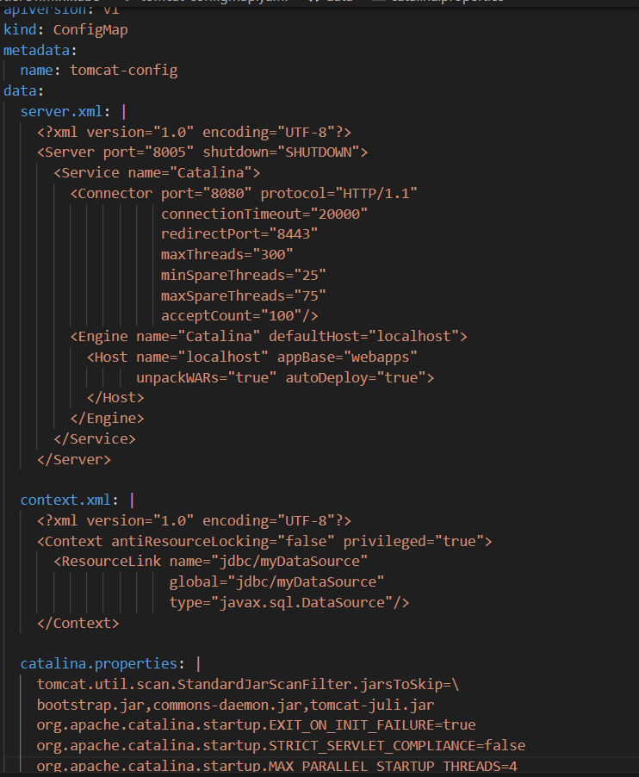

Apply configmap.yaml file

kubectl apply -f tomcat-configmap.yaml

tomcat-deployment.yaml

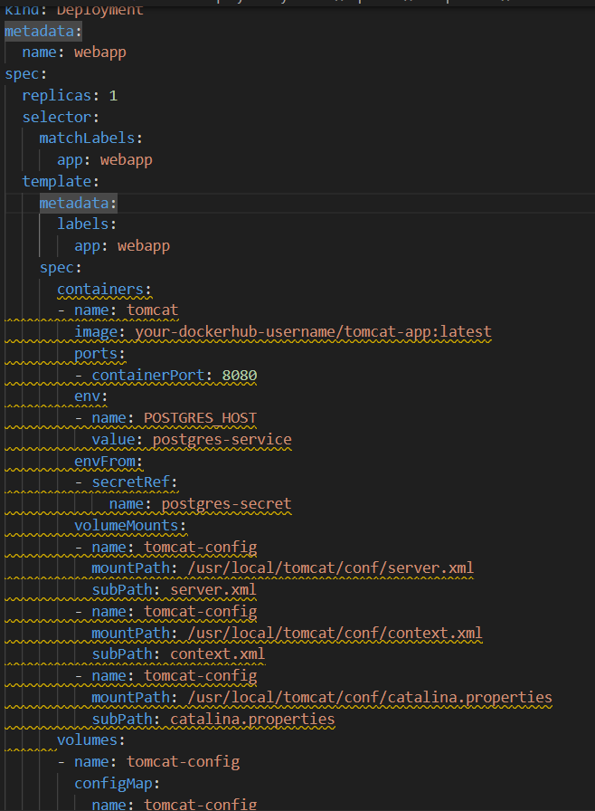

Update the deployment

kubectl apply -f tomcat-deployment.yaml

Useful Commands

kubectl get pods –o wide

kubectl get all

kubectl logs -f deployment/webapp

Troubleshooting

NA

Useful Links

https://kubernetes.io/docs/tasks/tools/

https://minikube.sigs.k8s.io/docs/start/?arch=%2Fwindows%2Fx86-64%2Fstable%2F.exe+download

https://kubernetes.io/docs/concepts/workloads/controllers/deployment/

https://kubernetes.io/docs/concepts/services-networking/service/

