Ques 1

“**Grep**” command is used for searching the pattern in any file.

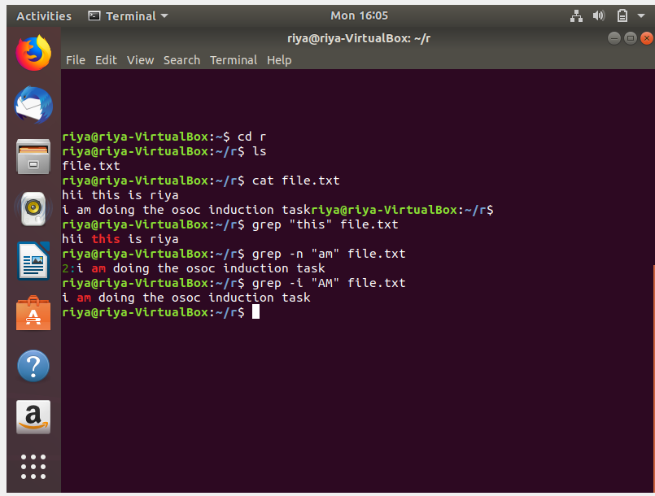

Ques 2

“**chmod**” command is used for changing the permissions.

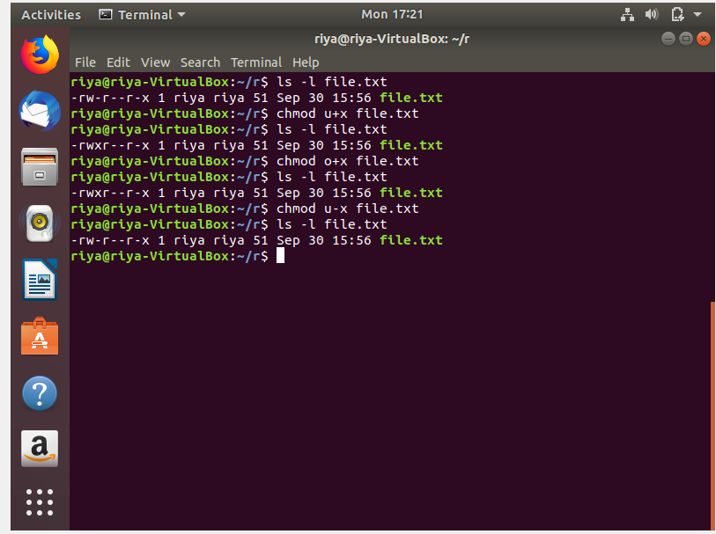

Ques 3

“cp” command is used for copying one text file of one directory to another directory.

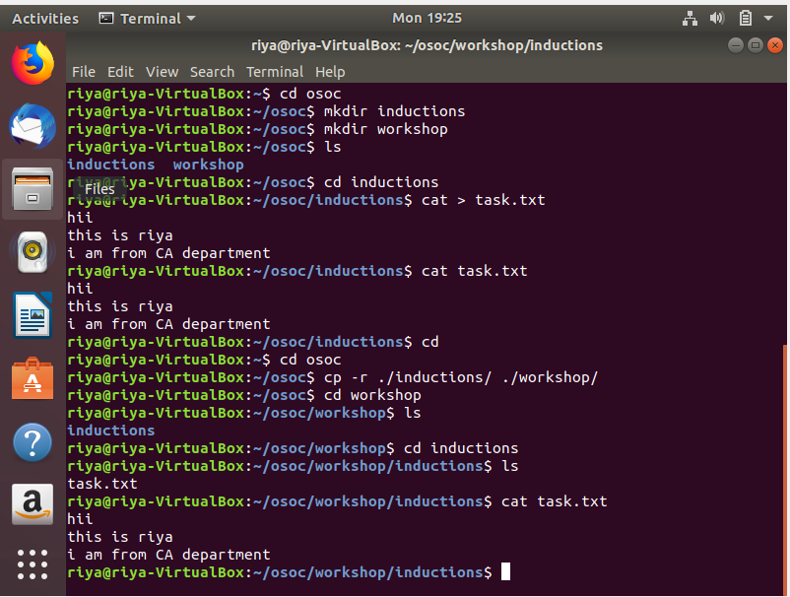

Ques 4

“**ping**” command is used for checking the network connection.

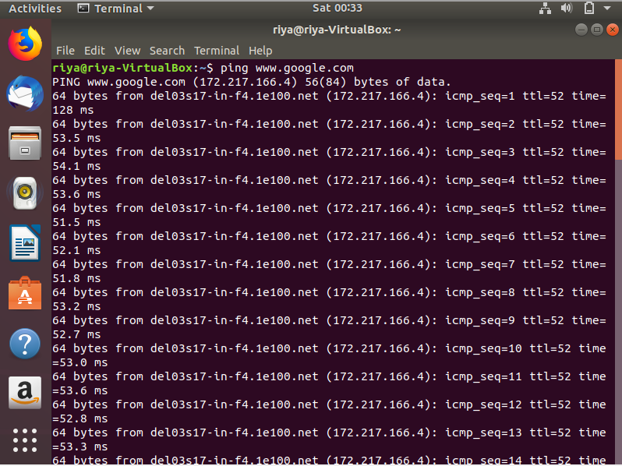

Ques 5

“**passwd**” command is used for changing the user password.

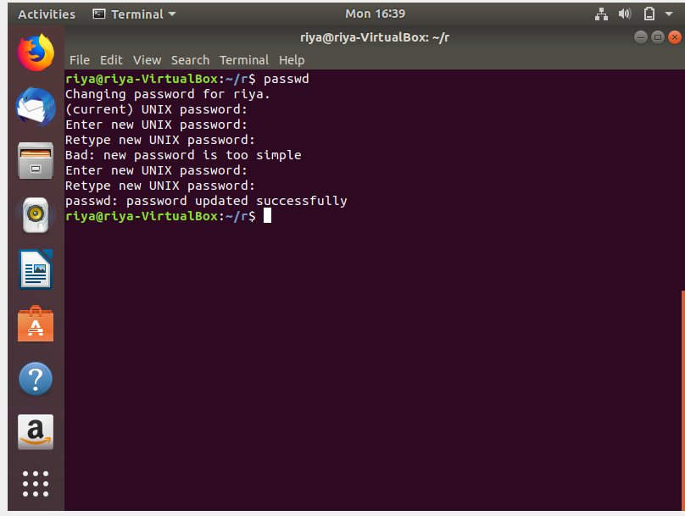

Ques 6

For shell scripting we use .sh extension. For writing the shell script use editor command like gedit, vi, etc.

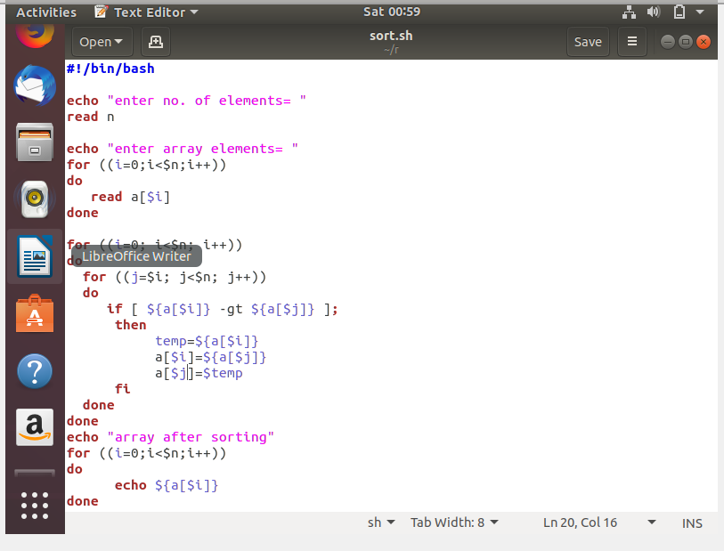

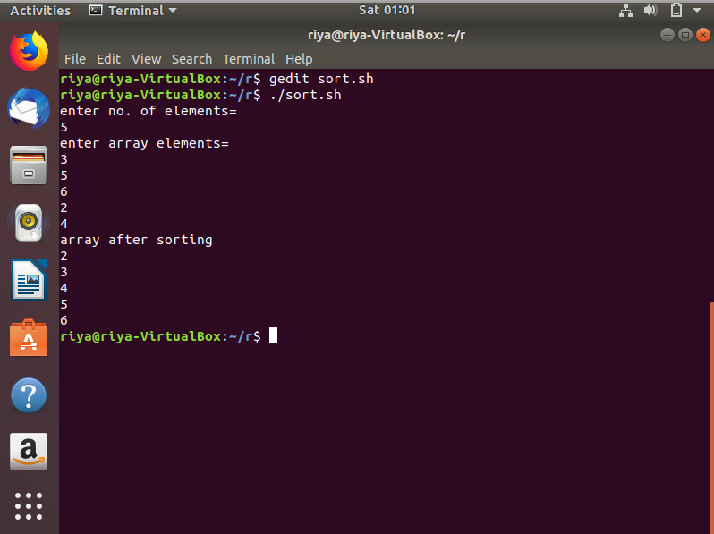

Ques 7

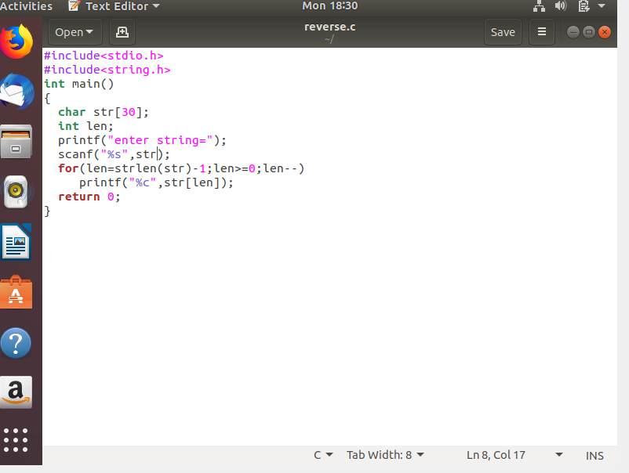

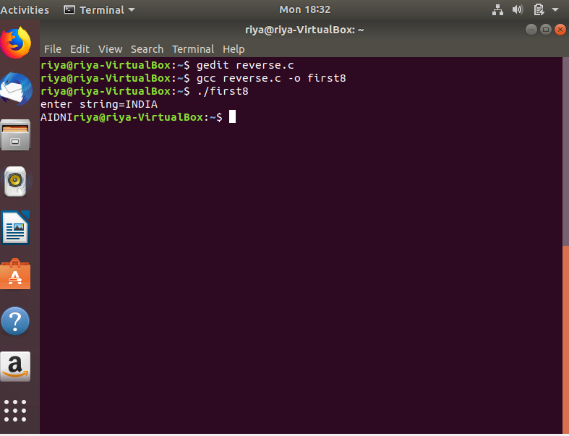

Ques 8

A branch in Git is simply a lightweight movable pointer to one of these commits. The default branch name in Git is master. As you initially make commits, you’re given a master branch that points to the last commit you made. Every time you commit, it moves forward automatically.

**Why it is useful ?**

When we first pick up Git, a lot of us think that the Origin remote and the Master branch is all we have available to us and that additional remotes and branches are for those super advanced users. Not so. These are actually the very basics of Git and not using these features defeats a lot of the purpose of using version control. If you’re not taking advantage of remotes and branching you might as well just use a Time Machine backup of your hard drive as your VCS.

In Git a remote is a copy of your repository stored somewhere other than your local system. Remotes are where you’d clone fresh copies of your projects from.

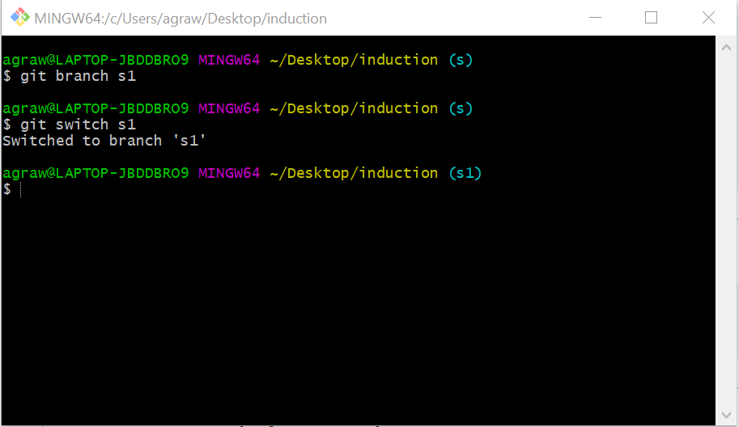

**Ques 9**

* **Commit** - committing is the process which records changes in the repository. Think of it as a snapshot of the current status of the project. Commits are done locally.

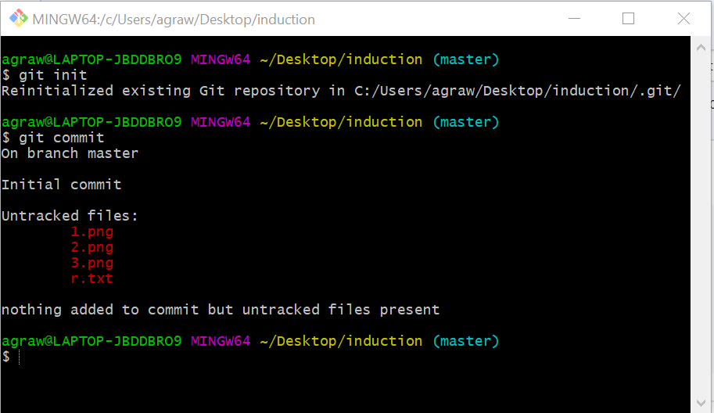

* **Push** - pushing sends the recent commit history from your local repository up to GitHub. If you're the only one working on a repository, pushing is fairly simple. If there are others accessing the repository, you may need to pull before you can push.

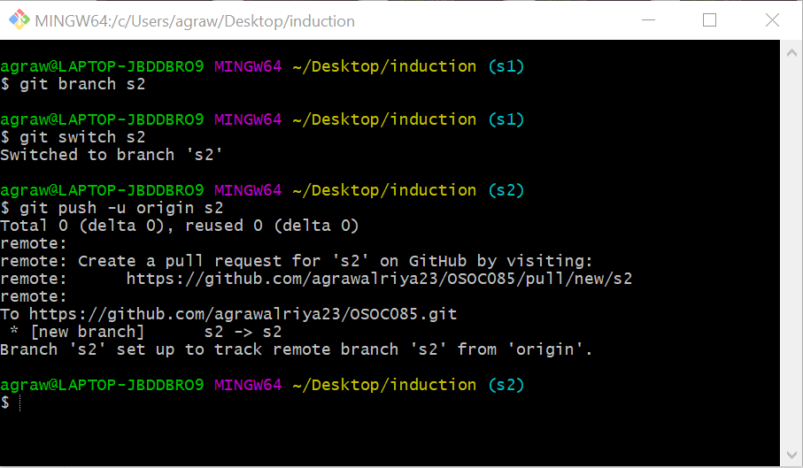

* **Pull** - a pull grabs any changes from the GitHub repository and merges them into your local repository.