CAREERSHALA — PROJECT REPORT
CAREERSHALA: AI CAREER CO-PILOT, SMART ATS & VISION PROCTORING PLATFORM
OF MAJOR PROJECT

Submitted in partial fulfillment of the requirements for the award of the degree of Bachelor of Technology in Computer Science & Engineering
Batch-2023-27

SUBMITTED BY SUBMITTED TO
Rohit Agrawal : 2310303170 DEPARTMENT OF COMPUTER SCIENCE & ENGINEERING
Suprabh Sharma: 2310303114 INVERTIS UNIVERSITY
Jahnvi Malik – 2310303144 Bareilly-Lucknow National Highway NH-24, Bareilly 243123
Aryan Gupta - 2310303142


DEPARTMENT OF COMPUTER SCIENCE & ENGINEERING INVERTIS UNIVERSITY
Bareilly-Lucknow National Highway NH-24, Bareilly 243123
INDEX
- Title Page
- Index
- Notations and Nomenclature
- Introduction 4.1 Background & Context 4.2 Problem Statement 4.3 Proposed System & Objectives 4.4 Discovered System Architecture & Module Breakdown 4.5 Technical & Academic Significance
- Feasibility Study 5.1 Technical Feasibility 5.2 Economic Feasibility 5.3 Operational Feasibility 5.4 Need and Significance Analysis
- Methodology / Planning of Work 6.1 Multi-Agent Workflow Engineering (LangGraph) 6.2 Deterministic & Vector Dual-Engine ATS Methodology 6.3 Edge Computer Vision Proctoring Framework 6.4 Phase-Wise Development Plan
- Facilities Required 7.1 Hardware Requirements 7.2 Software & Framework Requirements 7.3 External Services & Cloud Infrastructure
- Bibliography
NOTATIONS AND NOMENCLATURE
ATS: Applicant Tracking System — Corporate software used to screen, rank, and filter job applicants based on resume parsing and job description matching.
LLM: Large Language Model — Generative artificial intelligence model used for natural language understanding, resume enhancement, and interview evaluation.
LangGraph: State graph orchestration framework built on LangChain for controlling stateful multi-agent AI execution loops.
TF-IDF: Term Frequency-Inverse Document Frequency — Statistical vectorization method used to evaluate term importance across document corpora.
Cosine Similarity: Vector space metric calculating the cosine of the angle between two multi-dimensional vectors to determine semantic closeness.
Proctoring Telemetry: Real-time stream of candidate behavioral events (gaze shift, head pose, multiple faces, devtools detection) gathered during remote assessment.
STAR Method: Situation, Task, Action, Result — Behavioral interview evaluation framework.
HITL: Human-In-The-Loop — Interactive system architecture where human verification gates AI execution to prevent model hallucination.
REST: Representational State Transfer — Architectural software style for web API design over HTTP/HTTPS.
JWT: JSON Web Token — Compact, URL-safe means of representing claims to be transferred between two parties.
1. INTRODUCTION
1.1 Background & Context In today's job market, companies receive thousands of resumes and use Applicant Tracking Systems (ATS) to filter them automatically. Unfortunately, many good candidates get rejected simply because their resume formatting confuses the ATS software. Moreover, students struggle with interview preparation and face difficulties in applying to multiple companies manually. To solve this, our team developed CareerShala, a complete AI-powered career platform hosted on a custom domain (careershala.tech). It provides ATS health checks, live mock interviews with AI proctoring, and automated job applications.
1.2 Problem Statement The current recruitment process has several flaws:
- ATS Rejections: Traditional systems reject resumes due to complex designs or multi-column layouts without telling the candidate why.
- Cheating in Remote Interviews: Online mock interviews often lack proper monitoring, making it hard to evaluate a candidate's true skills.
- Manual Application Process: Writing personalized cover letters and emails for every single job is very time-consuming for students.
1.3 Proposed System & Objectives CareerShala solves these problems using modern web technologies and AI:
- Smart ATS Engine: A dual-engine system that checks resume formatting strictly and uses AI (TF-IDF) to match candidate skills with the job description.
- Edge-Vision Proctoring: A completely browser-based monitoring system using MediaPipe. It tracks head movement and detects mobile phones through the webcam to ensure no cheating happens during mock interviews.
- AI Apply Assistant: An automated tool that reads a job description, writes a custom cover letter, and sends it directly to HR via the Brevo API.
- AI Dynamic Portfolio Builder: Automatically generates hosted, SEO-optimized personal portfolio websites for candidates using their resume and GitHub data.
1.4 System Architecture & Deployment (CI/CD) The project is built for enterprise-level scale using a modern deployment strategy:
- Frontend: Built with React 18, Vite, and Tailwind CSS for a fast, responsive user interface.
- Backend & Database: Powered by FastAPI (Python) for quick API responses, connected to MongoDB Atlas cloud database.
- CI/CD Pipeline & Azure Hosting: The entire platform is deployed using an automated CI/CD pipeline via GitHub Actions. Whenever new code is pushed, it is automatically tested and deployed to Microsoft Azure App Services, ensuring zero downtime. The primary application is live on our custom domain: https://careershala.tech.

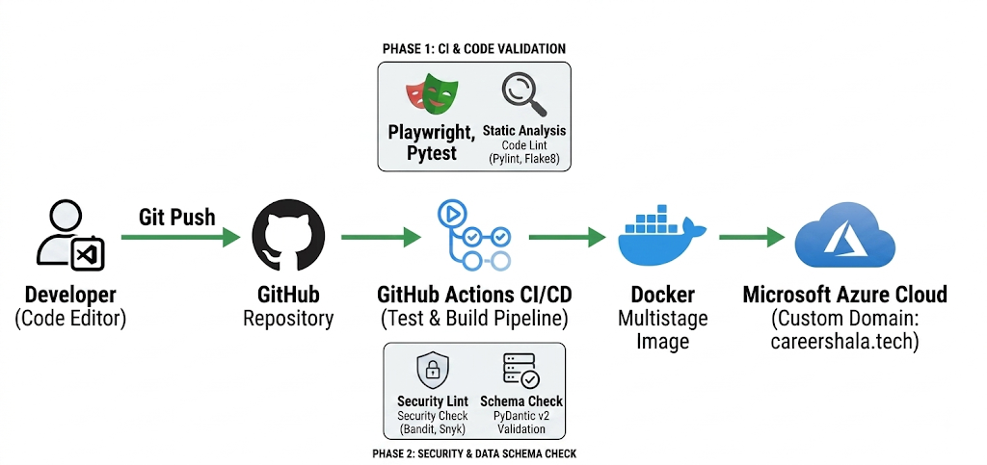
Fig 2: Automated CI/CD Pipeline and Cloud Deployment
1.4 Discovered System Architecture & Module Breakdown The project codebase is architected into five primary subsystems:
- Dual-Engine ATS Engine: Evaluates parsing health (detecting shredded words from 2-column layouts), knockout rules (hard experience and degree rank checks), exact keyword matching, and knockout math (50% skills, 30% experience, 20% education). The Vector Semantic Matcher utilizes Hugging Face BGE embeddings and TF-IDF cosine similarity.
- LangGraph Agentic Workflows: Includes a 3-node graph for ATS evaluation, an enhancer graph that categorizes skill taxonomies while deterministically preserving experience bullet points, and a 4-node apply assistant graph (jd_analyzer → email_generator → cover_letter_generator → quality_validator).
- Edge Computer Vision Proctoring Engine: Operates entirely inside the client's browser to calculate 3D head pose matrix (pitch, yaw, roll), iris gaze direction, multiple face detection, phone detection, and DevTools/tab-switch tracking. Telemetry events dynamically update session integrity scores.
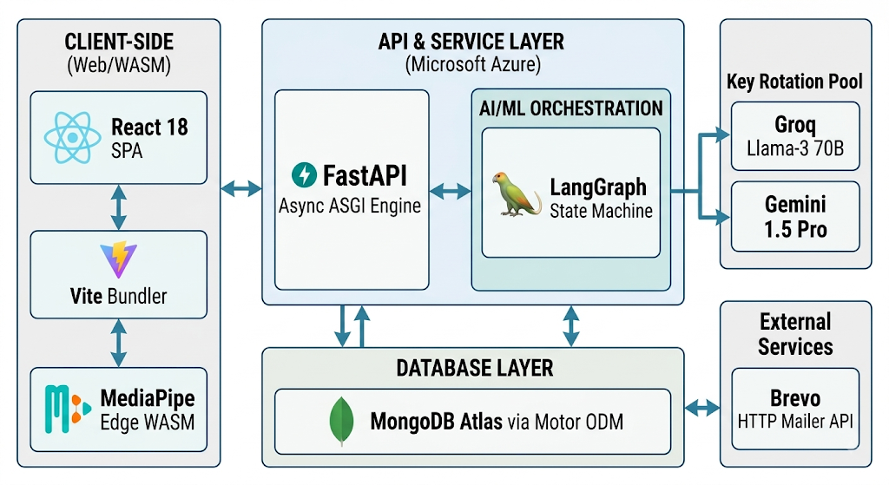
- Gamification & Cryptographic Certificates: Manages XP points, 9-tier level progressions, 28-day monthly activity heatmaps, and generates zero-network vector PDF skill certificates with unique SHA-256 cryptographic hashes and embedded QR verification codes.
Fig 1: CareerShala High-Level System Architecture
1.5 Technical & Academic Significance CareerShala demonstrates how stateful graph orchestration (LangGraph), deterministic NLP algorithms, browser computer vision, and asynchronous web architectures (FastAPI + React) can be combined into a scalable software application. It advances computer science applied research in hybrid NLP matching, multi-agent AI safety, and low-latency browser proctoring.

2. FEASIBILITY STUDY
2.1 Technical Feasibility The technical feasibility of CareerShala is established through its modular stack:
- Backend Architecture: FastAPI provides an asynchronous ASGI framework capable of handling concurrent requests with low latencies (< 50ms for API routing).
- AI Model Fallback Pool: By engineering multi-key rotation pools (groq_key_pool, gemini_key_pool) and fallback chains (Groq → Gemini → Mistral → Anthropic → Local Templates), the system eliminates API rate-limit bottlenecks and model single-point-of-failure risks.
- Edge Proctoring Efficiency: Running MediaPipe FaceMesh and COCO-SSD in WebAssembly/WebGL on the client device shifts computer vision computation away from backend servers, making proctoring scalable without expensive GPU server infrastructure.
- Database Async ODM: Motor and PyMongo maintain non-blocking connection pools to MongoDB Atlas, supporting concurrent operations across users, resumes, interview sessions, and telemetry logs.
2.2 Economic Feasibility
- Zero GPU Server Costs: Offloading vision proctoring to the client's browser eliminates the need for expensive server-side video processing nodes.
- Low-Cost LLM Inference: Utilizing Groq's high-speed inference tier alongside Gemini Flash models reduces AI operational expenses to near zero during development and scaling.
- HTTPS REST Email Infrastructure: Employing Brevo's HTTP API over standard HTTPS Port 443 avoids cloud SMTP port-blocking (ports 25, 587) and costly third-party SMTP relay add-ons.
- Open-Source Core Dependencies: All core libraries (FastAPI, React, NLTK, Scikit-learn, ReportLab, MediaPipe) are open-source and free from commercial licensing constraints.
2.3 Operational Feasibility
- User-Centric Web Interface: Built with React 18 and Tailwind CSS, the platform delivers a responsive user interface with dark mode visual hierarchy, glassmorphism UI cards, and step-by-step onboarding wizards.
- Direct HR Reply Routing: The Apply Assistant dispatches emails with candidate-direct replyTo headers, allowing HR recruiter responses to route directly to the candidate's personal inbox.
- Role-Based Workflows: Separate dashboards for Candidates, Recruiters (RecruiterDashboard.jsx), and System Administrators (AdminDashboard.jsx) ensure intuitive operational workflows tailored to each user role.
2.4 Need and Significance Analysis CareerShala addresses a critical market mismatch: candidates need transparent tools to pass automated recruitment filters, while employers require verified, authentic candidate assessments. By combining deterministic resume verification with AI-assisted enhancement and vision proctoring, CareerShala provides an end-to-end platform for job seekers and hiring managers.

3. METHODOLOGY / PLANNING OF WORK
3.1 Multi-Agent Workflow Engineering (LangGraph) The platform uses LangGraph to structure complex LLM execution into stateful graphs:
- ATS Evaluation Graph: Executes a 3-node pipeline—extractor (deterministic NLP extraction), evaluator (knockout math and vector embedding), and scorer (blending deterministic and semantic scores).
- Resume Enhancer Graph: Receives human-verified ground truth data, invokes Gemini 2.5 Flash with strict JSON schemas, and executes a post-LLM Python bullet restoration pass to preserve original experience highlights verbatim.
- AI Apply Assistant Graph: Functions through a 4-node graph: jd_analyzer extracts required skills; email_generator & cover_letter_generator draft outreach text; and quality_validator evaluates output for placeholders, triggering auto-retries if validation fails.
3.2 Deterministic & Vector Dual-Engine ATS Methodology The dual-engine ATS architecture evaluates resumes through two complementary algorithms: Final ATS Score = (0.70 × Knockout Math Score) + (0.30 × Vector Similarity Score)
- Knockout Math Score: Blends mandatory skill matches (50%), professional experience ratios (30%), and education degree rank (20%).
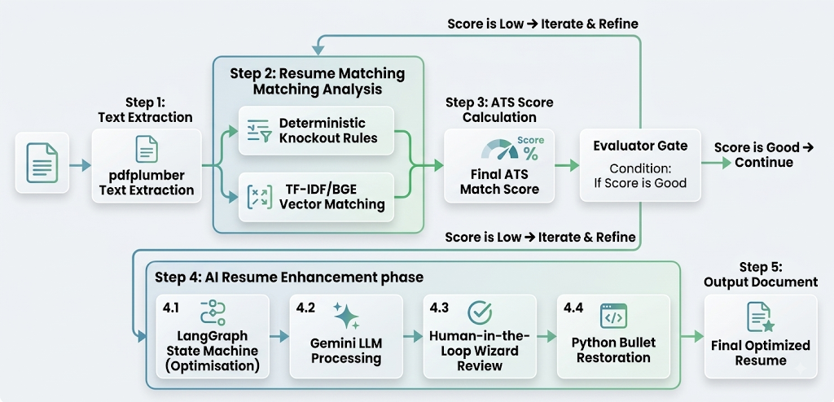
- Vector Similarity Score: Cosine similarity calculated over TF-IDF matrices or Hugging Face BGE embeddings (BAAI/bge-large-en-v1.5).
Fig 3: Dual-Engine ATS Evaluation Flow
3.3 Edge Computer Vision Proctoring Framework During mock interview sessions, the frontend proctoring engine executes an asynchronous canvas loop:
- Face Mesh Tracking: Detects 468 3D facial landmarks to compute head rotation angles (Pitch, Yaw, Roll).
- Object & Face Detection: Uses COCO-SSD to detect unauthorized items (e.g., cell phones) and counts visible faces.
- Cheating Event Telemetry: Emits telemetry events (tab_switch, multiple_faces, devtools_open) to update a weighted cheating risk score. Sessions with 5+ warnings are automatically aborted.
3.4 Phase-Wise Development Plan The project development was executed across six logical phases:
- Phase 1: System Specification & Data Modeling: Schema definition for MongoDB collections and REST API routing conventions.
- Phase 2: Parsing & ATS Engine: Development of text extraction, parsing health checks, and knockout math.
- Phase 3: LangGraph Workflows: Construction of state graph pipelines for evaluation, enhancement, and drafting.
- Phase 4: Vision Proctoring & AI Interviews: Integration of browser computer vision models and real-time cheating scoring.
- Phase 5: Gamification & Brevo Services: Implementation of zero-network ReportLab PDF certificate generation, XP mechanics, and Brevo REST API email dispatching.
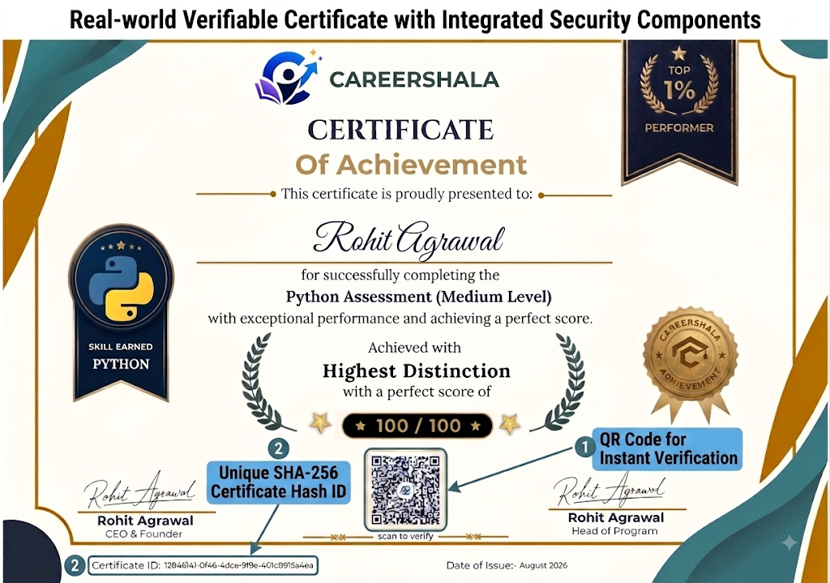
- Phase 6: UI Integration & Deployment: Frontend React SPA assembly, Docker containerization, and cloud deployment configuration.

Fig 4: CareerShala User Dashboard and Verifiable Cryptographic Certificate
7. FACILITIES REQUIRED
7.1 Hardware Requirements
- Development & Server Environment:
  - Processor: Intel Core i5 / AMD Ryzen 5 or higher (Multi-core CPU required for Uvicorn async worker execution).
  - System RAM: Minimum 8 GB (16 GB recommended for concurrent Docker container operation).
  - Storage: Minimum 10 GB available SSD space.
  - Network: High-speed broadband internet connection.
- Client Assessment Environment:
  - Processor: Dual-core 2.0 GHz CPU or higher.
  - System RAM: Minimum 4 GB.
  - Peripherals: Integrated or external Web Camera (720p resolution minimum) and Microphone for video/audio proctored interviews.
7.2 Software & Framework Requirements
- Operating System: Windows 10/11, Linux (Ubuntu 22.04 LTS), or macOS 12+.
- Runtime Environments: Python 3.10+ (Backend), Node.js v18.0+ / NPM v9.0+ (Frontend).
- Web Frameworks: FastAPI ^0.110.0 (Backend), React ^18.3.1 (Frontend).
- Build Tools & Servers: Vite ^5.3.3, Uvicorn ^0.29.0, Nginx (Reverse Proxy).
- Database System: MongoDB Community Edition / MongoDB Atlas (Cloud Cluster).
7.3 External Services & Cloud Infrastructure
- AI & LLM Services: Groq API, Google Gemini API, Hugging Face Inference API.
- Transactional Email: Brevo HTTP REST API (v3) operating over HTTPS Port 443.
- Media & Assets: Cloudinary CDN SDK for image/resume asset storage.
- Hosting Platforms: Vercel (Frontend SPA), Render / Azure App Service (Backend Docker Container).
- Cloud Hosting & CI/CD: Microsoft Azure App Service for production hosting, and GitHub Actions for continuous integration and deployment.

BIBLIOGRAPHY
- LangChain AI. (2024). LangGraph Documentation & State Machine Design Patterns. [Online]. Available: https://python.langchain.com/docs/langgraph/
- Ramírez, S. (2023). FastAPI Web Framework & Asynchronous ASGI Specifications. [Online]. Available: https://fastapi.tiangolo.com/
- Kartynnik, Y., Ablavatski, A., Grishchenko, I., and Grundmann, M. (2019). "MediaPipe Face Mesh: Real-Time 3D Facial Landmark Detection on Mobile and Web Devices." arXiv preprint arXiv:1907.06724.
- Reimers, S. and Gurevych, I. (2019). "Sentence-BERT: Sentence Embeddings using Siamese BERT-Networks." Proceedings of the 2019 Conference on Empirical Methods in Natural Language Processing (EMNLP).
- ReportLab Europe Ltd. (2023). ReportLab PDF Generation User Guide. [Online]. Available: https://www.reportlab.com/docs/reportlab-userguide.pdf

