**The Web Crawler’s Fun Video Site**

**Milestone 1 Part A**

Jeffrey Su, Jay Patel, Hardik Joshi, Jagrut Desai, Saurav Agrawal

Dec. 6, 2014

CS 174

Group 1: Web Crawlers

**Assigned domain: Tai Chi**

**Table of Contents**

Individual Contribution Summary

Introduction

What have been accomplished in this milestone

Data correction and preparation

Restoring Data

Data processing

Data correction

Tagging videos

Video info modifying site

Login/Registration

Cookies for storing login info

Favorite videos

Additional info

# **Individual Contribution Summary**

|  |  |  |
| --- | --- | --- |
| **Student Name** | **Technical part** | **Report drafting** |
| Jeffrey Su | * Wrote the Login page and backend script that handles login * Wrote registration page and handles the backend script that handles adding a user to db * Wrote all of the initial site (for bonus hw) and improved it for other team members | * Started the report draft and made initial edits * Wrote details about contribution for Parts B and C of report * Wrote host info about where website is hosted |
| Jay Patel | * Wrote the script that adds the favorite videos that user will select while viewing through video listings. * Utilized sessions to add videos to favorites. * Displayed user’s favorite videos on user’s homepage upon login. | * Wrote details about contribution for Part D. * Provided detailed screenshots to explain details about Part D. * Helped team in constructing a final report. |
| Hardik Joshi | * Inserted the data to blank fun_video database table and recover all rows of data. * Corrected discrepancy that I noticed in the videos. * Worked on displaying the video icon image for those videos that didn’t had any icon image. | * Wrote details about my contribution for Part A. * Helped team by creating the group chat to communicate for recent updates from individual. * Setup the github repository for team members to access the most recent copy of project files. |
| Jagrut Desai | * Cleaned the primary data provided by instructor * removed repetition and special character from the fun_video.sql provided * Updated sensible and user friendly tags for each videos * Helped Jay on session and cookie for favorite video requirement. | * Wrote about restoring data and its’ importation in phpmyadmin * Wrote about writing java programs to delete duplicates and videos that did not qualify. * Contributed on writing other parts of the report like tagging and use of sessions. |
| Saurav Agrwal | * Added edit video script that uses GET method to retrieve video ID and return values of video to admin for editing * Wrote backend script that updates values on database | * Wrote the part of the report pertaining to the editing video |

## 

# 

# **Introduction**

## What has been accomplished in this milestone

<http://www.sjsu-cs.org/classes/cs174/sec1/su/project/index.php>

Accounts for testing login info:

1. u: test1, p: test1 (Regular User)
2. u: test2, p:test2 (Regular User)
3. u: admin1, p:secret123 (Admin user)

Describe what you have accomplished in bullet form:

* Corrected then inserted given data into database
* Fixed existing website from bonus hw (Jeffrey’s site) and implemented additional features
  + Implemented Login page using sessions and cookies (for remembering users)
  + Implemented Registration page
  + Implemented favorite video check box and display page
  + Implemented edit button for admin user to edit video information

# **Data correction and preparation**

## Restoring Data(Jagrut)

Given the fun_video1.sql file, we first created the fun_video table using the original template and copy pasted data from fun_video1.sql into phpmyadmin’s SQL query page to insert the rows into the table. The original Data had a few rows that were missing certain attributes like “highest resolution” so that had to be resolved first before inserting because mysql was throwing errors.

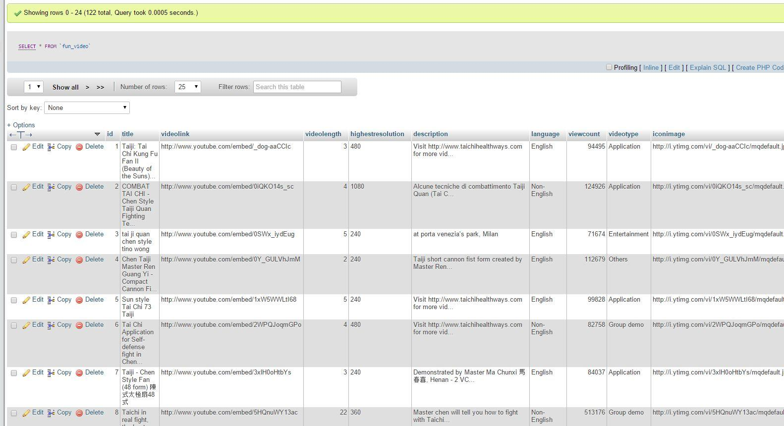

## Data processing(Jagrut)

I wrote a JAVA program which reads in a fun_video.sql. I was faced with a various challenges like removing duplicates and video which are 50,000 view count or less. First, I wrote program to store each entry of fun_video.sql into a list and to find duplicates I only included videos that were not already included in the list. The way I knew that video was already included was the last eleven characters of the video link. After that I printed out the ids of those duplicates, so I can manually remove them from database. The next challenge was to delete videos which has less than 50,000 view count, so I again did what I had done for finding duplicate, I found ids for video which had view count less than 50,000 and printed them out to delete them form database. The other thing I did was to give a uniform structure to all the video link which was also done by this program. There were still some manual challenges we were facing that was not solvable by this JAVA program which Hardik worked on.

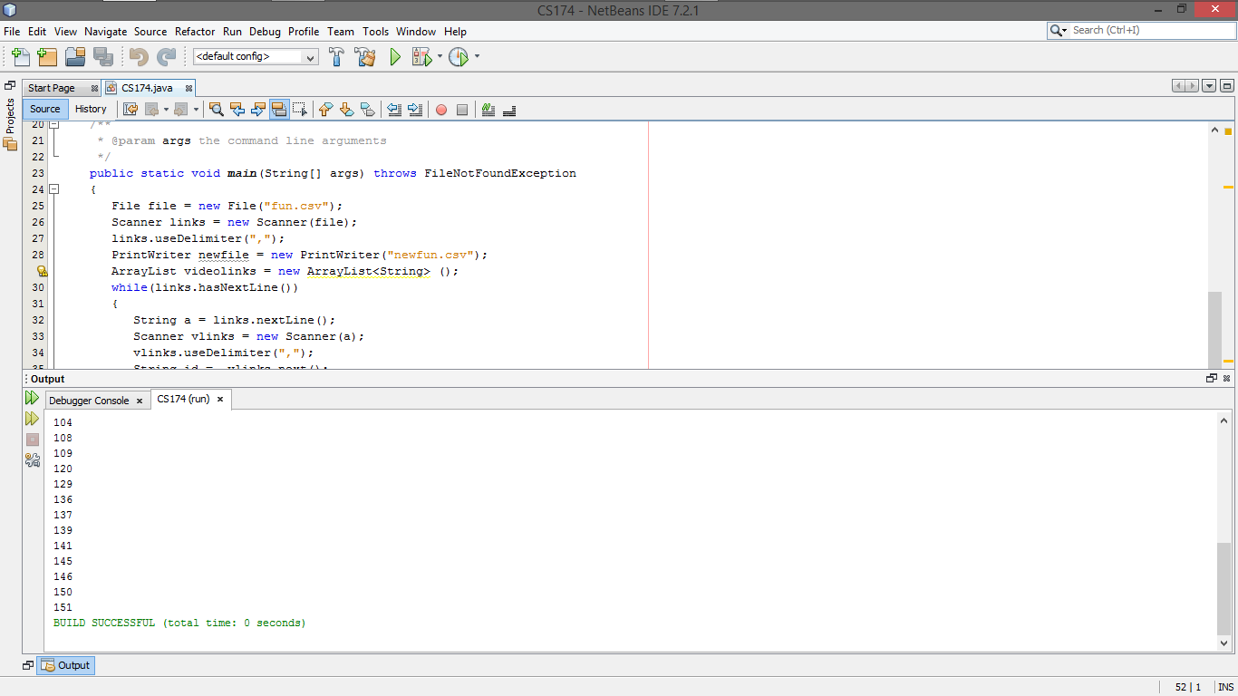

## Data correction (Hardik)

First, I started trying all the video links on browser to confirm that they are working fine. If I see any broken video link then I removed it from the database. Then I had to modify the database schema to allow longer title names with non-english character. After modification, I recopied the title from video link to get the most accurate tile of all videos. Also, I make sure the video length, highest resolution, description and so on are accurate with video links. For some video icon link there were some issues displaying the icon image of video, so I fixed that as well. Finally, worked on modifying users table depending on team members need.

## Tagging videos (Hardik)

I read through the description and go over the videos that had english language in it. I modified the tag of videos accordingly in the database.

## Video info modifying site (Saurav)

If the user is logged in as Administrator, he/she will see the “Edit” button when videos are searched using search feature or via categories. The image below describes the search result with “Edit” button.

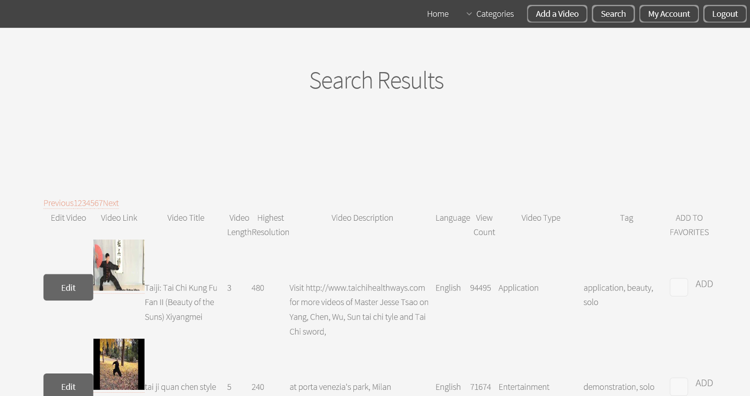

If the administrator wants to edit the video then when he/she clicks on “Edit” button the user will be presented with “Video Edit Form for Administrator” which is handled by “editvideo.php” script as shown below. The form will be preloaded with the current data from database.

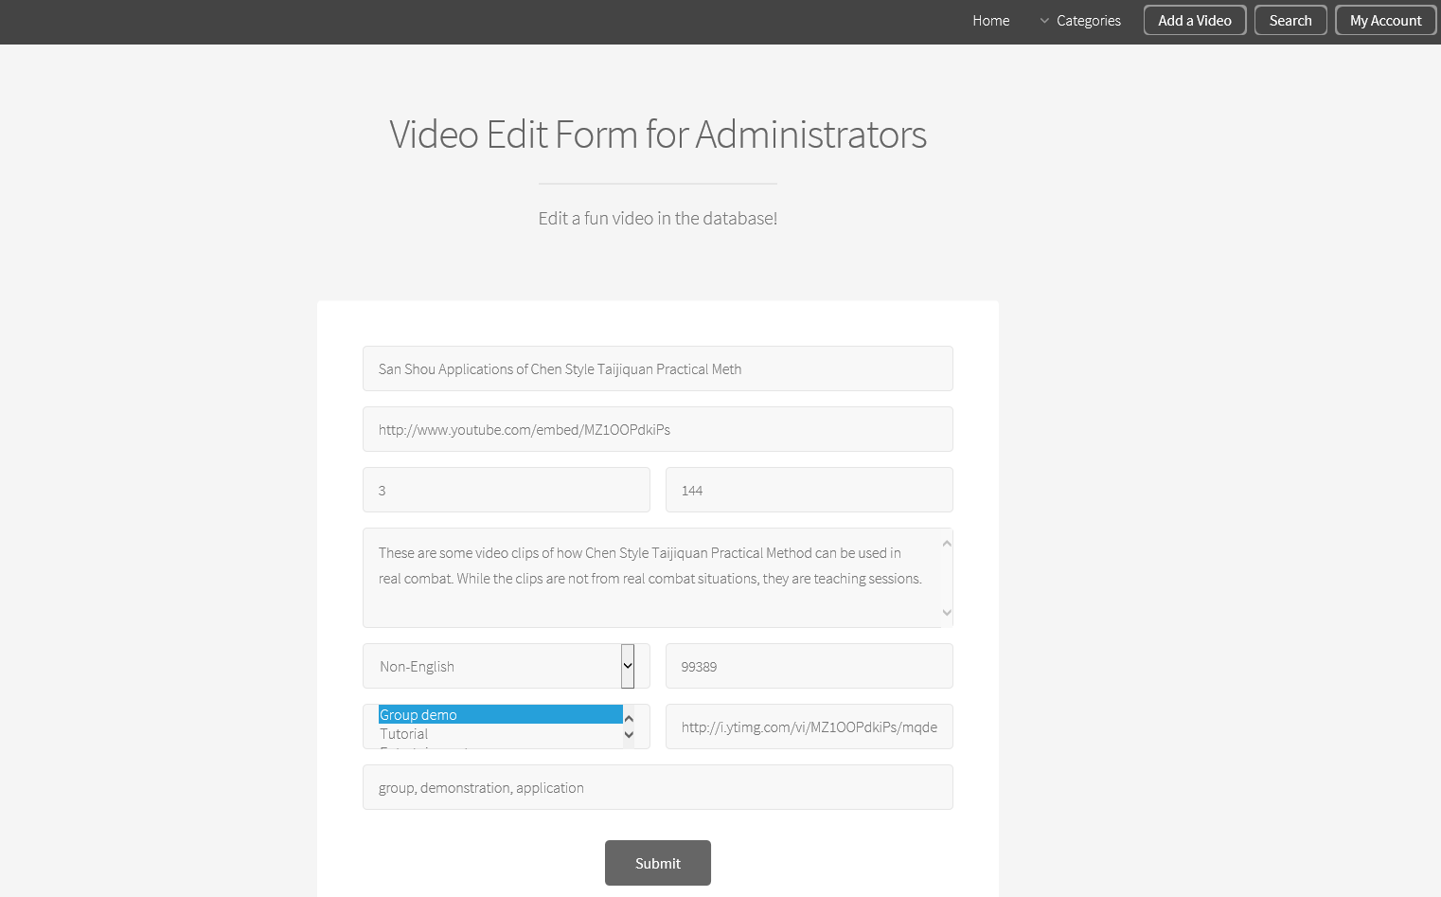

Admin user can modify the data and hit “Submit” button to apply the changes to database using “editentry.php” script. And finally the user will be shown “thank you” page as shown below. That completes the edit part of video for admin users.

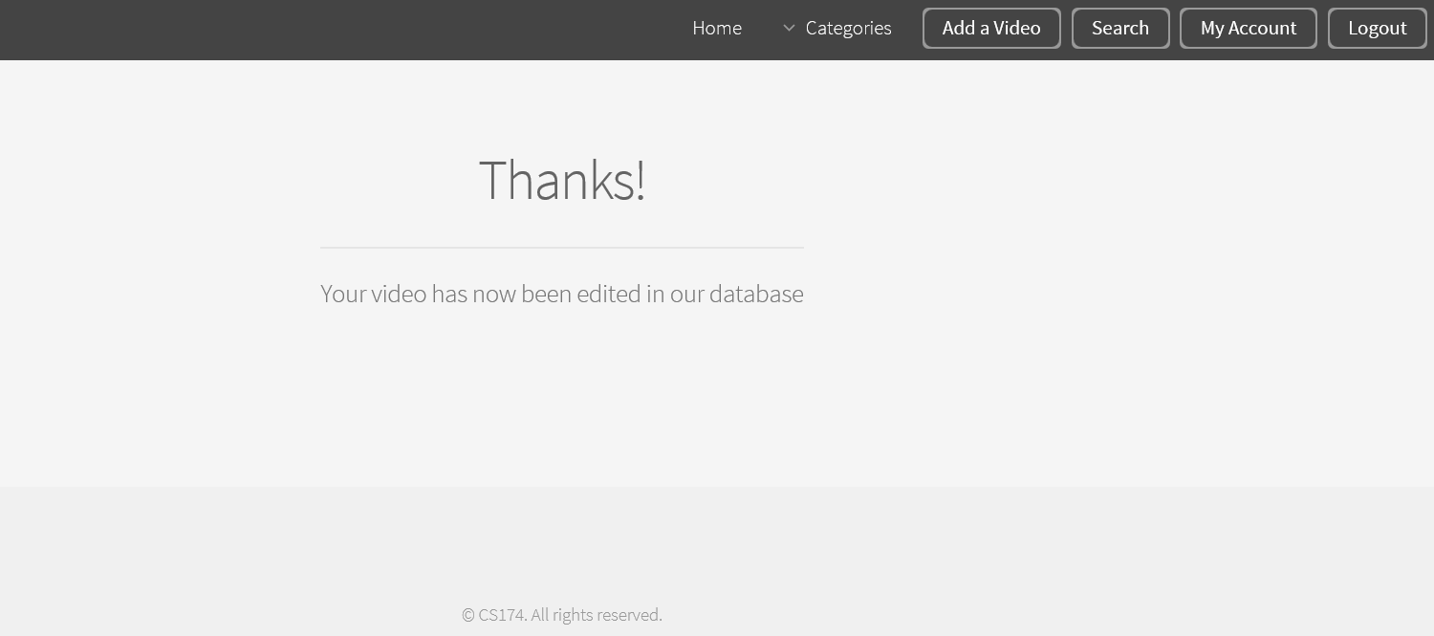

# **Login/Registration (Jeffrey)**

To begin, I moved the main title headers and navigation bar (on top of all pages) to a separate nav.php file and “included” that script in all the pages so the navigation bar will be printed on all pages.

I also made changes to the bar by adding login and registration buttons if the session is not set:

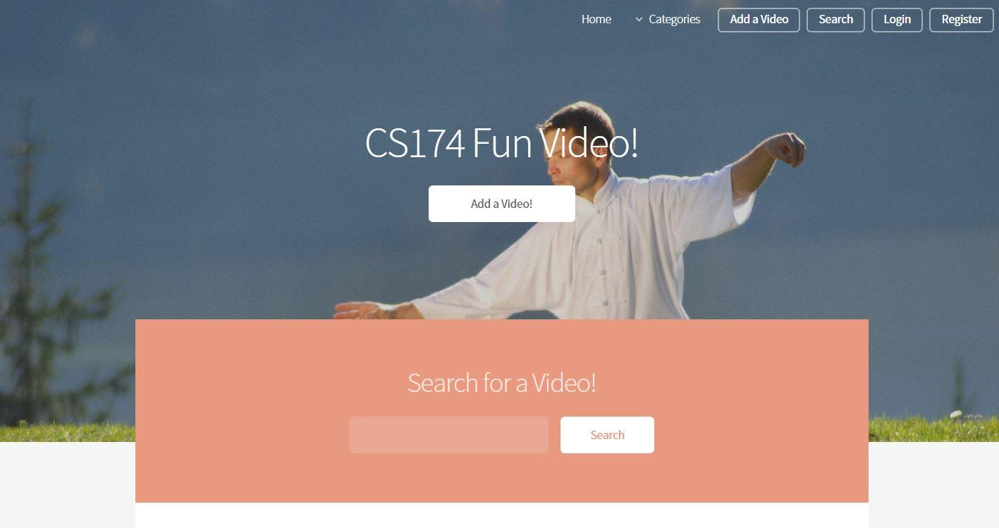 When Logged in the bar looks like this:

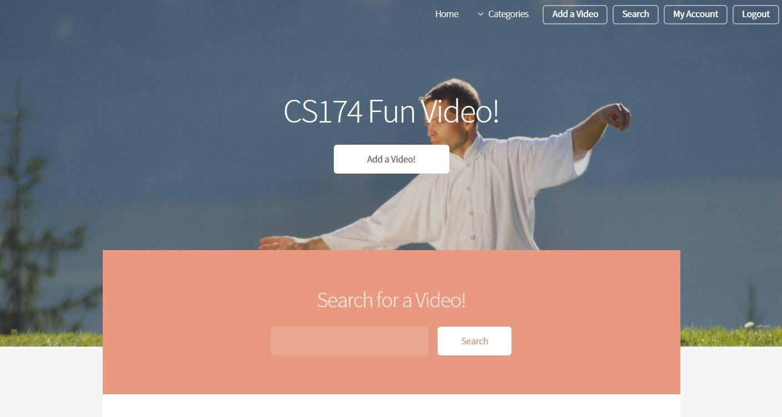

As you can see from the above image, there is now a “My Account” button and a “Logout” button instead of a login and register button. The my account button takes users to their favorite video dashboard which is explained later in this document. Also note that the login session lasts for about 30 min after start of inactivity. Then users will have to login again unless they use “remember me which is also explained below”

The login page looks like this: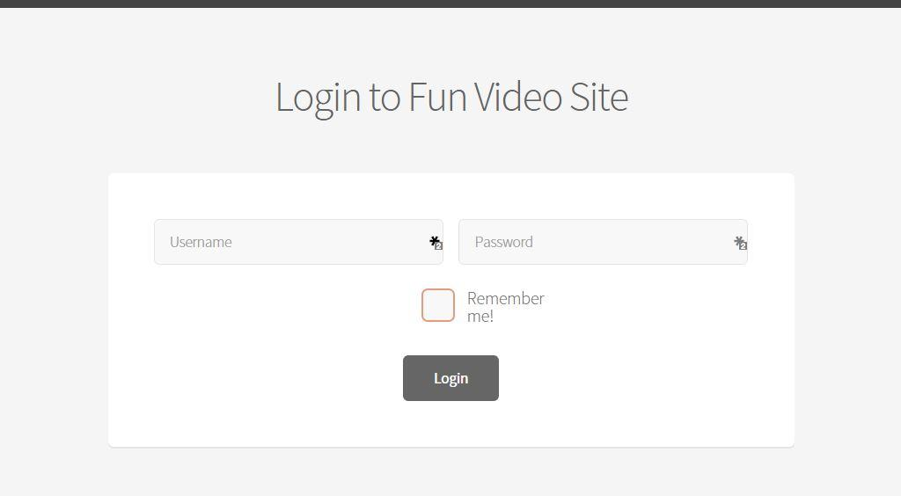

The registration page for new users looks like this:

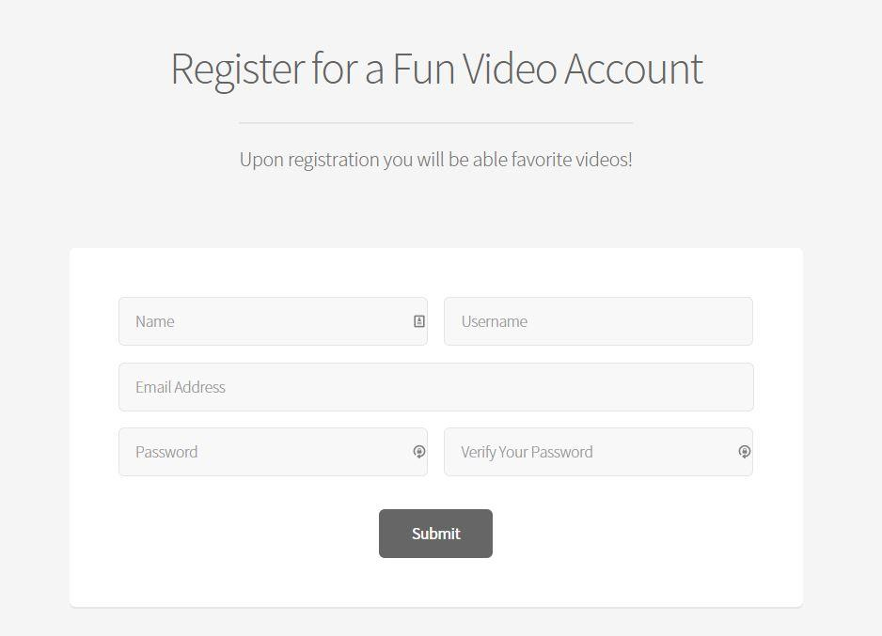

The php script on the same page inserts into the user table on the database which is used to query the login.

**Cookies for storing login info (Jeffrey)**

Users have the option to choose “remember me” which will store their username in a cookie stored on their computer to avoid having to login every time they come back to our site. The login page looks like this with remember me checked:

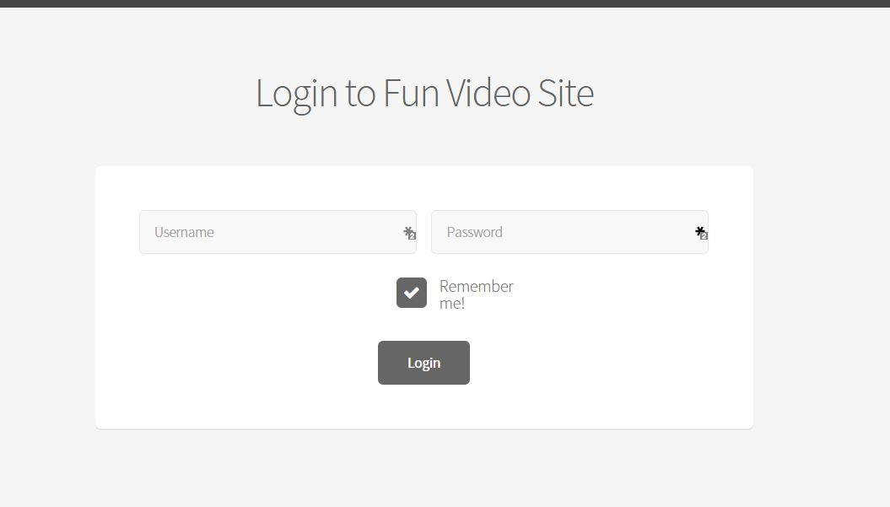

Each page checks if a cookie is set, if not check if session is set, if not then display “non logged in navigation bar” and in some pages it will send users to the login page.

# **Favorite videos (Jay)**

Show how you use sessions to store and retrieve favorite videos selected by users.

Narrated screenshots to describe the workflow is needed.

User will see their favorite videos upon logging in:

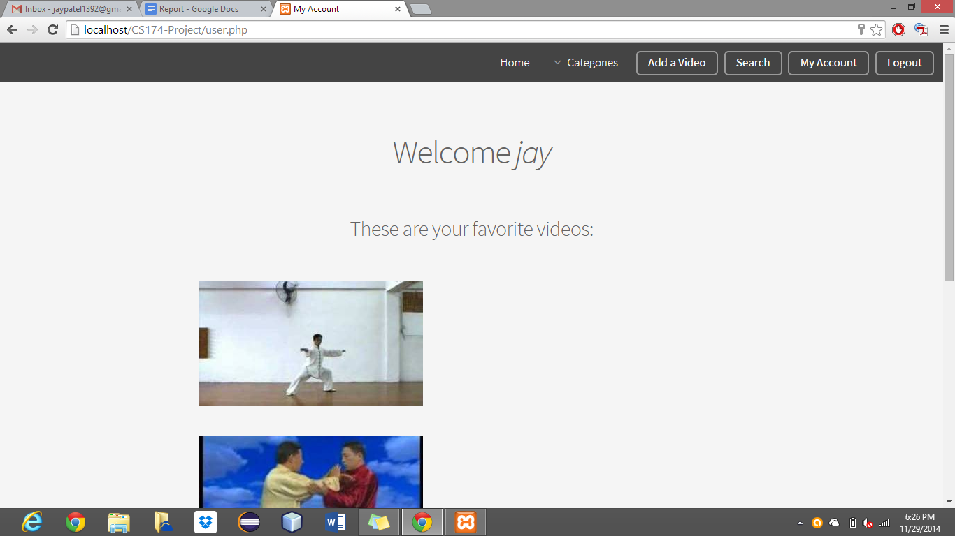

User will be able to select what videos they would like to add to their favorites lists: They can select any video they like while browsing through our collection of videos.

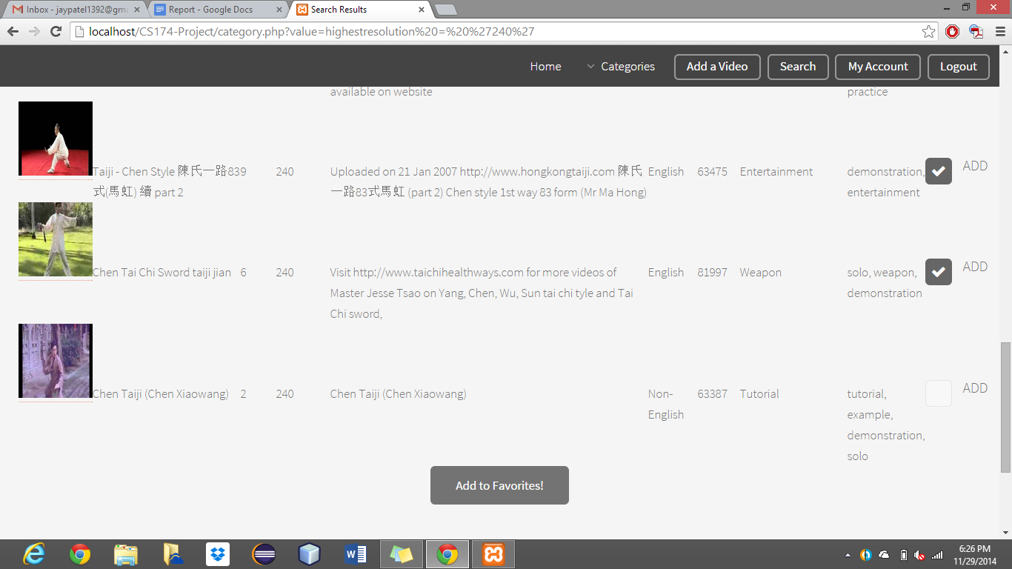

User’s latest likes will be displayed on their dashboards. If they liked some new videos during their active session, those videos will be displayed on their dashboards.

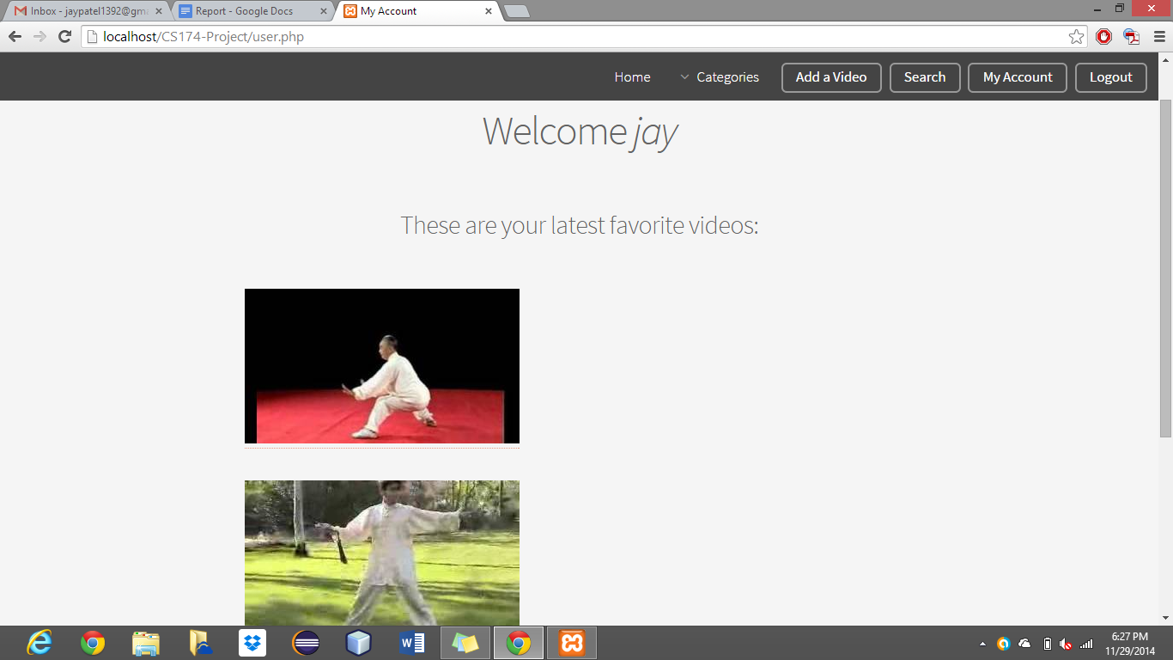

If the user is not logged-in, script will check for this and will prompt user to log in before adding their favorite videos.

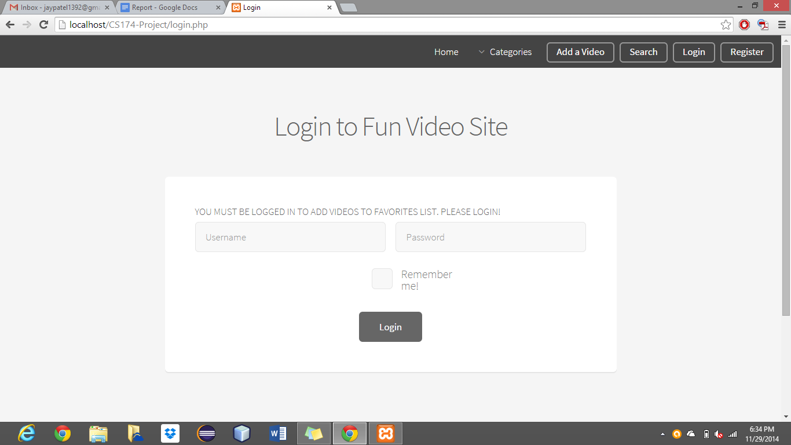

I created an associative array variable within session to store favorite videos. User Id served as a key, and videos they selected to add to favorites acted as a values. This allowed me to store all of user’s favorite videos and uniquely mapped those videos with their user ID. I used session throughout implementation of favorite videos. First of all, there were two areas where users can choose to add their videos to favorite videos. One of the place where users were able to add videos to favorite videos was on category and second location where users were allowed to add to their favorite lists was search page. So, I made sure that on both page there is an option for user to add videos to their favorites list.