[](https://templatelab.com/)

Starters / Dish #23

I get a lot of orders at Two Fingers from sportsman who need to eat a lot of very healthful food, and this recipe has been a favourite of my menu planning clients to make themselves. This is such a favourite because it easy, delicious and well rounded.

{title}

1. Cook pasta according to package directions. Drain and set aside.
2. In a small saucepan or deep frying pan, melt butter. Add onion, mushrooms, and flour.
3. While onions and mushrooms are browning, chop bacon to slices. Add to pan and mix five more minutes.
4. Lorem ipsum dolor sit amet, consectetuer adipiscing elit. Maecenas porttitor congue massa.
5. Fusce posuere, magna sed pulvinar ultricies, purus lectus malesuada libero, sit amet commodo magna eros quis urna.

PREPARATION STEPS

INGREDIENTS

1 pound whole wheat angel hair pasta, 1/2 pound mushrooms, 1 small onion, diced 3-4 cloves garlic, 2 tablespoons butter or Earth Balance, 1 cup 0.1%, 2 tablespoons white whole wheat flour, 2 tablespoons fresh dill or parsley, 2 tablespoons red onion, diced or thinly sliced, 1/2 cup plus 2 tablespoons grated parmesan, Sea salt and black pepper.

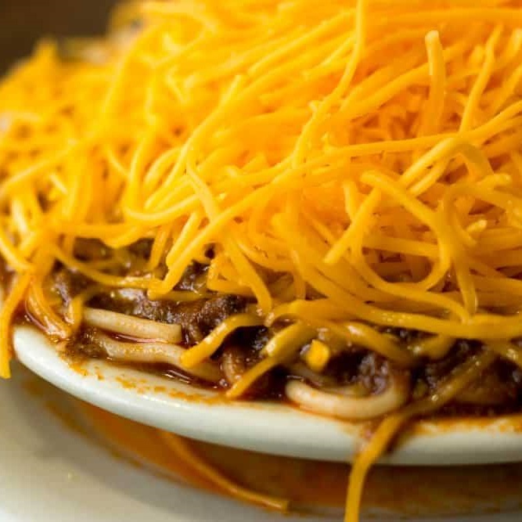

[© TemplateLab.com](https://templatelab.com/)