Rationale

Yi Chen

Yc2329

● VALIDATION

In this part, I mainly use js/validation.js to validate the input.

Since it is game characters, I allow duplicates/

For name, since it is a game, game character names can be various. So I allowed characters, spaces, numbers, underscores, dashes. From 1 to 20 characters, thus I can display it nicely on the screen. Name can’t be all spaces.

Status number(hunger, sanity and health): only integers are accepted. According to the game, numbers are restricted within 30 to 500.

imageURL: because we don’t necessarily need an image. But still to check it, only checked the input contains picture format.

Perk: for display purpose, only accept 3 to 120 characters, and cant be all spaces.

● Search example

male and difficult:

Wes: male, difficult.

Wilson: male, easy.

Maxwell: male, difficult.

So I searched male,difficult:

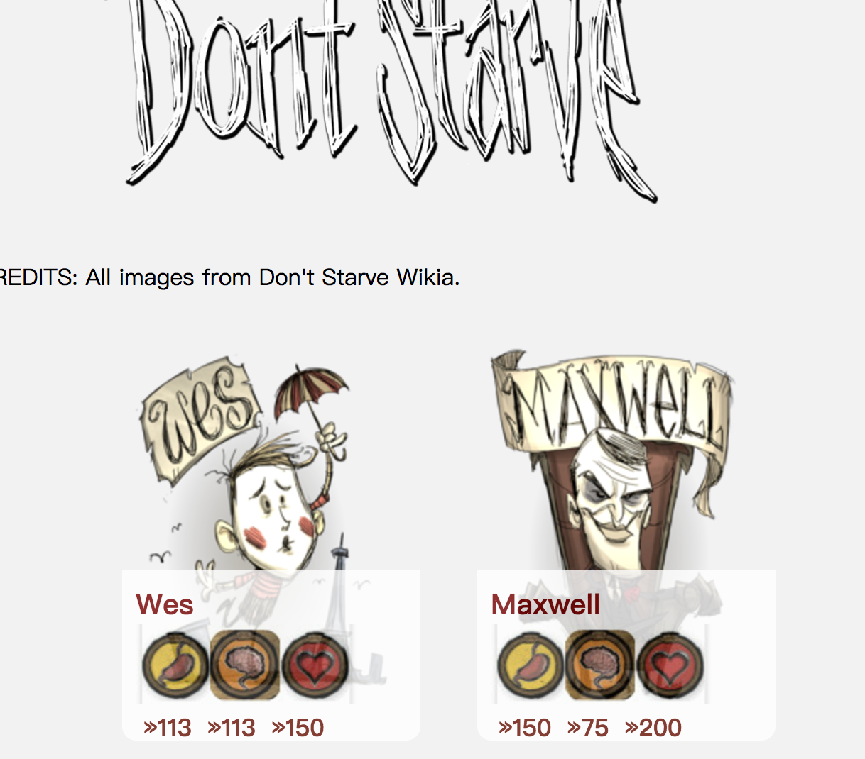

I searched Wilson, male, easy:

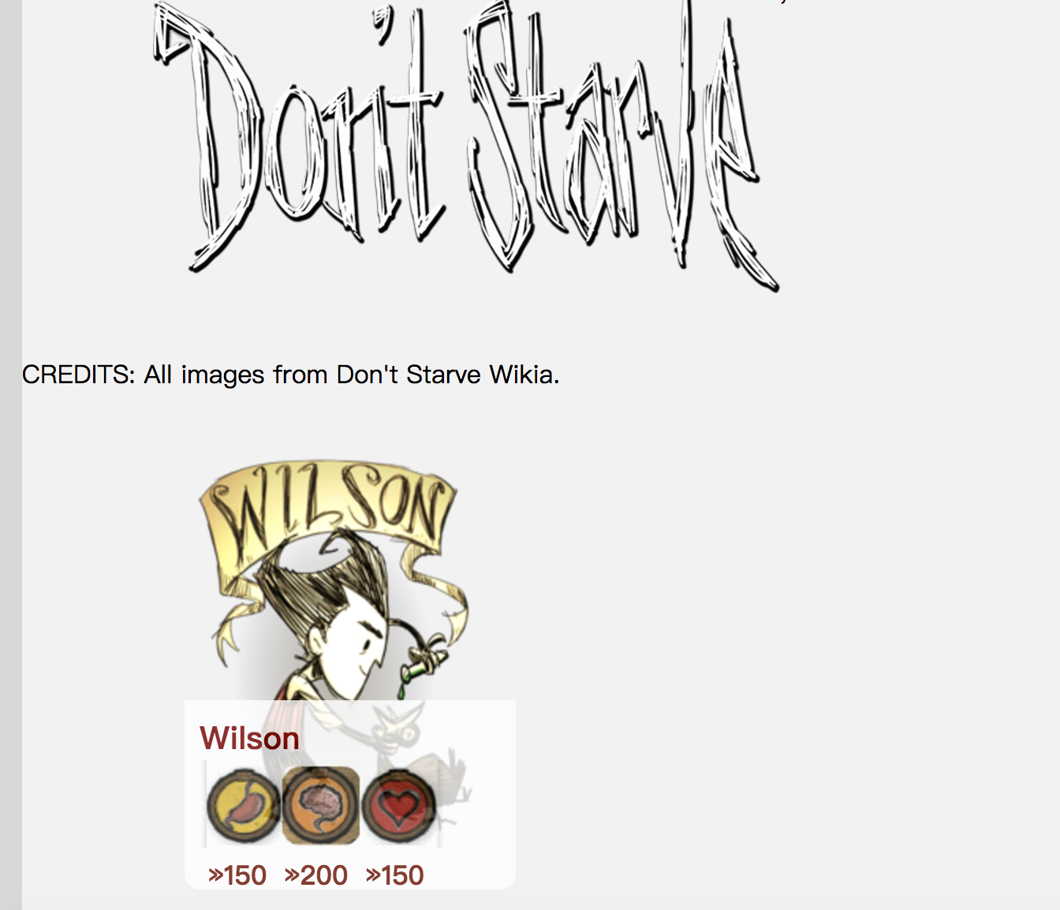

● When searching multiple fields, is it an “or” search, an “and” search or do you offer a choice? Why did you do it this way?

I used “and”. Because it is a filter to choose characters

● Any other design decisions, additional functionality, or notes you want us to know about (WOW!!!!)

I have php functions of SEARCH in search.php.

I have used advanced php and jscript to add, search and validate.

It is a WOW topic! And I think it looks fantastic!

CREDITS: all images from Don’t Starve Wikia.

http://dontstarve.wikia.com/wiki/Don%27t_Starve_Wiki