(excerpt from The National Elevation Dataset chapter in the 2nd edition of Digital Elevation Model Technologies and Applications: The DEM Users Manual, to be published by ASPRS in November 2006)

Accuracy Assessment

The accuracy of the NED varies spatially because of the variable quality of the source DEMs. As such, the NED inherits the accuracy of the source DEMs. Some accuracy statistics are available in the header records of the USGS DEM source files, and this information is captured in the spatially referenced metadata. Many times, this accuracy information has limited usefulness because it is a relative measure of how well the DEM fits the source material from which it was generated. In an effort to provide more information to users on the vertical accuracy of the NED, the data set has been tested by comparing it with an independent reference source of very high accuracy. The reference data are the geodetic control points that NGS uses for gravity and geoid modeling (Smith and Roman, 2001; National Geodetic Survey, 2003). The distribution of this set of more than 13,000 high-precision survey points across the conterminous United States is shown in Figure X.9.

Absolute Vertical Accuracy
To complete the accuracy assessment, the NED value at each of the NGS control point locations was derived through bilinear interpolation, and error statistics were calculated (Table X.1). The overall absolute vertical accuracy expressed as the root mean square error (RMSE) is 2.44 meters. Table X.1 also contains the accuracy expressed in terms of the National Map Accuracy Standards (NMAS), which use a 90 percent confidence interval, and in terms of the National Standard for Spatial Data Accuracy (NSSDA), which uses a 95 percent confidence interval. The methods described in Maune et al. (2001) were used to convert the measured vertical RMSE to equivalent NMAS and NSSDA expressions.

An advantage of the 2.44-meter RMSE as an accuracy report is that it is an actual measured quantity, in contrast to the often quoted RMSE of 7 meters for USGS DEMs, from which most of NED is derived. The 7-meter RMSE, often cited as the accuracy of USGS 7.5-minute DEMs, is a production goal described in the USGS Data Users Guide 5—Digital Elevation Models, last published in 1993 and traditionally known by many users as the “blue book” (see also U.S. Geological Survey, 1997). Note that the version of the NED that was tested by comparison with the Global Positioning System (GPS) points was the 1-arc-second layer released in June 2003, which was the last version assembled completely from USGS 10-meter and 30-meter 7.5-minute DEMs. Since that time, some areas have been updated based on high-resolution lidar or photogrammetric data, which may have even better accuracy than the quadrangle-based USGS DEMs.

Accuracy assessments were conducted on earlier versions of the NED using a smaller set of control points from the NGS known as the High Accuracy Reference Network (HARN). Approximately 5,800 points were used to measure the absolute vertical accuracy of the 1-arc-second layer of the NED for the conterminous United States as it existed in September 1999, October 2001, and October 2002. Table X.2 shows the improvement in overall vertical accuracy of the NED, as the more recent versions have incorporated better source data. Most of the HARN points used for the earlier assessments were also included in the larger GPS benchmarks data set, which was used for the most recent assessment of the June 2003 version of the NED.

Use of the NED spatially referenced metadata also allows for the calculation of accuracy statistics segmented by source DEM characteristics. Because the NED is derived from source DEMs that were produced with several different methods, it may be important for a user to know what levels of accuracy can be expected for areas based on DEMs produced with the various methods. The four primary production methods used for USGS 7.5-minute DEMs include electronic image correlation (Gestalt Photo Mapper (GPM) instrument), manual profiling (MP) on stereoplotters, contour-to-grid interpolation (CTOG), and an improved contour-to-grid interpolation known as “LineTrace+” (LT4X). Details for each production method are given in Osborn et al. (2001). To calculate the accuracy of DEMs resulting from each production method, the reference control point data set was partitioned into subsets according to the production method of the quadrangle on which each point was located. Table X.3 shows the error statistics for the areas of the NED derived from DEMs produced with each of the four production methods. Note that the DEMs derived from photogrammetric methods (GPM and MP) are less accurate than those derived from 1:24,000-scale contours. This is not surprising, given that the photogrammetric DEMs were compiled from 1:80,000-scale aerial photography and were a by-product of the orthophoto generation process.

Land surface characteristics derived directly from the NED, including slope, aspect, and local relief, allow for examining accuracy as a function of specific terrain conditions. Figure X.10 shows the NED error at each GPS control point plotted against elevation, slope, aspect, and local relief (relief within approximately one square mile centered on the point location). The NED errors appear to be truly random, as there is no discernible correlation or relationship with any of the terrain parameters. This is evident in the distribution of data points in the scatterplots; in each case, the values are uniformly distributed around the zero error axis. Thus, in general, NED users can expect a consistent level of accuracy across the data set regardless of varying terrain conditions.

Relative Vertical Accuracy
For some applications of elevation data, the relative, or point-to-point, vertical accuracy is more important than the absolute vertical accuracy. Whereas absolute accuracy accounts for the combined effects of systematic and random errors, relative accuracy is a measure of just random errors. The relative vertical accuracy of a data set is especially important for derivative products that make use of the local differences among adjacent elevation values, such as slope and aspect calculations. To characterize the relative vertical accuracy of the NED, the same set of reference geodetic control points used in the assessment of absolute vertical accuracy was processed and analyzed. As with the test of absolute accuracy, the NED 1-arc-second layer released in June 2003 was tested. Each point in the reference control point data set was processed to identify its closest neighboring point, and this resulted in 9,187 unique point pairs for which the NED elevation at each point location and the distance between the points were recorded. The relative vertical accuracy, RV, was calculated for each point pair with the following formula (National Digital Elevation Program, 2004):



where 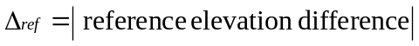


Averaged over all 9,187 point pairs, the relative vertical accuracy is 1.64 meters (other summary statistics are shown in Table X.4). The separation distance for points in a pair ranges from a few meters to more than 118 kilometers, with the average distance slightly greater than 7,000 meters and the median distance slightly less than 2,200 meters. Assessing relative accuracy across very long distances can have the effect of averaging random errors, thereby reducing the overall error. As stated, the pairs of reference points used here have a wide range of distances. At the lower end of the range is a subset of 109 point pairs that have a distance of 90 meters or less, which is about three times the nominal post spacing of the 1-arc-second NED layer. For this subset of 109 point pairs, the average relative vertical accuracy is 0.78 meters, so the very closely spaced points that were tested show a very high degree of relative accuracy.

One use of relative accuracy information is to estimate the uncertainty of slope calculated from raster elevation data such as the NED. Slope is often calculated from DEMs by assigning a slope value to each grid cell based on the maximum elevation change across its eight adjacent neighbors (a 3-by-3 window). To illustrate how relative vertical accuracy of a DEM affects slope accuracy, assume that an area of the land surface represented by a 3-by-3 window of elevation cells is flat. Thus, all nine elevation values should be the same and the derived slope should be zero. However, because of random errors inherent in elevation data, assume that the maximum elevation difference among the cells surrounding the center cell of the window is 1.64 meters. The minimum measurement baseline for slope within the window occurs when the maximum elevation difference is between two cells that are either immediately above and below, or left and right, of the center cell. In this case, if the post spacing of the DEM is 30 meters, the measurement baseline, or run, for slope calculation is 60 meters. Given the elevation difference (rise) of 1.64 meters and the baseline (run) of 60 meters, the calculated slope (rise/run x 100) is 2.73 percent (1.57 degrees). Thus, using the relative vertical accuracy figure of 1.64 meters results in an average accuracy of 2.73 percent for slope derived from the 1-arc-second NED layer. Figure X.11 depicts in graphic form how this estimate of slope accuracy is calculated.

One caveat to note about the accuracy assessment presented here is that even though the reference control point data set is large, the number of quadrangle-based USGS DEMs on which the points are located is relatively small. Approximately 11 percent of the source DEMs have at least one point located within. Thus, if users have a need for very specific accuracy information for the NED for a local area, a separate assessment should be done with suitable reference data just for that area. In addition, even though the reference control points are located broadly across the conterminous United States, the distribution of elevations and terrain conditions within the data set is not completely representative of the nation’s topography. This stands to reason, as surveyed benchmarks are generally located in open, accessible areas. Thus, high elevation, steep slope locations are under-represented in the reference data set. Despite this limitation with the reference data, the overall vertical accuracy reported here is useful for applications that need to factor in the quality of the NED over large areas. Also, prior to the accuracy assessment reported here, there were no actual measured absolute or relative error statistics for USGS DEMs as a whole, so for the first time the user community now has a useful quantitative estimate of quality. As the NED is continually upgraded based on new acquisitions of high-resolution data, the overall vertical accuracy should improve. In many cases, the source data sets will have comprehensive error reports supplied with them, and these statistics will be captured and preserved in the NED metadata.

References

Maune, D.F., Maitra, J.B., and McKay, E.J., 2001, Chapter 3—Accuracy standards, in Maune, D.F., ed., Digital Elevation Model Technologies and Applications: The DEM Users Manual: Bethesda, Maryland, American Society for Photogrammetry and Remote Sensing, p. 61–82.

National Digital Elevation Program, 2004, Guidelines for digital elevation data—Version 1, 93 p., URL: http://www.ndep.gov/NDEP_Elevation_Guidelines_Ver1_10May2004.pdf (last date accessed: 23 January 2006).

National Geodetic Survey, 2003, GPS on bench marks for GEOID03, URL: http://www.ngs.noaa.gov/GEOID/GPSonBM03/index.html (last date accessed: 26 April 2004).

Osborn, K., List, J., Gesch, D., Crowe, J., Merrill, G., Constance, E., Mauck, J., Lund, C., Caruso, V., and Kosovich, J., 2001, Chapter 4—National digital elevation program (NDEP), in Maune, D.F., ed., Digital Elevation Model Technologies and Applications: The DEM Users Manual: Bethesda, Maryland, American Society for Photogrammetry and Remote Sensing, p. 83–120.

Smith, D.A., and Roman, D.R., 2001, GEOID99 and G99SSS: 1-arc-minute geoid models for the United States: Journal of Geodesy, v. 75, no.9–10, p. 469–490.

U.S. Geological Survey, 1997, Part 1: General—Standards for digital elevation models, 11 p., URL: http://rockyweb.cr.usgs.gov/nmpstds/acrodocs/dem/1DEM0897.PDF (last date accessed: 20 January 2006)
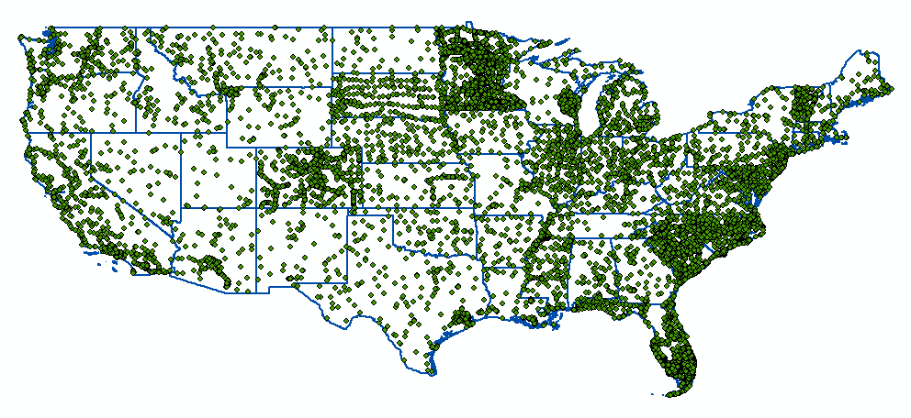
National Geodetic Survey GPS on bench marks dataset
13,305 geodetic control points

Figure X.9. Reference control point data set used for accuracy assessment of the NED.

Minimum | Maximum | Mean | Standard Deviation | RMSE | NMAS (90%) | NSSDA (95%)
–42.64 | 18.74 | –0.32 | 2.42 | 2.44 | 3.99 | 4.75

Table X.1. Error statistics (in meters) of the NED vs. 13,305 reference geodetic control points.

Version Date of the NED | RMSE | NMAS (90%) | NSSDA (95%)
September 1999 | 3.74 | 6.15 | 7.34
October 2001 | 3.13 | 5.15 | 6.14
October 2002 | 2.70 | 4.44 | 5.29
June 2003 | 2.44 | 3.99 | 4.75

Table X.2. Results of accuracy assessments of the NED vs. reference geodetic control points (all numbers are in meters).

Production Method | Number of Reference GPS Points | Minimum | Maximum | Mean | Standard Deviation | RMSE
GPM | 809 | –11.98 | 17.44 | 2.00 | 4.21 | 4.66
MP | 465 | –15.31 | 14.34 | 0.05 | 3.63 | 3.63
CTOG | 1,537 | –20.83 | 9.18 | –0.60 | 1.94 | 2.03
LT4X | 10,476 | –42.64 | 18.74 | –0.47 | 2.12 | 2.17

Table X.3. Error statistics (in meters) of the NED for areas derived from USGS 7.5-minute DEMs produced with each of the four primary production methods.
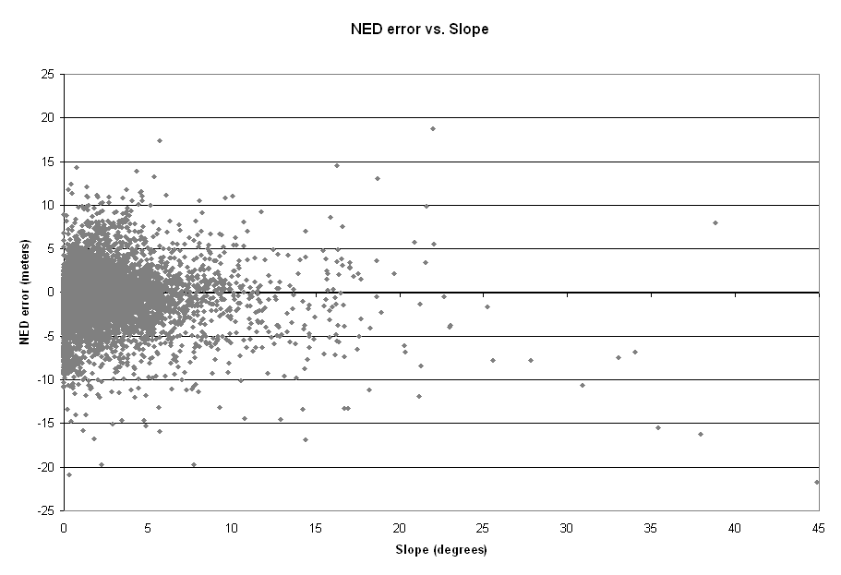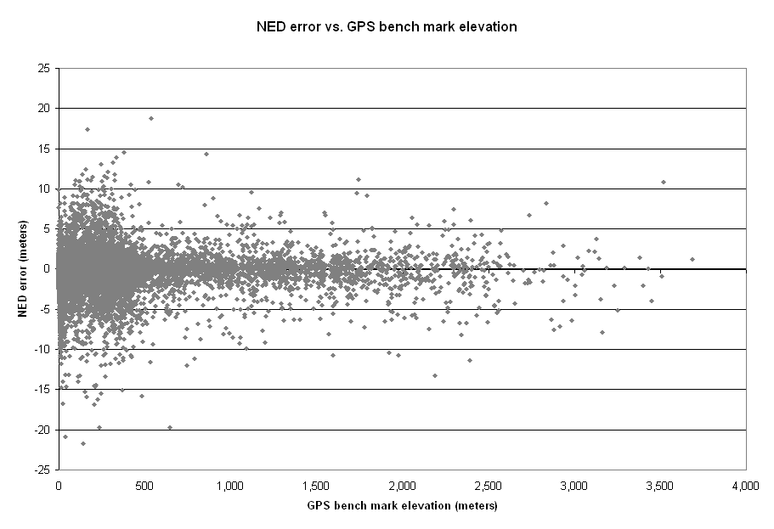
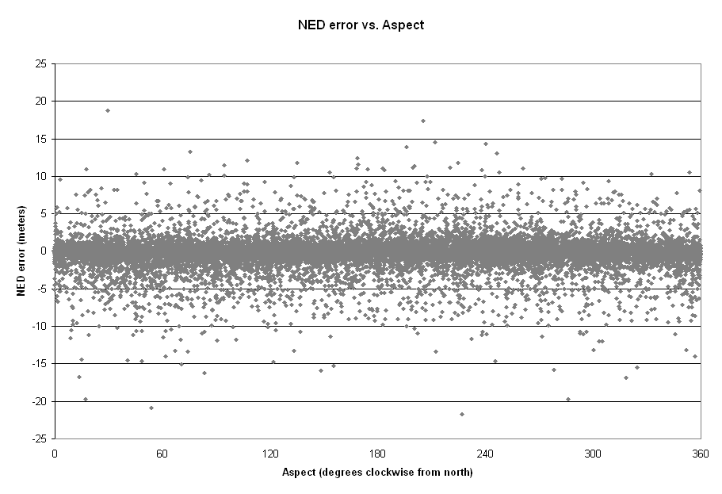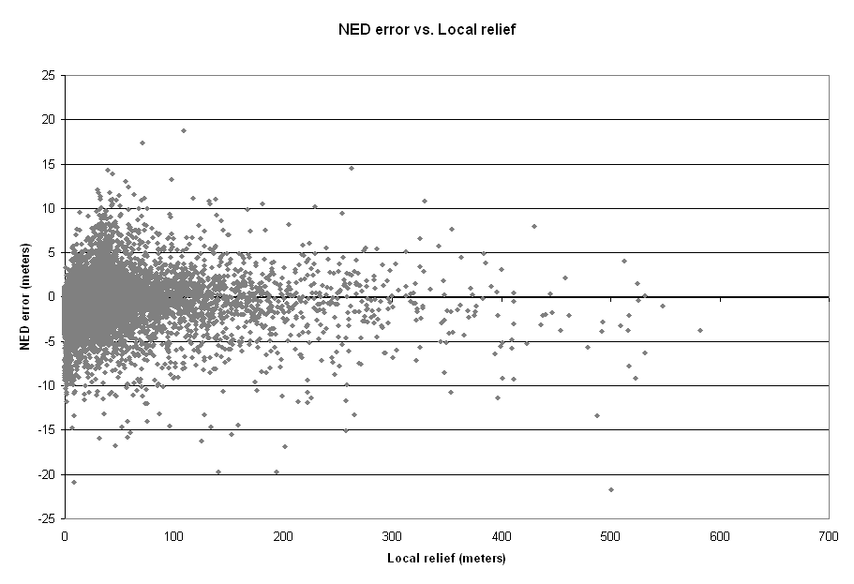

Figure X.10. NED errors (in meters) plotted against elevation (upper left), slope (upper right), aspect (lower left), and local relief (lower right).
Minimum | Maximum | Mean | Standard Deviation | Median
0.00 | 22.07 | 1.64 | 2.08 | 0.89

Table X.4. Relative vertical accuracy statistics for the NED based on 9,187 unique pairs of reference geodetic points (all numbers are in meters).
30 m
30 m
30 m
30 m
30 m
30 m
Minimum measurement baseline = 60 meters
3-by-3 window of raster elevation data:
A
B
Relative vertical accuracy (rise) between point A and point B = 1.64 meters
Baseline (run) = 60 meters
Percent slope = (rise/run) x 100
= (1.64/60) x 100
= 2.73%

Figure X.11. Calculation of accuracy of slope derived from 30-meter resolution elevation data. Assume that the area covered by the window is flat, and thus all elevation posts within the window should be the same. However, random error in the elevation data causes a difference of 1.64 meters in elevation between point A and point B. If the elevation data were free of error, a slope of zero would be assigned to the center cell, but in this case a slope of 2.73% is calculated, and it represents the slope accuracy.

