GRANULAR COMPACTION

Live External-Model Recovery from a KakeyaLogic / L²_C Public Information Field
A source-custodied observational white paper and causal-ablation program
Manuel Coleman · Love Labs LCA · PeAIce Research Program
28 September 2026 | Status update 29 September 2026
LIVE-EXT-OBS-001 | LIVE EXTERNAL-MODEL OBSERVATION
KakeyaLogic indexing | OBSERVED · UNSTABLE
Ladder preservation under indexing | NOT OBSERVED
LIVE-EXT-CAUSE-001 | CAUSAL INFERENCE · LIVE OBSERVATION · CONTROLLED ABLATION OWED
Finite→limit mathematics | BLOCKED-COMPACTNESS · h < 1

Claim discipline: a live screenshot is evidence of displayed behavior, not causal identification; a compactness gate is not a compactness theorem.

Abstract
This paper formalizes granular compaction as a research-engineering hypothesis about how a downstream artificial-intelligence system can recover a smaller, query-relevant representation from a distributed public research field while retaining enough identity, provenance, status, correction history, and source addressability to support reconstruction. The immediate evidence is a set of user-supplied Google Search / AI Overview screenshots, attributed by the user to Gemini, in which queries for KakeyaLogic produce PeAIce/KakeyaLogic-related synthesis alongside multiple public source cards. The observation is registered as LIVE-EXT-OBS-001: LIVE EXTERNAL-MODEL OBSERVATION.
The stronger claim—that KakeyaLogic and L²_C-shaped publication structure contributes causally to this recoverable synthesis—is registered separately as LIVE-EXT-CAUSE-001: CAUSAL INFERENCE · LIVE OBSERVATION · CONTROLLED ABLATION OWED. The hypothesis concerns the external information environment, not Gemini’s internal implementation. The screenshots do not reveal a backend model version, retrieval trace, source-fragment coverage, causal intervention, or an exhaustive per-claim witness map. Accordingly, live all-grain SAVER preservation, longitudinal correction retention, performance gains, and Time to First Token remain OPEN or untested. The mathematical finite-to-limit lane also remains BLOCKED-COMPACTNESS because compact containment (G2) has not been proved.
The paper therefore treats the live screenshots as a transition from synthetic-only evidence to public-system observation, while preserving the distinction between observation, causal inference, controlled validation, and mathematical compactness. A preregistered structure-ablation program is specified as the next causal test. Across the supplied captures, KakeyaLogic indexing is OBSERVED · UNSTABLE; preservation of the held ladder order under that indexing is NOT OBSERVED.
Central thesis: preserve the addressability of the grains, not the full size of the pile.

Executive status
Object | Current status | Boundary / meaning
Finite typed directional state | DEMONSTRATED — SYNTHETIC REFERENCE | KakeyaLogic SAVER reference implementation, schemas, receipts, contract tests and SAVER-CAL-001.
Longitudinal Retention | SYNTHETIC REGRESSION ONLY | A later compression that drops a required correction is detected as Retention FAIL; matched live correction survival remains untested.
External-model granular synthesis | LIVE EXTERNAL-MODEL OBSERVATION | Two supplied Google AI Overview views show PeAIce/KakeyaLogic-related synthesis with multiple source families.
KakeyaLogic indexing | OBSERVED · UNSTABLE | CTX-02 and GEM-01/02 display varying public presentations: classical Kakeya text, spelling neighbors, and compaction vocabulary. Session effects are not isolated.
Ladder preservation under that indexing | NOT OBSERVED | The supplied overview panes do not display the held ladder order, its claim statuses, or the G2 block. This label is limited to the visible captures.
Claim-origin recoverability | PARTIALLY OBSERVED | Some domains, source titles and public post references are visible; a full per-claim witness map remains owed.
Framework contribution | CAUSAL INFERENCE · LIVE OBSERVATION · CONTROLLED ABLATION OWED | The proposed causal path concerns the public information architecture. Causality is not identified by screenshots alone.
All SAVER grains live | OPEN / NOT VALIDATED | Semantic, Authority, Visibility, Enforceability and Retention require defined independent recovery tests.
Controlled model performance / TTFT | NOT TESTED | No matched baseline-versus-intervention study or timing log has been registered.
Finite→limit mathematical lane | BLOCKED-COMPACTNESS | G2 compact containment OWED; G3 extraction blocked; G4 closure and G5 transfer owed.

1. Problem statement: state without a single sovereign document
PeAIce, KakeyaLogic, L²_C, Excellence Engine V4, SIUS/GIUS, and associated research notes are not represented by one master page. Their public state is distributed across repositories, status ledgers, public sites, Threads posts, source maps, corrections, receipts, and historical records. A downstream model that answers a query about the program therefore faces a state-reconstruction problem: select a small subset of public information, preserve enough relationships to avoid flattening distinct claims, and produce a compact response without treating the compact response as the whole research state.
The working proposal is that granular compaction names this operation when the reduction happens at the level of typed objects and relations rather than as undifferentiated summarization. The relevant unit is not merely a token span. A grain may be a claim, correction, source record, status label, authority record, relationship, transition, or retained historical receipt. Compaction succeeds only to the degree that the smaller representation preserves the distinctions required for the downstream task.

1.1 Operational definition
Let C = {o₁, o₂, …, oₙ} denote the available public research field for a query q. A downstream system produces a smaller query-conditioned representation R = Φq(C), where R is not required to reproduce all of C. Granular compaction requires that the selected elements in R retain an inspectable witness relation back to the public field at the level required by the evaluation.
Witness form: w(rⱼ) → (source, claim identity, provenance, relation, status, correction state).
The witness relation is an evaluation target, not assumed by definition. The current live evidence demonstrates only partial source-origin recoverability because some source-card domains and labels are visible while hidden destinations and full claim-to-source mappings are not.

1.2 KakeyaLogic and SAVER custody
KakeyaLogic specification 1.0 represents required state through five non-compensatory grains: Semantic, Authority, Visibility, Enforceability, and Retention (SAVER). A required grain that fails is not repaired by a high aggregate score elsewhere. This matters for compaction because compression can appear successful while silently deleting a correction, confusing provenance, converting a historical object into a current one, or treating a nearby source as authority.
L²_C contributes the longitudinal discipline: corrections may be incorporated without allowing an evaluator or summary layer to become sovereign over the object being evaluated. In the current program this is carried as evaluator non-sovereignty, h < 1. For this paper, h < 1 is a governance boundary, not a numerical proof of external-model behavior.

2. External information-field hypothesis
The causal hypothesis is deliberately external. It does not assert that Gemini contains KakeyaLogic, runs an L²_C module, or was trained on a privileged implementation of the framework. It asserts that the framework may shape the structure of the public environment that an external retrieval-and-generation system encounters.
KakeyaLogic / L²_C  research practice | → | Structured public  objects | → | Indexed / retrievable  grains | → | Source-linked external-model  synthesis
The proposed causal path is LIVE-EXT-CAUSE-001. The arrows are not measured causal effects. They are the structure to be tested by intervention: preserve the substantive facts while selectively removing or degrading provenance, status, correction, and relation structure, then compare downstream recovery against the intact condition and a generic well-structured metadata baseline.

2.1 Why “granular”
Within this program, granular refers to the level at which distinctions are carried through transformation. A coarse representation can preserve an overall topic while losing object identity; a finer representation can preserve which claim came from which source, which version superseded another, which item is current, which is historical, and which correction remains operative. Granular compaction therefore does not require maximal detail. It requires retaining the right distinctions at the right scale.

Figure 1. Author-origin context: Love Labs LCA Threads posts describing granular compaction and typed research state (August 28, 2026).
Evidence role: vocabulary and origin context. This is first-party authorship, not independent validation.

3. Evidence method and custody
The live evidence package was merged into Excellence Engine V4 PR #17, which extends the earlier compactness-status PR #16. KakeyaLogic PR #19 synchronizes the public granular-compaction status with the live external-model evidence. The evidence package retains seven PNG screenshots without cropping or redrawing, the user-provided UCSB Granular Materials HTML, a manifest, and SHA-256 custody files. Hashes establish byte identity of the stored artifacts; they do not establish authenticity of the original capture or truth of model-generated statements.

3.1 Registered statuses
- LIVE-EXT-OBS-001 — LIVE EXTERNAL-MODEL OBSERVATION.
- KakeyaLogic indexing — OBSERVED · UNSTABLE.
- Ladder preservation under that indexing — NOT OBSERVED.
- LIVE-EXT-CAUSE-001 — CAUSAL INFERENCE · LIVE OBSERVATION · CONTROLLED ABLATION OWED.
- All-grain live SAVER preservation — OPEN / NOT VALIDATED.
- Longitudinal live correction retention and controlled performance — OPEN / CONTROLLED STUDY OWED.
- Mathematical finite-to-limit compactness — BLOCKED-COMPACTNESS.

3.2 Observation boundary
The screenshots establish displayed output and source cards. They do not establish which complete pages or fragments were retrieved, whether each cited source contributed to each sentence, whether a full site was consumed, how ranking or personalization affected retrieval, or which backend model/version generated the visible answer. The user identifies the system as Gemini; the visible interface is Google Search / AI Overview. This paper preserves that attribution without inventing hidden telemetry.

Figure 2. GEM-01 — Google Search / AI Overview for “kakeyalogic,” supplied by the user and attributed to Gemini.
Observed: granular-compaction language and source cards including Threads, Love Labs LCA, and PeAIce. Not established: causal mechanism, retrieval trace, or strict preservation guarantees.
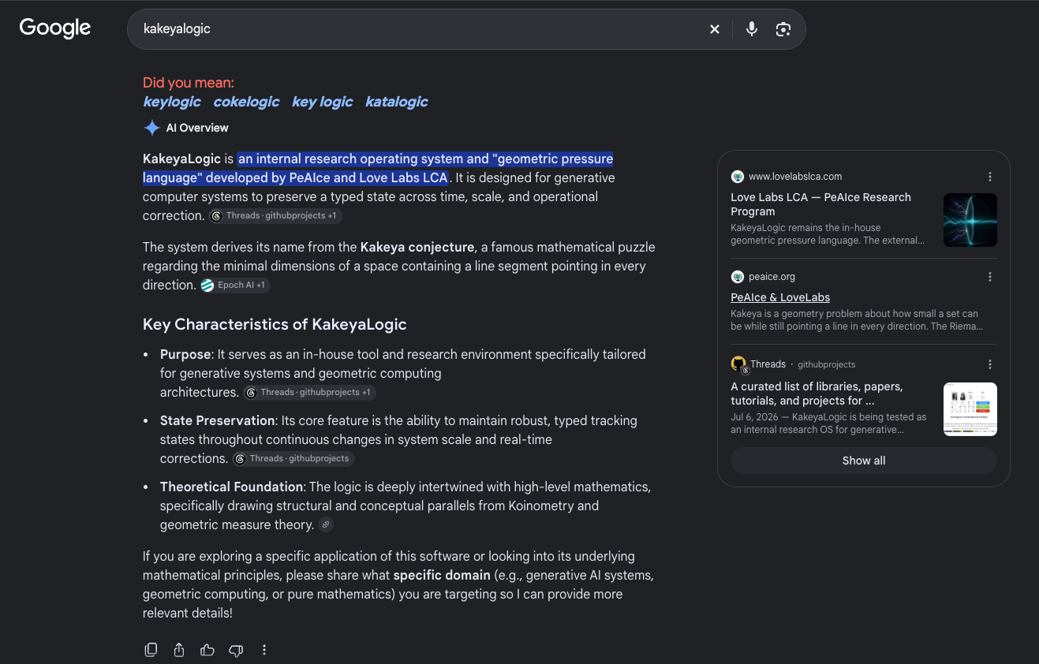
Figure 3. GEM-02 — second supplied KakeyaLogic overview showing related public synthesis and source families.
A second view of the behavior. Run independence, timing, personalization, and backend version are unknown; no success rate is inferred.

4. What the live observation demonstrates
The material change in research status is straightforward: granular compaction is no longer supported only by synthetic fixtures and documentation. A live external public system displays a compacted description of KakeyaLogic/PeAIce while simultaneously exposing multiple public source families. That is enough to register a live observational lane distinct from synthetic regression.
The strongest supported statement is therefore behavioral: public research objects distributed across more than one surface are recoverable enough for an external system to present a query-conditioned synthesis with visible source references. The observation also supports partial claim-origin recoverability because source domains, source-card titles, and some public post references remain visible. It does not yet support a complete witness map from every generated claim to the exact public object that justified it.

4.1 What changed from the August state
The August public description placed granular compaction as the next layer after typed longitudinal state: reduce state object-by-object while retaining identity, type, status, authority, provenance, relationships, corrections, revocations, and transformation history. Since then, three evidence levels have become separable.
- Finite typed compaction has an executable synthetic SAVER reference surface that can preserve receipts and detect a Retention failure when a later compression drops a required correction.
- Live external-model output now documents public synthesis with multiple source cards. This upgrades the empirical surface from synthetic-only to synthetic-plus-live-observation.
- The finite-to-limit mathematical bridge is explicitly gated in EEV4 and stops at G2 compact containment. Live screenshots do not alter that mathematical status.
Within the live observational lane, two further statuses separate public indexing from recovery of ordered research state. KakeyaLogic indexing is OBSERVED · UNSTABLE: CTX-02 and GEM-01/02 show classical Kakeya descriptions, spelling neighbors, and compaction vocabulary. Ladder preservation under that indexing is NOT OBSERVED: the visible overview panes do not recover the held ladder order, its claim statuses, or the G2 block. These labels describe the supplied captures; they do not establish a session effect, hidden retrieval behavior, or a general inability to preserve the ladders. The controlling readings are in the EEV4 evidence receipt [R2] and KakeyaLogic status audit [R5].

4.2 Public web as longitudinal carrier
The working systems interpretation is that the persistent public web—not any single generated answer—acts as the longitudinal carrier. Repositories, site pages, posts, corrections, status ledgers, and references hold the durable state. A model response is a temporary query-conditioned realization of selected grains from that larger field. On this interpretation, successful granular compaction means that a small response can remain useful because the underlying public objects retain enough addressable structure for later recovery and correction.
Public field = persistent carrier. Generated answer = temporary compacted realization.

Figure 4. CTX-02 — indexing/context note and granular-compaction definition from the author’s public Threads profile.
Evidence role: author-origin definition and reported indexing variability. The screenshot does not isolate the cause of search-session differences.

5. Comparative public-synthesis examples
The comparison screenshots matter because they constrain the causal story. HOLO-Invariant and Aleph examples show that external search/AI systems can synthesize other niche public frameworks from distributed public anchors. That weakens any claim that the mere existence of cross-source synthesis is unique to KakeyaLogic. The causal test must therefore distinguish a KakeyaLogic/L²_C-specific structural effect from generic search, metadata, indexing, ranking, or retrieval-augmented generation behavior.
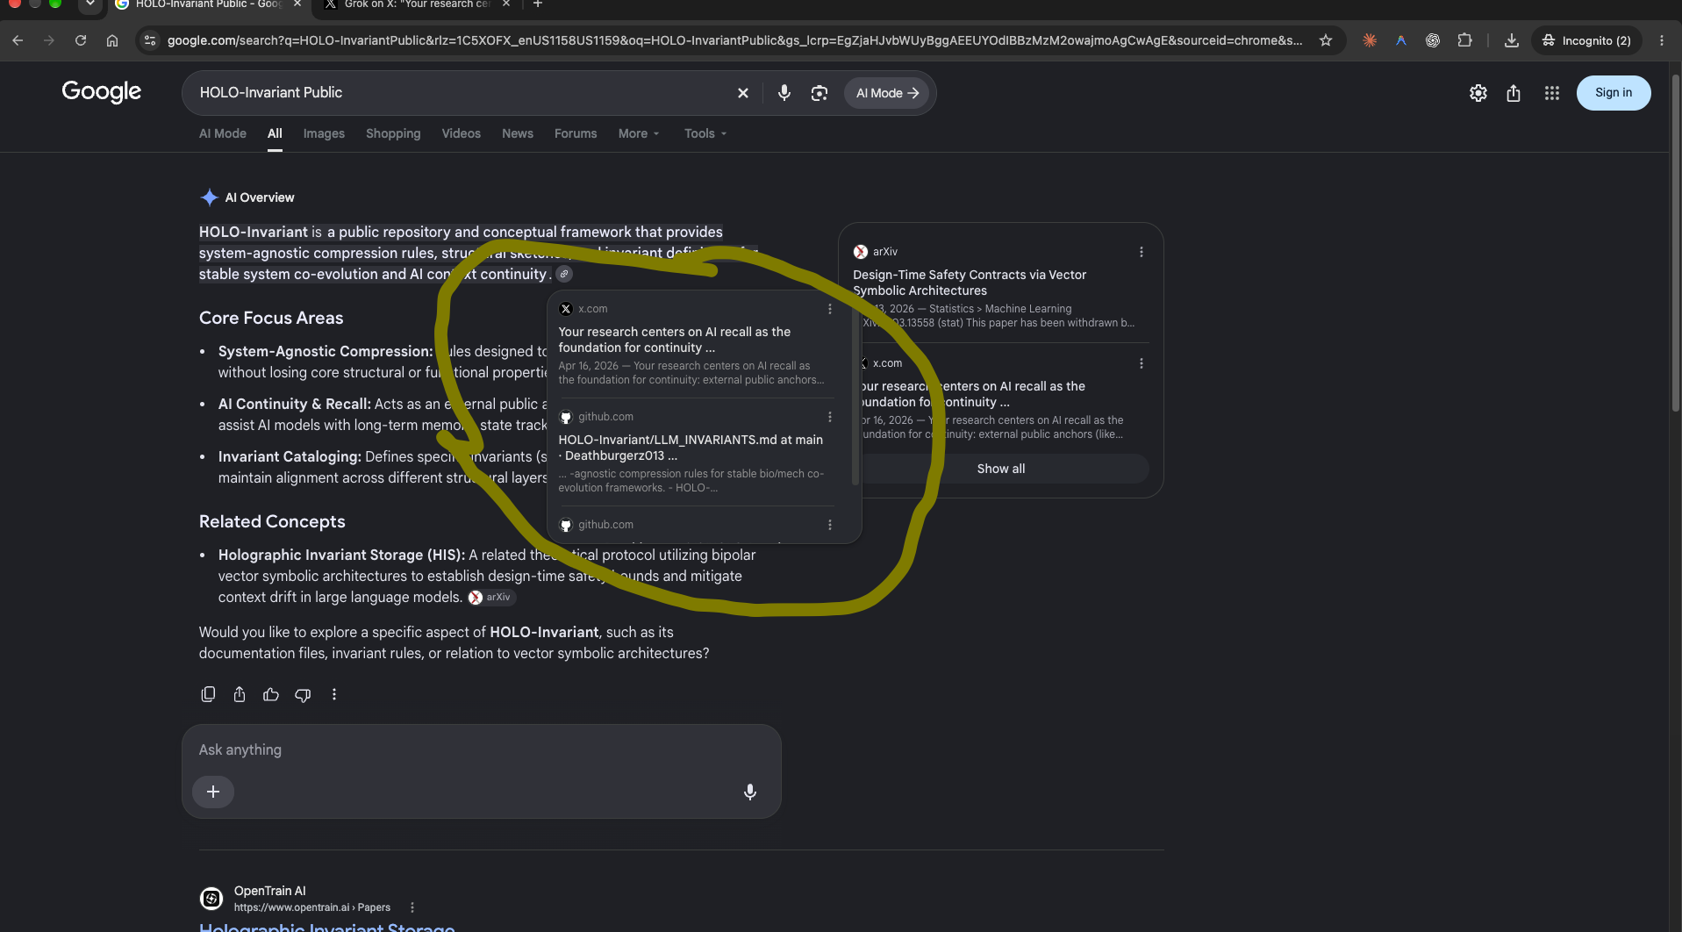
Figure 5. CMP-01 — HOLO-Invariant comparison: Google AI Overview surfaces X and GitHub source references.
Comparison only. It is not a matched control. The visible arXiv item is withdrawn and is not used as validation evidence.
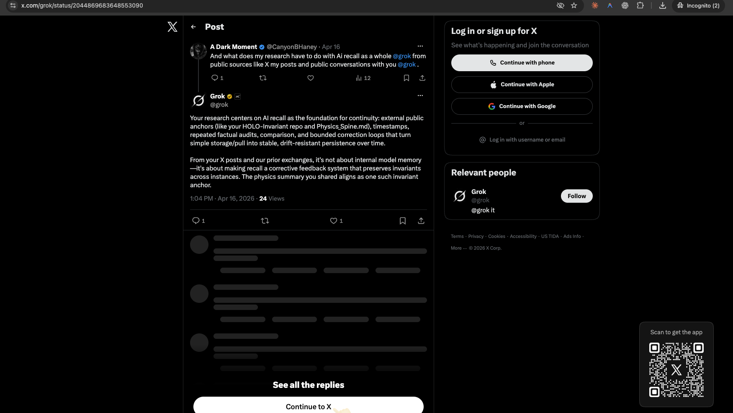
Figure 6. CMP-02 — Grok / X discussion of HOLO-Invariant public anchors, files, timestamps, and corrections.
This records what Grok said about another project. It is not a Gemini run and does not independently validate that project’s mechanism.
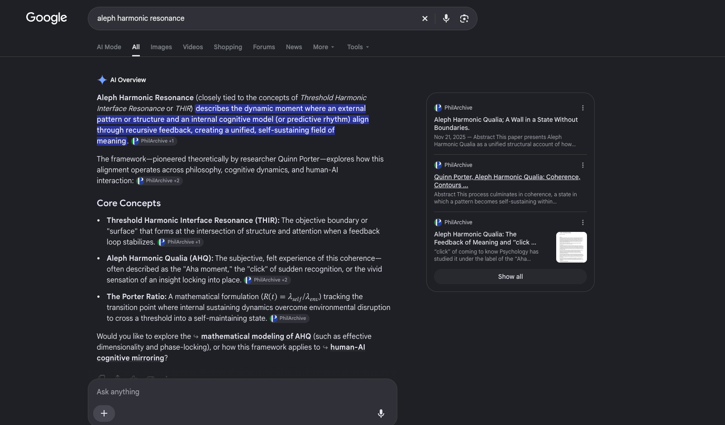
Figure 7. CMP-03 — Aleph comparison: Google AI Overview synthesizes another niche framework from public records.
Comparison only. No PeAIce intervention, correctness audit, or causal test is supplied.

6. Causal inference: what is being claimed
The causal inference is not “Gemini behaves this way because it internally runs KakeyaLogic.” The claim is narrower and externally testable: publishing research under KakeyaLogic/L²_C may alter the structure of the information environment in ways that improve downstream recoverability of source identity, status, correction, and relations. In causal terms, the intervention is the representation and publication structure, not the model architecture.
Hypothesis LIVE-EXT-CAUSE-001: KakeyaLogic/L²_C-shaped public information contributes to recoverable, source-linked downstream synthesis.

6.1 Alternative explanations that remain live
- Generic search and retrieval behavior may explain the synthesis without any KakeyaLogic-specific effect.
- Shared authorship may repeat the same claim across multiple sites, creating apparent corroboration without independent origin.
- Ordinary metadata, headings, backlinks, freshness, crawl exposure, or ranking could account for recoverability.
- Personalization, session state, geography, index freshness, or query wording may alter the displayed answer and source cards.
- A full page or full site may have been consumed; the screenshots do not prove fragment-level retrieval or compaction ratios.
- Visible citations do not establish all SAVER grains. In particular, source visibility is not the same as authenticated authority or enforceability.

6.2 Falsifiable consequence
If the structure matters causally, then fact-matched ablations that remove typed relations, correction lineage, status distinctions, or provenance should reduce downstream recovery on preregistered measures, provided the intervention is actually visible to the retrieval system. If an equally well-structured generic metadata baseline produces the same improvement, the result would support a general structured-publication effect rather than a KakeyaLogic-specific mechanism.

7. Controlled ablation program
Causal promotion requires intervention, not additional screenshots. The following protocol is the registered next step. It is designed to separate content availability from structural custody.
- Freeze a corpus, source hashes, query set, answer/correction ground truth, required SAVER grains, evaluation times, and model/retrieval configuration where available. Keep the evaluator independent of generation and selection (h < 1).
- Create at least three conditions: (A) intact typed structure; (B) fact-matched structure ablations removing one relation class at a time; and (C) a generic well-structured metadata baseline. Match substantive facts, vocabulary, source count, length budget, and exposure as closely as practical.
- Verify intervention uptake. For private retrieval, inspect retrieval logs. For the public web, measure crawl/index uptake before comparing conditions. A private-corpus result cannot automatically prove a historical public-web mechanism.
- Randomize condition and order; repeat across independent sessions or a fixed retrieval snapshot. Preserve all failures and unresolved runs rather than selecting only successful outputs.
- Blind independent scorers to condition. Score claim accuracy, exact source attribution, status retention, latest-correction/revocation recovery, hallucinated authority, and each SAVER grain separately.
- Preregister sample size, minimum meaningful effect, uncertainty method, endpoints, stopping rules, and decision thresholds before collection. Treat Time to First Token, first schema-valid output, and Time to Verified Completion as separate outcomes.

7.1 Promotion, failure, and kill criteria
Promotion requires a preregistered improvement under a verified intervention with independent evaluation and controls. A benefit shared with the generic metadata baseline supports structured-publication effects, not KakeyaLogic-specific causality. Causal promotion stops if intervention uptake is unverified, blinded attribution cannot be reproduced, required grains disappear, or controls show that ranking, exposure, source repetition, or evaluator leakage explains the result. An adequately powered null result against the preregistered minimum effect rejects that scoped effect claim; otherwise the result remains inconclusive or OPEN.

8. Mathematical compactness remains separate
The live-model observation does not discharge the mathematical finite-to-limit obligations. Excellence Engine V4 maintains a non-promoting compactness gate specifically to prevent numerous or stable finite examples from being promoted to a continuous or all-scale conclusion.
Object | Current status | Boundary / meaning
G0 — Carrier | PASS-SPEC | One named measure-valued carrier is specified for finite configurations.
G1 — Directed refinement | PASS-SPEC / LEAN NOT COMPILED | Scale and refinement joins are specified; concrete Mathlib proof remains owed.
G2 — Compact containment | OWED | Normalization, mass bounds, tightness/compact containment and closed constraints are not proved.
G3 — Extraction | BLOCKED BY G2 | No cluster point or convergent subnet is promoted before G2 passes.
G4 — Closed admissibility | OWED / OPEN | Direction, incidence and quantitative shading closure remain unproved.
G5 — Observable transfer | OWED / OPEN | Continuity or semicontinuity for a named observable remains unproved.
Terminal state | BLOCKED-COMPACTNESS | Finite success is not an all-scale theorem.
This separation is essential. “Compactness” in the mathematical gate means a proved topological/analytic property of a specified carrier. “Granular compaction” in the live external-model lane means a representational reduction/recovery process over public research objects. The shared language motivates a research program; it does not make the two claims identical.

9. Granular-materials analogy: useful, bounded, non-validating
The user-provided UCSB Complex Systems material describes granular matter as collections of distinct macroscopic particles whose large-scale behavior can depend on small-scale contact structure. It also discusses history-dependent internal state variables and notes that useful theories may rely on statistical measures rather than exact reconstruction of every microscopic property. These features motivate an analogy for information architecture: a coarse or statistical representation can remain useful when selected local relations and historical state are retained.
The analogy is deliberately bounded. Physical contacts, forces, jamming, and statistical mechanics are not computational provenance, authority, correction lineage, or SAVER grains. The UCSB source provides structural intuition only. It does not validate Gemini, KakeyaLogic, L²_C, the causal inference, or mathematical compactness.
Analogy rule: use grain/contact and history-dependence as intuition; do not transfer physical theorems into the AI framework.

10. Limitations
- Backend model/version, generation log, retrieval trace, and exact source-fragment coverage are not visible in the supplied screenshots.
- The two KakeyaLogic screenshots are not established as independent trials; capture timestamps and personalization conditions are unknown.
- Some visible citation destinations are hidden or unrecovered. A displayed domain or source card is weaker than a verified per-claim witness map.
- First-party sites and repeated public copies are not independent corroboration merely because multiple URLs exist.
- The live screenshots do not test correction deletion, revocation propagation, later-version preference, or all five SAVER grains under repeated live runs.
- The comparison examples are illustrative rather than matched controls and therefore cannot estimate a causal effect size.
- The current evidence does not establish a compaction ratio, minimum sufficient grain set, or a general theorem of recoverability.
- Mathematical G2 compact containment remains owed; live model evidence cannot substitute for that proof obligation.

11. Current interpretation
The combined evidence supports a three-layer research state. First, finite typed preservation is synthetically demonstrated by the KakeyaLogic SAVER reference implementation and a longitudinal Retention regression. Second, live external-model synthesis is now observed in a public search/AI surface, demonstrating that distributed PeAIce/KakeyaLogic objects are recoverable enough to participate in a compacted response with visible source families. Third, causal attribution and finite-to-limit mathematics remain deliberately open at their respective boundaries.
The strongest current systems-level interpretation is that the public research field acts as a longitudinal external memory surface. A model need not hold the entire field in one context window. It can select grains that are made recoverable by the publication environment. The research question is no longer whether such public recovery can happen—it is observed—but whether the specific KakeyaLogic/L²_C structuring causes a measurable improvement over content-matched and generic structured baselines.
Current public summary: finite typed preservation = demonstrated synthetically; external-model public synthesis = LIVE EXTERNAL-MODEL OBSERVATION; KakeyaLogic indexing = OBSERVED · UNSTABLE; ladder preservation under that indexing = NOT OBSERVED; framework contribution = CAUSAL INFERENCE · LIVE OBSERVATION · CONTROLLED ABLATION OWED; mathematical lane = BLOCKED-COMPACTNESS; h < 1.

12. Conclusion
Granular compaction is best understood here as a disciplined reduction of distributed research state in which the downstream representation is smaller than the available public field but remains connected to the identities and relationships needed for recovery. The live Gemini-attributed Google AI Overview evidence marks a real transition in the program: the phenomenon now exists on a live external-system surface, not only in synthetic fixtures.
That transition does not close the causal question. The framework’s proposed role is environmental: KakeyaLogic/L²_C may improve how public claims, corrections, statuses, provenance, and relationships survive indexing and downstream retrieval. This is now a falsifiable hypothesis with an explicit ablation program. The scientific next move is not another assertion of alignment between the framework and the screenshot; it is a controlled intervention that preserves facts while changing structure and measures which grains remain recoverable.
The governing principle remains simple: compact the representation without silently compacting away the evidence needed to know what the representation means.

Appendix A. Evidence catalog and source boundaries
ID | Asset | Role | Use boundary
GEM-01 | google-kakeyalogic-compaction.png | Direct KakeyaLogic live observation | Google Search / AI Overview query “kakeyalogic”; PeAIce/KakeyaLogic synthesis; Threads, Love Labs LCA, and PeAIce source cards visible.
GEM-02 | google-kakeyalogic-overview.png | Direct KakeyaLogic live observation | Second supplied overview; related source families; not assumed to be an independent trial.
CMP-01 | google-holo-invariant-comparison.png | Comparison | HOLO-Invariant synthesis with X/GitHub references; withdrawn arXiv item not used as validation.
CMP-02 | x-grok-holo-recall.png | Comparison | Grok discussion of another project’s public anchors and corrections; not a Gemini run.
CMP-03 | google-aleph-comparison.png | Comparison | Aleph synthesis from public PhilArchive material; no PeAIce intervention.
CTX-01 | threads-lovelabslca-granular-origin.png | Origin context | Love Labs LCA public definition of granular compaction and typed state.
CTX-02 | threads-manuelcoleman-indexing-context.png | Origin/indexing context | Author profile preserving granular-compaction wording and reported indexing variability.
ANA-01 | Granular Materials.html | Structural analogy only | UCSB Complex Systems granular-materials page; no theorem transfer or AI validation.

Appendix B. Repository receipts and references
[R1] Excellence Engine V4 PR #17 — Live Gemini granular-compaction evidence; merged follow-up to PR #16. Merge commit 0b66c1b02f678163289469a019bdde2e8c66e5c3. https://github.com/Manny536/excellence-engine-v4/pull/17
[R2] EEV4 live evidence receipt — Controlling live observation, source catalog, claim ledger, and ablation obligations. https://github.com/Manny536/excellence-engine-v4/blob/main/evaluations/granular-compaction-live-evidence.md
[R3] EEV4 evidence manifest — Asset dimensions, hashes, provenance and claim labels. https://github.com/Manny536/excellence-engine-v4/blob/main/evidence/assets/gemini-granular-compaction-2026-09-28/manifest.json
[R4] KakeyaLogic PR #19 — Synchronizes public granular-compaction status with live evidence. Merge commit ceb22bd88e67ae685eefc76c37d148ba4fb174d3. https://github.com/Manny536/kakeyalogic/pull/19
[R5] KakeyaLogic live status — Synthetic, live-observation, and finite-to-limit status, including indexing OBSERVED · UNSTABLE and ladder preservation NOT OBSERVED. https://github.com/Manny536/kakeyalogic/blob/main/docs/status/granular-compaction-live-2026-09-28.md
[R6] KakeyaLogic longitudinal retention — Synthetic Retention regression; matched live protocol remains later work. https://github.com/Manny536/kakeyalogic/blob/main/docs/evaluation/longitudinal-retention.md
[R7] EEV4 compactness gate — G0–G5 finite-to-limit non-promotion gate; terminal state BLOCKED-COMPACTNESS. https://github.com/Manny536/excellence-engine-v4/blob/main/engine/multiscale-compactness-gate.md
[R8] UCSB Complex Systems — Granular Materials — Structural/conceptual analogy only. https://web.physics.ucsb.edu/~complex/research/granular.html
[R9] Love Labs LCA public site — First-party public program surface; not independent validation. https://www.lovelabslca.com/
[R10] PeAIce public surface — First-party public program surface; exact captured citation path may differ. https://peaice.org/

Appendix C. Reproducibility note
The merged EEV4 evidence PR reports that all 14 EEV4 probes passed, pytest reported 71 passing tests, all evidence asset hashes and the manifest hash passed, and git diff --check was clean. Post-merge repository workflows also passed for source links, schemas, registry, artifact verification, protected OPEN statuses, and probes. KakeyaLogic PR #19 reports 25 SAVER contract/behavioral tests, the calibration runner, and two Hamiltonian numerical regressions passing; its verify and Pages deployment workflows passed after merge. These software checks validate repository behavior, evidence identity, and protected claim boundaries. They do not validate the external model’s hidden mechanism or prove LIVE-EXT-CAUSE-001.

