Posted: May 15, 2017

Causal Comb Filters for Removal of the Non-Stationary and Non-Sinusoidal Transcranial Alternating Current Stimulation Artifact

Robert Guggenberger1,* and N.N.1

1Department for Translational Neurosurgery, University Hospital T bingen

*Corresponding author: robert.guggenberger@posteo.eu

May 15, 2017

Abstract Your abstract.

# Introduction

The combination of transcranial alternating current stimulation (tACS) and electroencephalogram (EEG) has been explored in several recent studies. While the analysis of EEG before or after stimulation posits limited technical challenges, the EEG recording during stimulation is heavily a ected by the stimulation artifact. This has been linked to the spatial distribution, the nonstationary amplitude and the distorted sinusoidality of the artifact.

## Spatial Covariance

It has been argued that unregularized spatial lters might be able to remove the stimulation artifact (Neuling et al., 2017). But if only few channels are recorded, the estimation of the spatial covariance can be insu cient. In the single-channel-case, spatial lters are impossible. Additionally, it has been reported that the spatial covariance is itself not stationary and that the artifact encompasses a large spatial subspace (Noury et al., 2016).

## Non-Stationary Amplitude Modulation

Consider the assumption that the artifact is stationary and superpositioned on the physiological signal. Then, modulations in the amplitude of the recorded EEG-signal must be caused by changes in the underlying physiology. This would be the case, even if frequency and phase are matched to the stimulation signal. Approaches assuming such stationarity of the stimulation artifact have been used e.g. by Pogosyan et al. (2009).

Yet, practical experience suggests that the stimulation artifact is actually not stationary (see gure 1a). As a recording can exhibit an amplitude modulation of the stimulation artifact when the clocks of stimulation and recording device are not synchronized, this has been suggested as a cause for amplitude modulations. It has also been suggested that the closed-loop current control process within the stimulator might be a further source of amplitude modulation (Neuling et al., 2017). Additionally, the amplitude has been reported to by modulated by heart-beat and respiration (Noury et al., 2016). Event-related modulation of skin impedance can also a ect the scalp conductance at stimulation electrodes.

In conclusion, recovering the true signal from the artifacted recording is technically challenging primarily because of such non-stationarities in the artifacts amplitude.

## Artifact Distortion

Ideally, the stimulation arti ct of tACS resembles a sinusoid. But practical experience suggests that the signal is often distorted to various degrees. Figure 1 shows examples of distortion and saturation in two recordings of tACS. The gray traces indicate nine invididual artifact periods, while the red trace indicates their average. In gure 1b, note the periodic, yet non-sinusoidal waveform. In gure 1c, note the saturation.

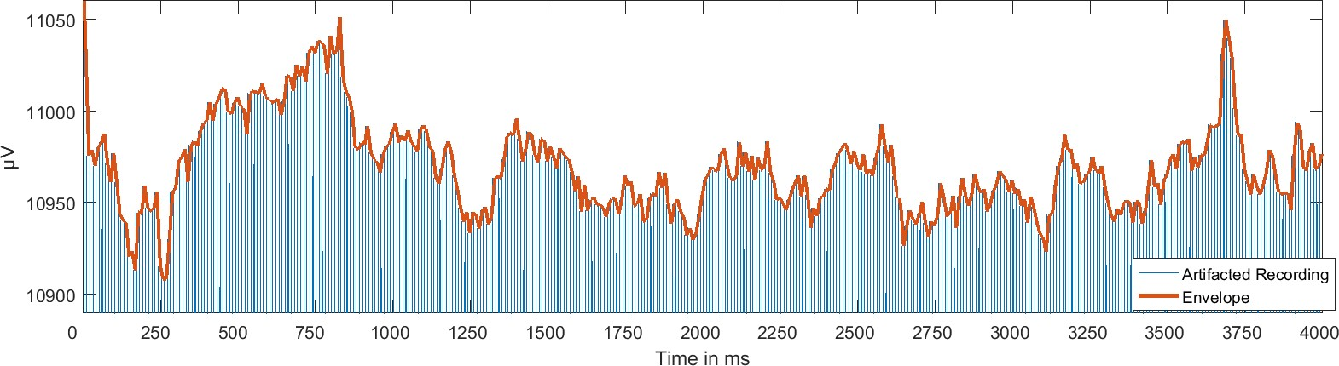

1. Non-Stationary Amplitude Modulation

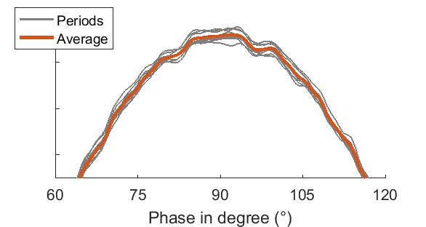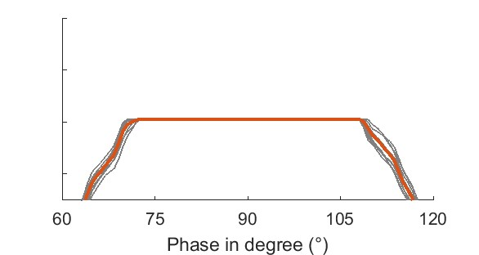

1. Distortion (c) Saturation

Figure 1: Exemplary Recordings highlight Distortion and Non-Stationarity

The temporally and spatially uneven impedance distribution has been suggested as cause of distortion. Additionally, non-linearites in the ampli er slew rate can distort the shape when the signal is close to the saturation threshold. But a major source of possible distortion can be ampli er saturation, i.e. the stimulation artifact exhibiting an amplitude to large for the dynamic range of the ampli er, causing the signal to be cut o . As information is lost, it is impossible to recover signals during periods of saturation.

## Computational Demands

Methods based on adaptive template construction and temporal principal component analysis (tPCA) (Niazy et al., 2005) have been explored for removal of non-stationary and misshaped tACS artifacts (Helfrich et al., 2014). Consider that the process of template construction, the estimation of accurate weights for removal by template subtraction and the suqsequent removal of residual artifacts using tPCA is computationally cumbersome. Additionally, it often requires o line analysis supported by visual inspection. Such a multi-staged template-approach is therefore of limited utility for on-line artifact removal, especially in a single-channel case.

## Motivation

We were interested in development of a computationally fast approach, feasible for online artifact removal in a single channel, and usable in embedded systems with limited computational power. The approach was required to account for the dynamical modulation of the artifact amplitude, and the possibility of non-sinusoidal distortion and saturation. Nonetheless, we wanted to develop an approach for o ine-analysis, to be usable for already recorded datasets and for the purpose of evaluation and comparison.

# Approach

The main idea is that at any given time point *t*, the recorded signal *r*(*t*) is a linear superposition of a neurophysiological signal *n*(*t*), the stimulation artifact *a*(*t*) and a white noise term *e*(*t*). The task is to recover *n*(*t*) by estimating *a*ˆ(*t*) and *e*(*t*) and subtracting from *r*(*t*).

|  |  |
| --- | --- |
| *r*(*t*) = *n*(*t*)+*a*(*t*)+*ϵ*(*t*) | (1) |
| *n*(*t*) = *r*(*t*)−*a*ˆ−*ϵ*(*t*) | (2) |

## Periodic Estimation

Assume that the tACS artifact were non-sinusoidal, but stationary and periodic. At the same time, assume that neurophysiological signals *n* and noise *ϵ* were absent. Then, we could estimate the amplitude of *a* at any time-point *t* by using the signal *r* recorded from any time-point, as long as this time-point is an integer multiple of the artifacts period length *p* earlier (3). Subtraction of a delayed version of the signal is also known as comb lter. Please note that for discretely sampled signals, this approach natively supports only frequencies which are integer divisibles of the sampling frequency. If this is not the case, upsampling the recorded signals to an appropriate sampling rate, comb ltering, and down ltering is a viable approach.

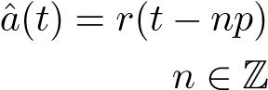(3)

(4)

2.1.1 Uniform Comb Filter

Consider that the noise term *ϵ* is still superpositioned on *r*. If the noise term were white, and because the expectation of white noise ⟨*ϵ*⟩ converges asymptotically to zero with increased sample size, an approach to estimate a bias-free artifact amplitude would be to average across as many earlier periods as possible (5). Subsequently, this estimate can be used to remove the artifact from *r*. In real applications, stimulation duration is limited and computational constraints exist. This is re ected by the fact that we have to use a nite number for *N*.

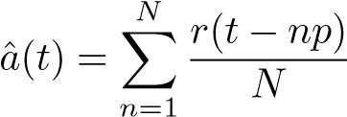 (5)

2.1.2 Superposition of Moving Averages

Please note that averaging across neighbouring periods *M* (6) has been suggested before and termed superposition of moving averages (SMA) by Kohli and Casson (2015).

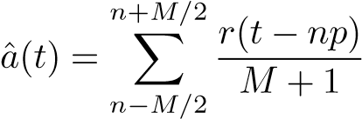 (6)

Consider that the approach using only past values (5) returns a causal lter. Applied online, a causal lter would be able to remove the artifact without the delay of (*Mp*)*/*2 necessary for SMA. Furthermore, SMA is well-de ned only for even *M*. This motivates the exploration of causal lters for artifact removal.

## Temporal Weighting

Consider that the amplitude of the artifact has been described to be non-stationary and dynamically modulated (Noury et al., 2016; Neuling et al., 2017). Although it has been suggested that there are event-dependent components of the amplitude modulation (e.g. by heartbeat or respiration Noury et al. (2016) or stimulator impedance check Neuling et al. (2017)), the parameters of the dynamical system governing event-independent amplitude modulation are usually not known a priori. This can render online artifact removal problematic.

One approach to tackle this problem is to use instead of a constant weight 1*/N* (5), a lag-dependent weighting function *wn* (7).

*N*

*a*ˆ(*t*) = ∑*wnr*(*t*−*np*) (7)

*n*=1

By controlling the parameters of the weight functions, can we attempt to match the process governing the amplitude modulation This might allow us to achieve a better artifact estimation and subsequent removal. Please note that if the reliability of past periods can be estimated, we might select weights empirically (see 2.4.3). Yet, these approaches require extended calculation periods and/or o ine analysis. In the following sections, we will discuss and justify three predeterminable weighting functions feasible for fast online- ltering.

2.2.1 Justi cation by Sampling

Consider for example the simple one-step comb lter, where we remove the artifact by subtracting a value sampled from any earlier period. Assume now that this value were not drawn from the last period, but instead drawn at random from the last *N* periods with uniform distribution. If the system governing amplitude modulation were fully stationary for the last *N* periods, performance would in law be virtually identical to the comb lter based on averaging (5). If it were instead non-stationary, we would expect that the accuracy of the estimate degrades with longer delay while the precision improves by increasing the number of periods on which we base our estimate. For example, in the case of the uniform lter, we have a shape parameter *N*, de ning how far back we trust a measurement to have the same accuracy as earlier samples. This rationale justi es non-uniform weights, and to use weights that are designed to increase precision and accuracy of the estimate.

2.2.2 Justi cation by AR (1) process

Consider that the system governing the amplitude of the stimulation artifact could be decomposed into the constant amplitude *c* controlled by the stimulator and a dynamical, event-unrelated process governing the amplitude modulation. If we model this process as an AR (1) process, this would return for *N* approaching in nity:

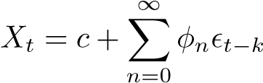 (8)

If the kernel Φ behind the modulation of the artifacts amplitude were known, or could be estimated su ciently, we could construct an optimal weighting function as a deconvolution lter. This line of reasoning is based on the similarity between the generic weighted comb lter (7) and the generic discrete-time AR (1) process (8). Note that, for practical applications, we would need nite *N*. This would limit the application to kernels decaying su ciently fast.

## Temporal Weighting Examples

2.3.1 Linear Weighting

One straight-forward approach is using a linear decreasing weighting function. The assumption of local linearity is widely used in the analyis of non-linear dynamical systems, which could render the kernel su ciently exible. Additionally, the function is simple and the necessary normalization can easily be calculated by using the triangular number for a given *N* as normalizing constant *k* (10). Hence, equation (9) returns weights for earlier periods based on a linear temporal weight decay.

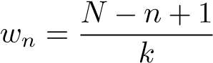 (9)

with the following normalization

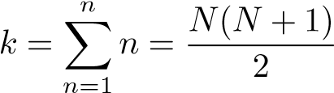 (10)

2.3.2 Exponential Weighting

Motivated by the fact that the autocorrelation function of an AR (1) process can be expressed as a decaying exponential, an alternative approach would be an exponential weighting function. The time constant *τ* of an exponential controls its temporal decay. To maintain the shape across di erent *N*, we consider it reasonable to normalize *n* by *N*. Hence, equation (11) returns weights for earlier periods based on their exponential temporal weight decay.

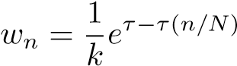 (11)

with the following normalization

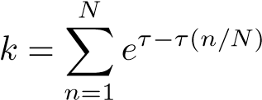 (12)

2.3.3 Gaussian Weighting

Consider that the amplitude modulation might be governed by more than one AR (1) process, or the process might be non-stationary itself. Motivated by the fact that such sums often converge to a normal distribution, an alternative approach would be a Gaussian weighting function. Using a suitable parameterization, and centering on zero, the inverse of the standard deviation 1*/σ*2 de nes the time constant *τ* of a Gaussian distribution, which controls its temporal decay. To maintain the shape across di erent *N*, we consider it again reasonable to normalize *n* by *N*. Hence, equation (13) returns weights for earlier periods based on their Gaussian temporal weight decay.

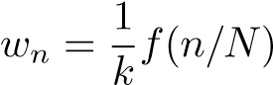 (13)

with the following generating function and normalization

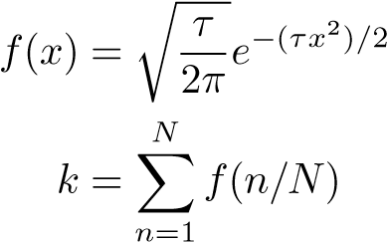(14)

(15)

## Alternative Filter Approaches

Besides the discussed real-valued causal comb lters, several other approaches for ltering the tACSartifact are possible. For example, one could derive the weight at each period from the autocorrelation across periods (see 2.4.1), or remove periodic principial components until the artifacts power is su ciently suppressed (see 2.4.3), or use complex-valued kernels which would natively support non-integer frequencies (see 2.4.2).

2.4.1 Automatic Weight Estimation

As mentioned, weighted comb lters can be just ed by using weights to maximize accuracy and precision of the artifact estimate based on sampling from earlier periods. This process can be put on an empirical foundation, e.g. by calculating the autocorrelation of the recording, which is dominated by the artifact. Weights are then based on the autocorrelation coe cients at periodic lags.

2.4.2 Causal Discrete Fourier Transformation

We might also tackle the non-stationarity of the artifact by estimating the artifacts power in a speci c frequency for each time-point, using a window of *N* periods based on the frequency of tACS. This approach can be implemented as convolution of the recording with a complex kernel at the artifacts frequency, followed by subtraction. While it has the advantage that it supports natively frequencies which are not integer divisibles of the sampling frequency, we need to assume sinusoidality of the artifact. Additionally, to remove the artifact at harmonic frequencies, the computation has to be performed several times for each harmonic frequency. Whether this approach is su cient, will therefore depend on whether the artifact can be su ciently catched by these few frequencies.

2.4.3 Adaptive Removal of Periodic Principal Components

Instead of understanding the artifacts in sinusoidal terms, we can also focus on its periodicity and estimate the modulation of the artifacts periodic components across time. This can be implemented by cutting a recording into epochs with period length, followed by prinical component analysis.[1]If the trial duration is signi cantly larger than the duration of the physiological signal, and as the artifacts amplitude is much larger than the physiological signal, we are justi ed to assume that the physiological signal will only span a subspace with small eigenvalues. The major components will catch the shape components of the artifact, their amplitude modulation over time, and if present, any phase-lag induced by clock asynchrony between stimulator and recording devices. Removing the largest principal components will therefore be more likely to reduce the power of the artifact, and not of the signal. Removal of the largest component derived using main periodic principal component analysis (pPCA) can be performed iteratively until a speci c condition is achieved. We implemented such an iterative approach by removing components until the power in the artifacts main frequency was reduced below the level of nearby, non-artifacted frequencies.

## Implementation

We implemented all of the discussed approaches for kernel creation and artifact removal in Matlab 2016b. The code can be accessed online 2,free and open source, and has been licensed under a

X11-license.

# Evaluation

We selected several kernel approaches and evaluated their frequency response characteristics (see 3.1). Additonally,we evaluated their performance in comparison also to alternative approaches on simulated (see 3.2) and real data (see 3.3).

## Evaluation of Frequency Response

Examine the following exemplary kernels constructed for a sampling rate of 1KHz, a stimulation frequency of 10 Hz and a memory of 10 periods (see gure 2).

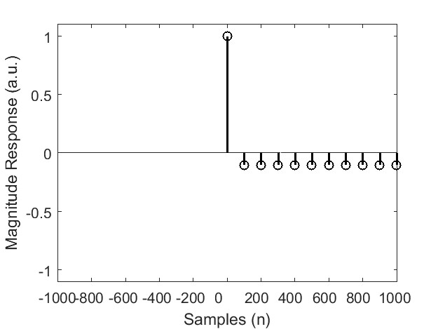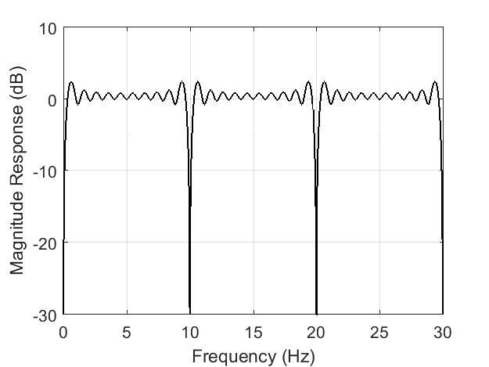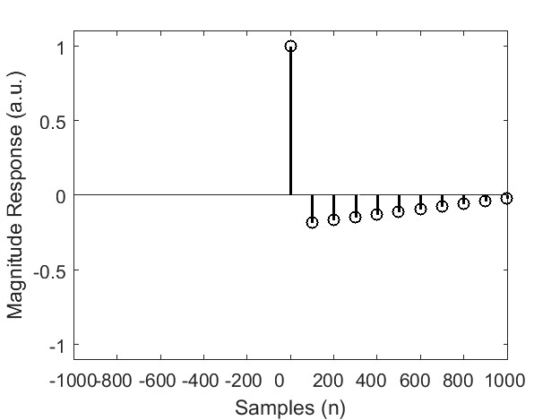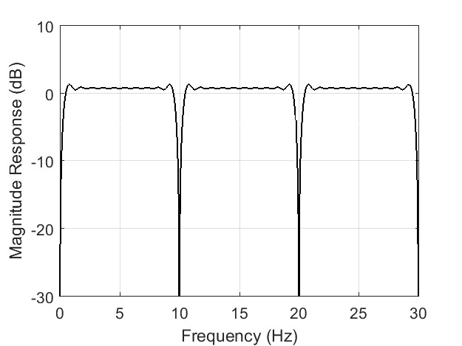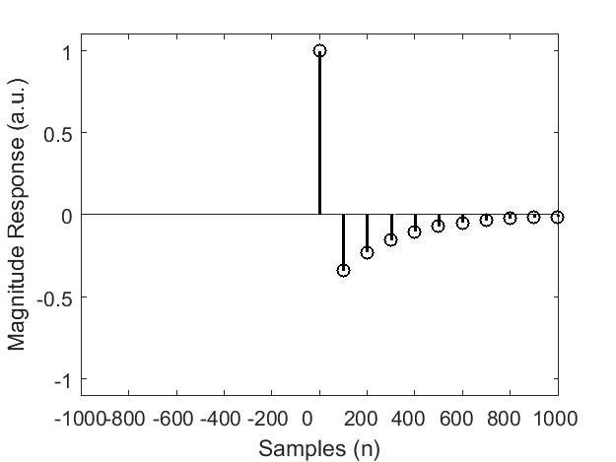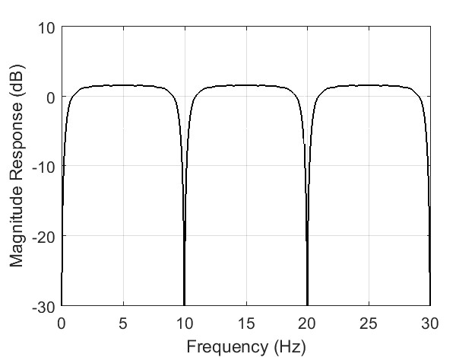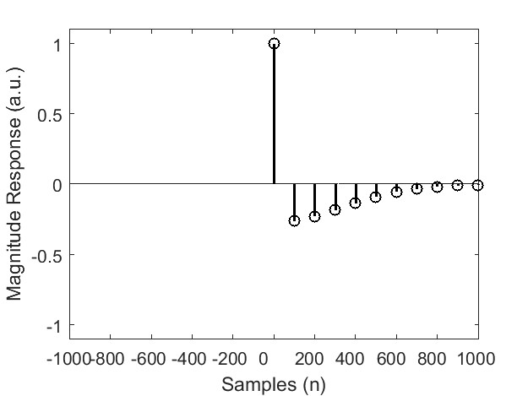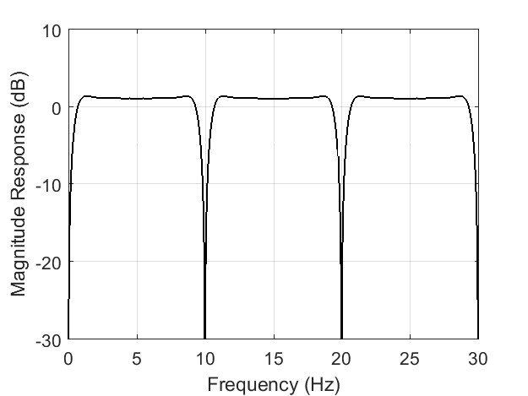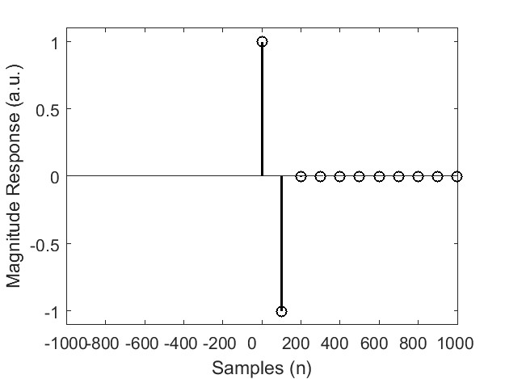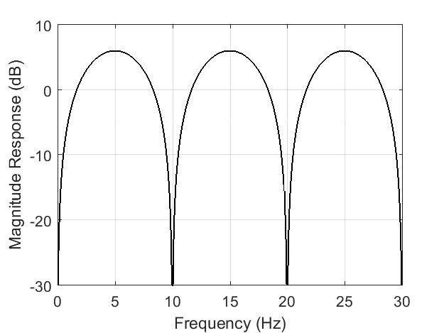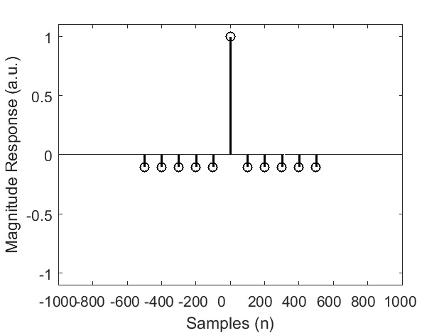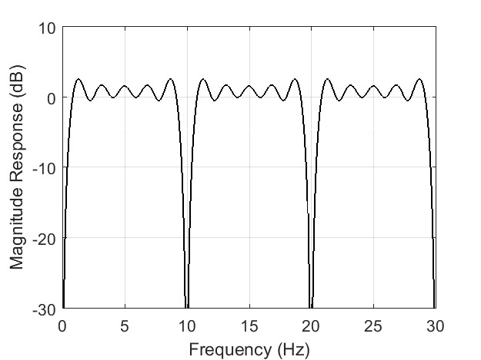

(a) Uniform (b) Linear (tialc) *τ* = 4Exponen- (d) Gaussian *τ* = 3 (e) Exp *τ* = 100 (formf) Symmetric Uni-

Figure 2: Exemplary Kernels highlight Di erences especially in the Pass-band

As you can see from gure 2, the magnitude responses of the comb lteres approaches are similar in their key characteristic. All exhibit a strong supression of the recordings DC component, the target frequency, and its harmonics. Yet, note that the lters exhibit strong di erence in passband behavior. We nd strong ringing in the passband for the uniform (2a) and linear kernel (2b), especially compared to the smooth transitions of the exponential (2c) or Gaussian kernel (2d). Passband ringing is also present for the SMA or symmetric uniform kernel (2f).

We also constructed a set of exponential kernels constructed with di erent *τ* to explore their behavior. We nd it of note that that in the limiting case of *τ* = 0, the exponential kernel virtually converges with the uniform kernel (see gure 2a). Using a *τ* equal to the artifacts period length, the exponential kernel almost fully converges with a simple one-step comb lter (see gure 2e). Note also that for all decreasing weight functions, very high *τ* would return an impulse response, and therefore just pass all signals.

## Evaluation on Simulated Signals

To evaluate the lters, we tested them on simulated signals. The simulated signal was created as superposition of a 10 Hz tACS-artifact, and an event-related potential (ERP). The ERP was simulated as the gradient of a at top window. The amplitude of the artifact was simulated as a distorted, non-stationary sinusoidal. The initial stimulation signal was modelled as sinusoidal signal. We distorted it by adding periodic white noise. Additionally, the stimulation amplitude was driven by an OrnsteinUhlenbeck process with a sti ness 0.5, and a Hanning window time-locked to the event-related potential. In that way, we were able to simulate event-independent modulations of the artifacts amplitude, and modulations locked to an event. [2] Such e ects were described by (Noury et al., 2016), as having a strong potential to mask the true event-related neurophysiological activity.

We simulated 100 trials with a length of 8000 samples. Subsequently, we explored di erent lters for 10 Hz, all with a period number of 10. The causal DFT lter was applied recursively not only at 10, but also at 20, 30, and 40 Hz to reduce harmonics.

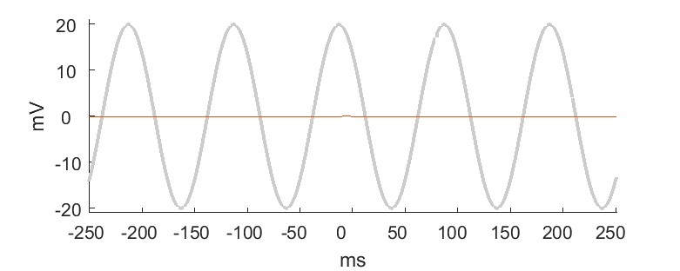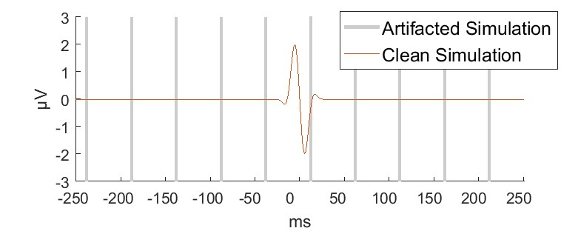

(b) Signal Comparison

(a) Experimental Setup

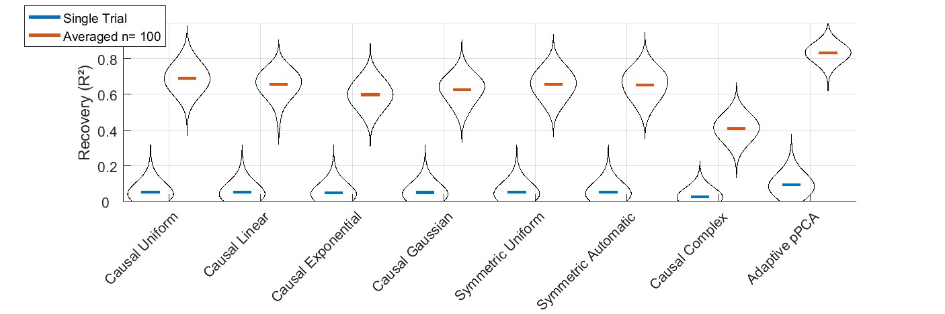

(c) Kernel Density Estimation of R† for di erent lter approaches

Figure 3: Overview for Artifact Removal from Simulated Signal suggests su cient Performance

Based on the correlation of the ltered, artifacted recording with the known shape of the simulated ERP, we calculated the R† value. Blue bars indicate the average R† for single-trial reconstructions, and red bars the average R† for boot-strapped grand-average ERPs (see gure 3c). Visual inspection of the R† estimates shows that all ltering approaches are able to recover at least some information about the ERP. Di erences between the comb lters is small.

## Evaluation on real data

To evaluate the lters further, we tested them on real physiological signals. Consider that tACS can have physiological e ects on cortical ERP. To properly evaluate the recovery using the ltering approaches, we needed a physiological signal unlikely to be a ected by tACS.

We therefore measured electrocardiogram (ECG) at the exor digitorum of the left upper limb, while we stimulated distal and proximal with tACS to the recording electrodes (see gure 4a). We also recorded ECG at the chest, and detected the R-peak for epoching the data. Please note that no tACS-artifact was visible in the chest ECG. Physiological signals were acquired using BrainProducts ampli ers at a sampling rate of 1 kHz and low-pass ltered below 35 Hz. Stimulation as delivered using a NeuroConn DC Stimulator Plus with carbon rubber electrodes and Ten20 electrode gel with an intensity of 1 mA at a frequency of 11 Hz.

We detected the R-peak based on the chest-recordings, which allowed us to cut epochs of 8s duration for the recording at the upper limb, for a total of 134 R-peaks without stimulation and 136 with stimulation. We estimated the true shape of the R-peak by taking the average of the stimulation-free signal. Based on the correlation of the ltered, artifacted recordings with the averaged stimulation-free recording, we calculated the R† value. Blue bars indicate the average R† for single-trial reconstructions, and red bars the average R† for boot-strapped grand-average ERPs based on 100 epochs (see gure 4c). Additionally, note the recovery of the signal in the timedomain (see gure 4.2).

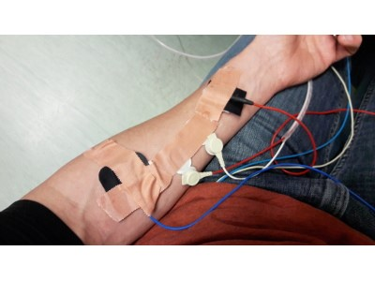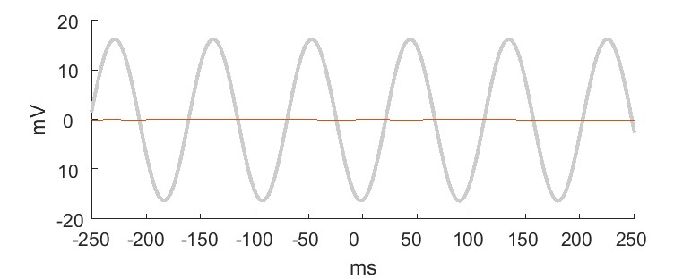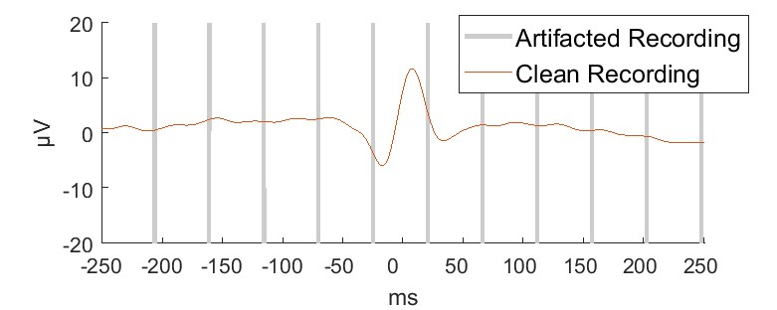

(b) Signal Comparison

(a) Experimental Setup

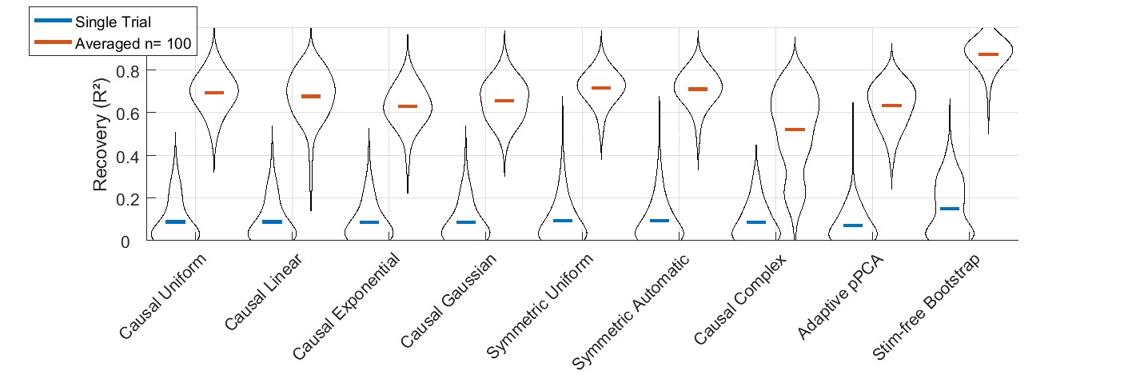

(c) Kernel Density Estimation of R† for di erent lter approaches

Figure 4: Overview for Artifact Removal from Upper Limb Electrocardiogram suggests su cient Performance

# Discussion

We developed a justi cation for weighted comb lters, and explored their frequency response and their performance on simulated and real data.

## Performance

We found that independent of the weighting function, all comb lters exhibit strong suppression of the DC component, the artifacts frequency and harmonics (see 3.2). Yet, di erent weighting functions exhibit di erent pass-band performance, which is especially evident as ringing (see gure 2a) or ampli cation (see gure 2e).

For real and simulated datasets, all approaches were able to recover the signal. Contrasting their performance on simulated (see 3.2) or real data (see 3.3), we found generally quite similar proles.

All comb lters performed very similar, but it should be noted that the weighted lters exhibited slightly average lower R† values in both settings and a slightly more skewed distribution for real data (see gure 4c). This might be linked to distortion by echos (see 4.2) or insu cient artifact removal in a few trials. The causal complex lter performed worst, although we ltered not only the main frequency of the artifact, but also the harmonical frequencies. This is most likely caused by the non-sinusoidality of the artifact.

Most interestingly, the causal uniform lter performed on par with the symmetric lters, regardless of whether these were weighted uniform or based on the autocorrelation. This suggests that the causal uniform lter can be highly e ective, in spite of its low computational complexity,

The pPCA showed superior performance in the simulation, but only average performance in the real dataset. The likely reason is that the linear composition of the simulated recording was a prime candidate for linear separation by pPCA and suggests that simulation studies for exploration of lter performance can exaggerate the performance of decomposition approaches.

## Echos

A key disadvantage of comb lters is that while they subtract the artifacts, any underlying physiologal signal will cause a periodic echo according to the weights of the kernel.

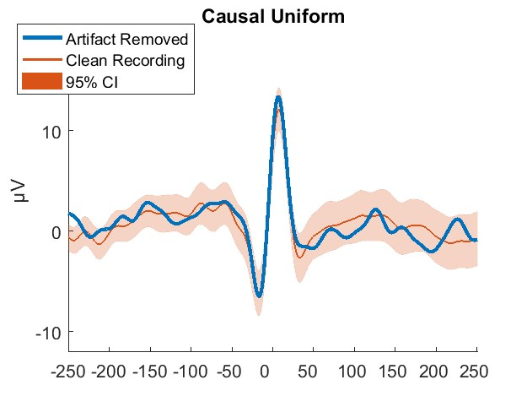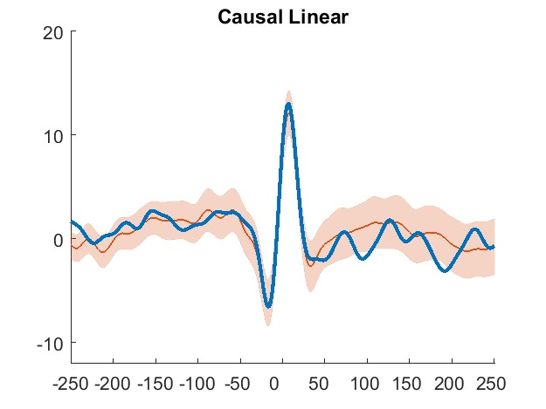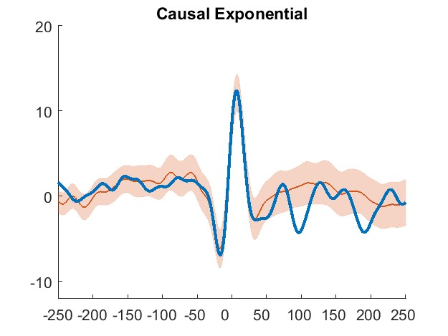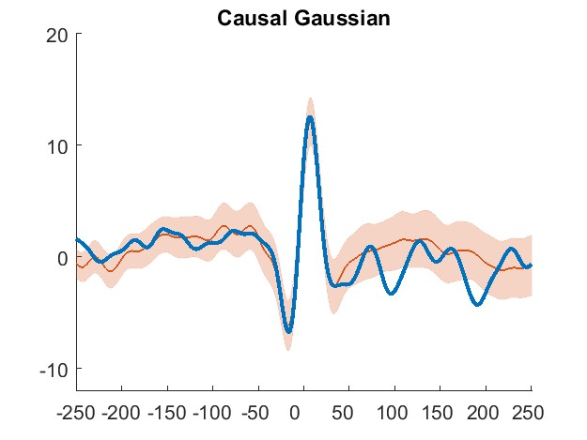

(a) Causal Uniform (b) Causal Linear (c) Causal Exponential (d) Causal Gaussian

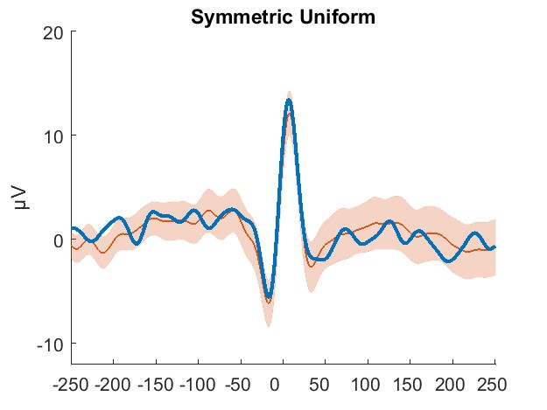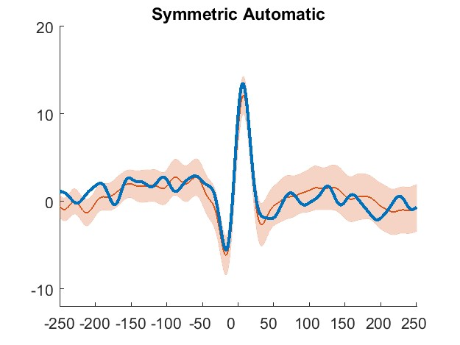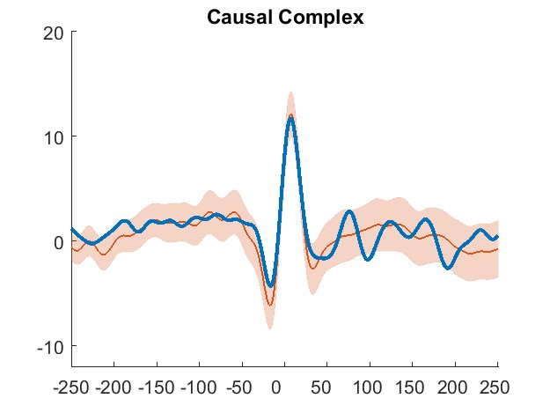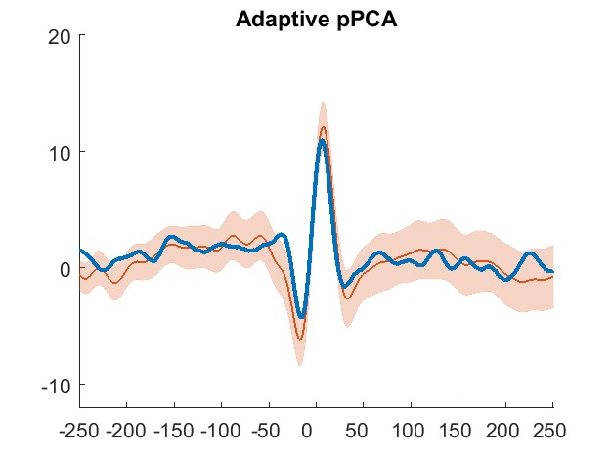

(e) Symmetric Uniform (f) Symmetric Automatic (g) Causal Complex (h) Adaptive pPCA

Figure 5: Overview of Reconstruction in the time domain highlights possibility of echos

This means that strong weights close to the kernels center might increase the precision of the artifact amplitude estimate, but can also induce unwanted and strong echos close to the occurence of a physiologically interesting event .

Additionally, if the duration of the physiological signal is longer than the period of the kernel, the signal will be distorted by the echo. This could be addressed by delaying the kernel, i.e. kernels with zero weights for a number of periods before their estimation weights start, or inverting the kernels, i.e. kernels with increasing instead of decreasing weights with increasing delay, or applying causal lters piece-wise left and right of the signal. [3]

## Matched Phase and Frequency

Simulation studies suggested that the power of endogenous oscillations increases if the frequency of tACS matches the targets eigenfrequency (Kutchko and Fr hlich, 2013; Zaehle et al., 2010). This has been supported by evidence from animal studies (Schmidt et al., 2014), and human studies combining tACS with transcranial magnetic stimulation (TMS) (Guerra et al., 2016), or contrasting pre and post resting state power analysis (Zaehle et al., 2010). It has also been suggested that the phase of neuronal populations would be locked to the phase of the tACS signal (Reato et al., 2013). This has been supported by evidence from studies combining tACS with motor output (Brittain et al., 2013), TMS (Raco et al., 2016; Nakazono et al., 2016) or sensory perception (Gundlach et al., 2016). At the same time, event-locked modulation of skin impedance can mimic phase and/or frequency locked modulations. Events might even be endogenous, e.g. heart beats (Noury et al., 2016). This suggests that transient and event-locked modulations in frequency and phase matching to the tACS can make the distinction between artifact and neurophysiological e ect di cult or impossible.

## Conclusion

We note that all lters were able to recover the signal (see gure 4c), and that the causal uniform lter is comparable to computationally more complex approaches (see 4.1).

This suggests its utility for environments with limited computational power, or for parallel application on multiple channels. Furthermore, being a purely causal lter, it can achieve online performance at high speed and with minimal delay.

Finally, note that comb lters are purely periodic with no assumptions about the shape of the artifact. Comb lters might therefore be useful for ltering of deliberately non-sinusoidal, e.g. pulsed (Jaberzadeh et al., 2015) or misshaped (Cole and Voytek, 2017) transcranial current stimulation.

# References

Brittain, J.-S., Probert-Smith, P., Aziz, T. Z., and Brown, P. (2013). Tremor suppression by rhythmic transcranial current stimulation. Current Biology, 23(5):436 440, DOI: [10.1016/j.cub.2013.01.068](http://oadoi.org/10.1016/j.cub.2013.01.068).

Cole, S. R. and Voytek, B. (2017). Brain oscillations and the importance of waveform shape. Trends in Cognitive Sciences, 21(2):137 149, DOI: [10.1016/j.tics.2016.12.008](http://oadoi.org/10.1016/j.tics.2016.12.008).

Guerra, A., Pogosyan, A., Nowak, M., Tan, H., Ferreri, F., Lazzaro, V. D., and Brown, P. (2016). Phase dependency of the human primary motor cortex and cholinergic inhibition cancelation during beta tACS. Cerebral Cortex, 26(10):3977 3990, DOI: [10.1093/cercor/bhw245](http://oadoi.org/10.1093/cercor/bhw245).

Gundlach, C., M ller, M. M., Nierhaus, T., Villringer, A., and Sehm, B. (2016). Phasic modulation of human somatosensory perception by transcranially applied oscillating currents. Brain Stimulation, 9(5):712 719, DOI: [10.1016/j.brs.2016.04.014](http://oadoi.org/10.1016/j.brs.2016.04.014).

Helfrich, R. F., Schneider, T. R., Rach, S., Trautmann-Lengsfeld, S. A., Engel, A. K., and Herrmann, C. S. (2014). Entrainment of brain oscillations by transcranial alternating current stimulation. Current Biology, 24(3):333 339, DOI: [10.1016/j.cub.2013.12.041](http://oadoi.org/10.1016/j.cub.2013.12.041).

Jaberzadeh, S., Bastani, A., Zoghi, M., Morgan, P., and Fitzgerald, P. B. (2015). Anodal transcranial pulsed current stimulation: The e ects of pulse duration on corticospinal excitability. PLOS ONE, 10(7):e0131779, DOI: [10.1371/journal.pone.0131779](http://oadoi.org/10.1371/journal.pone.0131779).

Kohli, S. and Casson, A. J. (2015). Removal of transcranial a.c. current stimulation artifact from simultaneous EEG recordings by superposition of moving averages. In 2015 37th Annual International Conference of the IEEE Engineering in Medicine and Biology Society (EMBC). IEEE, DOI: [10.1109/embc.2015.7319131](http://oadoi.org/10.1109/embc.2015.7319131).

Kutchko, K. M. and Fr hlich, F. (2013). Emergence of metastable state dynamics in interconnected cortical networks with propagation delays. PLoS Computational Biology, 9(10):e1003304, DOI: [10.1371/journal.pcbi.1003304](http://oadoi.org/10.1371/journal.pcbi.1003304).

Nakazono, H., Ogata, K., Kuroda, T., and Tobimatsu, S. (2016). Phase and frequency-dependent e ects of transcranial alternating current stimulation on motor cortical excitability. PLOS ONE, 11(9):e0162521, DOI: [10.1371/journal.pone.0162521](http://oadoi.org/10.1371/journal.pone.0162521).

Neuling, T., Ruhnau, P., Weisz, N., Herrmann, C. S., and Demarchi, G. (2017). Faith and oscillations recovered: On analyzing EEG/MEG signals during tACS. NeuroImage, 147:960 963, DOI: [10.1016/j.neuroimage.2016.11.022](http://oadoi.org/10.1016/j.neuroimage.2016.11.022).

Niazy, R., Beckmann, C., Iannetti, G., Brady, J., and Smith, S. (2005). Removal of FMRI environment artifacts from EEG data using optimal basis sets. NeuroImage, 28(3):720 737, DOI: [10.1016/j.neuroimage.2005.06.067](http://oadoi.org/10.1016/j.neuroimage.2005.06.067).

Noury, N., Hipp, J. F., and Siegel, M. (2016). Physiological processes non-linearly a ect electrophysiological recordings during transcranial electric stimulation. NeuroImage, 140:99 109, DOI:

[10.1016/j.neuroimage.2016.03.065](http://oadoi.org/10.1016/j.neuroimage.2016.03.065).

Pogosyan, A., Gaynor, L. D., Eusebio, A., and Brown, P. (2009). Boosting cortical activity at beta-band frequencies slows movement in humans. Current Biology, 19(19):1637 1641, DOI: [10.1016/j.cub.2009.07.074](http://oadoi.org/10.1016/j.cub.2009.07.074).

Raco, V., Bauer, R., Tharsan, S., and Gharabaghi, A. (2016). Combining TMS and tACS for closedloop phase-dependent modulation of corticospinal excitability: A feasibility study. Frontiers in Cellular Neuroscience, 10, DOI: [10.3389/fncel.2016.00143](http://oadoi.org/10.3389/fncel.2016.00143).

Reato, D., Rahman, A., Bikson, M., and Parra, L. C. (2013). E ects of weak transcranial alternating current stimulation on brain activity a review of known mechanisms from animal studies. Frontiers in Human Neuroscience, 7, DOI: [10.3389/fnhum.2013.00687](http://oadoi.org/10.3389/fnhum.2013.00687).

Schmidt, S. L., Iyengar, A. K., Foulser, A. A., Boyle, M. R., and Fr hlich, F. (2014). Endogenous cortical oscillations constrain neuromodulation by weak electric elds. Brain Stimulation, 7(6):878 889, DOI: [10.1016/j.brs.2014.07.033](http://oadoi.org/10.1016/j.brs.2014.07.033).

Zaehle, T., Rach, S., and Herrmann, C. S. (2010). Transcranial alternating current stimulation enhances individual alpha activity in human EEG. PLoS ONE, 5(11):e13766, DOI:

[10.1371/journal.pone.0013766](http://oadoi.org/10.1371/journal.pone.0013766).

1. Please note that we found that the naive approach of simply cutting the recording into epochs of period length returned boundary artifacts at the start and end of each epoch. Running the algorithm at a set of random initial lags, and subsequently averaging their results was su cient to remove such boundary artifacts. 2<https://github.com/agricolab/ARtACS>
2. Code for signal generation is included in the toolbox at <https://github.com/agricolab/ARtACS>
3. If delayed or inverted kernels are used in a symmetric kernel, they appear concave. While such concave, delayed or inverted kernels might extend the window free of echos around physiological signals, they might not su ciently account for the non-stationarity of the artifacts amplitude. The ltered signal might contain a residual artifact. Whether the trade-o between echo and residual artifact warrants concave kernels depends strongly on the signal under research. Please note that at least on our datasets and simulations, concave approaches were usually inferior to the regular causal or symmetric kernels.